Agent_OneAmFam – Evan Feller

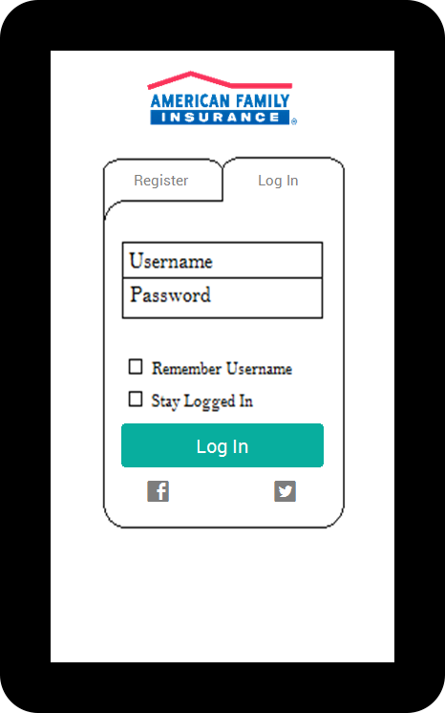

LOGINACTIVITY

1. Register Tab
   1. In a list View
      1. Username, password, AgentID, name, email, phoneNumber, address, city,zip edit texts
      2. State dropdown – list of states with abbreviations
   2. Register Button
2. Log in tab
   1. username, Password edit texts
   2. remember username, stay logged in checkboxes
      1. use shared preferences to handle these checks
   3. Log In Button, goes to a home screen
3. Facebook/twitter log in, we will handle this if we get time, if we do not get it finished we can leave the buttons and comment on how we did not get it to work

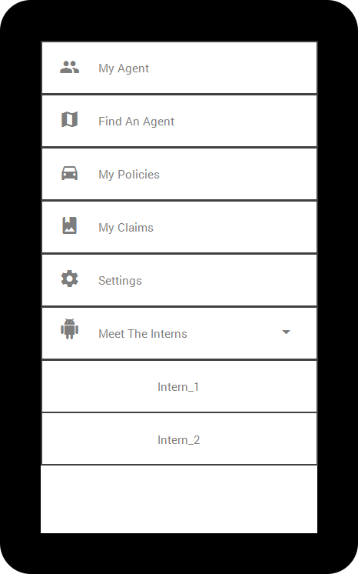

NAVIGATIONDRAWERFRAGMENT

1. My agent goes to/open MyAgentFragment
2. Find An Agent, shows all amfam agents within 30 miles, start an intent for this
3. My Policies, goes to/open the MyPoliciesragment
4. My Claims, goes to/open the ClaimsListFragment
5. Settings, goes to/open the SettingsFragment
6. Meet The Interns, is a dropdown listview that if we get time we will each implement our own fragment that when our name is clicked will go to

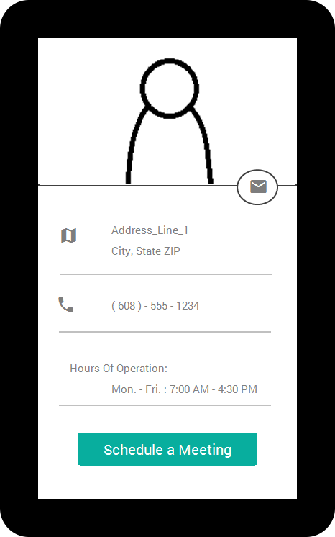

MYAGENTFRAGMENT

1. Shows the agents image on top
   1. Sends the agent an email if the email button is pressed
2. Will pull up directions to agents address if map is clicked
3. Will call the agent if the phone is clicked
4. Schedule a meeting will open up the google calendar intent ( not sure how we are implementing this in agent so I will update it to that point when we get there )

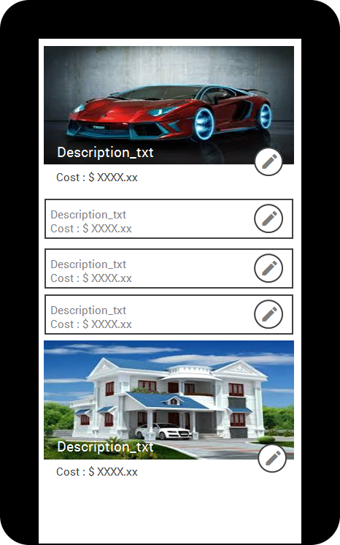

MYPOLICIESFRAGMENT

1. We will be using cards to display this, if it does have uploads it will display the first image in the card, if no uploads it will display the simple card
   1. Both will show the description and the cost
2. The edit pencil button will open up the PolicyScreenFragment with the editTexts enable to edit, the add button will be displayed, and the uploads can have their comments edited and be deleted
3. If the card is clicked on the PolicyScreenFragment will open with the editTexts disabled and the add button not visible, as well as no option to change comments or delete uploads
4. Plus button on the app bar to add new policy

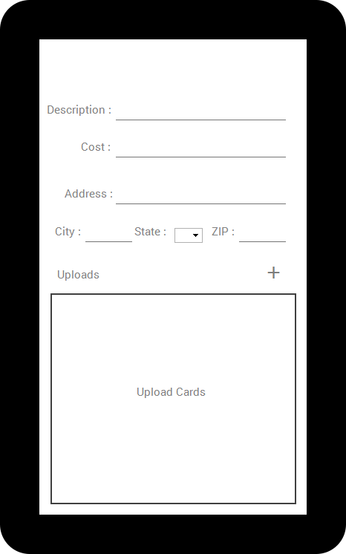

POLICYSCREENFRAGMENT

1. Comes up blank if the plus button from app bar is pressed
2. Comes up with info filled in and everything enabled if the edit button is clicked
3. Comes up with info filled in and all editTexts unchangeable as well as plus button not visible/disabled, and no ability to edit uploads and delete them

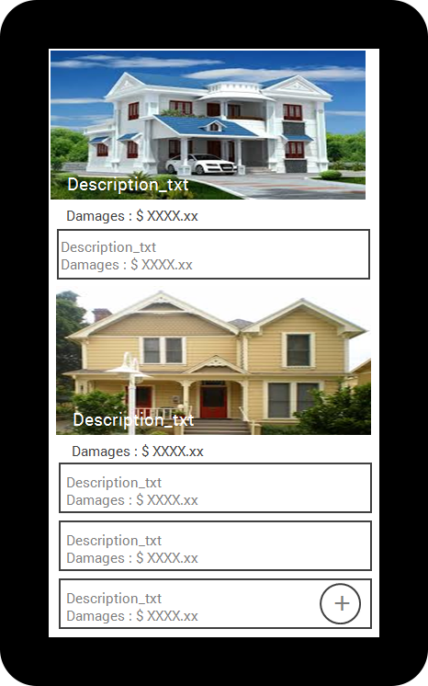

MYCLAIMSFRAGMENT

1. We will be using cards to display this, if it does have uploads it will display the first image in the card, if no uploads it will display the simple card
   1. Will display the description and the damages
2. The plus button will open the ClaimScreenFragment with the editTexts editable and the upload button implemented and the uploads editable/removable
3. If card is clicked on it will open the ClaimScreenFragment with the editTexts being un editable and the upload button invisible/disabled, and the uploads not editable or removable

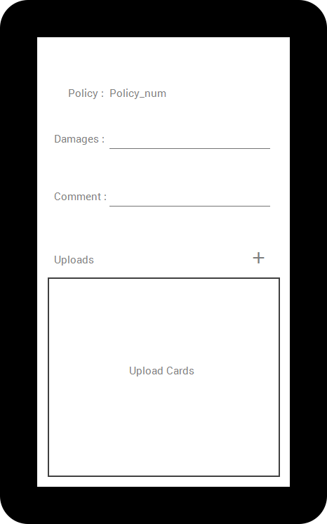

CLAIMSCREENFRAGMENT

1. Comes up blank if the plus button is pressed
2. Comes up with info filled in and all editTexts unchangeable as well as plus button not visible/disabled, and no ability to edit uploads and delete them
3. We will use a listview to save time instead of card view

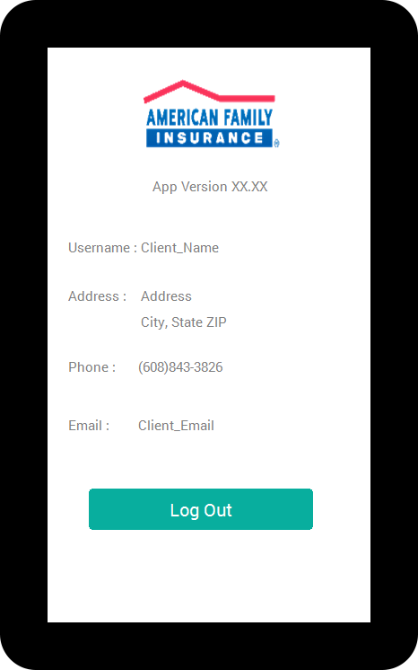

SETTINGSFRAGMENT

1. Will display all the information in textViews
2. current app version at the top
3. log out button which will take you back to the loginactivity

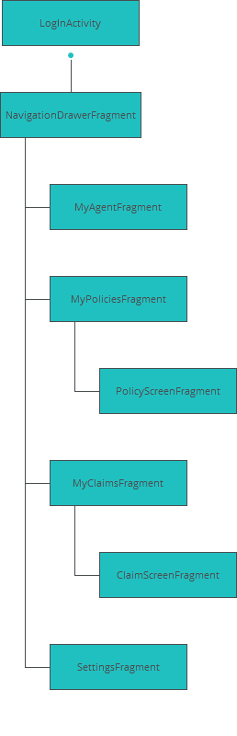

SITE MAP