Intern Client_OneAmFam App  
Revision: 1  
Date: 06/29/15

Description: This will be the client version of our One AmFam app series that will allow a client user to find an agent near them using google navigation, schedule a meeting with an agent via google calendar, look through their policies as well as create a new one, and look through old and current claims as well as create new claims. Finally the user should be able to connect their account to Facebook or google+.

Username: EFELLER@AMFAM.COM

Password : amfamintern

Project : OneAmFam

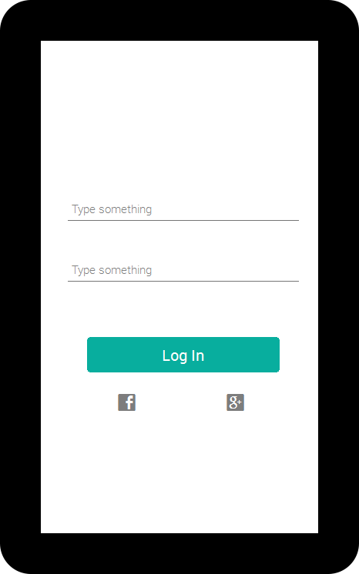

LOGIN SCREEN

1. USERID and Password saved on Parse
   1. After logging in it will save the information to shared preferences
   2. Option to log out in a settings menu
2. Option to connect account with Facebook or google+

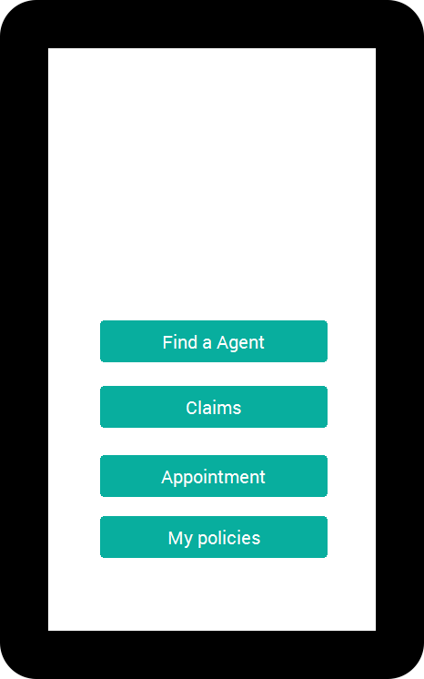

MAIN SCREEN

1. Find a Agent Button
   1. Opens a google navigation that will search for the closest agent within 40 miles
2. Claims button
   1. Will bring up the list of claims pulled down from parse for that specific user
3. Appointment button
   1. Will bring up the google calendar and handle our appointments through that.
4. My Policies Button
   1. Will bring up the list of policies pulled down from parse for that specific user

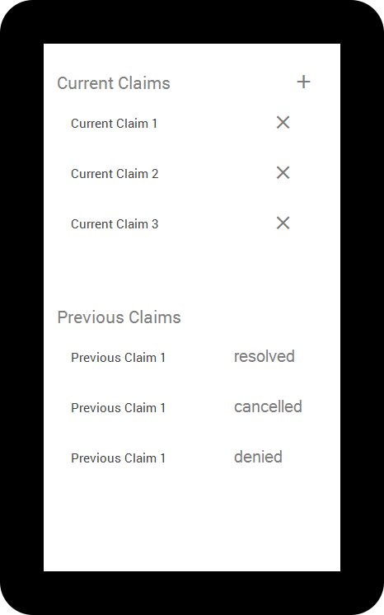

CLAIMS LIST SCREEN

1. Add (+) Image View
   1. Will add a new blank claim to your current claim
      1. Gets a claim number from parse and puts it in automatically
2. List of Current Claims
   1. Name of the Claim (Claim number)
   2. Delete ( x ) Image View
      1. When clicked will delete that item from the list
      2. Marked as cancelled
3. List of Previous Claims
   1. Name of the Claim (Claim number)
   2. TextView of the status of that claim ( resolved, cancelled, or denied )

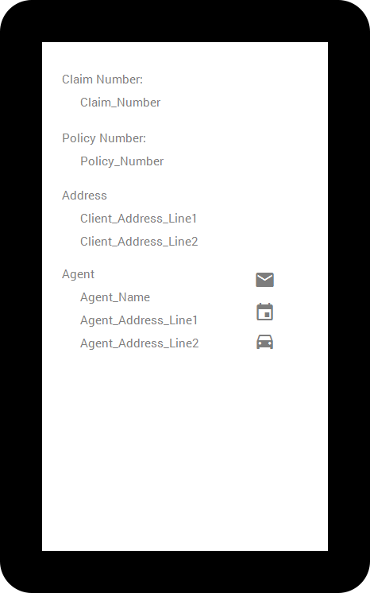

CLAIM SCREEN

1. Shows the claim number, policy number, address for the client/claim, address and name of the agent
   1. If clicked from previous claim these will be a textView, if clicked from current claim policy number will be a drop down with the policies of that client, automatically fill with a policy to start.
2. Email Agent Button
   1. Opens an email intent to that agent
3. Calendar Agent Button
   1. Sends a Meeting Request to that agent
4. Car Agent Button
   1. Opens a Navigation intent to that Agent

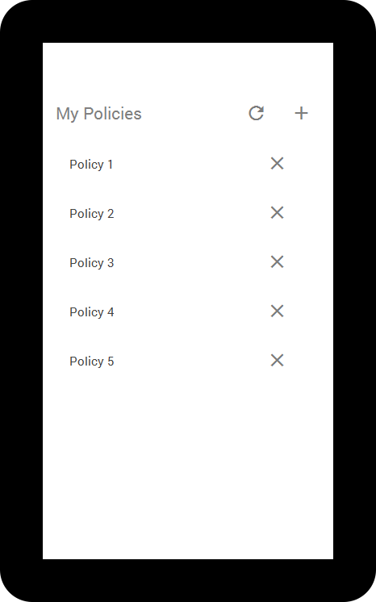

POLICY LIST SCREEN

1. Refresh button
   1. Re-Pull list of policies from parse and update
2. Add button
   1. Adds a new blank policy with policy number to the list
3. List of Policies
   1. Name of Policy (Policy Number/Type )
   2. Delete Policy Button
      1. Will remove that policy from the list of policies

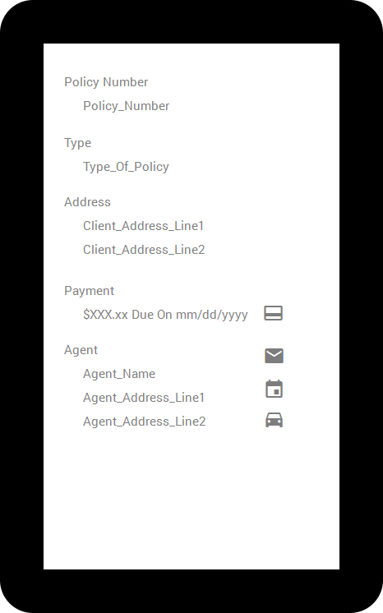

POLICY SCREEN

1. Will show the policy number, Agent information, and Payment as Text View always
2. Type and Address are Edit Text
   1. Allows user to update their policy
3. Payment button
   1. Opens PayPal sandbox payment
4. E mail Agent Button
   1. Opens an email intent to that agent
5. Calendar Agent Button
   1. Sends a Meeting Request to that agent
6. Car Agent Button
   1. Opens a Navigation intent to that Agent