CDAC, Bangalore (E-city), PGDAC Aug -2014

Software Requirements Specification

For
“Query Stack System”

Prepared By: - Vivek Kumar Sharma 140851920097
Ganesh Dutt Sharma 140851920024
Rishabh Sharma 140851920072
Abhay Singh 140851920001
Gaurav Rao 140851920025
Piyush Joshi 140851920060
Table of Contents
Table of Contents...................................................................................... |  |  | ii
Revision History....................................................................................... |  |  | ii
1. | Introduction........................................................................................... |  | 1
 | 1.1 | Purpose............................................................................................................................................ | 1
 | 1.2 | Document Conventions.................................................................................................................... | 1
 | 1.3 | Intended Audience and Reading Suggestions.................................................................................. | 1
 | 1.4 | Product Scope.................................................................................................................................. | 1
 | 1.5 | References........................................................................................................................................ | 1
2. | Overall Description................................................................................. |  | 2
 | 2.1 | Product Perspective......................................................................................................................... | 2
 |  |  | 2
 |  |  | 2
 | 2.2 | Operating Environment.................................................................................................................... | 3
 | 2.3 | Design and Implementation Constraints.......................................................................................... | 3
 | 2.4 | User Documentation........................................................................................................................ | 3
 | 2.5 | Assumptions and Dependencies...................................................................................................... | 3
3. | External Interface Requirements......................................................................................... |  | 3
 | 3.1 | User Interfaces................................................................................................................................. | 3
 | 3.2 | Hardware & Software Interfaces..................................................................................................... | 4
 | 3.3 | Behaviour Requirement..................................................................................................................... | 5
4. | System Features........................................................................................... |  | 8
 | 4.1 | System Feature 1.............................................................................................................................. | 8
 | 4.2 | System Feature 2 (and so on)........................................................................................................... | 8
5. | Other Requirements................................................................................. |  | 8
Appendix A: Glossary....................................................................................................... |  |  | 9
Appendix B: Analysis Models....................................................................... |  |  | 9
Appendix C: To Be Determined List.............................................................. |  |  | 9

Revision History
 | Name | Date | Reason For Changes | Version

1. Introduction
1.1 Purpose
This project is aimed at developing web-based centralized library for solutions to all technical problems. The features of query stack system will be asking questions, submitting solutions to the problems, earning reputation on the basis of likes and favourite and applying for the jobs posted on the website. The “Query Stack System” allows its user to explore the website for the solutions and allow asking or submitting solution to any problem only after registration. Admin keeps track of all activities of its registered users.
1.2 Document Conventions
This document was prepared using the IEEE recommended practice for Software Requirements Specification.
1.3 Intended Audience and Reading Suggestions
The different types of reader that this document is intended for are developers, project managers, marketing staff, users, testers, and documentation writers. The rest of this SRS contains Overall Description, External Interface Requirements, System Features, Non Functional Requirements and Other Requirements. Suggested sequence for reading the document - begin with the overview sections and proceed through the sections that are most pertinent to each reader type.
1.4 Product Scope

Scope of this project is very broad compared to manually taken exams. They are:-
- This app can be used in educational institutions as well as in corporate world.
- Can be used anywhere any time as it is a web based application (user location doesn’t matter).
- The website is acts like a vast library for the problems and their solutions submitted by the programmers.No manual work of preparing and storing the result information.
- Less time consumption, as the solution to problem is found immediately and this solution can be up voted and down voted which helps to find the best solution from them

1.5 References

This web application has been prepared on the basis of discussion with Team members and also taken information from following website – www.google.com , www.stackoverflow.com and the IEEE website.

2. Overall Description
2.1 Product Perspective
Query System is an on-line application. It is accessible via the Internet, 24 hours a day, 7 days a week. The objective of this app is to anyone can search for solution to the problem faced in programming and development phase. This app will only allow the anonymous users with view only permission and registered user to ask question and submit solutions. The various stages in the app are as follows:-
Module in this project:
- Administrator
- Visitor
- Registered users.

Brief description on the modules:
- Administrator: Admin has the full authority over the website. He can take suitable action with respect to any registered user or questions and answer submitted by them.
- Visitors: Query Stack allows visitors to search for questions and their relevant solution on the website submitted by the registered member of the query stack.
- Registered Users: Visitors can register themselves on the website for asking their own problem and submitting the solutions to the problems.

2.2 Operating Environment
This app is internet based so it will run in any operating system with internet access through a web browser.
2.3 Design and Implementation Constraints
Anonymous user (without registration) cannot able to put question and answers. This system is capable to handle 50 simultaneously user.
2.4 User Documentation
The product will include a user manual. The user manual will include product overview, complete configuration of the required software and hardware, technical details and contact information which will include email address.
2.5 Assumptions and Dependencies
Proper working of this app is dependent on the internet connectivity of the users’ computer
Assumptions and dependencies:
-It is assumed that the user has basic knowledge of the system (i.e. he/she is not a first time computer user on internet) as any action by the user is considered valid during an accessing the site.
-It is assumed that the data entered by the user while registering is valid and true.
3. External Interface Requirements
3.1.1 User Interfaces
• Registration Screen:
Various fields available on this screen will be:-
- Name
- Email Id
- Password
- DOB
- Address
- Contact Number

• Login Screen:
Fields available on this screen are:-
- Email Id
- Password

• Asking Questions:
Various Fields are:
- Questions
- Category (Badges)
- Correct Answer

• Submit Answer Screen:
Various Fields are:
- Category
- Questions
- Answer
- Rating

• Admin Screen:
Various Fields are:
- User Details (User_Id, Timestamp, Status)
- Delete User
- Modify (Filter Answers, Forget Password)
3.1.2 Hardware Interfaces
Screen resolution of at least 800X600 is required for proper and complete viewing of screens. Higher resolution will be accepted.
3.1.3 Software Interfaces
-Any windows based operating system.
-Oracle Server Database
-Java and JavaScript enabled browser.

3.1.4 Communications Interfaces
None
3.2 Functional Requirements

This section gives a functional requirement that applicable to the Online Query system.
There are three sub modules in this phase.
- Login (Sign In) module.
- Registration (Sign Up) module.
- Administration module.
- Asking Questions
- Submit the Answers
- Discussion Forum module

3.3 Behavior Requirement

3.3.1 Use Case Diagram

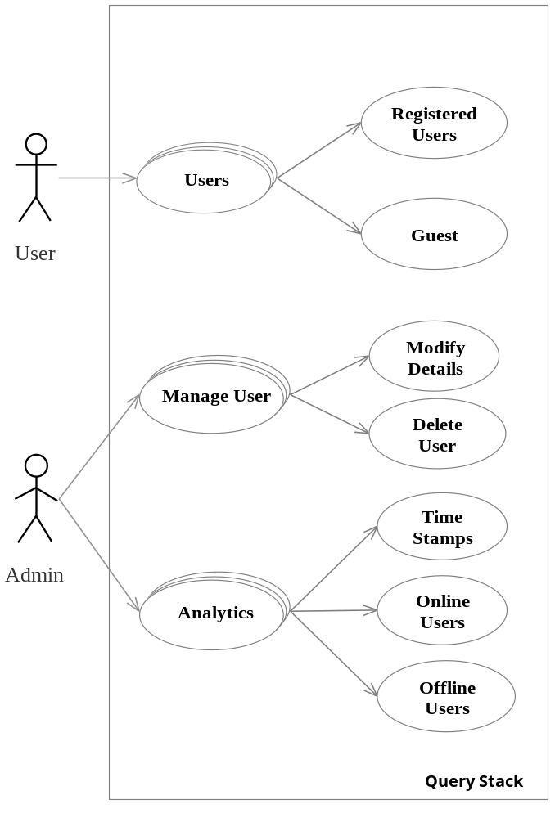

3.3.2 Entity Relationship Diagram

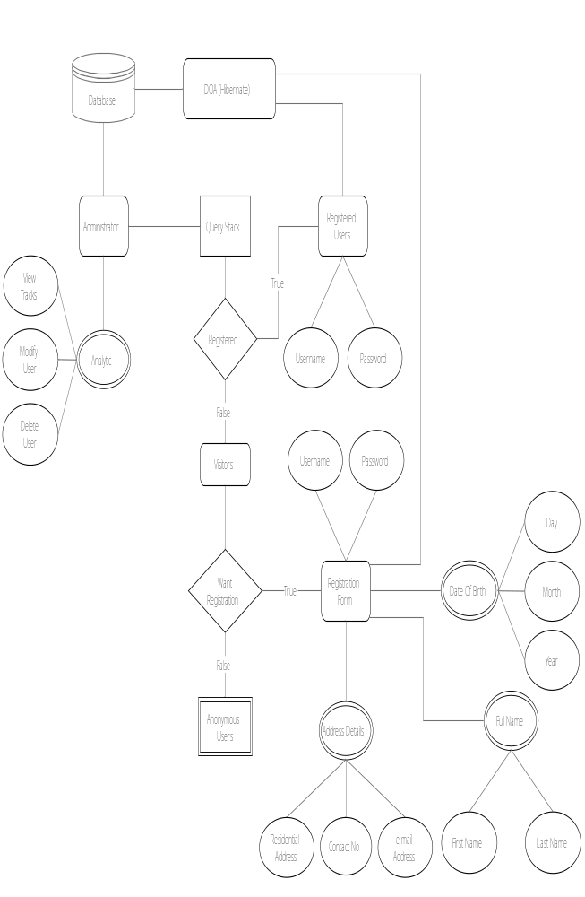
3.3.4 Database Name: QUERY SYSTEM
User1
User_Id | Email |  | Name |  | DOB
Badges
Badges_Id | Badges_Name
Login
Email_Id | Password
Question
User_ID | Ques_Id | Name |  | Votes | Ans |  | Title |  |  |  |  |  |  |  |  |  |  |  |  | Ques | Date
Solution
Sol_ID | Ques_Id | User_Id |  | Name | Solution |  | Post_Date |  |  |  |  |  |  |  |  |  |  |  |  | Date | Votes

4. System Features

Some Performance requirements identified is listed below:

- The database shall be able to accommodate a minimum of 1,000 records of Users.
- The software shall support use of multiple users at a time.
- There are no other specific performance requirements that will affect development.
- Preventing browser from caching web pages.
- Preventing submission on refresh by Send-Redirect-GET pattern
- Smart and quick searching.

4.1 Safety and Security Requirements
4.1.2 Safety Requirements
The database may get crashed at any certain time due to virus or operating system failure. Therefore, it is required to take the database backup.
4.1.3 Security Requirements
Some of the factors that are identified to protect the software from accidental or malicious access, use, modification below. Keep specific log or history data sets
- Assign certain functions to different modules.
4.2Software Quality Attributes
The Quality of the System is maintained in such a way so that it can be very user friendly to all the users.

The software quality attributes are assumed as under:
- Accurate and hence reliable.
- Secured.
- Fast speed.
- Compatibility.

5. Other Requirements

Display high rating questions and their answers.

Appendix A: Glossary
Appendix B: Analysis Models
Appendix C: To Be Determined List

