In my application, I apply two time series machine learning algorithms: the recently released FBProphet and Long term short term memory (LSTM) with Keras and tensorflow.

Each algorithm has a python implementation and functions similarly operationally:
Raw Datasets
Predictions in same
units as raw data
Data reversion/inversion

Data munging, normalization, standardization, column renaming, data type conversions, split data into a training and test set

Prepared/supervised
dataset

Facebook Prophet Benefits to Prophet: it intrinsically discovers and optimizes for multiple seasonality and changing growth rates, called changepoints. By default, Prophet uses a linear model for its forecast. By default, the model provides confidence intervals framing the predictive point.

Changepoints are points in the time series that mark the starting point of abrupt changes in trajectory and connote a change in mean and variance in the time series. FBProphet conducts changepoint detection by default. This feature serves crypto market prediction well because of the drastic changes in levels/trajectories and volatility. The broad market observed a spike in both levels and volatility in November of 2017 and again in January 2018. This dramatic shock marginalizes simple linear regression and is best modeled when changes in intrinsic trends are allowed to differ. Changepoints are detected then subsequently eliminated in an internal optimization scheme. The user also has the ability to specify changepoints, however, that is best done by adjusting the regularization of the model. Internally, Prophet uses a Bayesian mechanism to eliminate and identify the most influential changes points. Additionally, the amount of flexibility and influence caused by short term market extreme levels can be tailored. A market-based example of user tailoring of changepoints, could be a user identifying a changepoint and the subsequent short term levels or trajectory as short term market noise/euphoria, and eliminates this so as not to contaminate predictions. Predictions would be contaminated because the model will project the same rate of changepoints in the future as the past. The Prophet model can be made more brittle or more flexible - which can lead to overfitting.

Output plot: Predictions along with prediction bands are made over the entire series, including two weeks out of sample.
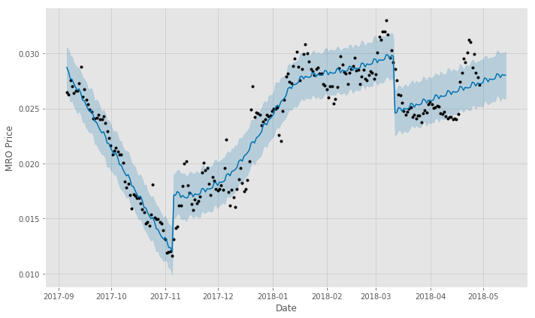

Ability to add regressors, ie independent, explanatory variables. This is extremely relevant to all markets because of the behavioral effects manifested by price levels relative to rolling window statistics and co-movement with other currencies. There are some requirements and assumptions made on extra regressors: They cannot be a constant, need not be binary, if another time series is recruited its future values would have to be known, scale can also be specified, ie is the variable standardized. However, the applicability is restrained by the requirement that the regressor values be imputed in the forecasted dataframe. This would compliment a monte carlo strategy where path of regressors are simulated and weighted.

Predictions of both studies: only price and price along with regressor:
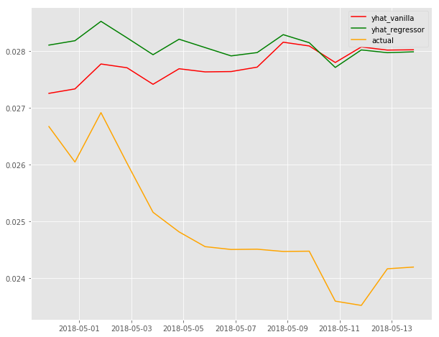

Both forecasts converge as the forecast term is extended. However, it appears as though the vanilla model performed better.

Uncertainty levels: FB Prophet accounts for three types: trend, seasonality,

The Prophet API includes diagnostics like cross validation. One such implementation accommodates selecting a cutoff point, prior to which (chronologically) a model is fit. Then, forecasts can be compared and tested against historical, actual values. This technique is referred to as "simulated historical forecasts".

Forecasting several periods in the future is very advantageous and not always made available in other ML

Weaknesses and inconveniences: in order to fine tune the model, the author must have a pronounced understanding of the time series. Without pronounce understanding or opinion of the time series, the users must trust the chanepoints optimizer.

Another con is the inability to extract coefficients when fitting on more than one explanatory variable. In lieu of this, can calculate such error statistics as Absolute Mean Error and the sum of squared residuals.

Long short term memory – Recurrent Neural Networks
Recurrent neural network (RNN) - algorithm that adds the explicit handling of order in input observations. It learns a mapping function between the inputs and outputs. This mapping function is learned with an implicit account of time. It introduces time and lag to the learning process. The benefit is that the lag factor must not be specified. It is learned and subsequently allowed to change through the series. This benefits deployment on a market-based time series because of the frequent change in underlying quantitative attributes through time and the user’s unlikely understanding of them all.

Feed-forward neural networks do offer great capability but still suffer from the key limitation of having to specify the temporal dependence upfront in the design of the model. Effectively, the dependence between the variables is established, and this co-dependence restricts the flexibility of the model and forecasting.

Some other benefits to this approach:
- It is not entirely necessary to reduce the time series to a stationary process.
- Robust to Noise. Neural networks are robust to noise in input data and in the mapping function and can even support learning and prediction in the presence of missing values.
- Nonlinear. Neural networks do not make strong assumptions about the mapping function and readily learn linear and nonlinear relationships.
- It excels at mutlivariate time series datasets.

Weaknesses and inconveniences: Some experts believe that Multilayer Perceptron (MLP) is more appropriate for time series data than LSTM. "Our results suggest to use LSTM only on tasks where traditional time window-based approaches must fail. LSTM’s ability to track slow oscillations in the chaotic signal may be applicable to cognitive domains such as rhythm detection in speech and music."

The suitability and proper application of LSTM is precarious; however, it’s appropriateness should be tested in a multi-algorithm iterative process.

"LSTM’s have an advantage over more classical statistical approaches like ARIMA : they can fit non-linear functions and moreover , you do not need to specify the type of non-linearity . There also lies the danger : regularisation is absolutely crucial to avoid overfitting "

Excessive treatment and inversion of dataset: The algorithm requires excessive preparation of the dataset:
- Scaling of the inputs: this can be executed in several manners including splitting the dataframe into regressors and outputs
- Reshaping the 2-d arrays
- proper identification of each array when calling the algorithm
- proper concatenation of all the arrays
- inverse transforming the proper arrays

Failing to conduct all these steps properly will throw errors or decompose the output in nonsensical units, which itself will not throw an error.

