Pasting the series of related graphs here: trial starts, member starts and overlays of both. TODO is to QA the counts I’m seeing for the 4th quarter of every year, as I’m not seeing the dramatic decline in the gg_season plot in the bar plot. QA by measuring trial starts by month for each of these years (the input to the barplot) and compare with the values plotted on the gg_season plot
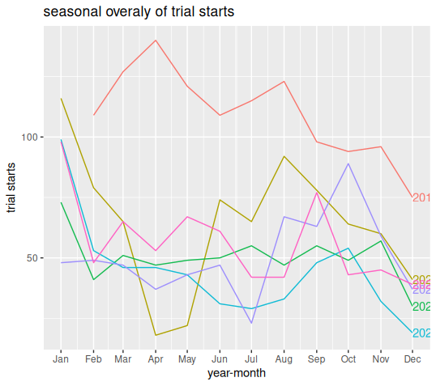
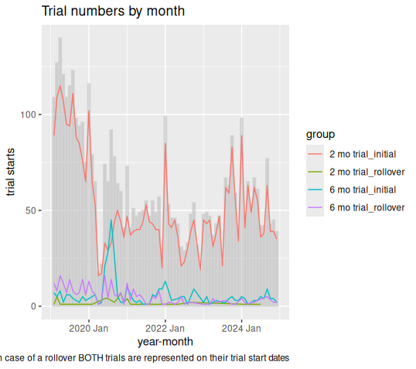
Sdfsdf

