The client has not looked at their 2016 denials data; however a change in billing processing was enacted at the midpoint of the year and had a dramatic effect on billing: Total dollars denied decreased significantly, while number of denials stayed by-and-large stable. Potentially, management may have been operating under a trade-off rubric where they opted to improve one portion of their billing system at the expense of another. We will look at specifically what factors among service line, denial type and insurance carrier and their subfactors were leveraged and quantify the impact. Lastly, I will make recommendations following the firm's preference towards recouping dollars over minimizing denials.

Background: Claims are compiled and submitted in a hybrid manual/automated process using our firm's proprietary software. Once metadata on the procedure/service line is entered, our software accesses the database to pull information on the patient's insurance provider. Internally, meta data and individualized workflows are executed according to the provider and service line.

Overview of client’s denials

Total dollar denials for entirety of 2016 was $75,907,000. The split by half was $40,906,000 in the first half 2016 and $35,001,000 in the second half of 2016 - a decrease of 14.4%. However, there was only a marginal decrease of 1.3% in the number of denied claims.

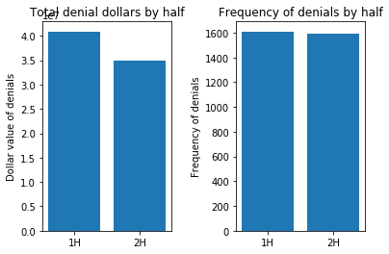

The implementation served to reduce total dollars denied, but frequency of denials stayed flat. The impact both to dollars and frequency was not systemic, however, across the three factors. The dollar impact reverberated heterogeneously across the component factors in their billing practices; however we do detect systemic trends in some of those factors. I uncover those after the factor analysis.

The below displays the bottom line impacts of the client’s implementation. The high dollar bills have been reduced significantly, while those $35K and under have either increased or remained flat. We inform our factor analysis with the distribution of high dollar claims.

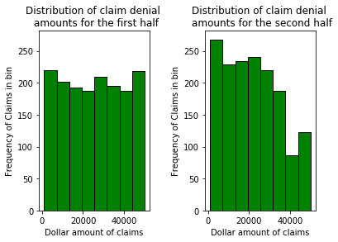

Ripples through the factors
Below is a first half and second half snapshot of those factors on several metrics.

The client offers an array of cancer treatment services and bills nine insurance carriers. Below are their distributions.

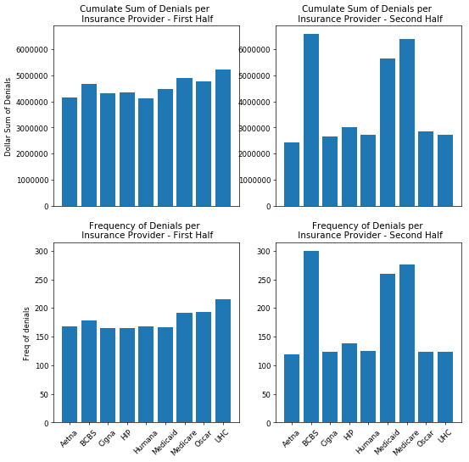

Observable above is the trade-off theme playing out with insurance carriers: The three worst performing carriers (BCBS, Medicare and Medicaid) had an average increase in denial dollars of ~31%, while the other six benefited from ~41% decreases in denial dollars. A similar trade-off is observable in the frequency of denials per insurance carrier: the insurance carriers experiencing the decrease in dollars also saw a decrease in number of denials, while the poor performers saw upticks in frequency.

Because we see a distinct change at the carrier level, we are ready to test the above ‘large bill’ theory by looking at proportions of large bills with the two carrier groups (increase and decrease in denials).

First Half Frequency of Second Half
denials by denial size
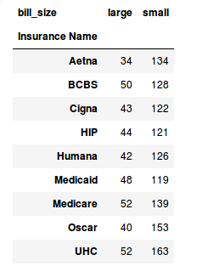
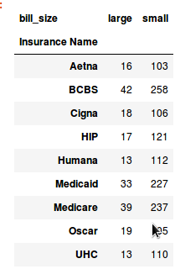

From the frequency table, we see that denials spiked for the weaker performers, although systemically, all large claims declined across carriers. We don’t know whether the spike in denials was from more patients with those carriers, or if this is another expression of the trade-off strategy that was employed by the client.

From a reverse perspective, we see the impacts to the type, frequency and nominal value by denial type. Again, the trade-off pattern of total dollars and frequency of claim is apparent: Authorization, Coding and Credentialing total dollars decreased significantly – average of ~42%, while frequency for those denial types decreased a highly notable 27-37%. The other denial-type buckets realized total dollar increases of 8-15%, while the frequency of denied claims increased 20-30% for the others. We will investigate the interaction and relationship between large claims and denials in the first half, as well as large claims and insurance an
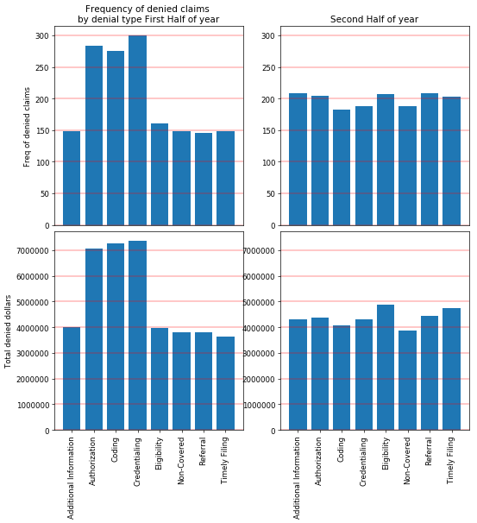

Service Line Data

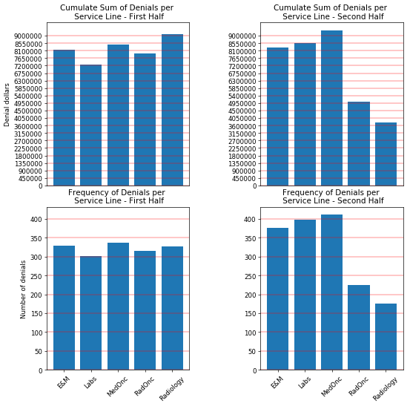
Prominently displayed above is the decrease in both total dollars and frequency of denials for both RadOnc and Radiology. The trade-off as expressed from this perspective is that systemic denials addressed for RadOnc and Radiology were essentially pushed into the other service lines.

Interactions between factors
Because the firm has not looked at their denials data for 2016, their strategy addressed one or more levels among multiple factors:
- consistent improvement as measured by denials of the MedOnc and Radiology service lines
- A deterioration of denial dollars and frequency for BCBS, Medicare and Medicaid

A proportions table in the form of a heatmap showing the interaction of Insurance Carrier and Service Line.

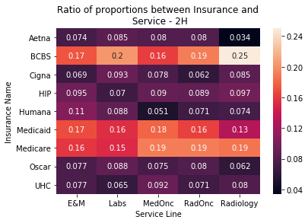
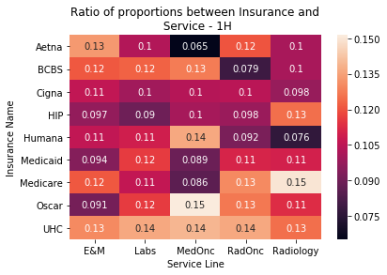
The proportions in the first half among the carrier lines were random – the carriers impacted with the firm’s implementation aren’t the consistent carriers in the service lines that realized declines in denials: MedOnc and Radiology.

Afforded insight into their denial data, the firm has noted weakness in .
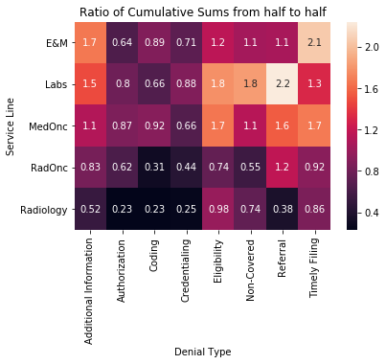

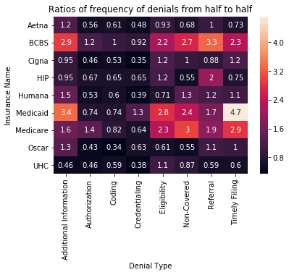

Focusing on insurers:

We note the volatility in their implementation across denial type

