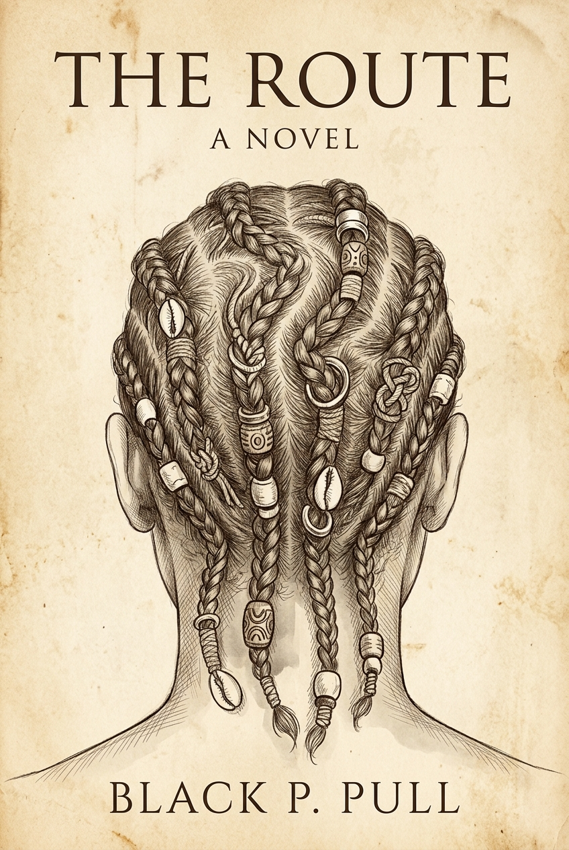

Cliff's Notes Study Guide: *The Route*
**By Black P. Pull**
---

1. Executive Book Overview & Central Double Entendre
*The Route* is an allegorical epic and philosophical Bildungsroman following the lifelong journey of **Cairo** and his companion **Ash**. The novel operates on a deliberate double entendre and homonym:
1. **The Route:** The physical, winding overland trail through forests, ridges, rivers, and canyons that tests human survival, discernment, intuition, and fortitude.
2. **The Root:** The subterranean foundation of discovery, personal growth, human connection, civilization, and intergenerational legacy. One cannot truly understand the *route* without planting and discovering the *root*.
The narrative is structured around four elemental movements:
- **Part 1 — Embers (Chapters 1–4):** The spark of life, departure from innocence, childhood curiosity, and the silent forging of brotherhood.
- **Part 2 — Current (Chapters 5–26):** The river-like flow of youth, learning navigation, encountering competing epistemologies (Keepers vs. Archivists), and confronting systemic corruption (The Valley Feeders).
- **Part 3 — Ashes & Rain (Chapters 27–36):** Adulthood, returning home, settling in the Promised Land, domesticity, love, tragedy (the delayed poison of past horrors), generational renewal, and the painful necessity of parting.
- **Part 4 — Wind (Chapter 37):** Old age, spiritual transcendence, full-circle cyclical return, and the eternal continuity of the road.
---

2. In-Depth Character Guide & Symbolic Architecture

**Cairo (The Victorious / Seeker)**
- **Etymology:** Derived from the Arabic *Al-Qāhirah* ("The Victorious" or "The Conqueror").
- **Symbolism & Arc:** Cairo conquers not through violence, conquest, or dominion, but through keen observation, quiet patience, and empathetic listening. He is the novel's first-person voice. His journey begins when his parents let him go onto the path as a boy and ends as an elder with silver hair who leaves markers for the young. He balances the wanderlust of exploration with the grounded love he builds with Lulu.

**Ash (Endurance / Memory / Moral North)**
- **Etymology:** Dual origin—Sanskrit *Asha* ("hope / life / desire") and Old English *æsc* (the enduring ash tree) alongside literal ash from burnt embers (survival, memory, renewal).
- **Symbolism & Arc:** Ash is Cairo's alter ego and lifelong brother of the road. He represents physical resilience and ethical steadiness. When tragedy strikes his family in the valley, Ash absorbs the grief silently, raises his children until they are ready to walk, and becomes the first to return to the path.

**Lulu / Tululuh (The Living Anchor / Patience)**
- **Etymology:** Short for *Tululuh* ("pearl of patience" or "hidden gem cultivated in quiet dark").
- **Symbolism & Arc:** Rescued from the Valley Feeders by Cairo and Ash, Lulu is a Keeper whose braided hair holds the geographic and cultural wisdom of generations. While Cairo and Ash are creatures of the open horizon, Lulu embodies the sanctity of home, cultivation, and the soil. She represents the conscious choice to plant roots without bitterness when others must walk.

**Ash's Wife: Amara (The Soft Grace / The Innocent Shadow)**
- **Etymology & Symbolism:** Soft, feminine, and profoundly metaphorical. Derived from the Igbo word for *"grace, mercy, and quiet blessing"*, from Sanskrit meaning *"immortal / undying"*, and evoking the Latin root for bittersweet love (*amare*).
- **Story Significance:** Amara embodies the fragile, gentle blossom that takes root in the Promised Land. Born in the famine-ravaged feeder valleys, she unknowingly ingested tainted sustenance as a child during an era of desperation. Her presence brings peace, domestic warmth, and the blessing of children to Ash after his years of hardship. Her delayed, prion-like illness years later represents how systemic trauma silently touches even the purest souls. In passing, her grace remains immortal, anchored beneath the riverside tree where Ash buries her.

**The Keepers (Living Oral & Braided Cartography)**
- **Symbolism & Cultural Heritage:** Nomadic guardians who braid intricate topographical maps, elevation contours, river paths, and moral histories directly into their hair. Though unstated in the prose, the characters are Black; this motif draws upon the historical African diasporic tradition of braiding escape routes, landmarks, and survival seeds into cornrows. The Keepers embody somatic memory, ancestral resilience, and knowledge that is carried physically upon the person.

**The Archivists (Written Record & Codification)**
- **Symbolism:** Solitary scholars who record journeys in ink upon paper. They represent institutional knowledge, civilization's documentation, and permanent history. The novel demonstrates that while Archivists protect against human forgetting, their records can be incomplete or manipulated without direct lived experience.

**The Valley Feeders (Systemic Perversion of Survival)**
- **Symbolism:** A predatory faction operating out of deep canyons and hollowed farms. Originating from extreme famine and population management, they evolved into an insidious predatory society that lures wanderers off cliffs or into slaughter under false pretenses of food and work. They represent institutional deceit, utilitarian cruelty, and the normalization of atrocities.
---

3. Comprehensive Plot & Continuity Review (Thematic & Structural Audit)
Our deep model audit reveals a tightly woven, meditative narrative. Below are key observations and thematic alignments:
---

4. Complete Chapter Summaries (Chapters 1 – 37)

**Part 1 — Embers**
- **Chapter 1 (The First Steps):** Cairo steps out into the crisp morning air as a young boy, leaving behind the warm hands of his parents. He watches a fledging bird struggle and soar, internalizing his father's mantra: *Walk your own path. You are ready.*
- **Chapter 2 (First Encounters):** Cairo senses others nearby. At a deep ravine, he meets a boy of his own age—Ash. Without spoken words, Ash hands him a small wrapped gift, planting the ember of lifelong camaraderie.
- **Chapter 3 (Learning the Way):** Cairo learns trail literacy: cairns, ash pits, and trampled grass. He crosses paths with Ash by a stream; their silent connection deepens through shared vigilance.
- **Chapter 4 (Crossing Shadows):** Navigating rugged ravines, Cairo finds Ash by an evening campfire. Sitting in stillness, they solidify an unspoken pact to journey as one.

**Part 2 — Current**
- **Chapter 5 (Moving Together):** Moving in tandem, the boys discover braided hair clippings caught on branches—the signature of Keepers. They realize the trail is mapped in living bodies.
- **Chapter 6 (Shadows in the Flow):** A dangerous ridge crossing tests their mutual trust. They realize that true alignment on the road is proven through physical sacrifice, not promises.
- **Chapter 7 (Knots in the Flow):** An adult female Keeper demonstrates how complex knots etched in the dirt and braided in locks convey terrain, hazards, and moral warnings.
- **Chapter 8 (Ink and Memory):** An encounter with an Archivist writing on vellum introduces the counterweight to Keeper culture: permanence on page versus fluid somatic memory.
- **Chapter 9 (Shadows and Intent):** A deceptive party attempts to lead them toward a treacherous cliff edge. Trusting his intuition, Cairo steers Ash away, learning to spot masked malice.
- **Chapter 10 (Knots and Paths):** They witness a Keeper mother braiding survival maps into her son's hair, learning that history is an heirloom worn upon the head.
- **Chapter 11 (Lines of Truth):** Cairo and Ash observe a Keeper and an Archivist working adjacent to one another, understanding that diverse mediums can converge on single truths.
- **Chapter 12 (Shadows Among Knots):** A smooth-talking scout tries to infiltrate a camp of travelers. The sinister shadow of the Valley Feeders begins to cast its chill.
- **Chapter 13 (The Edge of the Path):** A charismatic stranger attempts to guide them into a narrow gorge. Remembering earlier signs of false cairns, they refuse and survive.
- **Chapter 14 (False Promises):** Recruiters solicit laborers for a prosperous "farm." The boys smell dried iron in the wind, identifying it as a predatory human trap.
- **Chapter 15 (The Hollowed Farm):** Scoping out the compound, they witness the horrific reality of the Feeders' processing hub and quietly divert an unsuspecting boy away from slaughter.
- **Chapter 16 (Echoes of the Valley):** Cairo and Ash meet veteran Keepers who silently confirm the spreading blight of the Feeders and the necessity of communal vigilance.
- **Chapter 17 (The Edge of Trust):** Another party of false guides attempts to shepherd travelers into a cul-de-sac; the duo relies strictly on their mutual instinct to slip away.
- **Chapter 18 (The Keeper and the Knots):** A warm campfire with an elder Keeper woman provides sanctuary. She teaches Cairo how specific twists warn against cannibal corridors.
- **Chapter 19 (Learning the Knots):** Cairo and Ash practice braiding rudimentary signal cords, weaving map-lines of memory into practical ropes.
- **Chapter 20 (The Archivist):** An Archivist shows them sprawling scroll chambers, prompting Cairo to question whether books capture the sweat and terror of the actual trail.
- **Chapter 21 (False Paths):** A fraudulent traveler bearing counterfeit Keeper knots attempts to mislead them. They decode the discrepancies and escape the snare.
- **Chapter 22 (The Valley Feeders):** Descending into the Feeder heartland, they witness captives being marched toward cliffs. In a daring, stealthy intervention, they rescue **Lulu**, a young Keeper bound for slaughter.
- **Chapter 23 (Shadows and Lessons):** Traveling with Lulu, her intimate knowledge of the terrain protects them. She teaches them subtle dialects of movement and safe encampments.
- **Chapter 24 (The Archivist):** The trio visits an ancient stone archive. They see that written histories can be edited, censored, or forgotten, reinforcing Lulu’s somatic wisdom.
- **Chapter 25 (Choices in the Shadows):** A weary traveler begs for diversion. Working in seamless synergy, Cairo, Ash, and Lulu detect an ambush and navigate safely past.
- **Chapter 26 (Shadows of Leadership):** They traverse an oppressed plain where villagers live in submissive terror under Feeder despots. Lulu departs with a caravan of her Keeper kin, leaving Cairo with an ache of longing.

**Part 3 — Ashes & Rain**
- **Chapter 27 (The Accidental Return):** The trail circles unexpectedly. Cairo finds himself gazing upon his childhood valley. He reunites with his aging parents, sharing quiet meals and stories. He realizes that wandering must eventually give birth to building.
- **Chapter 28 (Leaving the Valley):** Cairo bids his parents an emotional farewell. With Ash beside him, they set out with a mature mission: to find fertile soil to establish their own legacy.
- **Chapter 29 (The Reunion):** Guided by serendipity, they cross paths with Lulu once more on an open ridge. The circle closes; the trio is reunited.
- **Chapter 30 (The Promised Land):** They discover a lush, untouched valley with clear rivers and rich loam. They christen it the Promised Land. Cairo and Lulu marry; Ash takes a wife; homes and terraced fields are built.
- **Chapter 31 (New Steps):** Children are born into the settlement. Cairo watches Lulu cradle their infant, marveling at the transition from footsteps to roots. They teach the young how to read stone and stream.
- **Chapter 32 (A Shadow from the Past):** Ash's wife succumbs to a mysterious tremor and weakness. Cairo and Ash realize she was born in the famine valleys and unknowingly ingested human flesh as a child. She passes away peacefully; Ash buries her beneath a sunlit tree and dedicates himself to raising his children.
- **Chapter 33 (When Children Walk):** Ash's children reach adulthood and gaze upon the surrounding ridges with restless yearning. Ash blesses their departure onto the road, knowing his fatherly duty is complete.
- **Chapter 34 (The Road Calls Again):** With his children gone and his home quiet, Ash feels the irresistible pull of the trail. He bids Cairo and Lulu a loving farewell and steps back into the wild.
- **Chapter 35 (Roots and Horizons):** Cairo and Lulu grow old together as the settlement flourishes. Lulu is at peace among her orchards; Cairo finds himself staring at the distant ridges at twilight.
- **Chapter 36 (The Hardest Step):** Cairo and Lulu share a tender, heartbreaking understanding: her calling is the root; his calling is the route. With her blessing and mutual devotion, Cairo packs his staff and departs.

**Part 4 — Wind**
- **Chapter 37 (Keepers of the Road):** Decades later, an elderly, silver-haired Cairo walks a high ridge. Ahead of him, a weathered traveler moves with a familiar rhythm. They lock eyes: *“Ash?” / “Cairo.”* The two brothers reunite without missing a stride, walking side-by-side into the horizon as the keepers of living memory.
---

5. Classroom & Book Club Discussion Guide
1. **The Dialectic of Movement vs. Stasis:** How does the contrast between Cairo's perpetual wanderlust and Lulu's agricultural settling challenge conventional definitions of fulfillment?
2. **Epistemology on the Trail:** Compare the Keepers (somatic/braided knowledge) with the Archivists (textual records). Which form of history is more resilient against tyranny?
3. **The Morality of the Feeders:** What does the delayed illness of Ash's wife suggest about historical trauma and societal complicity? Can an individual ever truly escape the moral sins of their birthplace?
4. **The Road as Archetype:** How does *The Route* build upon the tradition of American journey literature (Whitman, Twain, Kerouac, McCarthy) while introducing a collectivist, meditative ethos?

