The Title
An Author
This is some text before a section. It shouldn’t be indented. Each section should start on a new page (but subsections shouldn’t).

This is a section
This is some test text. This is formatted in italics and bold, with - various – dashes—, and trailing dots…
‘These quotes should be curly,’ and “so should these.” There should be a blank line before the next paragraph:

And then there should be some text ^{in superscript} and _{in subscript}, and a footnote with a star, a footnote with a dagger, and this should be monospace.

Subsection
Test text test text test text.
This is a quote block. It should be indented slightly and shouldn’t contain a line break.
This is a quoted line block. It should be indented slightly
and have a line break after ‘slightly’, and formatting.
“These literal double curly quotes, used where smart
quotes gets it wrong, curl the right way even though
they’re on different lines.”
‘These literal single curly quotes, used where smart
quotes gets it wrong, curl the right way even though
they’re on different lines.’
After this line there should be stars.
* * *
This is a new paragraph after the stars. This text is Small Caps. Here is a pound sign (£), a euro sign (€), and three letters with accents: ëóû.

This is a second section
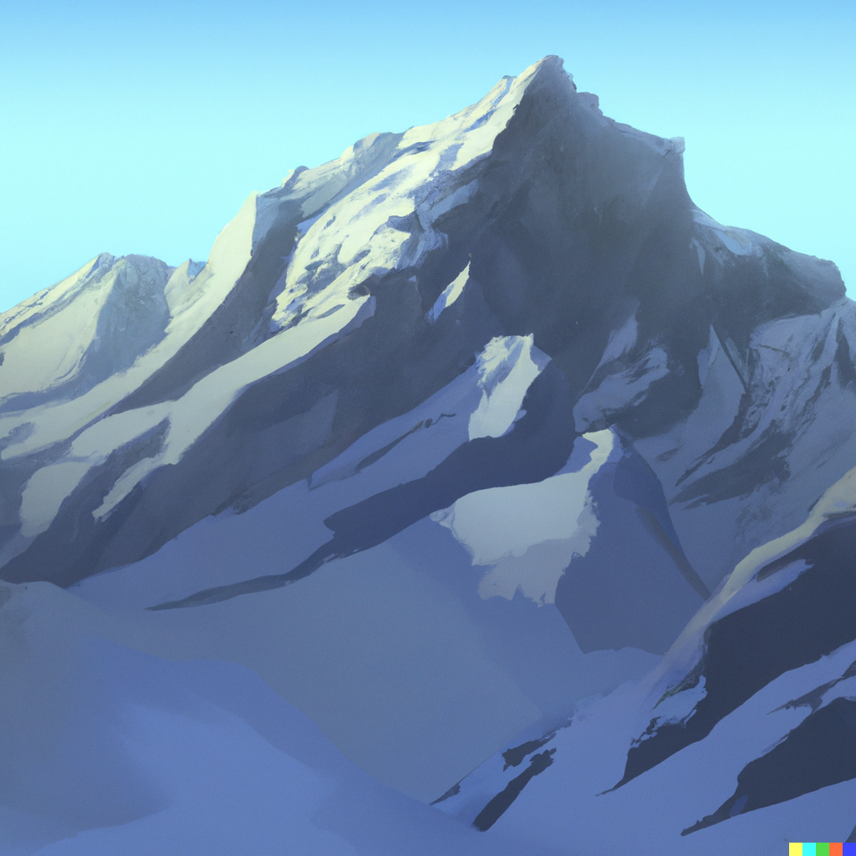
foo
There is an image here.
And this is even more italic text.

This is a footnote. It should appear at the bottom of the page.
Another footnote.

