Test 4

The Author

1 January 2022

Table of Contents

# The Title

This is some text before a section. It shouldn’t be indented.

## This is a section

This is some test text. This is formatted in *italics* and **bold**, with - various – dashes—, and trailing dots…

‘These quotes should be curly,’ and “so should these.” There should be a blank line before the next paragraph:

And then there should be some text in superscript and in subscript, and a footnote[1] with a star, a footnote[2] with a dagger, and this should be monospace.

### Subsection

Test text test text test text.

This is a quote block. It should be indented slightly and shouldn’t contain a line break.

This is a quoted line block. It should be indented slightly  
and have a *line break* after ‘slightly’, and **formatting**.

“These literal double curly quotes, used where smart  
quotes gets it wrong, curl the right way even though  
they’re on different lines.”

‘These literal single curly quotes, used where smart  
quotes gets it wrong, curl the right way even though  
they’re on different lines.’

After this line there should be stars.

* * *

This is a new paragraph after the stars. This text is Small Caps. Here is a pound sign (£), a euro sign (€), and three letters with accents: ëóû.

# The Title

**An Author**

This is some text before a section. It shouldn’t be indented. Each section should start on a new page (but subsections shouldn’t).

## This is a section

This is some test text. This is formatted in *italics* and **bold**, with - various – dashes—, and trailing dots…

‘These quotes should be curly,’ and “so should these.” There should be a blank line before the next paragraph:

And then there should be some text in superscript and in subscript, and a footnote[3] with a star, a footnote[4] with a dagger, and this should be monospace.

### Subsection

Test text test text test text.

This is a quote block. It should be indented slightly and shouldn’t contain a line break.

This is a quoted line block. It should be indented slightly  
and have a *line break* after ‘slightly’, and **formatting**.

“These literal double curly quotes, used where smart  
quotes gets it wrong, curl the right way even though  
they’re on different lines.”

‘These literal single curly quotes, used where smart  
quotes gets it wrong, curl the right way even though  
they’re on different lines.’

After this line there should be stars.

* * *

This is a new paragraph after the stars. This text is Small Caps. Here is a pound sign (£), a euro sign (€), and three letters with accents: ëóû.

## This is a second section

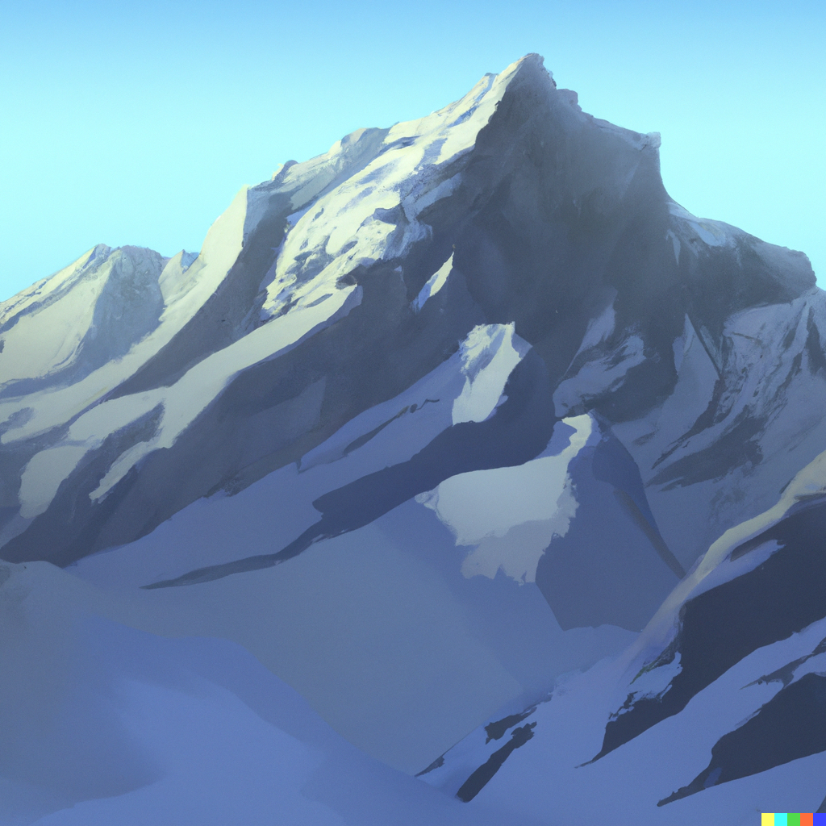

foo

There is an image here.

And this is *even more italic text*.

# The Title Is ‘Baz’

**An Author, 23 February 2019 baz**

## This is a section

This is some test text. This is formatted in *italics* and **bold**, with - various – dashes—, and trailing dots…

‘These quotes should be curly,’ and “so should these.” There should be a blank line before the next paragraph:

And then we do a simple include:

Text before a section in simple include.

## Section in simple include

This is a quote block. It should be indented slightly and shouldn’t contain a line break.

This is a quoted line block. It should be indented slightly  
and have a *line break* after ‘slightly’, and **formatting**.

Text before recursive include, with *italic*, **bold**, “curly quotes,” and— an em dash.

Text before section in recursive include.

## Section in recursive include

Text in recursive include, with *italic*, **bold**, “curly quotes,” and— an em dash.

### Subsection in recursive include

“These literal double curly quotes, used where smart  
quotes gets it wrong, curl the right way even though  
they’re on different lines.”

‘These literal single curly quotes, used where smart  
quotes gets it wrong, curl the right way even though  
they’re on different lines.’

Test text test text test text. After this line there should be stars.

* * *

And then there should be some text in superscript and in subscript, and a footnote[5] with a star, a footnote[6] with a dagger, and this should be monospace.

Text after recursive include. Here is a pound sign (£), a euro sign (€), and three letters with accents: ëóû.

## Second section in simple include

Test text.

Text after simple include.

### Subsection

This is a new paragraph. This text is Small Caps.

## This is a second section

And this is *even more italic text*. Foo.

# Code blocks aren't spellchecked: quux

Inline code isn’t spellchecked: quux.

div classes aren’t spellchecked.

Anything in a nospellcheck div isn’t spellchecked: quux.

Automatic links aren’t spellchecked: <http://quux.com>. Neither are the targets or attributes of inline links: [Foo](http://quux.com). Neither are span classes. Anything in a nospellcheck span isn’t spellchecked.

# Title

**4 January 2022**

This is text before a section. It shouldn’t be indented.

1. This is a footnote. It should appear at the bottom of the page.
2. Another footnote.
3. This is a footnote. It should appear at the bottom of the page.
4. Another footnote.
5. This is a footnote. It should appear at the bottom of the page.
6. Another footnote.