**Logical modelling of Car Dealership and Parts**

After my friend Mr.sanjeev Banmala provided me with the requirement analysis of the car dealership and parts company , I tried to model it by building its appropriate ER model.

Some of the possible entities listed by my friend are:

1. Car
2. Customer
3. Salesperson
4. Service
5. Service Ticket
6. Parts
7. Mechanic

**Business Rules**

* A salesperson may sell many cars, but each car is sold by only one salesperson.
* A customer may buy many cars, but each car is bought by only one customer.
* A salesperson writes a single invoice for each car he or she sells.
* A customer gets an invoice for each car he or she buys.
* A customer may come in just to have his or her car serviced; that is, a customer need not buy a car to be classified as a customer.
* When a customer takes one or more cars in for repair or service, one service ticket is written for each car.
* The car dealership maintains a service history for each of the cars serviced. The service records are referenced by the car’s serial number.
* A car brought in for service can be worked on by many mechanics, and each mechanic may work on many cars.
* A car that is serviced may or may not need parts (e.g., adjusting a carburetor or cleaning a fuel injector nozzle does not require providing new parts).

We already found the entities , attributes and their basic relationship before in the requirement analysis.Now we will give the description of the entities , description of their attributes and the attributes domain.

|  |  |  |
| --- | --- | --- |
| **Entity** | **Description** | **Domain** |
| customer | The customer which buys the car ,parts or does the servicing in the dealership |  |
| **Attributes**:  id  name  phone_number  email  address | Identifier for user entity,SK,PK  First name + Last name  Valid phone numbers of customer  Valid email address of the customer  Valid legal address of the customer | Auto generated  Text  Number verification  Email verification  Text |
| brand | The brand name of the car |  |
| **Attributes**:  id  name  website_address  description | Identifier of the brand entity,SK,PK  Name of the brand  Link address of the brand  The description about the brand | Auto generated  Text  URL Link  Text |
| category |  |  |
| **Attributes**:  id  name  description | Identifier of the category entity,SK,PK  Name of the category  The detail description about the category | Auto generated  Text  Text |
| parts |  |  |
| **Attributes**:  id  name  type  Description  quantity | Identifier of the category entity,SK,PK  Name of the parts  The type of the parts  The details description about the parts  The certain number that the stock has. | Auto generated  Text  Text  Text  Numeric field |
| car_parts | The intermediate table connects the many to many fields of two entities: car and parts. |  |
| **Attributes**:  parts_id  car_id | FK referencing the parts entity.  FK referencing the car entity | Valid id from parts table  Valid id from car table |
| car | The car in the company for sales. |  |
| **Attributes:**  id  brand_id  category_id  engine_number  description | Identifier of the car entity,Sk,PK  FK referencing the brand entity.  FK referencing the category entity.  The engine number of the car,unique  The detail description about the car | Auto generated  Valid id from table brand  Valid id from table category  Text+Numeric  Text |
| employee | The peoples working on the company |  |
| **Attributes**:  id  name  phone_number  email | Identifier of the employee entity , SK,PK  Name of the employee  The valid phone number of the employee  The valid email address of the employee | Auto generated  Text  Validation of phone number  Validation of email |
| salesperson | The employee is working as a salesperson. |  |
| **Attributes**:  employee_id  total_sales | FK referencing the employee table.(PK)  The total sales made by the salesperson | Valid id from the table  employee  Numeric format |
| mechanic | The employee is working as a mechanic. |  |
| **Attributes**:  employee_id  name  total_service | FK referencing the employee table.(PK)  The total number of service provided by the salesperson | Valid id from the employee table  Numeric format |
| Invoive_details | The details of the invoice |  |
| **Attributes:**  id  car_id  quantity  price  discount | Identifier of the invoice_details entity.SK,FK  FK referencing the car  The total quantity of cars bought.  The total price  The discount amount or percentage of discount. | Auto generated  Valid id of table car  Numeric format  Numeric format  Numeric format |
| invoice | The accumulated total invoice from invoice_details of a customer |  |
| **Attributes:**  Id  invoice_details_id  cutomer_id  date_time  amount | Identifier of the invoice entity.SK,FK  Fk referencing the invoice_details entity.  FK referencing the customer.  The date and time of the invoice  The total amount of the invoice | Auto generated  Valid id from invoice_detail table  Valid id from customer  Time Stamp  Numeric format |
| service_ticket | The ticket for doing servicing. |  |
| **Attributes:**  id  customer_id  datetime  engine_number | Identifier of the service_ticket entity.SK,FK  FK referencing the customer entity.  Date and time of the servicing  The valid engine number of the car. | Auto generated  Valid id from table customer  Date and Time  Text+Number |
| service | The servicing of the car. |  |
| **Attributes:**  id  type  description  price | Identifier of the service entity.SK,FK  The type of the servicing.  The description about the servicing  The total price of the servicing | Auto generated  Text  Text  Numeric type |
| mechanic_service | The table represents the many to many relationship between mechanic and service |  |
| **Attributes:**  employee_id  service_id | FK referencing the employee entity.(PK)  FK referencing the employee.(PK) | Valid id from employee table  Valid id from service table |
| parts_service | The table represents the many to many relationship between the servicing and parts. |  |
| **Attributes:**  parts_id  service_id | FK referencing the parts entity.(PK)  FK referencing the service entity.(PK) | Valid id from table parts.  Valid if from table service. |

**Entity Relationship Diagram of Car Dealership and Parts**

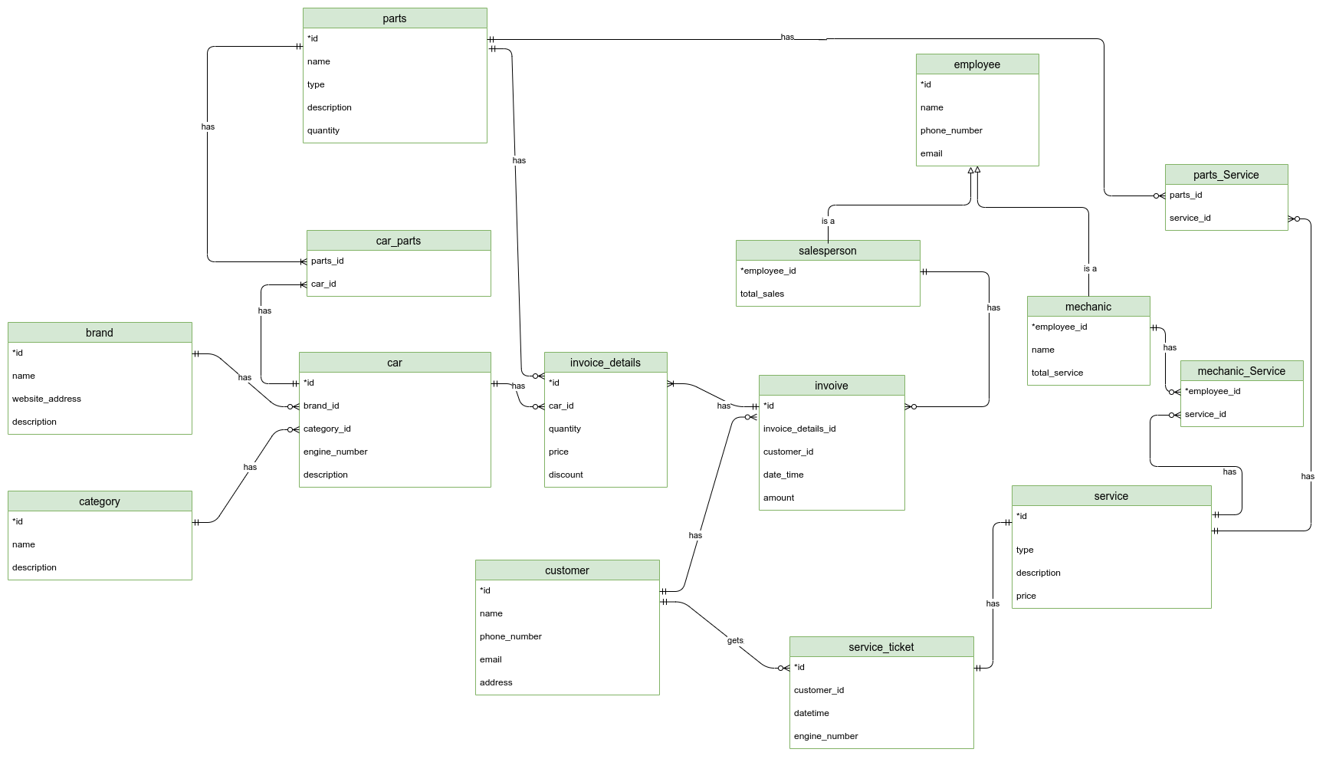

*Fig: ER diagram of Car Dealership and Parts*

**Verification**

As from the beginning I was taking in mind some of the problems like Fan-Trap and Chasm problems , the model I built above is free from it.

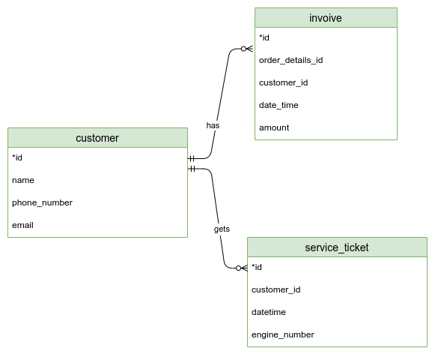

Still we can have a Fan-Trap problem if we tried to relate a service_ticket with an invoice.

But, does it even make sense .Do we need to relate a service_ticket with the invoice .

We can simply extract the information like a customer with an invoice and a service_ticket is simply a loyal customer which buys the product from the dealer and also does the servicing there.

But if we exactly want to relate the service_ticket with the invoice then , from the invoice we can extract the invoice details and further we can add an attribute like engine_number in the service_ticket to know that the service ticket for the car is bought by the customer from that specific dealer.

**Reference**:

1. Draw.io (for ER diagram)