Anil Kumar

12012076

Lovely professional university

nano internsctl

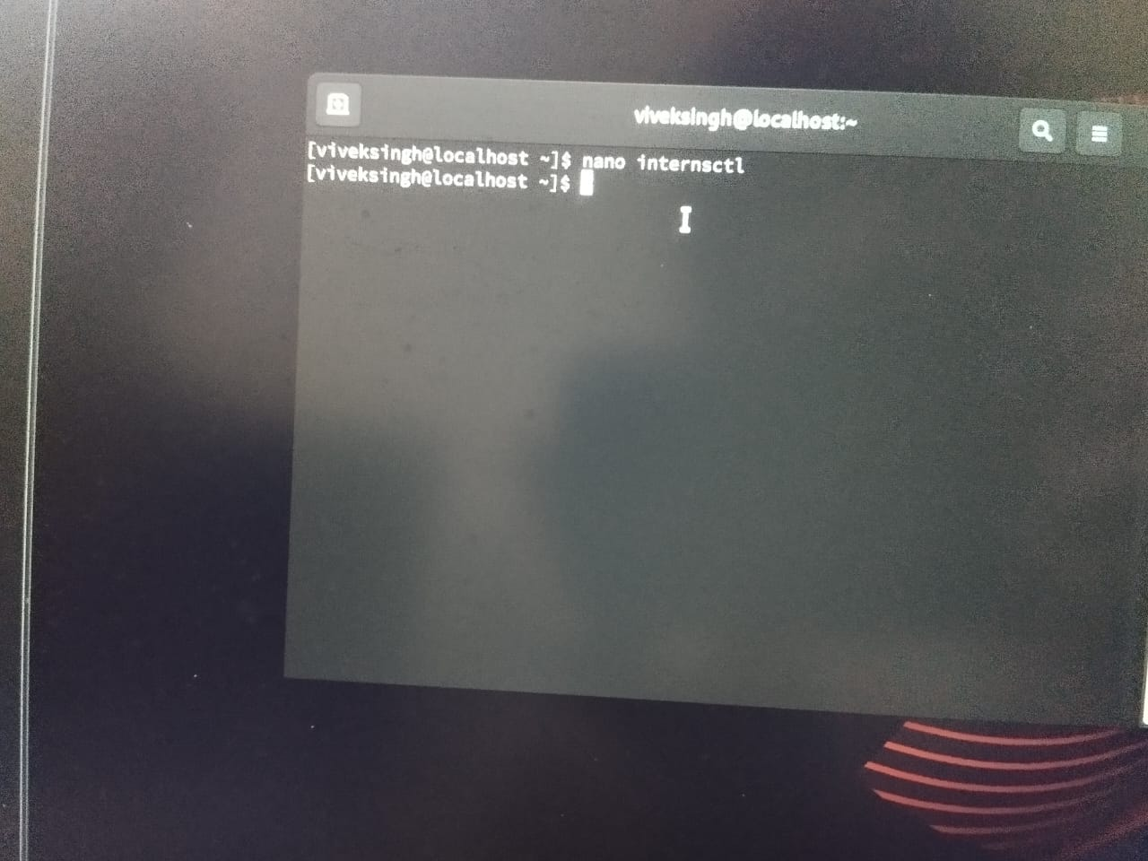

chmod +x internsctl

sudo mv internsctl /usr/local/bin/

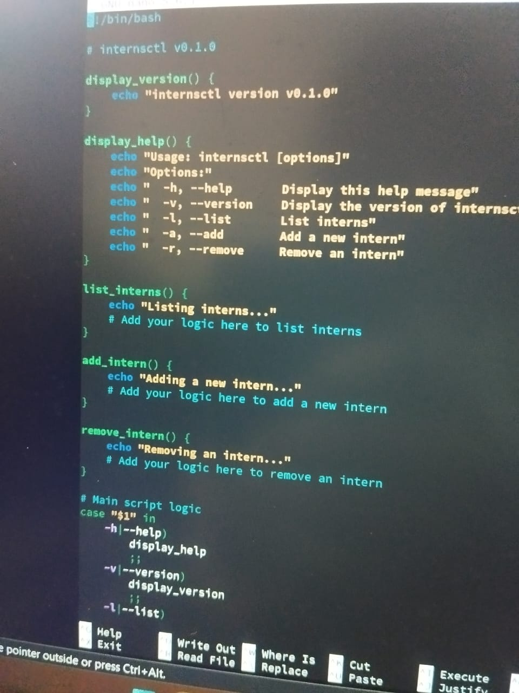

nano internsctl.1

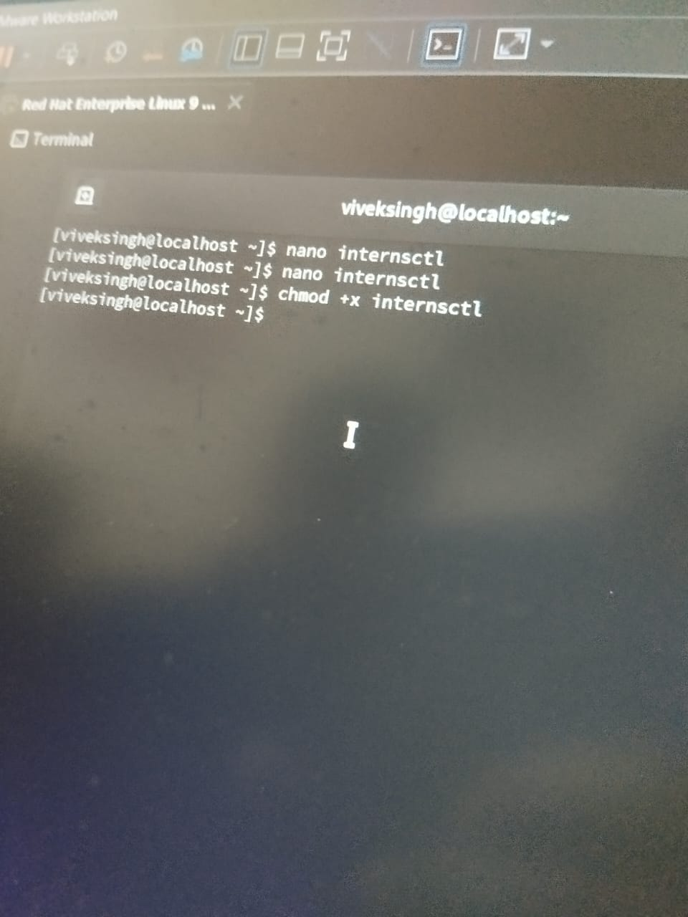

**sudo mandb**

**man internsctl**

**SECTION B**

**nano /usr/local/bin/internsctl**

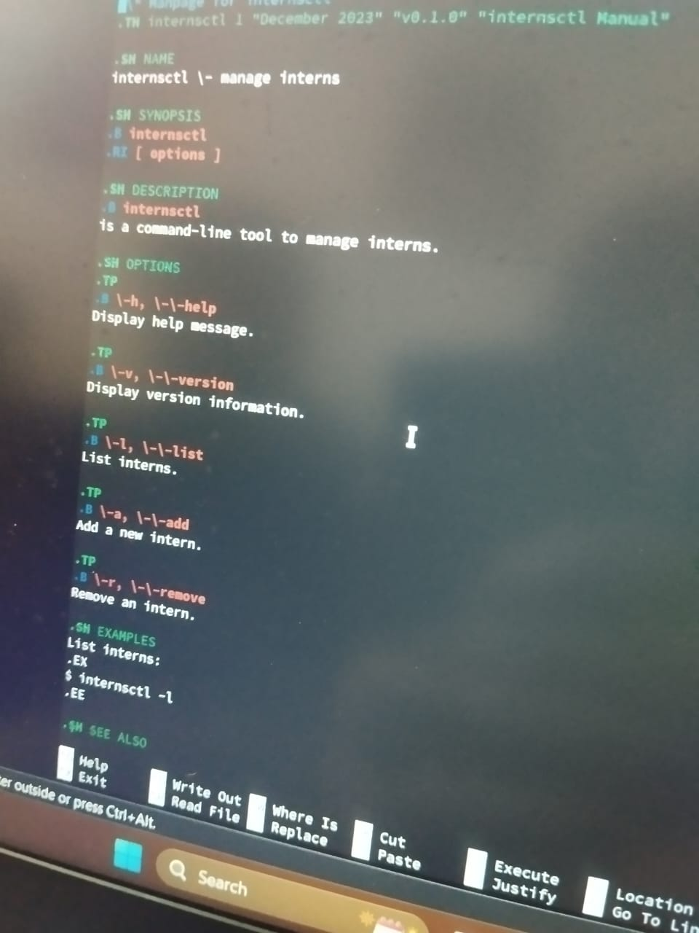

**chmod +x /usr/local/bin/internsctl**

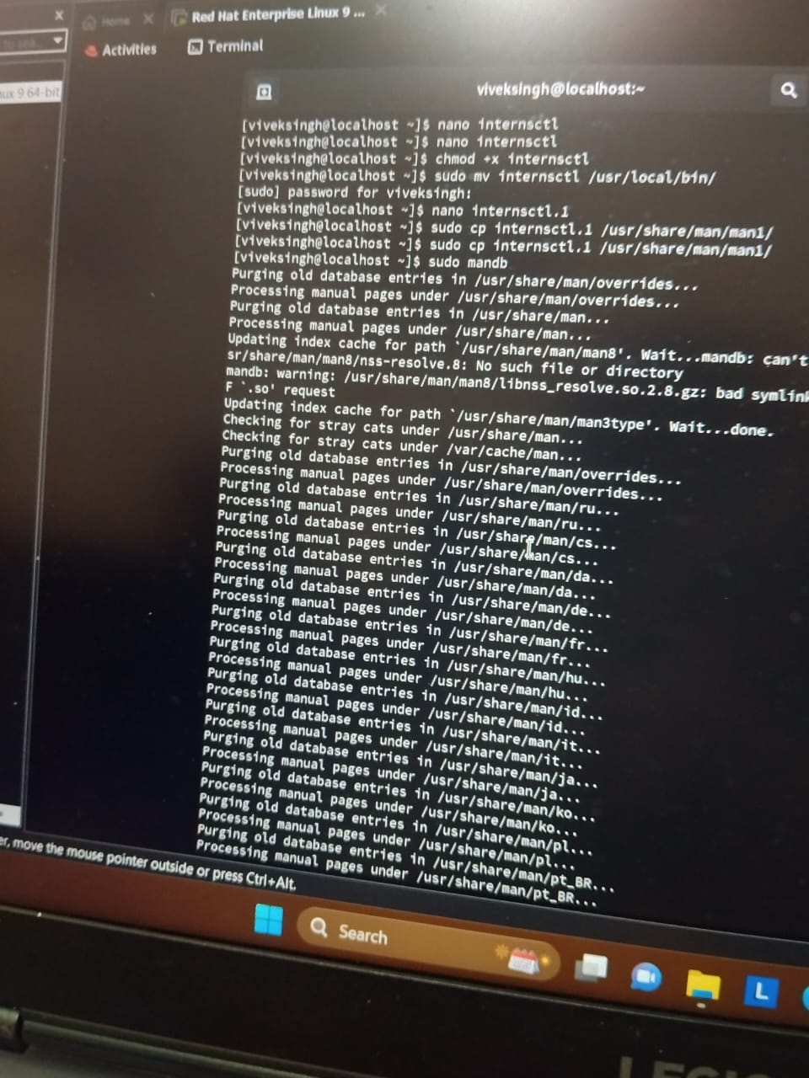

**internsctl cpu getinfo**

**nano /usr/local/bin/internsctl**

**SECTION -C**

**chmod +x /usr/local/bin/internsctl**

**internsctl cpu getinfo**