1. Link to the video: <https://homepages.uc.edu/~bokijoad/DrumKit>  
   if this link doesn’t work try this:  
   <https://homepages.uc.edu/~bokijoad/DrumKit/index.html>
2. 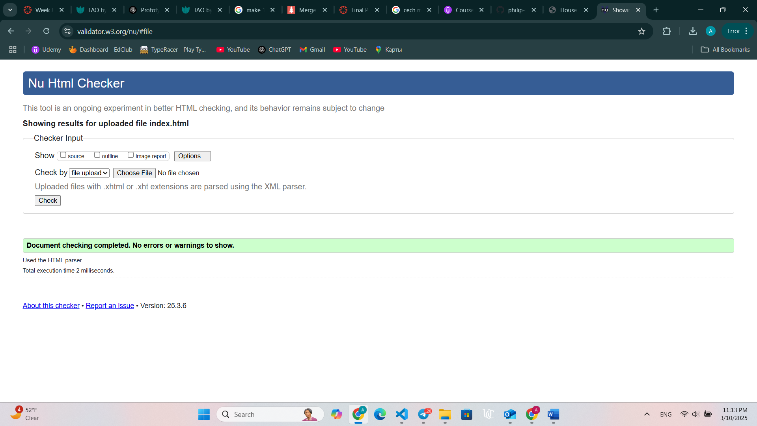

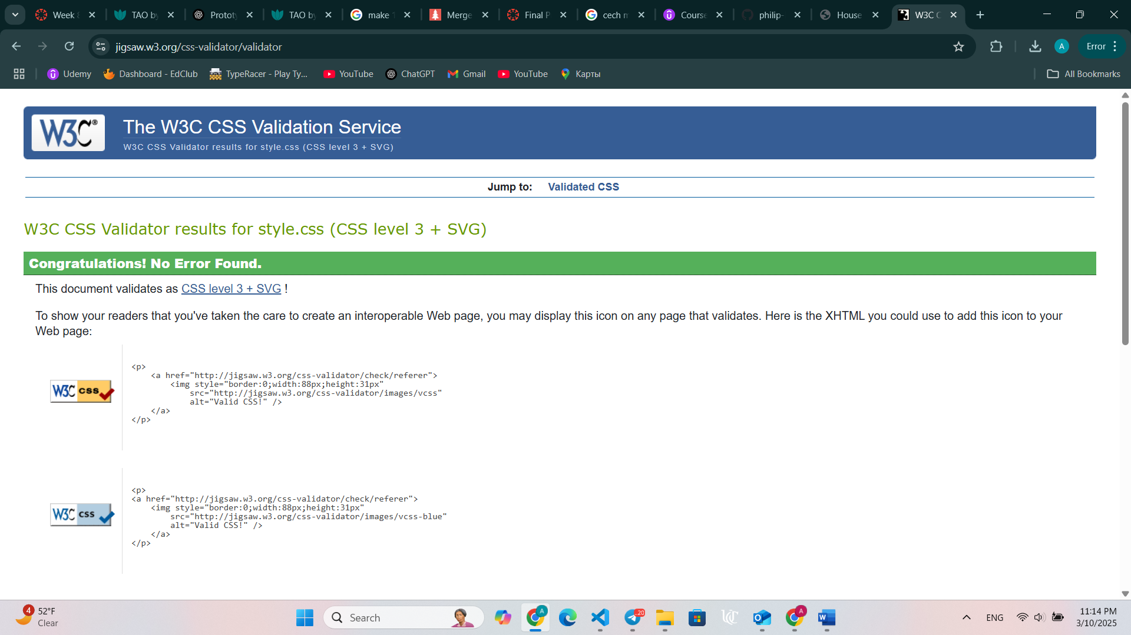

3)  
For my drum kit website, I have completed the HTML and CSS portions of the project but have not yet finished the JavaScript functionality. During the development of the HTML and CSS, I encountered some challenges in ensuring the layout was both visually appealing and functional. I had to adjust the size, alignment, and spacing of the drum pads to ensure they fit well on the page and were easily accessible. I also worked on making the design responsive so that it would look good on both desktop and mobile devices, but I plan to do more testing to fine-tune this aspect.

In terms of changes from the original wireframe, I made some adjustments to the spacing between the drum pads and the header to make the page look more balanced. Additionally, I altered the footer's position slightly to make sure it didn't overlap with other content. Moving forward, I plan to focus on implementing the JavaScript functionality, such as adding sound to each drum pad and possibly introducing animation or visual effects when the drums are triggered.

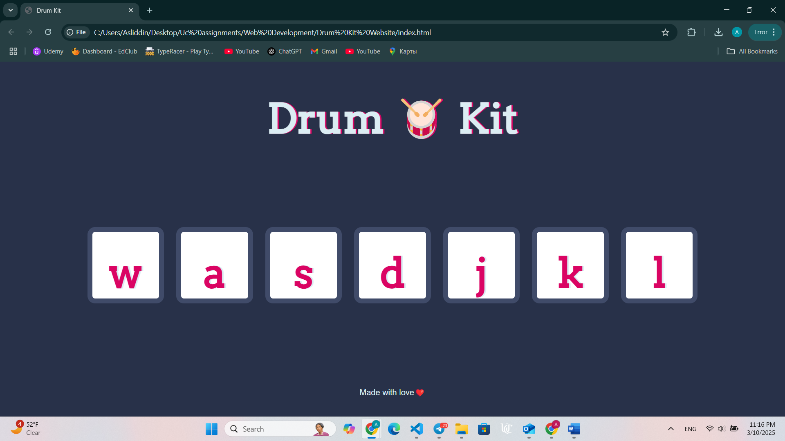  
  
4) I will upload zip file in the canvas platform.