

DESIGN OF ANALYSIS OF ALGORITHM

**GitHub id :- https://github.com/callmedon007**

LAB ASSIGNMENT: -

LAB 1: Implement the insertion inside iterative and recursive Binary search tree and compare their performance.

**-: ASSIGNMENT_1.C**

#include <stdio.h> #include <stdlib.h> #include <time.h>

// Structure for a BST node struct Node {

int data;

struct Node* left; struct Node* right;

};

// Create a new node

struct Node* createNode(int data) {

struct Node* newNode = (struct Node*)malloc(sizeof(struct Node)); newNode->data = data;

newNode->left = NULL; newNode->right = NULL; return newNode;

}

// Iterative BST insertion

struct Node* iterativeInsert(struct Node* root, int data) { struct Node* newNode =

createNode(data); if (root == NULL) return newNode;

struct Node* parent = NULL; struct Node* current = root; while (current != NULL) {

parent = current;

if (data < current->data) current = current->left;

else if (data > current-

>data)

current = current->right; else

return root; // No duplicates

}

if (data < parent->data) parent->left = newNode;

else

parent->right = newNode; return root;

}

// Recursive BST insertion

struct Node* recursiveInsert(struct Node* root, int data) { if (root == NULL) return createNode(data); if (data < root->data)

root->left = recursiveInsert(root->left, data); else if (data > root->data)

root->right = recursiveInsert(root->right, data); return root;

}

// Utility function to print BST in-order (for verification) void inorderTraversal(struct Node* root)

if (root != NULL) { inorderTraversal(root->left); printf("%d ", root->data); inorderTraversal(root->right);

} }

// Time comparison function for both insertions void compareInsertionTimes(int arrays[5][10], int

sizes[5]) { for (int i = 0; i < 5; i++) { printf("\n--- Array %d ---\n", i + 1);

struct Node* root1 = NULL; // For iterative insertions struct Node* root2 = NULL; // For recursive insertions

// Measure time for iterative insertion clock_t startIter = clock();

for (int j = 0; j < sizes[i]; j++) {

root1 = iterativeInsert(root1, arrays[i][j]);

}

clock_t endIter = clock();

double timeIter = ((double)(endIter - startIter)) / CLOCKS_PER_SEC;

// Measure time for recursive insertion clock_t startRecur = clock();

for (int j = 0; j < sizes[i]; j++) {

root2 = recursiveInsert(root2, arrays[i][j]);

}

clock_t endRecur = clock();

double timeRecur = ((double)(endRecur - startRecur)) / CLOCKS_PER_SEC; printf("Iterative Insertion Time: %f seconds\n", timeIter);

printf("Recursive Insertion Time: %f seconds\n", timeRecur);

// Optional: Print BST (for verification) printf("In-order traversal (Iterative): "); inorderTraversal(root1);

printf("\nIn-order traversal (Recursive): "); inorderTraversal(root2);

printf("\n");

} }

// Driver function int main() {

// Define five sample arrays int arrays[5][10] = {

{50, 30, 20, 40, 70, 60, 80}, // 7 elements

{10, 20, 30, 40, 50, 60, 70, 80, 90}, // 9 elements

{25, 15, 50, 10, 22, 35, 70, 40, 80}, // 9 elements

{100, 90, 80, 70, 60}, // 5 elements

{5, 25, 15, 35, 20, 30, 10} // 7 elements

};

// Define the size of each array int sizes[5] = {7, 9, 9,

5, 7};

// Compare insertion times compareInsertionTimes(arrays, sizes); return 0;

}

-: CREATE AN EMPTY (ASSIGNMENT_1.exe) FILE.

-: ASSIGNMENT_1.py

# -*- coding: utf-8 -*- """graph1.py

Automatically generated by Colab.

Original file is located at https://colab.research.google.com/drive/1BZtdoC6NETTa08-m6Ykv-

4Nbsz90yUL4 """

import matplotlib.pyplot as plt

# Updated data for Array Size, Iterative Time, and Recursive Time array_size = [5000, 10000, 50000, 100000, 1000000]

iterative_time = [0.000000, 0.001000, 0.006000, 0.012000, 0.110000]

recursive_time = [0.000000, 0.001000, 0.008000, 0.014000, 0.140000]

# Create the plot

plt.figure(figsize=(10, 6))

# Plot the Iterative Time vs Array Size

plt.plot(array_size, iterative_time, label='Iterative Time', marker='o', color='blue', linestyle='-', linewidth=2)

# Plot the Recursive Time vs Array Size

plt.plot(array_size, recursive_time, label='Recursive Time', marker='o', color='red', linestyle='-', linewidth=2)

# Add labels and title plt.xlabel('Array Size') plt.ylabel('Time (seconds)')

plt.title('Performance Comparison: Iterative vs Recursive BST Insertion') # Set logarithmic scale for both axes for better visualization plt.xscale('log')

plt.yscale('log ') # Add a legend plt.legend()

# Add grid for better readability

plt.grid(True)

# Display the plot plt.show()

**-: ASSIGNMENT_1_OUTPUT.png**

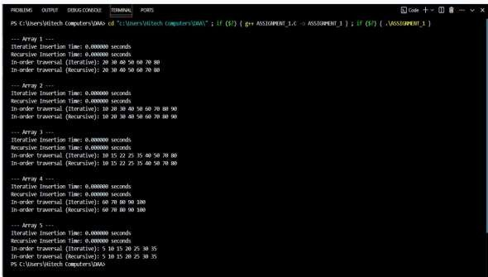

**-: GRAPH_1_OUTPUT.png**

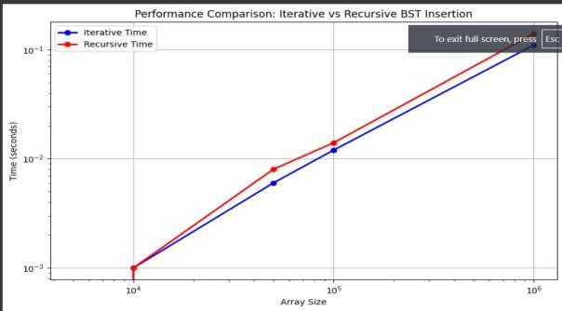

**-: CREATE AN EMPTY (TEMP) FILE.**

# Lab 2: Implement divide and conquer based merge sort and quick sort algorithms and compare their performance for the same set of elements.

**-: ASSIGNMENT_2.C**

#include <stdio.h> #include <stdlib.h> #include <time.h> #include <string.h>

// Merge function for merge sort

void merge(int arr[], int left, int mid, int right)

{ int i, j, k;

int n1 = mid - left + 1; int n2 = right - mid; int L[n1],

R[n2];

for (i = 0; i < n1; i++) L[i] = arr[left + i]; for (j = 0; j < n2; j++)

R[j] = arr[mid + 1 + j];

i = 0;

j = 0;

k = left;

while (i < n1 && j < n2) { if (L[i] <= R[j]) {

arr[k] = L[i]; i++;

} else {

arr[k] = R[j]; j++;

}

k++; }

while (i < n1) { arr[k] = L[i]; i++;

k++;

}

while (j < n2) { arr[k] = R[j]; j++;

k++;

} }

// Merge Sort function

void mergeSort(int arr[], int left, int right) { if (left < right) {

int mid = left + (right - left) / 2; mergeSort(arr, left, mid); mergeSort(arr, mid + 1, right); merge(arr, left, mid, right);

} }

// Function to swap two elements void swap(int* a, int* b) {

int t = *a;

*a = *b;

*b = t; }

// Partition function for quick sort

int partition(int arr[], int low, int high) { int pivot = arr[high];

int i = (low - 1);

for (int j = low; j <= high - 1; j++) { if (arr[j] < pivot) {

i++;

swap(&arr[i], &arr[j]);

} }

swap(&arr[i + 1], &arr[high]); return (i + 1);

}

// Quick Sort function

void quickSort(int arr[], int low, int high)

{ if (low < high) {

int pi = partition(arr, low, high); quickSort(arr, low, pi - 1); quickSort(arr, pi + 1, high);

} }

// Function to generate random array

void generateRandomArray(int arr[], int n)

{ for (int i = 0; i < n; i++) {

arr[i] = rand() % 10000; // Random numbers between 0 and 9999

} }

// Function to measure sorting time

double measureSortingTime(void (*sortFunction)(int[], int, int), int arr[], int n) { clock_t start, end;

double cpu_time_used;

int* arrCopy = (int*)malloc(n * sizeof(int)); memcpy(arrCopy, arr, n * sizeof(int));

start = clock(); sortFunction(arrCopy, 0, n - 1); end = clock();

cpu_time_used = ((double) (end - start)) / CLOCKS_PER_SEC; free(arrCopy);

return cpu_time_used; } int main() {

srand(time(NULL));

int sizes[] = {1000, 5000, 10000, 50000, 100000}

[int num_sets = sizeof(sizes) / sizeof(sizes[0]); printf("Set\tSize\tMerge Sort Time\tQuick Sort Time\n"); for (int i = 0; i < num_sets; i++) {

int n = sizes[i];

int* arr = (int*)malloc(n * sizeof(int)); generateRandomArray(arr, n)

double mergeSortTime = measureSortingTime(mergeSort, arr, n); double quickSortTime = measureSortingTime(quickSort, arr, n);

printf("%d\t%d\t%.6f\t\t%.6f\n", i+1, n, mergeSortTime, quickSortTime); free(arr);

}

return 0;

}

**-: CREATE AN EMPTY (ASSIGNMENT_2.exe) FILE.**

**-: ASSIGNMENT_2.py**

# -*- coding: utf-8 -*- """graph1.py

Automatically generated by Colab.

Original file is located at https://colab.research.google.com/drive/1BZtdoC6NETTa08-m6Ykv-

4Nbsz90yUL4 """

import matplotlib.pyplot as plt

# Data for Set Size, Merge Sort Time, and Quick Sort Time

set_size = [1000, 5000, 10000, 50000, 100000]

merge_sort_time = [0.000000, 0.001000, 0.000000, 0.016000, 0.026000]

quick_sort_time = [0.000000, 0.000000, 0.003000, 0.007000, 0.022000]

# Create the plot plt.figure(figsize=(10, 6))

# Plot the Merge Sort Time vs Set Size

plt.plot(set_size, merge_sort_time, label='Merge Sort Time', marker='o', color='blue', linestyle='-', linewidth=2)

# Plot the Quick Sort Time vs Set Size

plt.plot(set_size, quick_sort_time, label='Quick Sort Time', marker='o', color='red', linestyle='-', linewidth=2)

# Add labels and title plt.xlabel('Set Size') plt.ylabel('Time (seconds)')

plt.title('Performance Comparison: Merge Sort vs Quick Sort') # Add a legend

plt.legend()

# Add grid for better readability plt.grid(True)

# Display the plot plt.show()

**-: ASSIGNMENT_2_OUTPUT.png**

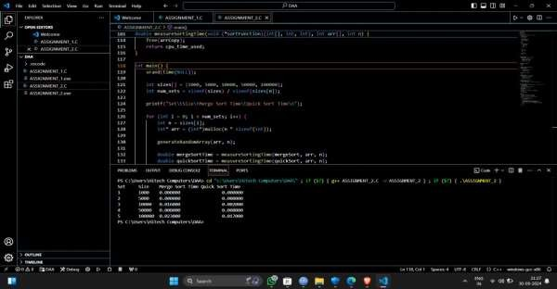

**-: GRAPH_2_OUTPUT.png**

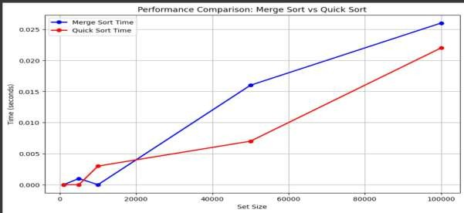

**-: CREATE AN EMPTY (TEMP) FILE.**

# LAB 3 : Compare the performance of Strassen method of matrix multiplication with traditional way of matrix multiplication.

**-:** [**ASSIGNMENT_3.C**](https://github.com/Simrannegi26/Algorithm_Lab_3rd_Sem-500122724-/blob/main/LAB%203/ASSIGNMENT_3.C)

#include <stdio.h> #include <stdlib.h> #include <time.h>

// Function to allocate memory for a matrix int** allocateMatrix(int n) {

int** matrix = (int**)malloc(n * sizeof(int*)); for (int i = 0; i < n; i++) {

matrix[i] = (int*)malloc(n * sizeof(int));

}

return matrix;

}

// Function to free memory of a matrix void freeMatrix(int** matrix, int n) {

for (int i = 0; i < n; i++) { free(matrix[i]);

}

free(matrix); }

// Function to add two matrices

void addMatrix(int** A, int** B, int** C, int n) { for (int i = 0; i < n; i++) {

for (int j = 0; j < n; j++) { C[i][j] = A[i][j] + B[i][j];

} } }

// Function to subtract two matrices

void subtractMatrix(int** A, int** B, int** C, int n)

{ for (int i = 0; i < n; i++) { for (int j = 0; j < n; j++) {

C[i][j] = A[i][j] - B[i][j];

} } }

// Traditional matrix multiplication

void traditionalMultiply(int** A, int** B, int** C, int n) { for (int i = 0; i < n; i++) {

for (int j = 0; j < n; j++) { C[i][j] = 0;

for (int k = 0; k < n; k++) { C[i][j] += A[i][k] * B[k][j];

} } }

// Strassen's matrix multiplication

void strassenMultiply(int** A, int** B, int** C, int n) {

if (n <= 64) { // Base case: use traditional method for small matrices traditionalMultiply(A, B, C, n);

return;

}

int newSize = n / 2;

int** A11 = allocateMatrix(newSize); int** A12 = allocateMatrix(newSize); int** A21 = allocateMatrix(newSize);

int** A22 = allocateMatrix(newSize); int** B11 = allocateMatrix(newSize); int** B12 = allocateMatrix(newSize); int** B21 = allocateMatrix(newSize); int** B22 = allocateMatrix(newSize); int** P1 = allocateMatrix(newSize); int** P2 = allocateMatrix(newSize); int** P3 = allocateMatrix(newSize); int** P4 = allocateMatrix(newSize); int** P5 = allocateMatrix(newSize); int** P6 = allocateMatrix(newSize); int** P7 = allocateMatrix(newSize); int** C11 = allocateMatrix(newSize); int** C12 = allocateMatrix(newSize); int** C21 = allocateMatrix(newSize); int** C22 = allocateMatrix(newSize); int** tempA = allocateMatrix(newSize); int** tempB = allocateMatrix(newSize);

// Dividing matrices into 4 sub-matrices for (int i = 0; i < newSize; i++) {

for (int j = 0; j < newSize; j++) { A11[i][j] = A[i][j];

A12[i][j] = A[i][j + newSize];

A21[i][j] = A[i + newSize][j]; A22[i][j] = A[i + newSize][j + newSize]; B11[i][j] = B[i][j];

B12[i][j] = B[i][j + newSize];

B21[i][j] = B[i + newSize][j];

B22[i][j] = B[i + newSize][j + newSize];

} }

// Calculate P1 to P7 addMatrix(A11, A22, tempA, newSize);

addMatrix(B11, B22, tempB, newSize);

strassenMultiply(tempA, tempB, P1, newSize); // P1 = (A11 + A22) * (B11 + B22) addMatrix(A21, A22, tempA, newSize);

strassenMultiply(tempA, B11, P2, newSize); // P2 = (A21 + A22) * B11 subtractMatrix(B12, B22, tempB, newSize);

strassenMultiply(A11, tempB, P3, newSize); // P3 = A11 * (B12 - B22) subtractMatrix(B21, B11, tempB, newSize);

strassenMultiply(A22, tempB, P4, newSize); // P4 = A22 * (B21 - B11) addMatrix(A11, A12, tempA, newSize);

strassenMultiply(tempA, B22, P5, newSize); // P5 = (A11 + A12) * B22 subtractMatrix(A21, A11, tempA, newSize);

addMatrix(B11, B12, tempB, newSize);

strassenMultiply(tempA, tempB, P6, newSize); // P6 = (A21 - A11) * (B11 + B12) subtractMatrix(A12, A22, tempA, newSize);

addMatrix(B21, B22, tempB, newSize);

strassenMultiply(tempA, tempB, P7, newSize); // P7 = (A12 - A22) * (B21 + B22)

// Calculate C11, C12, C21, C22 addMatrix(P1, P4, tempA, newSize); subtractMatrix(tempA, P5, tempB, newSize);

addMatrix(tempB, P7, C11, newSize); // C11 = P1 + P4 - P5 + P7 addMatrix(P3, P5, C12, newSize); // C12 = P3 + P5 addMatrix(P2, P4, C21, newSize); // C21 = P2 + P4 addMatrix(P1, P3, tempA, newSize);

subtractMatrix(tempA, P2, tempB, newSize); addMatrix(tempB, P6, C22, newSize); // C22 = P1 + P3 - P2 + P6

// Grouping into C

for (int i = 0; i < newSize; i++) { for (int j = 0; j < newSize; j++) {

C[i][j] = C11[i][j];

C[i][j + newSize] = C12[i][j];

C[i + newSize][j] = C21[i][j];

C[i + newSize][j + newSize] = C22[i][j];

} }

// Free allocated memory

freeMatrix(A11, newSize); freeMatrix(A12, newSize); freeMatrix(A21, newSize); freeMatrix(A22, newSize); freeMatrix(B11, newSize); freeMatrix(B12, newSize); freeMatrix(B21, newSize); freeMatrix(B22, newSize); freeMatrix(P1, newSize); freeMatrix(P2, newSize); freeMatrix(P3, newSize); freeMatrix(P4, newSize); freeMatrix(P5, newSize); freeMatrix(P6, newSize); freeMatrix(P7, newSize);

freeMatrix(C11, newSize); freeMatrix(C12, newSize); freeMatrix(C21, newSize); freeMatrix(C22, newSize); freeMatrix(tempA, newSize); freeMatrix(tempB, newSize);

}

// Function to measure execution time

double measureExecutionTime(void (*multiplyFunc)(int**, int**, int**, int), int** A, int** B, int** C, int n) {

clock_t start, end; double cpu_time_used; start = clock(); multiplyFunc(A, B, C, n); end = clock();

cpu_time_used = ((double) (end - start)) / CLOCKS_PER_SEC; return cpu_time_used;

}

int main() { srand(time(NULL));

int sizes[] = {64, 128, 256, 512, 1024, 2048};

int num_sizes = sizeof(sizes) / sizeof(sizes[0]); printf("Matrix Size\tTraditional Time\tStrassen Time\n"); for (int i = 0; i < num_sizes; i++) {

int n = sizes[i];

int** A = allocateMatrix(n)

int** B = allocateMatrix(n); int** C = allocateMatrix(n);

// Initialize matrices A and B with random values for (int j = 0; j < n; j++) { for (int k = 0; k < n; k++) {

A[j][k] = rand() % 10;

B[j][k] = rand() % 10;

} }

double traditionalTime = measureExecutionTime(traditionalMultiply, A, B, C, n); double strassenTime = measureExecutionTime(strassenMultiply, A, B, C, n); printf("%d x %d\t%.6f\t\t%.6f\n", n, n, traditionalTime, strassenTime); freeMatrix(A, n);

freeMatrix(B, n); freeMatrix(C, n);

}

return 0;

}

**-: CREATE AN EMPTY (ASSIGNMENT_3.exe) FILE.**

**-: ASSIGNMENT_3.py**

# -*- coding: utf-8 -*- """graph1.py

Automatically generated by Colab.

Original file is located at https://colab.research.google.com/drive/1BZtdoC6NETTa08-m6Ykv-

4Nbsz90yUL4 """

import matplotlib.pyplot as plt

# Data for Matrix Size, Traditional Time, and Strassen Time

matrix_size = ['64x64', '128x128', '256x256', '512x512', '1024x1024', '2048x2048'] traditional_time = [0.000000, 0.013000, 0.106000, 0.822000, 7.965000, 93.234000]

strassen_time = [0.000000, 0.013000, 0.086000, 0.610000, 4.240000, 29.705000]

# Create the plot plt.figure(figsize=(10, 6))

# Plot the Traditional Time vs Matrix Size

plt.plot(matrix_size, traditional_time, label='Traditional Time', marker='o', color='blue', linestyle='-', linewidth=2)

# Plot the Strassen Time vs Matrix Size

plt.plot(matrix_size, strassen_time, label='Strassen Time', marker='o', color='red', linestyle='-', linewidth=2)

# Add labels and title plt.xlabel('Matrix Size') plt.ylabel('Time (seconds)')

plt.title('Performance Comparison: Traditional vs Strassen Matrix Multiplication') # Add a legend

plt.legend()

# Add grid for better readability plt.grid(True) # Display the plot plt.show()

**-: ASSIGNMENT_3_OUTPUT.png**

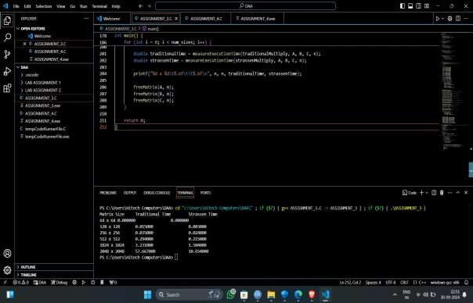

**-: GRAPH_3_OUTPUT.png**

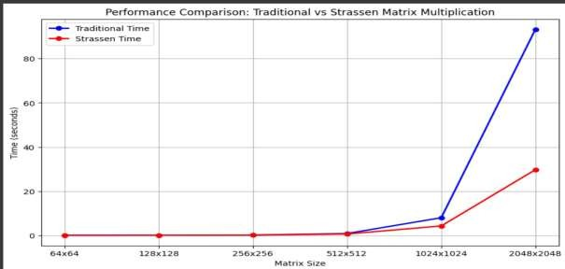

**-: CREATE AN EMPTY (TEMP) FILE.**

# LAB 4: Implement the activity selection problem to get a clear understanding of greedy approach.

**:- ASSIGNMENT_4.C**

#include <stdio.h>

// Function to print the maximum number of activities that can be done void activitySelection(int start[], int end[], int

n) { int i, j;

printf("Selected activities are:\n");

// The first activity is always selected i = 0;

printf("Activity %d (Start: %d, End: %d)\n", i+1, start[i], end[i]);

// Consider rest of the activities for (j = 1; j < n; j++) {

// If this activity has a start time greater than or equal to the

// end time of the previously selected activity, select it if (start[j] >= end[i]) {

printf("Activity %d (Start: %d, End: %d)\n", j+1, start[j], end[j]); i = j; // Update i to the current activity

} } }

int main() {

// Example set of activities with their start and end times int start[] = {1, 3, 0, 5, 8, 5};

int end[] = {2, 4, 6, 7, 9, 9};

int n = sizeof(start) / sizeof(start[0]); activitySelection(start, end, n); return 0;

}

**:- CREATE AN EMPTY (ASSIGNMENT_4.exe) FILE.**

**:- ASSIGNMENT_4_OUTPUT.png**

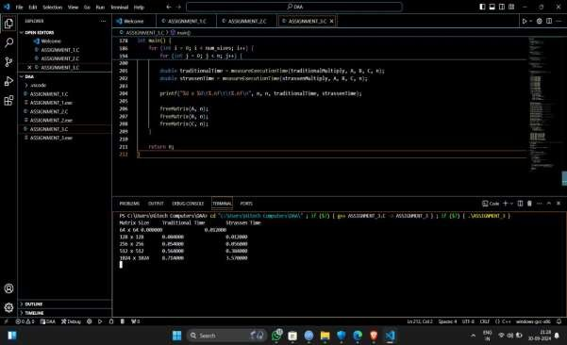

**:- CREATE AN EMPTY (TEMP) FILE.**

# LAB 5: Get a detailed insight of dynamic programming approach by the implementation of Matrix Chain Multiplication problem and see the impact of parenthesis positioning on time requirements for matrix multiplication.

**:- ASSIGNMENT_5.c**

#include <stdio.h> #include <limits.h>

int matrixChainOrder(int p[], int n)

{ int m[n][n];

int i, j, k, L;

for (i = 1; i < n; i++) {

m[i][i] = 0; }

for (L = 2; L < n; L++) {

for (i = 1; i < n - L + 1; i++) { j = i + L - 1;

m[i][j] = INT_MAX;

for (k = i; k < j; k++) {

int q = m[i][k] + m[k + 1][j] + p[i - 1] * p[k] * p[j]; if (q < m[i][j]) {

m[i][j] = q;

} } } }

return m[1][n - 1]; }

int main() {

int p[] = {30, 35, 15, 5, 10};

int n = sizeof(p) / sizeof(p[0]);

int result = matrixChainOrder(p, n);

printf("Minimum number of scalar multiplications: %d\n", result); return 0;

}

**:- CREATE AN EMPTY (ASSIGNMENT_5.exe) FILE.**

**:- ASSIGNMENT_5_OUTPUT.png**

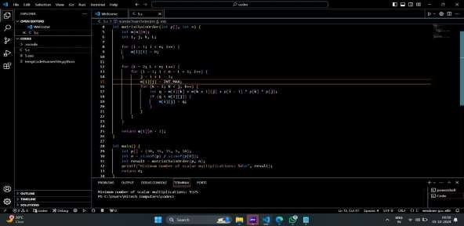

**:- CREATE AN EMPTY (TEMP) FILE.**

# LAB 6: Compare the performance of Dijkstra and Bellman ford algorithm for the single source shortest path problem.

**:- ASSIGNMENT_6.c**

#include <stdio.h> #include <limits.h> #define INF INT_MAX

void dijkstra(int graph[][5], int source) { int distance[5];

int visited[5];

for (int i = 0; i < 5; i++) { distance[i] = INF; visited[i] = 0;

}

distance[source] = 0; for (int i = 0; i < 5; i++) {

int min_distance = INF; int min_index = -1;

for (int j = 0; j < 5; j++) {

if (!visited[j] && distance[j] < min_distance) { min_distance = distance[j];

min_index = j;

} }

visited[min_index] = 1; for (int j = 0; j < 5; j++) {

if (!visited[j] && graph[min_index][j] != 0 && distance[min_index] + graph[min_index][j] < distance[j]) {

distance[j] = distance[min_index] + graph[min_index][j];

} }

printf("Shortest distances from source %d:\n", source); for (int i = 0; i < 5; i++) {

printf("%d: %d\n", i, distance[i]);

} }

void bellman_ford(int graph[][5], int source) { int distance[5];

for (int i = 0; i < 5; i++) { distance[i] = INF;

}

distance[source] = 0;

for (int i = 0; i < 5 - 1; i++) { for (int j = 0; j < 5; j++) {

for (int k = 0; k < 5; k++) {

if (graph[j][k] != 0 && distance[j] + graph[j][k] < distance[k]) { distance[k] = distance[j] + graph[j][k]; }

}

printf("Shortest distances from source %d:\n", source); for (int i = 0; i < 5; i++) {

printf("%d: %d\n", i, distance[i]);

} }

int main() {

int graph[][5] = {

{0, 4, 0, 0, 0},

{0, 0, 8, 0, 0},

{0, 0, 0, 7, 0},

{0, 0, 0, 0, 9},

{0, 0, 0, 0, 0}

};

dijkstra(graph, 0);

bellman_ford(graph, 0);

return 0;

}

**:- CREATE AN EMPTY (ASSIGNMENT_6.exe) FILE.**

**:- ASSIGNMENT_6_OUTPUT.png**

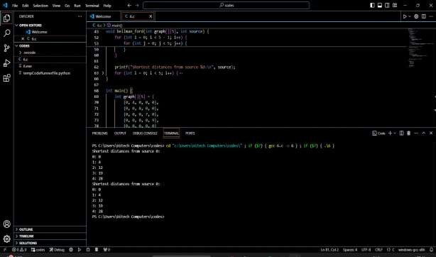

**:- CREATE AN EMPTY (TEMP) FILE.**

# LAB 7: Through 0/1 Knapsack problem, analyse the greedy and dynamic programming approach for the same dataset.

**:- ASSIGNMENT_7.c**

#include <stdio.h>

// Structure to represent an item typedef struct {

int weight; int value;

} Item;

// Function to calculate the value-to-weight ratio float ratio(Item item) {

return (float)item.value / item.weight;

}

// Function to sort items based on the ratio in descending order void sortItems(Item items[], int n) {

for (int i = 0; i < n - 1; i++) { for (int j = i + 1; j < n; j++) {

if (ratio(items[i]) < ratio(items[j])) {

// Swap items

Item temp = items[i]; items[i] = items[j]; items[j] = temp;

} } } }

// Function to solve the 0/1 Knapsack problem using the greedy approach int greedyKnapsack(Item items[], int n, int capacity) {

int totalValue = 0;

int remainingCapacity = capacity; sortItems(items, n);

for (int i = 0; i < n; i++) {

if (items[i].weight <= remainingCapacity)

{ totalValue += items[i].value; remainingCapacity -= items[i].weight;

} }

return totalValue;

}

// Function to solve the 0/1 Knapsack problem using dynamic programming int dynamicKnapsack(Item items[], int n, int capacity) {

int dp[n + 1][capacity + 1];

// Initialize the table

for (int i = 0; i <= n; i++) {

for (int j = 0; j <= capacity; j++) { if (i == 0 || j == 0) {

dp[i][j] = 0;

} else if (items[i - 1].weight <= j) {

dp[i][j] = (dp[i - 1][j] > dp[i - 1][j - items[i - 1].weight] + items[i - 1].value) ? dp[i - 1][j] : dp[i - 1][j - items[i - 1].weight] + items[i - 1].value;

} else {

dp[i][j] = dp[i - 1][j];

} } }

return dp[n][capacity]; } int main() {

// Define the items Item items[] = {

{10, 60},

{20, 100},

{30, 120}

};

int n = sizeof(items) / sizeof(items[0]); int capacity = 50;

int maxValueGreedy = greedyKnapsack(items, n, capacity);

int maxValueDynamic = dynamicKnapsack(items, n, capacity); printf("Maximum value using greedy approach: %d\n", maxValueGreedy); printf("Maximum value using dynamic programming approach: %d\n",

maxValueDynamic); return 0;

}

**:- CREATE AN EMPTY ( ASSIGNMENT_7.exe) FILE.**

**:- ASSIGNMENT_7_OUTPUT.png**

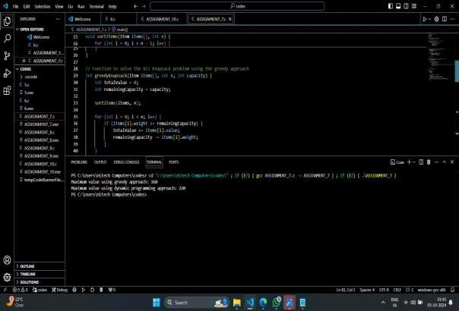

**:- CREATE AN EMPTY (TEMP) FILE.**

# LAB 8: Implement the sum of subset.

**:- ASSIGNMENT_8.c**

#include <stdio.h>

// Function to calculate the sum of a subset

void sumOfSubsets(int arr[], int n, int sum, int index, int currentSum) { if (index == n) {

if (currentSum == sum) { printf("Subset with sum %d: ", sum); for (int i = 0; i < n; i++) {

if (arr[i] <= sum) { printf("%d ", arr[i]); sum -= arr[i];

} }

printf("\n");

}

return;

}

// Include the current element in the subset

sumOfSubsets(arr, n, sum, index + 1, currentSum + arr[index]);

// Exclude the current element from the subset sumOfSubsets(arr, n, sum, index + 1, currentSum);

}

int main() {

int arr[] = {2, 3, 5, 7};

int n = sizeof(arr) / sizeof(arr[0]); int sum = 10;

printf("Sum of subset problem:\n"); sumOfSubsets(arr, n, sum, 0, 0);

return 0;

}

**:- CREATE AN EMPTY (ASSIGNMENT_8.exe) FILE.**

**:- ASSIGNMENT_8_OUTPUT.png**

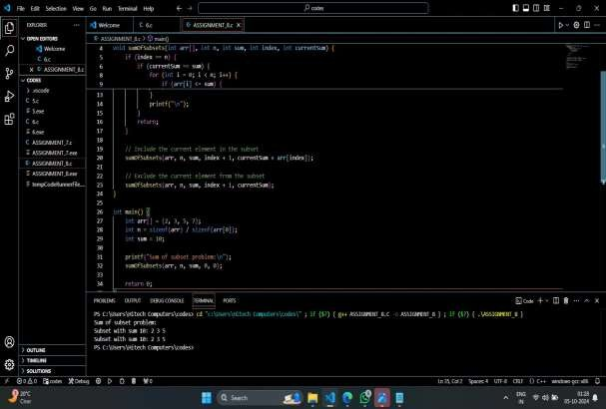

**:- CREATE AN EMPTY (TEMP) FILE.**

# LAB 9: Compare the Backtracking and Branch & Bound Approach by the implementation of 0/1 Knapsack problem. Also compare the performance with dynamic programming approach.

**:- ASSIGNMENT_9.c**

#include <stdio.h>

// Structure to represent an item typedef struct {

int weight; int value;

} Item;

// Function to implement backtracking approach

void backtrackKnapsack(Item items[], int n, int capacity, int i, int totalValue, int totalWeight) {

if (i == n) {

if (totalWeight <= capacity) {

printf("Backtracking Approach: Total value = %d\n", totalValue);

}

return;

}

// Include the current item in the knapsack

if (totalWeight + items[i].weight <= capacity) {

backtrackKnapsack(items, n, capacity, i + 1, totalValue + items[i].value, totalWeight +

items[i].weight);

}

// Exclude the current item from the knapsack backtrackKnapsack(items, n, capacity, i + 1, totalValue, totalWeight);

}

// Function to implement branch and bound approach

void branchAndBoundKnapsack(Item items[], int n, int capacity, int i, int totalValue, int totalWeight, int upperBound) {

if (i == n) {

if (totalWeight <= capacity) {

printf("Branch and Bound Approach: Total value = %d\n", totalValue);

}

return;

}

// Calculate the upper bound

int newUpperBound = upperBound - items[i].value;

// Include the current item in the knapsack

if (totalWeight + items[i].weight <= capacity) { branchAndBoundKnapsack(items, n, capacity, i + 1, totalValue + items[i].value,

totalWeight + items[i].weight, newUpperBound);

}

// Exclude the current item from the knapsack

branchAndBoundKnapsack(items, n, capacity, i + 1, totalValue, totalWeight, upperBound);

}

// Function to implement dynamic programming

approach int dynamicKnapsack(Item items[], int n, int capacity) {

int dp[n + 1][capacity + 1];

// Initialize the table

for (int i = 0; i <= n; i++) {

for (int j = 0; j <= capacity; j++) { if (i == 0 || j == 0) {

dp[i][j] = 0;

} else if (items[i - 1].weight <= j) {

dp[i][j] = (dp[i - 1][j] > dp[i - 1][j - items[i - 1].weight] + items[i - 1].value) ? dp[i - 1][j] : dp[i - 1][j - items[i - 1].weight] + items[i - 1].value;

} else {

dp[i][j] = dp[i - 1][j];

} } }

return dp[n][capacity]; } int main() {

// Define the items Item items[] = {

{10, 60},

{20, 100},

{30, 120}

};

int n = sizeof(items) / sizeof(items[0]); int capacity = 50; printf("Backtracking Approach:\n");

backtrackKnapsack(items, n, capacity, 0, 0, 0); printf("\nBranch and Bound Approach:\n"); branchAndBoundKnapsack(items, n, capacity, 0, 0, 0, 1000); printf("\nDynamic Programming Approach:\n"); int maxValue = dynamicKnapsack(items, n,

capacity); printf("Total value = %d\n", maxValue); return 0;

}

**:- CREATE AN EMPTY (ASSIGNMENT_8.exe) FILE.**

**:- ASSIGNMENT_8_OUTPUT.png**

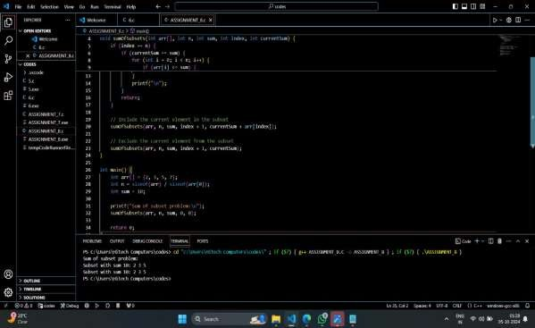

**:- CREATE AN EMPTY (TEMP) FILE.**

# LAB 10: Compare the performance of Rabin-Karp, Knuth- Morris-Pratt and naive string□matching algorithms.

**:- ASSIGNMENT_10.c**

#include <stdio.h> #include <string.h> #include <time.h>

#define d 256 // Number of characters in the input alphabet #define q 101 // A prime number

// Naive String Matching Algorithm void naiveStringMatch(char *text, char

*pattern) { int n = strlen(text); int m = strlen(pattern);

for (int i = 0; i <= n - m; i++) { int j;

for (j = 0; j < m; j++) {

if (text[i + j] != pattern[j]) {

break;

} }

if (j == m) {

printf("Naive: Pattern found at index %d\n", i);

} } }

// Rabin-Karp Algorithm

void rabinKarp(char *text, char

*pattern) { int n = strlen(text); int m = strlen(pattern);

int p = 0; // hash value for pattern int t = 0; // hash value for text

int h = 1;

// Calculate the value of h for (int i = 0; i < m - 1; i++)

h = (h * d) % q;

// Calculate hash value for pattern and first window of text for (int i = 0; i < m; i++) {

p = (d * p + pattern[i]) % q; t = (d * t + text[i]) % q;

}

// Slide the pattern over text for (int i = 0; i <= n - m; i++) {

if (p == t) { int j;

for (j = 0; j < m; j++) {

if (text[i + j] != pattern[j]) break;

}

if (j == m) {

printf("Rabin-Karp: Pattern found at index %d\n", i);

} }

// Calculate hash value for next window of text

if (i < n - m) {

t = (d * (t - text[i] * h) + text[i + m]) % q; if (t < 0) t += q;

} } }

// KMP Algorithm

void computeLPSArray(char *pattern, int m, int

*lps) { int length = 0; lps[0] = 0;

int i = 1; while (i < m) {

if (pattern[i] == pattern[length]) { length++;

lps[i] = length; i++;

} else {

if (length != 0) {

length = lps[length - 1];

} else { lps[i] = 0; i++;

} } }

void KMP(char *text, char

*pattern) { int n = strlen(text); int m = strlen(pattern);

int lps[m]; computeLPSArray(pattern, m, lps); int i = 0; // index for text int j = 0; // index for pattern while (i < n) {

if (pattern[j] == text[i]) { i++;

j++; }

if (j == m) {

printf("KMP: Pattern found at index %d\n", i - j); j = lps[j - 1];

} else if (i < n && pattern[j] != text[i])

{ if (j != 0)

j = lps[j - 1]; else

i++;

} } }

int main() {

char text[] = "ABABDABACDABABCABAB";

char pattern[] = "ABABCABAB";

printf("Text: %s\nPattern: %s\n", text, pattern);

// Naive String Match

printf("\nRunning Naive String Matching...\n"); clock_t start = clock();

naiveStringMatch(text, pattern); clock_t end = clock();

printf("Time taken: %.6f seconds\n", (double)(end - start) / CLOCKS_PER_SEC);

// Rabin-Karp

printf("\nRunning Rabin-Karp...\n"); start = clock();

rabinKarp(text, pattern); end = clock();

printf("Time taken: %.6f seconds\n", (double)(end - start) / CLOCKS_PER_SEC);

// KMP

printf("\nRunning KMP...\n"); start = clock();

KMP(text, pattern); end = clock();

printf("Time taken: %.6f seconds\n", (double)(end - start) / CLOCKS_PER_SEC); return 0;

}

**:- CREATE AN EMPTY (ASSIGNMENT_10.exe) FILE.**

**:- ASSIGNMENT_10_OUTPUT.png**

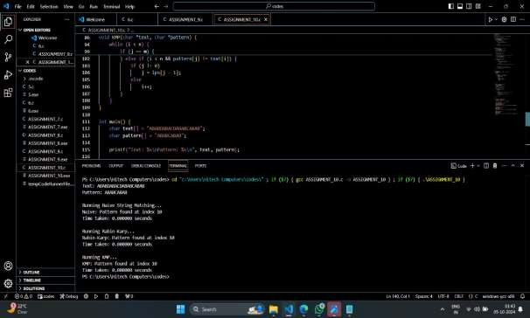

**:- CREATE AN EMPTY (TEMP) FILE.**

**Thank You!**

**GitHub id :- https://github.com/callmedon007**