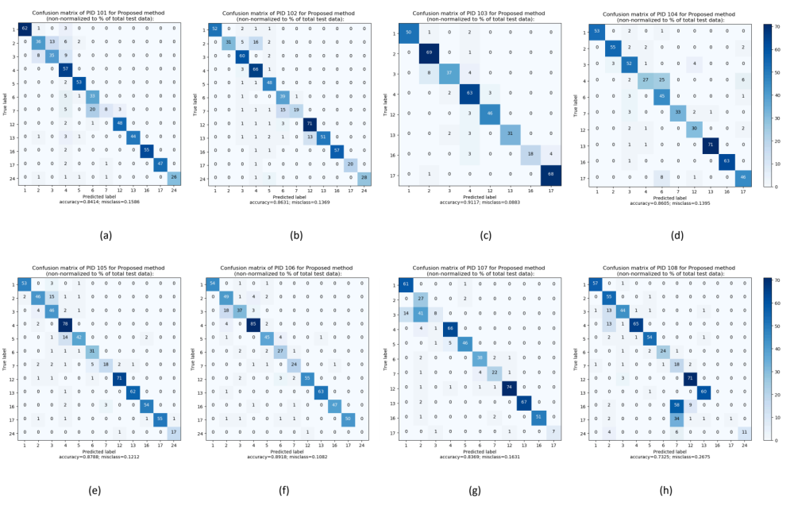
Figure 1. Non-normalized confusion matrices of each user for the proposed condition.

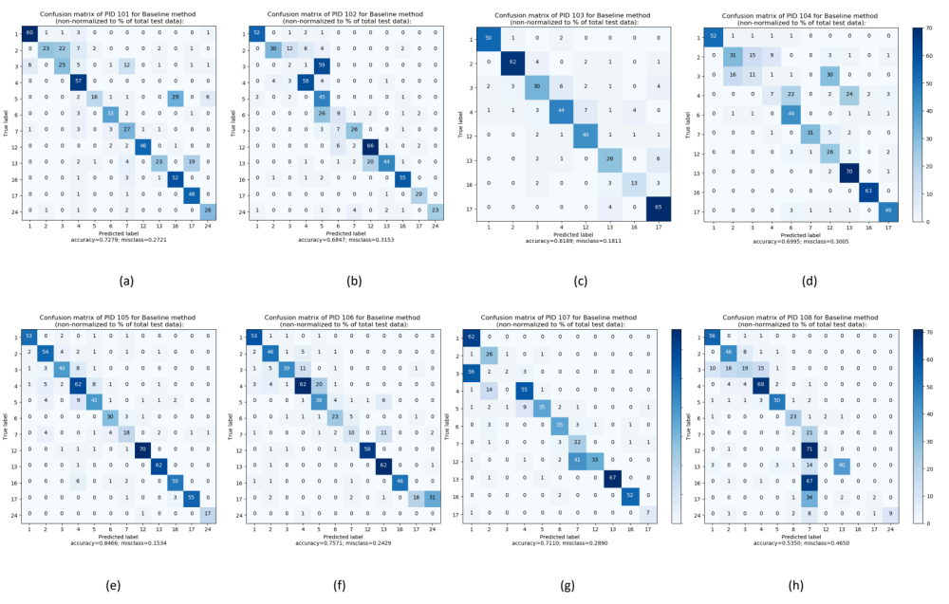
Figure 2. Non-normalized confusion matrices of each user for the baseline condition.

