

CAPSTONE PROJECT REPORT
Report 5 – Software Test Documentation

– Hanoi, 2026-10-30 –
Table of Contents
I. Record of Changes 4
II. Testing Documentation 5
1. Scope of Testing 5
1.1 Target-of-Test Overview 5
1.2 Features to be Tested 6
1.3 Features NOT to be Tested 8
1.4 Non-Functional Requirements to be Tested 9
1.5 Test Levels 10
1.6 Constraints and Assumptions 13
2. Test Strategy 14
2.1 Testing Types 14
2.2 Test Levels 17
2.3 Supporting Tools 18
3. Test Plan 18
3.1 Test Environment 18
3.2 Test Milestones 19
4. Test Cases 21
4.1. Unit Test Case 21
4.2. Integration Test Case 22
4.3. System Test Case 23
4.4. User Acceptance Test Case 23
5. Test Reports 24
5.1. Unit Test 24
5.2. Integration Test 24
5.3. System Test 25
5.4. User Acceptance Test 25

I. Record of Changes
Date | A*  M, D | In charge | Change Description
2026-10-30 | A | TC Team | Create the English TrustCabinet test plan, test designs and source inventory using the supplied Report 5 templates. Execution and customer feedback remain pending unless evidence is imported.
*A - Added M - Modified D - Deleted

II. Testing Documentation

1. Scope of Testing

1.1 Target-of-Test Overview
This plan documents the current TrustCabinet implementation (SEP490-G116), test designs and evidence requirements. The inventory contains 1129 xUnit definitions. Execution status: NotRun=1129. Verified evidence: not supplied.
- Verify Functional Correctness: Ensure all features and functionalities work as specified in the requirements
- Ensure System Reliability: Validate that the system performs consistently under normal operating conditions
- Validate Security Requirements: Confirm that security measures are properly implemented
- Verify Performance Standards: measure response and page-load timings against thresholds approved by the team; no measurements are claimed in this report.
- Ensure Usability: Confirm that the system is user-friendly and accessible
- Confirm Integration: Verify that all system components work together correctly

1.1.1 Test Scope Boundaries
What Will Be Tested:
- Implemented functional features and the workflows listed in the accompanying workbooks
- API endpoints and backend services
- Frontend components and user interfaces
- Database operations and data integrity
- Authentication and authorization flows
- Real-time notifications and agenda communication through SignalR
- Meeting validation, approval, publication and published-meeting rescheduling
- Integration between frontend and backend
- Error handling and edge cases
- Performance under normal load conditions
- Security measures and validations
- Cross-browser compatibility
- Responsive design
What Will NOT Be Tested:
- Third-party infrastructure operated by Google and the SMTP provider
- Offline functionality
- Extreme load testing beyond normal usage patterns
- Security penetration testing (separate security audit required)
- Browser compatibility for unsupported browsers (IE, very old versions)

1.1.2 System Under Test
- Backend: ASP.NET Core 10 Minimal API with Entity Framework Core and PostgreSQL
- Frontend: React 19, TypeScript and Vite; relative API paths through the same origin
- Real-time: ASP.NET Core SignalR; Redis supports refresh-token/session infrastructure
- External services: configured Google Sign-In and SMTP delivery; use test adapters or a sandbox as specified by each fixture

1.2 Features to be Tested

1.2.1 Authentication & Authorization
- User login/logout (via email)
- Google Sign-In for pre-provisioned active internal accounts
- JWT access tokens and HttpOnly refresh cookies
- Role-based access control
- Permission management
- Session management

1.2.2 Account Management
- Create, list and update users; activate or deactivate accounts
- Update account details through administration APIs
- Administrator-initiated password-reset email and single-use reset completion
- User search, filter, and pagination
- Role assignment

1.2.3 Role and Capability Management
- List roles and capability catalogue
- Create, rename and delete eligible custom roles
- Update role capabilities and persist assignments
- Protect system roles and the last active administrator

1.2.4 Draft Meeting Management
- Create and edit Draft meetings
- Validate meeting fields, times and sensitivity
- Filter, search and page the caller-visible meeting list
- Load details and status history under server-side access checks
- Maintain permitted organizer and approver relationships
- Reject invalid or unauthorized updates without partial changes

1.2.5 Meeting Approval Workflow
- Submit a ready Draft for approval
- Approve or reject as the assigned approver
- Record rejection reasons and append-only status history
- Revise and resubmit a Rejected meeting

1.2.6 Publication and Rescheduling
- Publish an Approved meeting with required active meeting roles
- Validate Chair and Secretary readiness before publication
- Update permitted schedule and location fields after publication
- Notify intended recipients and queue calendar email updates

1.2.7 Meeting Access and Recovery
- Filter meeting reads by caller relationship and state
- Return 404 for an inaccessible individual meeting
- Return 403 for a fixed API endpoint when capability is missing
- Re-authorize every state transition on the server
- Verify organizer-transfer and recovery behavior where backend endpoints exist
- Preserve evidence of earlier actions in meeting history

1.2.8 Agenda Backend
- Create and update agenda items through the implemented API
- Order and validate agenda items
- Verify concurrency and permitted agenda actions
- Check real-time agenda messages according to source tests
- Complete agenda UI workflow is Blocked until the missing UI and meeting-start integration exist

1.2.9 Persistence and Data Integrity
- Validate the EF Core model and provider configuration
- Verify repository queries and transaction behavior
- Verify migration and seeded-role invariants
- Check concurrency and administrator-invariant protection

1.2.10 Notifications
- Real-time notification delivery through SignalR
- Notification read/unread status
- Notification history
- Notification count display

1.2.11 Email Delivery
- Durable email queue, recipient selection and ICS invitation generation
- SMTP sandbox delivery, retry, deduplication and outage recovery

1.2.12 Calendar and Navigation
- Week, month and list calendar views
- Meeting preview and detail navigation
- Capability-filtered administration navigation
- Protected-route authentication and restricted-route 404 behavior
- Notification navigation when access to the target has changed

1.3 Features NOT to be Tested
- Unimplemented document, voting, recording, transcript, minutes and call workflows; do not infer completed features from entity tables
- Performance testing under extreme load (beyond normal usage)
- Security penetration testing (separate security audit)
- Browser compatibility testing for unsupported browsers (IE, older versions)
- Out-of-scope task tracking, voiceprints, multi-tenancy, organization units and eOffice integration

1.4 Non-Functional Requirements to be Tested

1.4.1 Performance
- Measure standard API response time; the team must approve the target before a pass/fail decision
- AI timing and quality tests are deferred until an implemented AI integration is in scope
- Measure page-load time and record browser, network and build conditions
- Database query optimization
- WebSocket connection stability
- Email-worker retry behavior and queue recovery under controlled SMTP failure

1.4.2 Security
- Authentication and authorization
- Input validation and sanitization
- SQL injection prevention
- XSS prevention
- CSRF protection
- JWT token security
- File handling is deferred where the corresponding business endpoint is not implemented

1.4.3 Usability
- User interface responsiveness
- Error message clarity
- Form validation feedback
- Navigation intuitiveness

1.4.4 Reliability
- Error handling and recovery
- Data consistency
- Transaction integrity
- System availability
- Graceful degradation

1.4.5 Compatibility
- Cross-browser compatibility (Chrome, Edge)
- Responsive design
- API version compatibility

1.5 Test Levels

1.5.1 Unit Testing
- In-Charge: Backend Developers
- Input/Time: source-defined method and fixture; record actual duration from the test runner
- Focus:
  - Individual functions and methods in isolation
  - Business logic validation
  - Data transformation
  - Token, password, validator and message-code behavior according to existing source tests
  - No frontend component or hook test suite is inferred from backend xUnit tests
- Acceptance Criteria:
  - All critical business logic functions have unit tests
  - Code coverage: measurement pending
  - All tests pass before code merge
  - Tests are maintainable and well-documented
- Tools:
  - Backend: Visual Studio Code (integrated terminal); Report5.1_Unit_Test.xlsx

1.5.2 Integration Testing
- In-Charge: Tester
- Input/Time: API, repository, database, Redis and source-contract definitions; duration comes from actual execution
- Focus:
  - API endpoint functionality
  - Database integration
  - Service layer integration
  - Authentication flow
  - WebSocket communication
  - External service integration
  - Component integration (multiple components working together)
  - API integration between frontend and backend, verified by the manual UI cases
  - State management integration (hooks, context, stores)
  - Routing integration (navigation between pages)
  - Form submission and validation flow
  - WebSocket client integration
- Acceptance Criteria:
  - All API endpoints tested with valid and invalid inputs
  - Database operations tested (CRUD, transactions)
  - Authentication and authorization flows verified
  - WebSocket connections and messaging tested
  - Critical-path coverage: BA review pending
  - All integration tests pass in CI/CD pipeline
  - Components work together correctly
  - API calls handle responses and errors properly
  - State updates propagate correctly
  - Navigation flows work as expected
  - Forms submit and validate correctly
- Tools
  - Backend: Visual Studio Code (integrated terminal)
  - Frontend: Microsoft Edge, Chrome Dev Tool
  - API source cases are in Report5.2.2_Integration_Test_API_Test.xlsx; non-HTTP and UI cases are in Report5.2_Integration_Test.xlsx

1.5.3 System Testing
- In-Charge: Tester
- Input/Time: nine source-reviewed workflows; actual execution duration is recorded with evidence
- Focus:
  - End-to-end user workflows
  - System behavior under normal conditions
  - Integration between frontend and backend
  - Complete business processes
  - System-level error handling
- Acceptance Criteria:
  - All critical user workflows tested end-to-end
  - System meets functional requirements
  - Approved performance targets are measured and met for the delivered scope
  - Security requirements verified
  - No critical bugs in production-ready features
  - Test results documented and reviewed
- Tools:
  - Manual testing checklists

1.5.4 User Acceptance Testing (UAT)
- In-Charge: End Users, Business Stakeholders, Product Owner
- Input/Time: eight proposed acceptance criteria and representative-user tasks; session timing is recorded when conducted
- Focus:
  - End-user perspective validation
  - Business requirement verification
  - Real-world usage scenarios
  - User workflow testing (complete business processes)
  - Usability from end-user standpoint
  - Feature completeness and correctness
  - User satisfaction and feedback
- Acceptance Criteria:
  - Delivered user stories are reviewed against business requirements; incomplete workflows remain explicitly deferred
  - Business requirements met and verified
  - System meets end-user expectations
  - User feedback collected and incorporated
  - Sign-off obtained from stakeholders
  - User training materials validated (if applicable)
- Tools:
  - Demonstrate the delivered workflow to representative administrators, organizers, approvers and participants
  - Feedback collection forms/surveys
  - Issue tracking system (Jira)

1.6 Constraints and Assumptions

1.6.1 Constraints
1. Time Constraints: Limited time for comprehensive testing of all features
- Testing must be completed before release deadlines
- Unimplemented workflows remain deferred or Blocked until prerequisites exist
2. Resource Constraints:
- Limited access to production-like environment
- Test data may not fully represent production data volume
3. Technical Constraints:
- Google and SMTP integrations use the adapters declared by tests; real-service verification requires a configured sandbox
- WebSocket testing requires specific setup
4. Environment Constraints:
- Test environment may differ from production
- Some integrations may not be available in test environment

1.6.2 Assumptions
1. Test Environment:
- Test database is properly configured and accessible
- Record differences between staging and production instead of assuming exact equivalence
2. Dependencies:
- All required services (Redis, PostgreSQL) are available
- Network connectivity is stable during testing
- Test data is available and consistent
3. User Behavior:
- Users follow expected workflows
- Users have appropriate permissions for their roles
- Users understand basic system functionality
4. Development Process:
- Code is reviewed before testing
- BA reconciles requirement documents during BA Final Review after frontend integration
- Jira SCRUM is the requirements source; testcase-to-UC mapping remains subject to BA review

2. Test Strategy

2.1 Testing Types

2.1.1 Component Test
Test Objective | This type of testing is used to test individual source code modules and ensure their accuracy and stability. It is typically used by software engineers to verify that their work is operational and performs as expected. The goal is to detect and resolve defects as early as possible in the development process.
Technique | - Execute source-defined xUnit methods with their fixtures and every data variant. Compare each assertion and record TRX results. This report separates isolated logic from database, Redis, source-contract and HTTP integrations.
Completion criteria | - All selected definitions execute against the documented build; failures are resolved or explicitly accepted; valid execution evidence is retained.
Special Consideration | Method count is not code coverage. Theory variants require complete evidence before a method is marked Passed.
Table 2.1.1 Component Test

2.1.2 API Test
Test Objective | This testing aims to ensure that the APIs correctly handle requests and responses, effectively communicate with external systems, and maintain data integrity.
Technique | - Use existing xUnit TestServer endpoint tests for valid, invalid and unauthorized requests. Verify response status, message code, payload and persisted state according to source assertions. Inspect fake adapters and run real-service checks separately where needed.
Completion criteria | - All APIs have been tested, and test cases cover a wide range of scenarios including positive, negative, boundary, and error cases.  - The API documentation is accurate and up to date, reflecting the correct usage and behaviour of each API endpoint.
Special Consideration | Fixed capability-protected API: 403. Inaccessible individual resource: 404. Anonymous protected request: 401.
Table 2.1.2 API Test

2.1.3 GUI Test
Test Objective | Navigation within the subject under assessment accurately  mirrors business operations and specifications, encompassing transitions between screens, fields, and utilization of entry points. Elements and attributes like menus, dimensions, arrangement, condition, and emphasis align with guidelines governing user interface and defined design.
Technique | - Evaluate the graphical user interface (GUI) elements, such as buttons, checkboxes, radio buttons, and dropdowns, to ensure they behave correctly.  - Verify the flow of navigation between different screens, menus, and features to ensure a smooth experience.
Completion criteria | - Elements, such as menus, buttons, text fields, and images, are positioned and styled correctly according to UI/UX design that is already designed.  - Users can seamlessly move between screens, menus, and features without encountering any unexpected behaviours.
Special Consideration | Execute the 20 source-reviewed UI scenarios in the integration workbook. Backend test success does not establish browser success.
Table 2.1.3 GUI Test

2.1.4 Regression Test
Test Objective | Ensure that new code changes, fixes, updates, or enhancements do not adversely affect the existing functionality of the application.
Technique | Execute the same test cases that were run during previous testing cycles to verify that the existing functionality is still working as expected.  - Focus on testing specific areas of the application that are likely to be affected by the code changes. This approach optimizes testing efforts by targeting high-risk areas.  - Prioritize test cases based on their importance and potential impact on the application. High-priority test cases are tested first.
Completion criteria | - All critical functionalities of the application must continue to work without any regressions or new critical defects.  - Regression testing has covered a representative set of test cases that encompass the key functionalities and affected areas.  - Test cases have been reviewed, updated, or modified as necessary to align with the changes in the application.
Special Consideration | Re-run affected tests after each change and retain separate evidence for each run; do not merge repeated attempts into the case count.
Table 2.1.4 Regression Test

2.2 Test Levels

Type of Tests | Test Level
Type of Tests | Unit | Integration | System | Acceptance
Component Test | X
API Test |  | X
Functional Test | X | X | X | X
GUI Test | X | X | X | X
Regression Test | X | X | X | X
Table 2.2. Testing Levels

2.3 Supporting Tools
Purpose | Tool | Vendor/In-house | Version
Test API and integration | Visual Studio Code | Microsoft | Installed version
Test unit logic | Visual Studio Code | Microsoft | Installed version
Test system and UAT | Chrome / Edge | Google / Microsoft | Record at execution
Write test documentation | Template export script | TrustCabinet | Current source
Manage testcases and reports | Excel / Word | Microsoft | Installed version
Manage bugs | Jira SCRUM | Atlassian | Hosted service
Table 2.3 Supporting Tools

3. Test Plan

3.1 Test Environment
Purpose | Tool | Provider | Version
Test graphical interface | Chrome / Edge | Google / Microsoft | Record at execution
Test backend APIs | Visual Studio Code | Microsoft | Installed version
Create and execute unit tests | Visual Studio Code | Microsoft | Installed version
Bug management | Jira SCRUM | Atlassian | Hosted service
Manage testcases and reports | Excel / Word | Microsoft | Installed version
Write test documentation | Template export script | TrustCabinet | Current source
Table 3.1 Test Environment

3.2 Test Milestones
Milestone Task | Start Date | End Date
Sprint 1 — schedule pending team agreement
Test plan | TBD | TBD
Create Test Case UT & IT | TBD | TBD
Execute UT & IT | TBD | TBD
Track & Fix Bug | TBD | TBD
Sprint 2 — schedule pending team agreement
Create Test Plan | TBD | TBD
Create Test Case UT & IT | TBD | TBD
Execute UT & IT | TBD | TBD
Track & Fix Bug | TBD | TBD
Sprint 3 — schedule pending team agreement
Create Test Plan | TBD | TBD
Create Test Case UT & IT & ST | TBD | TBD
Execute UT & IT | TBD | TBD
Test ST | TBD | TBD
Track & Fix Bug | TBD | TBD
Sprint 4 — schedule pending team agreement
Create Test Plan | TBD | TBD
Create Test Case UT & IT & ST | TBD | TBD
Execute UT & IT | TBD | TBD
Test ST | TBD | TBD
Track & Fix Bug | TBD | TBD
Sprint 5 — schedule pending team agreement
Customer test UAT | TBD | TBD
Create Test Plan | TBD | TBD
Create Test Case UT & IT & ST | TBD | TBD
Execute UT & IT | TBD | TBD
Test ST | TBD | TBD
Track & Fix Bug | TBD | TBD
Sprint 6 — schedule pending team agreement
Create Test Plan | TBD | TBD
Create Test Case UT & IT & ST | TBD | TBD
Execute UT & IT | TBD | TBD
Test ST | TBD | TBD
Track & Fix Bug | TBD | TBD
Customer test UAT | TBD | TBD
Table 3.2 Test Milestones

4. Test Cases

4.1. Unit Test Case

4.1.1 Unit Test Code
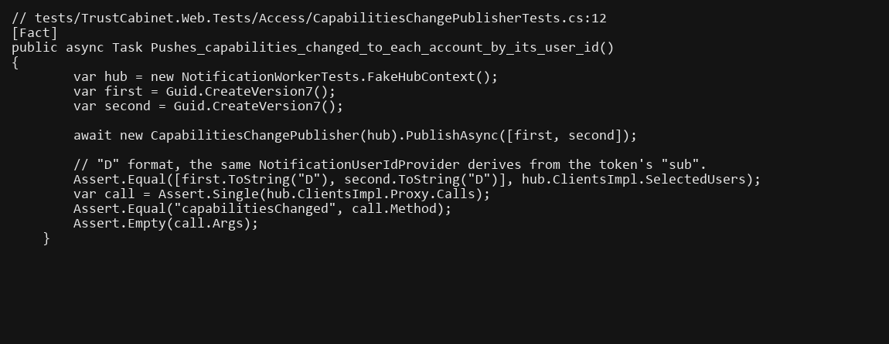
Figure 4.1.1. Unit Test Case Code Sample

4.1.2 Unit Test Document
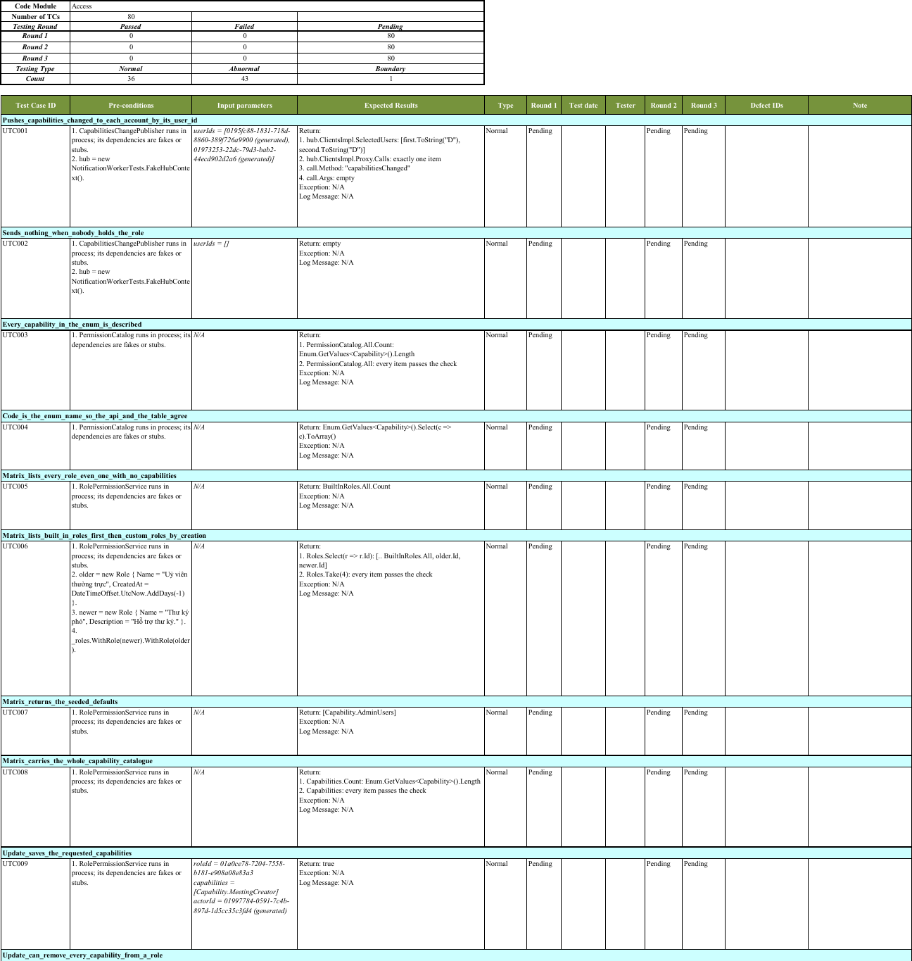
Figure 4.1.2. Unit Test Case Document Sample
- View Unit Test Case at: Report5.1_Unit_Test.xlsx

4.2. Integration Test Case
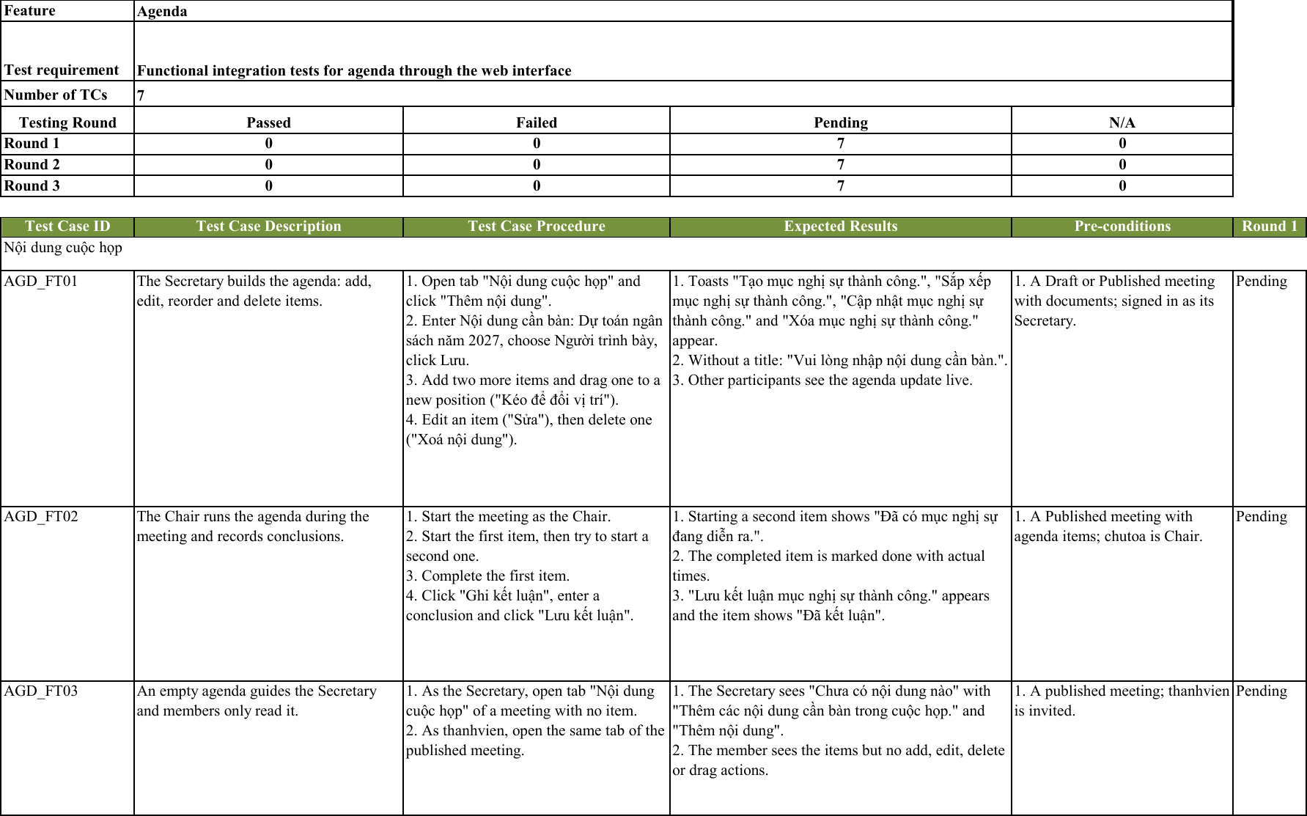Figure 4.2. Integration Test Case Sample
- View Integration Test Case at: Report5.2_Integration_Test.xlsx
- View API Test Case at: Report5.2.2_Integration_Test_API_Test.xlsx

4.3. System Test Case
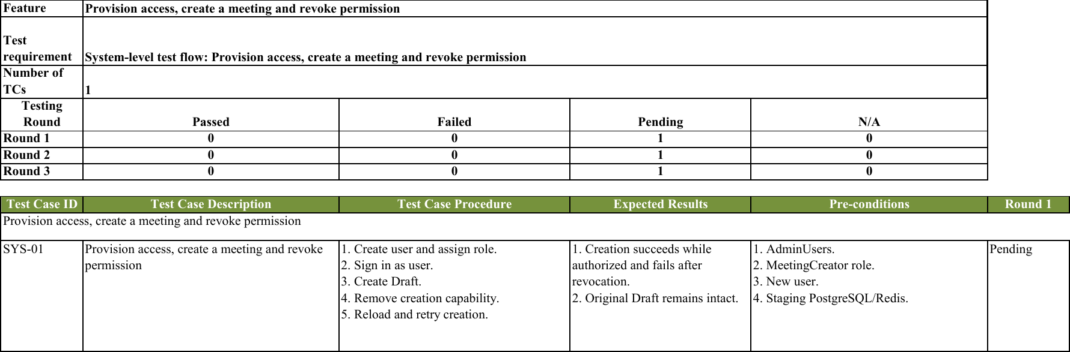Figure 4.3. System Test Case Sample
- View System Test Case at: Report5.3_System_Test.xlsx
- System test files: Drive folder; manual execution evidence is pending. SYS-09 is Blocked by missing workflow prerequisites.

4.4. User Acceptance Test Case
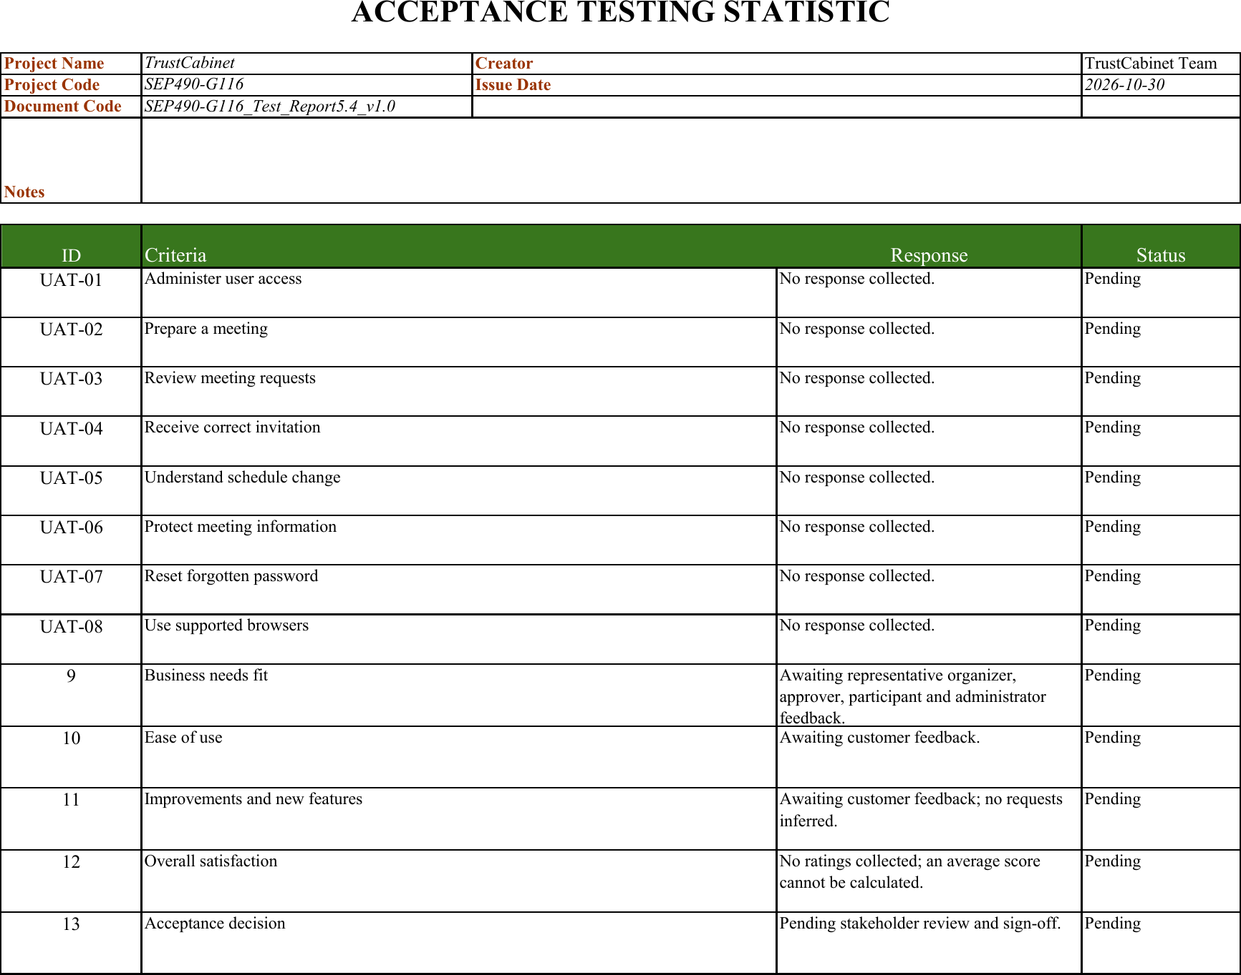Figure 4.4. User Acceptance Test Case Sample
- View Acceptance Test Case at: Report5.4_Acceptance_Test.xlsx
- Representative-user demo recording: not collected.
- Customer feedback: not collected. Record actual responses in Customers Feedbacks after a UAT session.

5. Test Reports

5.1. Unit Test
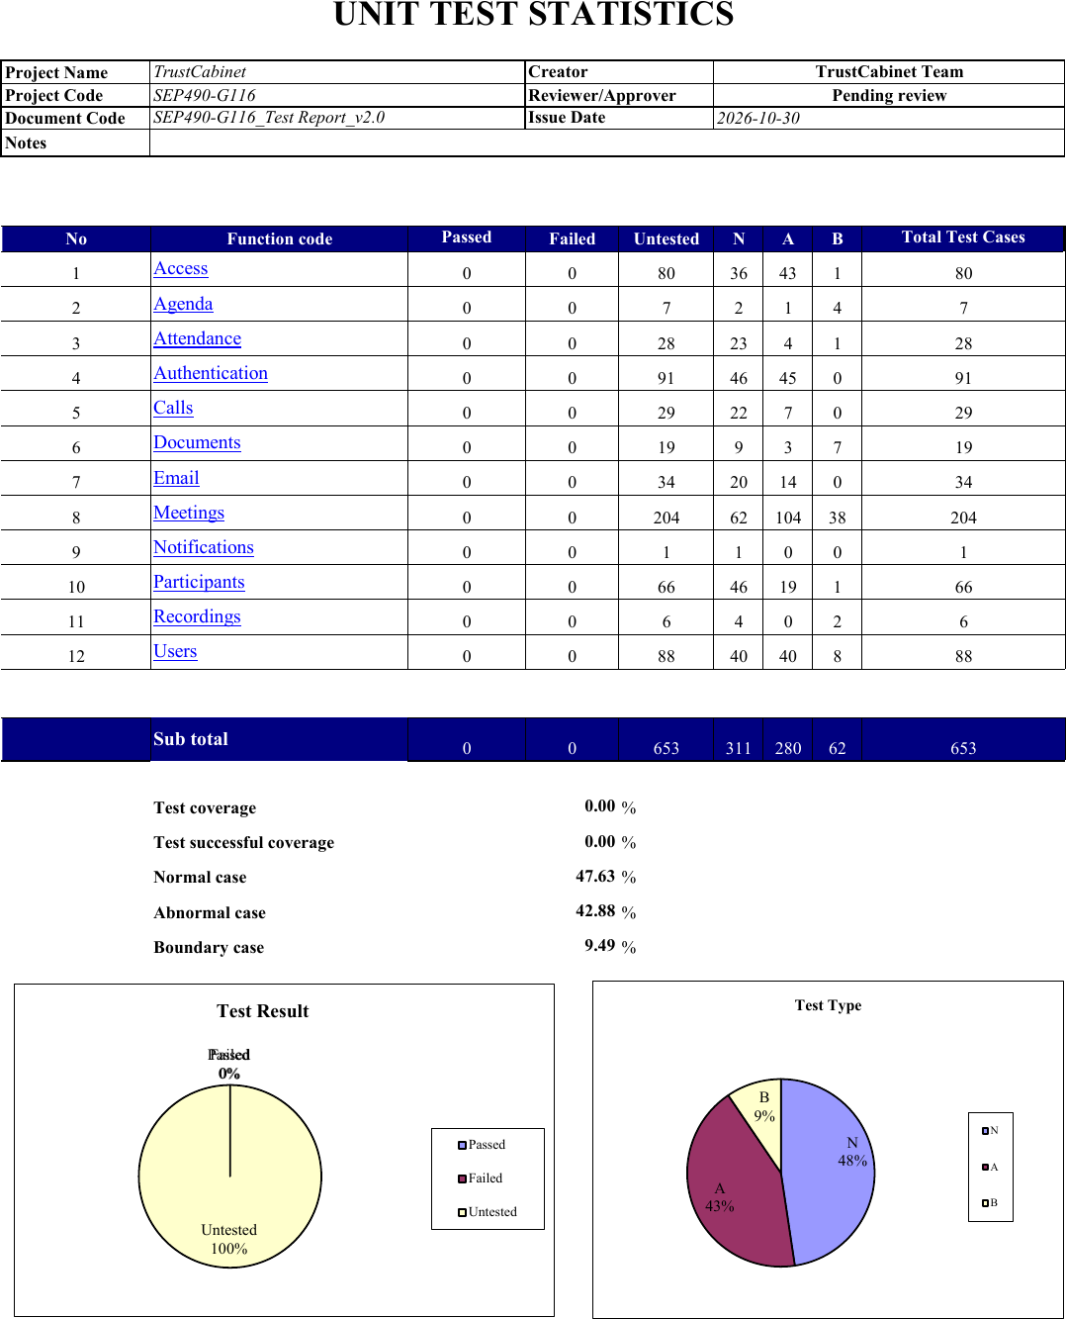Figure 5.1. Unit Test Report
- Refer: Report5.1_Unit_Test.xlsx. 447 definitions (653 test cases): NotRun=447.

5.2. Integration Test
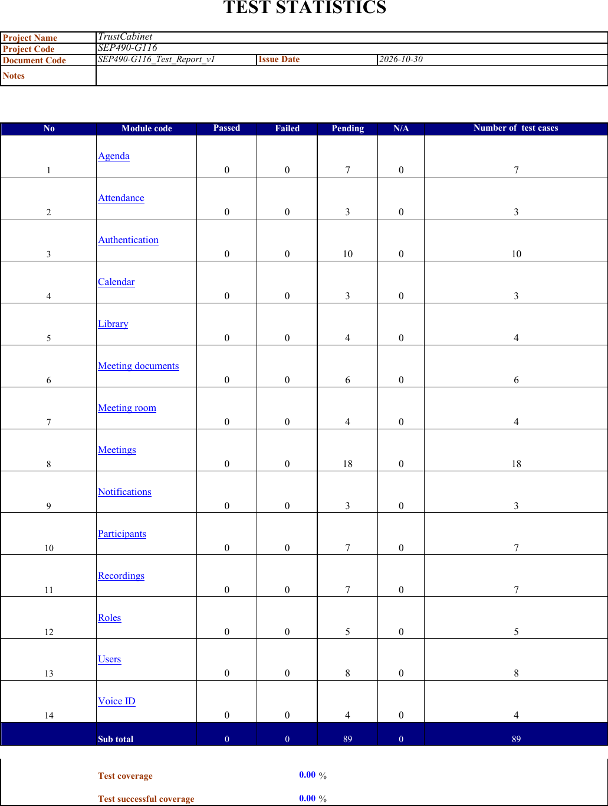Figure 5.2. Integration Test Report
- Refer: Report5.2_Integration_Test.xlsx and Report5.2.2_Integration_Test_API_Test.xlsx. 89 functional UI test cases and 479 API test cases; 203 automated infrastructure checks run with dotnet test.

5.3. System Test
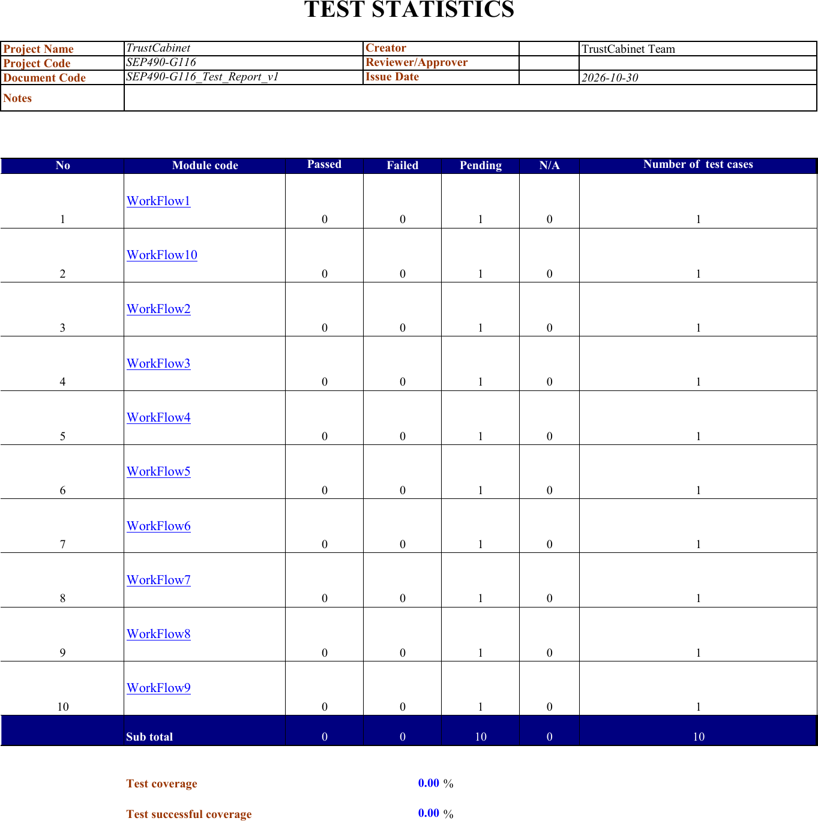Figure 5.3. System Test Report
- Refer: Report5.3_System_Test.xlsx. 10 definitions / scenarios: NotRun=9, Blocked=1.

5.4. User Acceptance Test
Figure 5.4. User Acceptance Test Report
Refer: Report5.4_Acceptance_Test.xlsx. 8 definitions / scenarios: NotRun=8. Customer feedback and stakeholder sign-off are pending.

