Enterprise Knowledge Base Framework
Reference architecture and proof-of-concept plan — draft for discussion

1. Purpose
This document sets out a framework for an enterprise knowledge base that brings governed unstructured content together with structured data, and makes it available through AI-assisted search and question answering. It describes the reference architecture, the technology stack, and a 10 to 12 week proof of concept (POC) to validate the approach.
The POC uses open-source components and platforms already in use in the bank, chosen so that the POC can become the first production release rather than a throwaway prototype.

2. Architecture at a glance
The framework has six layers, with security, audit, lineage and evaluation applied across all of them. Figure 1 on the following page shows the reference architecture, including which elements are in POC scope and which are planned for Phase 2.
Layer | What it does | Key components
1. Sources | Content entering the knowledge base | PDF documents (POC); email, Word, SharePoint and scans (Phase 2); existing data marts
2. Governance & ingestion | Controls what enters and who approved it | Flowable maker-checker workflow, PostgreSQL system of record, Apache Airflow
3. Storage & processing | Stores content in zones and extracts it | S3 / HDFS zones, Docling, Apache Tika, PaddleOCR, vLLM enrichment, Apache Iceberg
4. Knowledge layer | Turns content into retrievable knowledge | BGE-M3 embeddings, Elasticsearch hybrid search, Neo4j knowledge graph, reranker
5. Query & serving | Answers questions across documents and data | Haystack / LlamaIndex agent, Starburst for structured data and text-to-SQL
6. Consumption | Puts knowledge in front of users | LibreChat interface, faceted browsing, feedback captured in Langfuse

Figure 1. Reference architecture (POC)
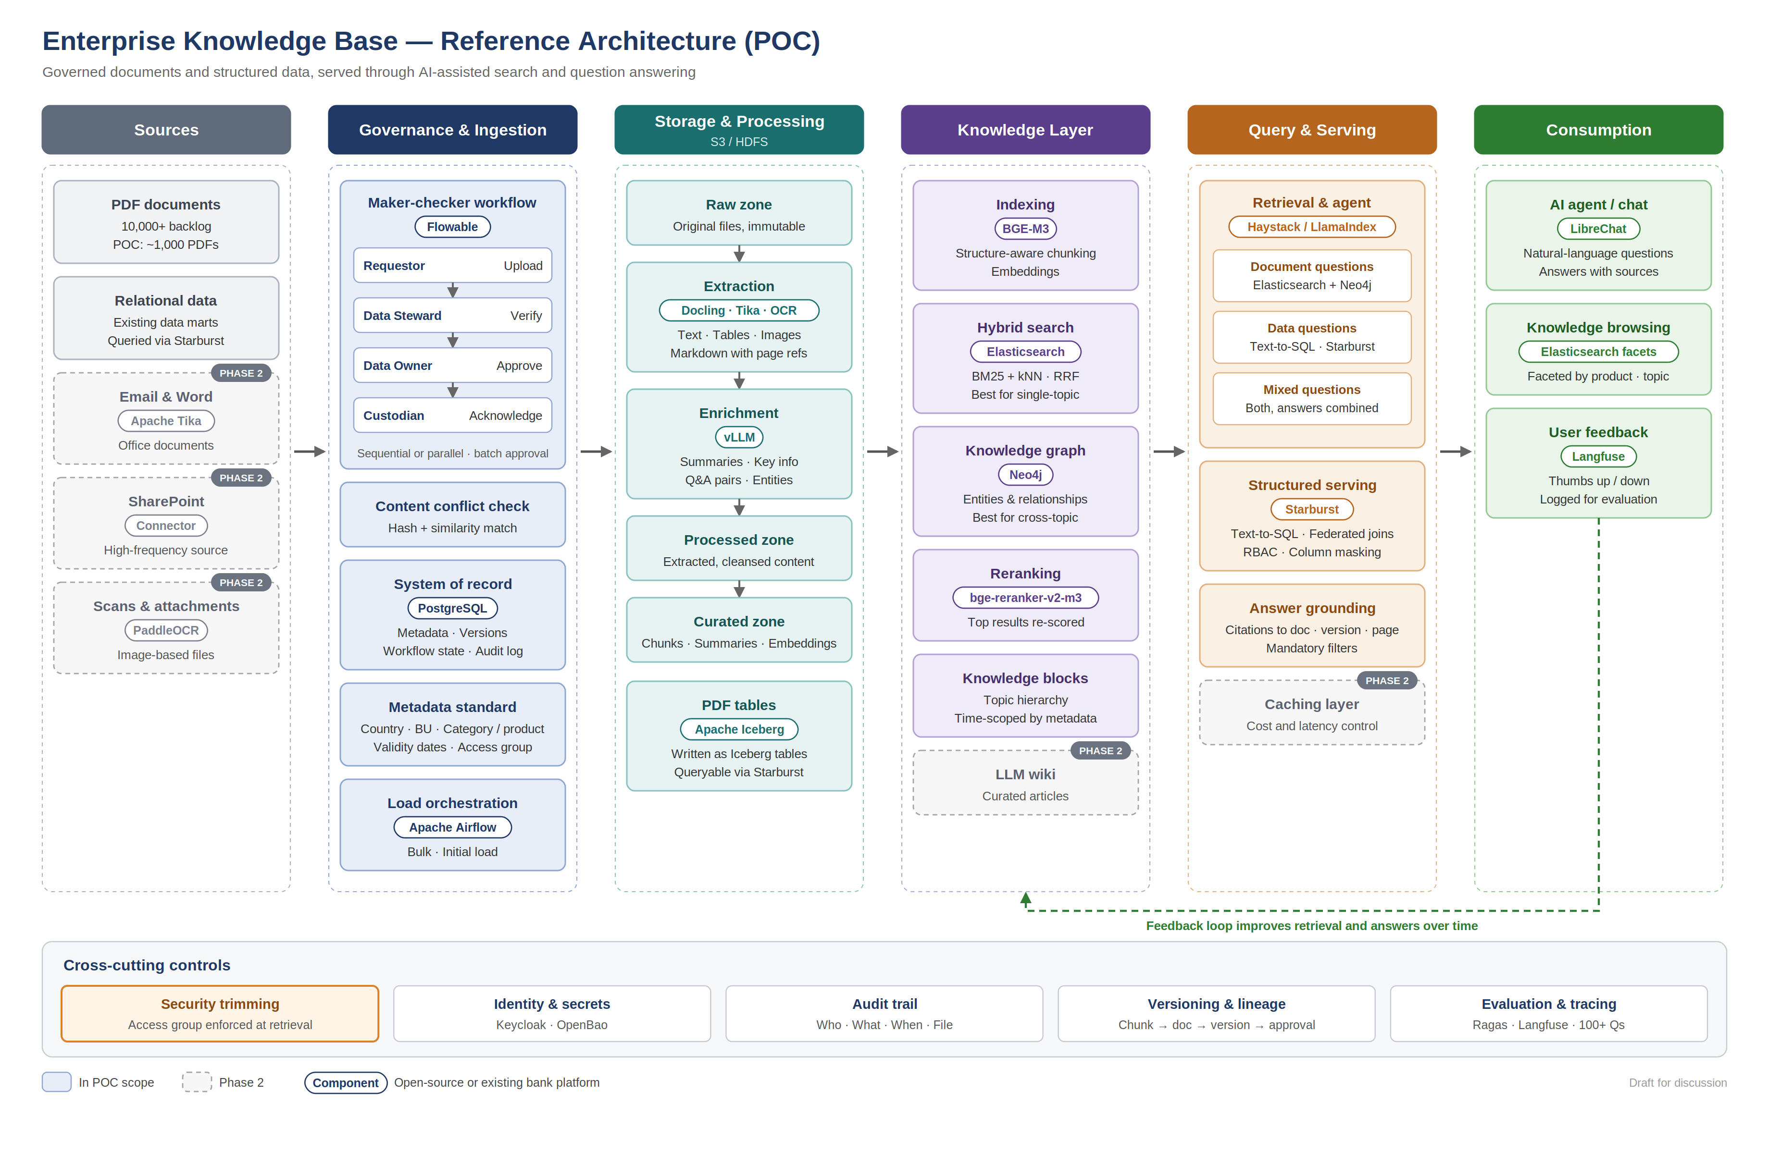

3. Governance and ingestion
Every document enters through a maker-checker process so that it has a clear owner, an approval record and a full audit history.
Role | Responsibility
Requestor | Uploads the document and its metadata
Data Steward | Verifies content quality and metadata accuracy
Data Owner | Approves the document for use
Data Custodian | Acknowledges and takes operational custody

- Workflow. Flowable runs the approval workflow, with sequential or parallel routing. For the initial bulk load, the owner approves a manifest of the whole batch rather than each document individually.
- System of record. PostgreSQL holds document metadata, versions, workflow state and an append-only audit log recording who did what, when, and on which file.
- Content conflict check. At approval, a file hash catches exact duplicates and embedding similarity flags near-duplicates and contradictions with existing content.
- Metadata standard. Every document carries country, business unit, category or product, effective and expiry dates, key information, version and access group.
- Orchestration. Apache Airflow orchestrates the bulk and initial loads. Incremental and in-flight loading follow in Phase 2.

4. Storage and processing
- Raw zone. Original files, immutable and checksummed, partitioned by country, business unit and category. Only approved documents are promoted out of this zone.
- Extraction. Docling handles PDF layout and tables, Apache Tika handles email and Office formats, and PaddleOCR handles scanned documents. Output is Markdown with page references, so answers can cite the page they came from.
- Enrichment. An open-weight model served through vLLM generates a summary, key information fields, sample question-and-answer pairs and named entities for each document.
- Processed zone. Holds extracted, cleansed content.
- Curated zone. Holds chunks, summaries and embeddings ready for indexing.
- PDF tables. Tables extracted from PDFs are written as Apache Iceberg tables, which makes them queryable through Starburst alongside existing structured data.

5. Knowledge layer
- Indexing. Documents are split by section heading, with tables kept whole. Each chunk carries its document, version, page, business metadata and access group. Embeddings use BGE-M3, which supports multiple languages.
- Hybrid search. Elasticsearch, already in use in the bank, combines keyword (BM25) and vector (kNN) search, merged with reciprocal rank fusion. This captures both meaning and exact terms such as product codes and clause references. The index sits behind an alias so it can be rebuilt without downtime.
- Knowledge graph. Neo4j stores entities such as products, policies, regulations, business units and documents, and the relationships between them, with links back to source chunks. It supports questions that span several topics. The graph sits behind an abstraction layer so the engine can be changed later.
- Reranking. A cross-encoder reranker (bge-reranker-v2-m3) re-scores the top results before they are passed to the model.
- Knowledge blocks. Content is organised into a topic hierarchy and scoped by validity dates.

6. Query and serving
A retrieval and agent service built on Haystack or LlamaIndex routes each question to the right path:
Question type | Path
Document question | Elasticsearch hybrid search, expanded with related entities from Neo4j
Data question | Text-to-SQL through Starburst across data marts, metadata and PDF tables
Mixed question | Both paths, with answers combined and cited

Starburst, already licensed in the bank, provides federated queries with its existing role-based access control, column masking and query audit. Every answer cites the document, version and page it came from, and mandatory filters apply on every query: active version only, within validity dates, and within the user's access group.

7. Consumption
- A chat interface (LibreChat) for natural-language questions, with sources shown for every answer.
- Faceted browsing by product and topic, using Elasticsearch metadata.
- User feedback (thumbs up or down) captured in Langfuse and used to improve retrieval and answers.

8. Cross-cutting controls
Control | How it is applied
Security trimming | Access groups flow from each document into every chunk and graph node, and are enforced inside every Elasticsearch and Neo4j query. Users never query the stores directly.
Identity and secrets | Keycloak or the bank's identity provider for single sign-on; OpenBao for secrets
Audit trail | Append-only log of every action and every model call
Versioning and lineage | Every chunk and graph node traces back to its document, version and approval record
Evaluation and tracing | Ragas scores answers against the question benchmark; Langfuse traces every model call

9. Technology stack
Layer | Component | Licence / status
Workflow | Flowable | Apache 2.0
System of record | PostgreSQL | Existing bank platform
Storage | S3 / HDFS | Existing bank platform
Orchestration | Apache Airflow | Apache 2.0
Extraction | Docling · Apache Tika · PaddleOCR | MIT · Apache 2.0 · Apache 2.0
Model serving | vLLM with Apache 2.0 licensed models | Apache 2.0
Embeddings / reranking | BGE-M3 · bge-reranker-v2-m3 | MIT · Apache 2.0
Hybrid search | Elasticsearch | Existing bank platform
Knowledge graph | Neo4j Community (POC) | GPLv3; Enterprise licence decided after POC
Table format | Apache Iceberg | Apache 2.0
Agent framework | Haystack / LlamaIndex | Apache 2.0 / MIT
Structured serving | Starburst | Existing bank licence
Evaluation / tracing | Ragas · Langfuse | Apache 2.0 · MIT (core)
Identity / secrets | Keycloak · OpenBao | Apache 2.0 · MPL 2.0
User interface | LibreChat | MIT

10. POC scope and later phases
Area | POC | Phase 2
Sources | About 1,000 PDFs from 1–2 categories | Email, Word, SharePoint connector, scans; full 10,000+ backlog
Loading | Bulk and initial load | Incremental and in-flight loading
Knowledge | Hybrid search, knowledge graph, reranking, knowledge blocks | LLM wiki
Serving | Agent routing, Starburst text-to-SQL, grounded answers | Caching layer
Consumption | Chat, faceted browsing, feedback | Wider rollout across business units
Graph platform | Neo4j Community | Neo4j Enterprise, if the POC shows clear benefit

11. POC plan
Phase | Weeks | Activities | Exit criteria
1. Foundations | 1–2 | Freeze metadata standard, access groups and question benchmark; confirm platform readiness and approvals | Signed-off scope and approvals
2. Governance & intake | 2–4 | Postgres schema, Flowable workflow, upload interface, batch approval, conflict check | 1,000 PDFs approved in Raw with full audit trail
3. Extraction & enrichment | 4–6 | Airflow pipeline with Docling, Tika and OCR; PDF tables to Iceberg; enrichment with vLLM | All documents in Processed and Curated zones
4. Indexing | 6–7 | Chunking and embeddings into Elasticsearch; entities and relationships into Neo4j | Hybrid search and graph traversal working
5. Serving & agent | 7–9 | Retrieval service with mandatory filters and reranking; Starburst text-to-SQL; chat with citations | End-to-end answers with sources
6. Evaluation | 9–11 | Benchmark search alone against search plus graph, split by single-topic and cross-topic questions | Accuracy report by question type
7. Decision | 12 | Present results, gaps and the production path, including the graph licence decision | Go / no-go for production

12. Open checks
- Elasticsearch version and licence tier, including whether reciprocal rank fusion and document-level security are included.
- Legal review of Neo4j Community (GPLv3) for internal use.
- GPU capacity for model serving.
- Available Starburst connectors (Elasticsearch, PostgreSQL, Iceberg).
- Data owner approval to index document content.
Known POC limitations: Neo4j Community has no high availability, online backup or multiple databases. These are acceptable for the POC and are addressed by Neo4j Enterprise in production.

