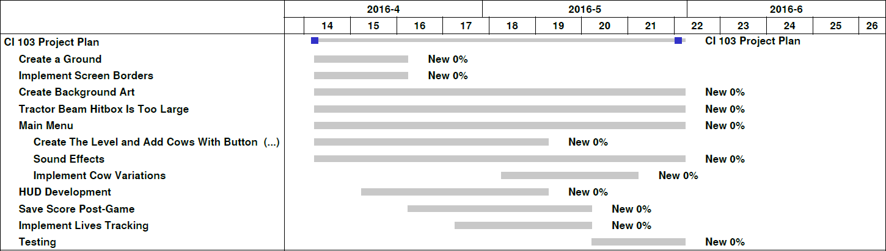

The various tasks required are:

* Create the ground
  + **Purpose:** If the tractor beam begins to suck up a cow but disappears before the cow touches the UFO and is destroyed, the cow must fall back to the ground; the ground will act as a reference for the point at which the cow should stop falling
  + **Requirements:** A ground sprite to be attached to a ground GameObject and a “Ground” layer for checking collisions with objects only on one layer (so cows do not stop falling when they land on each other)
* Implement screen borders
  + **Purpose:** Cows must despawn when they reach the border of the screen, decrementing the player’s lives count; in addition, the UFO must be kept from going off the screen
  + **Requirements:** A check inside both the PlayerController and Moove scripts for whether either has reached the edge of the screen and code that handles destroying the cows/preventing the UFO from moving farther
* Create background art
  + **Requirements:** A background image that scales nicely to 1920x1080 pixels to be applied as a background to the game’s menu and in-game screens
* Fix the tractor beam’s hitbox
  + **Purpose:** Cows currently are abducted when they are not actually touching the tractor beam, so this bug needs to be fixed
* Create a main menu
  + **Purpose:** To give the user a screen from which they can begin playing, open the scoreboard, or close the game
  + **Requirements:** Scripts for each button function (Play, Options, Scoreboard, Quit) and the UFO behavior so that the player can abduct the cow corresponding to each option; sprites for the signs that say each cow’s function
* Develop the in-game Heads-Up Display
  + **Purpose:** To display the player’s current score and lives count while in-game
  + **Requirements:** A script using Unity’s GUI libraries and assets for hearts that represent the player’s current lives count
* Save the player’s score post-game
  + **Purpose:** To store the player’s score for display in the scoreboard
  + **Requirements:** A script that prompts the user for three initials and saves the name and score into a text or ini file; a script that reads initials and scores from the file and displays them in a scoreboard
* Implement Lives tracking
  + **Purpose:** To display the amount of lives the player currently has so the player is aware of his/her performance
  + **Requirements:** A script that keeps track of the player’s lives and provides accessor and mutator methods for the variable for other scripts to use
* Test the game
  + **Purpose:** To find any unknown bugs and fix them
  + **Requirements:** Time spent testing the game on multiple computers and trying different things that may break the game