Project Proposal

For

Cow Panic!

Instructor: Professor Balduccini
Team Members:
Jake Carfagno
Drew Graham
Dan Sipe
Josh Karmel
Hugo Armella
Jonah Musto
Cycle:1 | 1
Date Submitted: | January 27, 2016

Document template copyright 2015, CCI Faculty, Version 2.0. Use permitted under Creative Commons license CC-BY-NC-SA. See http://creativecommons.org/licenses/by-nc-sa/3.0/

Grading Rubric – Project Proposal

This rubric outlines the grading criteria for this document. Note that the criteria represent a plan for grading. Change is possible, especially given the dynamic nature of this course. Any change will be applied consistently for the entire class.

Achievement | Minimal | Exemplary | Pts | Score
Content | Section(s) missing, not useful, inconsistent, or wrong. | Provides all relevant information correctly and with appropriate detail
Project |  |  | 30
Team |  |  | 10
Timeline |  |  | 30
Grammar and Spelling | Many serious mistakes in grammar or spelling | Grammar, punctuation, and spelling all correct | 10
Expression | Hard to follow or poor word choices | Clear and concise. A pleasure to read | 10
Tone | Tone not appropriate for technical writing | Tone is consistently professional
Organization | Information difficult to locate | All information is easy to find and important points stand out | 10
Layout | Layout is inconsistent, visually distracting, or hinders use | Layout is attractive, consistent, and helps guide the reader
Late Submission
Total |  |  | 100

Project Proposal

This report documents the initial definition of the project. It includes an abstract and project overview. It also includes a summary of issues related to the project and to the team.

Project

Project Name: Cow Panic!

Abstract

Cow Panic! will be an Android game created in the game engine Unity. The game will involve a player-controlled UFO that must abduct cows before they can move from the left side of the screen to the right. The game will be an effective time-sink for casual gamers and a viable mobile gaming option for those looking for a more in-depth experience. Cow Panic! will feature an Endless mode in which the player must last as long as possible against the increasingly elusive cows and a Campaign mode in which the player will progress through levels, upgrading the UFO to deal with more complex mechanics.

Project Deliverables

The game’s prototype, to be completed by Week 10, will act as a demonstration of Cow Panic!’s most basic mechanic: abducting cows. In the prototype, the player will be able to navigate the UFO around the screen using touch controls, abduct cows, and garner points from each cow abducted. The cows will run across the screen as they should in the finished game, and the player will receive feedback if a cow successfully escapes the player’s UFO.

To complement the game’s prototype, sprites and animations for the UFO and cows will be completed as well as a backdrop for the game.

Resources

The resources at the team’s disposal will be: the game engine Unity, multiple Android devices for testing, and the GameMaker game engine’s sprite editor for creating art assets. Both Unity and GameMaker are available free, and the Android devices are the team’s personal mobile devices and tablets.

Expertise

Hugo Armella and Josh Karmel have been tasked with creating the art assets in GameMaker’s included sprite editor. The software is free, and both have experience with the software.

Knowledge of Unity with the programming language C#, particularly for Android development, will be necessary for developing the game. Jake Carfagno possesses some knowledge of Unity with C#, and the entire group plans to use resources, such as Unity’s documentation, YouTube, and Stack Overflow, to obtain all the knowledge still needed to create Cow Panic!.

Team

Team Members and Roles

Figure 1, below, identifies all the team members and the initial role assigned to each person.
Name | User ID | Role
Jake Carfagno | jsc334 | Project manager, developer
Drew Graham | dmg346 | Developer, game designer
Dan Sipe | dgs65 | Developer
Josh Karmel | jnk44 | Artist, animator, developer
Hugo Armella | hsa36 | Artist, animator, developer
Jonah Musto | jm3832 | Developer
Figure 1 - Team Members and Roles

Timeline

The figure below shows the initially identified set of activities for this cycle.

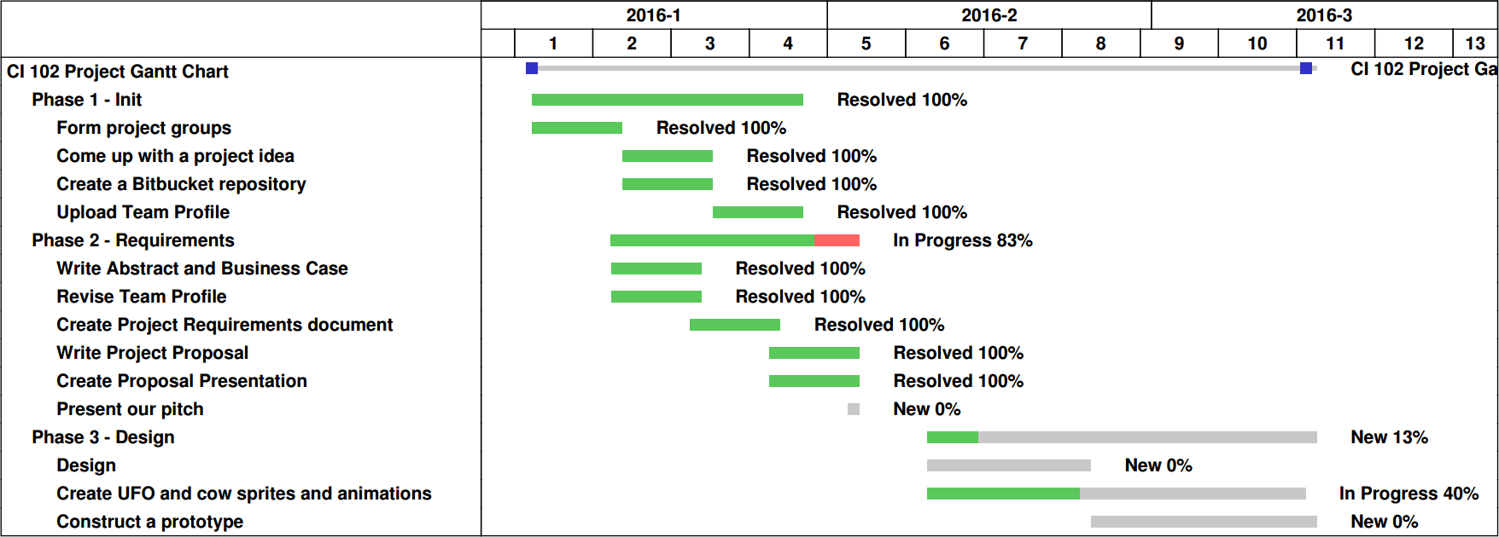

Figure 2 – Project Timeline

