Narrative Curriculum Vitae

DRAGAN DOSTANIĆ

03/07/1990, Bosnian-Herzegovinian, Male, dragandos@yahoo.com G. Strpci bb, 78430, Prnjavor, Bosnia and Herzegovina, (+387) 66833606, Viber: +387 66 833 606

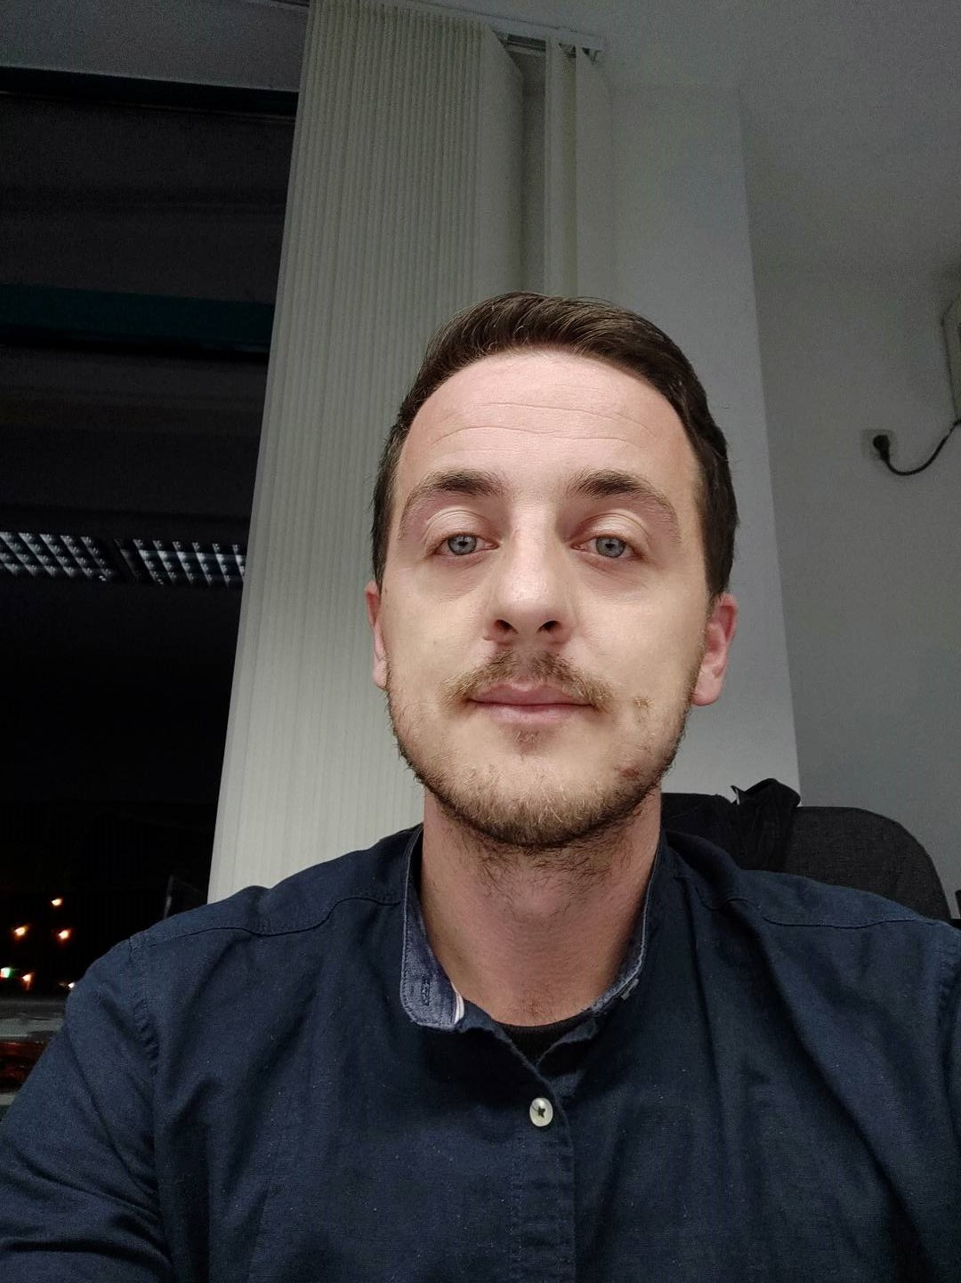

I was born in Prnjavor in 1990. I spent my childhood peacefully in my hometown. I finished primary and secondary school there. I have always been a good student and I have tried to learn a practical lesson from every situation and problem that arises. This enabled me to easily learn and handle complicated business tasks.

I listened to my instinct and immediately after high school I started working. I gathered my first work experiences in local sales shops, where I always tried to work honestly and responsibly.

The first big opportunity opened up in a competition for a cruise worker. I applied for the program and that was the beginning of the period of my life in which I acquired the most knowledge and skills.

I did the first two contracts for Marella Cruises. During the first contract, I was performing routine duties in cleaning and servicing of 30 guest rooms, 18 balconies twice a day, monitoring the work of my assistant who was assigned for bathrooms, cleaning lockers, pantries and ice stations according to PH standards,
handeling guest mini bar and room service items, proper handeling of working equipmant and reporting of any malfunctining in my section, taking care of public surfaces, together with my assistant.

During the second contract with Marella Cruises, my jobs were as follows:
Cleaning i maintaining of 30 guest bathrooms and balconies twice a day, assisting to cabin steward with cleaning of cabins, delivering towels and linen to my section,
daily vacuming of guest cabins and corridors, and cleaning HK. lockers, pantries and ice stations together wit cabin steward.
These contracts for Marella Cruises, in addition to opening up a whole new world of knowledge and skills to me, introduced me to a world I had never encountered before. I got acquainted with other cultures, civilizations, people, customs and all the other little things that make life bearable in other parts of the world.

Knowing and adapting to the vast world of diversity has taught me to constantly look for ways to improve as a human being. So I came to a better and more advanced contract where I worked for Royal Caribbean Cruises LTD (Celebrity Cruises).
I have worked on dozens of different jobs for this company. I have learned to communicate in business with both ordinary staff and people whose jobs carry more responsibility for passengers and crew. I will list just a few of the jobs here:
Reporting to my workstation assignment on time and properly groomed and dressed according to standards, during embarkation, greeting the guests of my assigned sections and introducing myself, explaining stateroom amenities and lay out including mini bar, interactive system and all available services onboard ship, describing my
function including duty hours and other available room services, sometimes assigned to the gangway to greet guests, if needed.
I was also providing personalized assistance to guests by following Celebrity’s standards of service and style, maintaining current knowledge of the ship’s regular events and special functions by reviewing all available data, including the daily
newsletter, in order to provide guests with accurate information to answer questions, following all daily, weekly and monthly stateroom, balcony and corridor cleaning procedures to ensure standards are met.
I was responsible to make beds according to the Save the Waves program, cleaning bathrooms and replenishing bathroom supplies and towels, inspecting work areas with entry-level staff to ensure USPH guidelines are met, provided guidance, instruction and demonstrated cleaning techniques to entry-level staff to meet requirements, and many other jobs that benefit companies and clients.

After all, the thing I am most proud of through my experience on cruises is not that I have learned to do dozens of jobs, improved my English, and met millions of people from all over the world. On the ship, I met my wife, a person who also changed my views of the world and life. I returned home with her, where I now live and work, and I am lucky and privileged to be the father of a wonderful little boy. So, it is a proof that business experience can change a person even existentially. Were it not for these contracts on cruise ships, and my courage to take on various difficult jobs, my life today would not look as good as it seems. Through effort and work I received the greatest reward for myself and my life.

Since there is no end to my interests and desire to improve, upon returning home, I became involved both professionally and in the public sphere. First a few sentences about my current professional orientation.

If I can’t physically continue to travel the world as I could when I was working on a cruise ship, through a new job I can connect with it in some way. That was my thinking when I accepted the job of dispatcher. I am currently a dispatcher for three different foreign companies: Balkan Express LLC, Leading Logistics INC, Leadway Logistics INC. This gives me the opportunity to work from home via laptop and cover the following activities: Develop delivery routes and maintain contact with drivers throughout the day, collaborate with management to modify daily routes to accommodate the needs of customers, act as a communication liaison through the two-way truck radio system and answer incoming phone calls from
drivers on the road, cultivate strong relationships with drivers and customers to reduce the stress that comes with last minute schedule changes, monitor any sudden route changes or road construction issues and work with drivers to establish new routes
for timely deliveries and tracking. This way I can do a flexible and interesting job, and be with my wife and son every day.

Now a few sentences about my public engagement. Having sailed around the world, I saw a lot of good things that function as a social reality, I decided to make my experience available to the community through activism. With a group of friends and enthusiasts from Prnjavor, I founded the non-governmental organization Res Publica. Through my organizational skills, this association managed to bring many intellectuals, cultural workers and activists to our small town in a very short time. Our activity consists in the organization of public cultural and educational events. We need to make people think and take an interest in their environment, and we believe that such events are the best way. I am very proud to be a member of this team.

Although I am very satisfied with the current situation, both privately and professionally, I believe that there is no end to training. and I am open to all agreements and engagements aimed at improving work, knowledge and noble skills.

