X SENTINEL Cross View Signals for Backdoor Suspicion in PE Malware Classifiers
Đặng Lý Quân • Trần Đặng Hữu Thắng • Lại Vĩnh Phú • Phạm Nguyễn Hoàng Phúc
FPT University, Ho Chi Minh City, Vietnam
danglyquan@gmail.com • callmewin06@gmail.com
vinhphu2020@gmail.com • tqtphamnguyenhoangphuc@gmail.com

Abstract
We investigate per-input backdoor suspicion in static PE malware classifiers using feature-view attribution and prediction signals. X-SENTINEL combines the maximum view share of absolute SHAP contributions with either a gated Behavioral SHAP signal or the positive probability gap between a clean Behavioral classifier and a suspicious main classifier. We evaluate frozen LightGBM models on EMBER2018 and the Win32, Win64 and .NET subset of EMBER2024. Each dataset has 27 poisoning configurations, and all configurations remain reported. Structural restricted edits and edits spanning three views are analyzed separately because neither has been verified as a realizable malware binary transformation. In the independently confirmed restricted cohort, full X-SENTINEL detects 42.94% of successful eligible attacks across 12 EMBER2018 runs and 59.75% across three EMBER2024 runs. On additional previously unused local source IDs, corresponding recall is 42.31% and 57.10%. An additional clean full-model shadow baseline detects substantially more attacks under richer access. Filtering the small number of failed PE parses changes some thresholds but does not establish dataset contamination as the cause of detection limitations. These results support a calibrated heuristic with explicit misses and resource assumptions; they do not establish universal backdoor detection or a future false-positive guarantee.
Keywords: PE malware classification; backdoor poisoning; LightGBM; SHAP; attribution views; inference-time suspicion; calibration.

1 Introduction
Static malware classifiers summarize executable files as feature vectors and predict whether an input is malicious. EMBER provides a public setting for studying Windows PE classification, while EMBER2024 expands feature extraction and evaluation coverage. BODMAS and SOREL-20M provide additional settings that emphasize scale and temporal evaluation. This study trains and evaluates only LightGBM models; these other datasets are background references and are not additional experiments. [1, 2, 3, 4, 6]
A poisoning attack changes training examples so that a model learns an unintended association. Backdoor attacks seek a target prediction when a trigger is present while retaining acceptable ordinary accuracy. Prior malware work demonstrates explanation-guided poisoning and selective triggering. Such results motivate inspection beyond the final malware label, but they do not guarantee that an arbitrary vector edit can be applied to an executable without changing its operation. [12, 13, 22]
We ask whether feature-view concentration and disagreement can help identify individual suspicious predictions from a possibly compromised classifier. The output is an alert alongside the malware probability. A low alert score is not evidence that a file is safe, and one alert does not prove that the deployed model contains a backdoor. The study concerns controlled poisoning artifacts rather than incident attribution on an unknown production model.
The contribution is an explicit implementation and paired evaluation of these signals under two resource settings, with locked benign calibration, complete attack records, component analysis and source-level uncertainty checks. We also report failures, compare an additional clean shadow baseline and examine the difference between vector edits and edits to a benign executable. The results constrain the claimed benefit rather than assuming that the proposed combination must win.

1 1 Research questions
RQ1: At separately calibrated thresholds, which successful attacks are detected by M3, M4 and their combination, and which are missed? RQ2: How do reduced and full resource settings compare on the same inputs and poisoned models, after separating restricted edits from edits spanning three views? RQ3: How stable are these observations under parse-flag sensitivity, previously unused local source IDs and a bounded adaptive optimizer? The former question about M5 is explicitly unanswered and moved to future work. Renumbering in this research manuscript does not assert that the course rubric has been changed.

2 Related work

2 1 Representations and evaluation of malware classifiers
Feature-based PE classification is one approach among several. EMBER and EMBER2024 publish extractor-based representations, while MalConv studies raw executable bytes and Saxe and Berlin study a learned representation from binary program features. DREBIN concerns Android and is cited only as an example of a different platform and feature regime. Results from these settings cannot be transferred directly to the PE view map used here. [1, 2, 5, 28, 29]
Gradient boosting and random forests provide historical context for tree classifiers. The current implementation uses LightGBM for the clean main, poisoned main and view models; it does not contain an SVM, neural malware classifier or random-forest experiment. SHAP and tree-specific attribution work support feature contribution analysis. LIME provides a related explanation approach but is not used in this detector. Explanations describe model behavior and do not establish executable semantics or causal compromise. [6, 7, 8, 9, 10, 11, 58]
Security evaluation can be distorted by data reuse, temporal mismatch and an inappropriate claim boundary. TESSERACT and work revisiting TRANSCEND motivate reporting time and partition roles, while guidance on machine learning in computer security motivates explicit evaluation assumptions. Our fixed-source comparisons do not isolate a causal effect of dataset age, extractor version or software family. [14, 15, 16]

2 2 Poisoning and evasion are different experiments
BadNets, neural trojan attacks, hidden triggers, label-consistent poisoning, Poison Frogs and Sleeper Agent cover different training-time threat models. Backdoor surveys organize this literature, but assumptions such as access to training data, clean reference data or network activations vary across methods. Image-classifier evaluation offers useful warnings about scenario dependence without constituting a PE comparison. [30, 31, 32, 33, 34, 35, 36, 56]
Adversarial input modification is distinct from poisoning a model. General robustness studies, black-box attacks and adaptive evaluation explain why an attacker should be allowed to react to a defense and why failure of one search is not proof of robustness. The relation between learned features and adversarial examples does not justify a semantic invariant for imported functions in a PE file. [17, 18, 19, 20, 21, 57]
Malware evasion work investigates API-sequence attacks, reinforcement learning, byte-level perturbations and functionality-preserving optimization. These methods reinforce the need to distinguish feature space from executable modification. We do not claim that replacing hash buckets corresponds to adding a valid import or that the present poisoning trigger preserves a malicious payload. [22, 23, 24, 25, 26, 27]

2 3 Defenses and calibration
STRIP studies perturbation-based prediction behavior. Spectral signatures, activation clustering and SPECTRE inspect representations; Neural Cleanse, Fine-Pruning and ABS analyze or modify models under their own assumptions. Anti-Backdoor Learning, attention distillation, decoupled training and Beatrix offer further defense strategies. These are literature comparisons, not baselines reimplemented for LightGBM here. Our STRIP adaptation perturbs numerical feature vectors and therefore differs from a physically valid PE transformation. [37, 38, 39, 40, 41, 42, 43, 44, 45, 46, 47]
Finite calibration and distribution-free risk literature motivate distinguishing empirical calibration behavior from a deployment guarantee. The threshold here is a specific empirical order statistic; the manuscript does not claim to implement conformal risk control. Bootstrap and correlated ROC analysis also motivate preserving shared input dependence. Wilson intervals describe individual proportions, while AUROC and precision–recall literature motivate naming the evaluated positive class precisely. [48, 49, 50, 51, 52, 53, 54, 55]

3 Method and resource assumptions

3 1 Attacker and defender access
The controlled attacker modifies selected benign fit vectors while keeping their label at zero. Poison counts are 1,000, 2,000 and 4,000, corresponding to 0.5%, 1% and 2% of the complete 200,000-vector fit pool, or 1%, 2% and 4% of its benign half. The main model architecture and training settings are fixed. The target is malware-to-benign prediction after adding the trigger. Success and stealth are measured screening conditions, not invariants promised for every input.
Table 1 Resources available during scoring
Setting | Main model | Benign reference and calibration | Additional clean models
Reduced | Suspicious LightGBM | 500 reference and 2,000 calibration | None
Full | Same suspicious model | Same source IDs | Three clean view models; M4 uses Behavioral
Shadow comparison | Same suspicious model | Same source IDs | Additional clean 500-round full model

The three view models were prepared from 200,000 clean labeled fit records, using 150 boosting rounds. Full therefore has substantially more information than a defender holding only a suspicious model and a few hundred benign samples. The shadow comparison is given a clean 500-round full model trained on that same fit pool. Reduced does not receive this model. Scoring primary detectors does not read final labels, poison IDs or the trigger manifest; the evaluator uses them to construct experiments.
Figure 1 Implemented score path and separate benign threshold selection
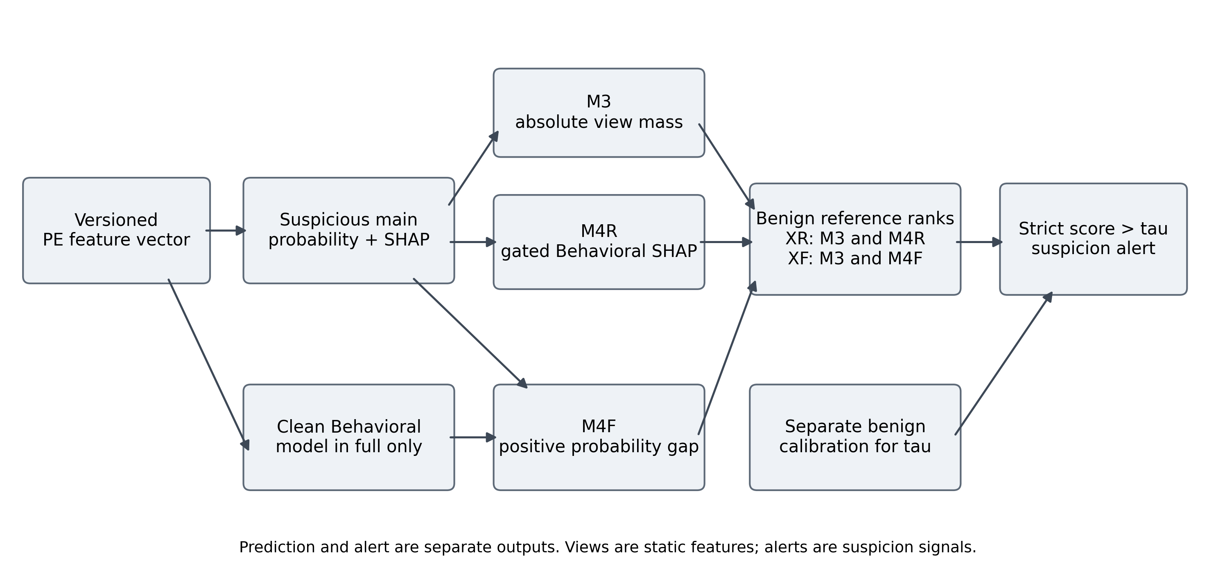
Figure 1 shows the primary core. STRIP is an independently scored comparator, and the main probability remains available separately from the alert. Reduced combines M3 and M4R; full combines M3 and M4F.

3 2 Versioned feature views
Table 2 Complete disjoint feature views
Dataset | Dim. | Structural | Behavioral | Metadata | Behavioral index interval
EMBER2018 | 2381 | 357 | 1408 | 616 | [943, 2351)
EMBER2024 | 2568 | 467 | 1411 | 690 | [994, 2405)

Behavioral denotes static import and export features. It is not a runtime trace, and it is not assumed immutable or monotone under all executable modifications. Metadata includes byte and string information. The versioned schema and model dimension are checked together; a V2 model cannot be evaluated as a V3 model. Table 2 replaces the incorrect V3 mapping in the source manuscript.

3 3 Components and fusion
Let p(x) be the main probability of malware and φj(x) its native LightGBM contribution to the raw margin, excluding the bias term. Let A be the total absolute contribution and Nv the signed contribution sum in view v. Contributions are interpreted as model evidence rather than verified program behavior. The epsilon is 10⁻⁹; the attribution ratios return zero when A is at most epsilon.
$$A = Σj |φj| Nv = Σj∈v φj$$
$$TADR = maxj |φj| / A$$
$$M3 = maxv (Σj∈v |φj| / A)$$
$$M4R = (1 - p(x)) max(NBehavioral, 0) / A$$
$$M4F = max(0, pBehavioral(xBehavioral) - p(x))$$
M3 measures concentration of absolute SHAP mass in a view. It is not the signed difference NBehavioral − NStructural. M4R is large when the main classifier favors benign while its Behavioral contribution is positive. M4F is a positive probability discrepancy. These are different signals, and changing to a polarity-contrast formula would require separate results. Full versus reduced changes both the information supplied and the M4 definition; the present comparison does not isolate these effects causally.
$$Rref(s) = \#\{r in benign reference : score(r) ≤ s\} / 500$$
$$XR = (Rref(M3) + Rref(M4R)) / 2$$
$$XF = (Rref(M3) + Rref(M4F)) / 2$$
Reference ranks use the right empirical CDF and ties are retained. Rank values and fusion values are not probabilities that an input contains a backdoor. Each component and combination has its own threshold for each poisoned model. TADR is the local maximum-feature absolute-attribution comparator; no universal 0.65 threshold is used.

3 4 STRIP and thresholds
For each input, STRIP draws 50 benign reference vectors with replacement and forms numerical blends with alpha 0.5. Binary entropy uses the prediction of each blend, and the score is one minus the mean entropy. The random sequence depends on the input content and seed so that batch order does not change the score. This is mean entropy, not entropy of the average probability. [37]
$$H(p) = -p log₂ p - (1 - p) log₂(1 - p)$$
$$STRIP(x) = 1 - (1/50) Σk H(p(0.5x + 0.5rk))$$
Sort the 2,000 benign calibration scores ascending and use the 1,980th score as tau for the 1% target. An input is flagged only if score > tau. This ensures at most 20 strict exceedances in that calibration sample and can yield fewer because of ties. It does not guarantee an unseen benign FPR of at most 1%. Thresholds and reference ranks are never selected from the final attack outcomes.

3 5 Decision policy and unanswered mechanism
The detector exposes malware probability and suspicion separately. For evaluation, flagged successful attacks are assumed to be stopped by a simulated triage policy. Post-defense ASR is therefore a policy statistic, not a measured recovery of the classifier or a real-world incident outcome. M5 is disabled in all primary bundles and has no primary ablation. Hashed feature buckets cannot establish the presence of a specific API; causal reconstruction remains future work.

4 Experimental protocol

4 1 Source and partition provenance
EMBER2024 vectors come from the joyce8/EMBER2024 dataset on Hugging Face, pinned to revision 3d23efef7c0f0b702c5024400cfff4c3744a3832. The six selected archives are Dot_Net_train.zip, Dot_Net_test.zip, Win32_train.zip, Win32_test.zip, Win64_train.zip and Win64_test.zip. Extraction code is from FutureComputing4AI/EMBER2024, pinned to commit 0ef753e81d98bf209f71b03cd331dfc190b5b54d. Dataset source and extractor source are separate provenance records. No APK, ELF or PDF archive is selected in this matrix. [2]
Table 3 EMBER2024 source composition and parse flags by role
Role | n | Win32 | Win64 | .NET | is_pe 0 | Benign malware
fit | 200,000 | 133,316 | 44,520 | 22,164 | 69 | 34/35
selection | 10,000 | 6,641 | 2,238 | 1,121 | 5 | 3/2
development | 10,000 | 6,653 | 2,237 | 1,110 | 7 | 3/4
confirmation | 10,000 | 6,656 | 2,233 | 1,111 | 4 | 2/2
reference | 500 | 331 | 126 | 43 | 0 | 0/0
calibration | 2,000 | 1,319 | 456 | 225 | 2 | 2/0
final | 20,000 | 13,313 | 4,470 | 2,217 | 3 | 3/0

Both datasets use fit 200,000; selection, development and confirmation 10,000 each; reference 500 benign; calibration 2,000 benign; and final 20,000 balanced records. Balanced roles have equal benign and malware counts. Source IDs are disjoint by role, and all final models within a dataset use the same source order. Source-format labels and parser success flags are different observations. EMBER2024 contains 90 is_pe=0 records across these roles, including two calibration records and three final benign records. Without their original bytes, a cause of parse failure is not established.

4 2 Models and attack screening
Table 4 Locked training and attack settings
Setting | Value
Main and clean full model | 500 rounds; 64 leaves; learning rate 0.05
Clean view models | 150 rounds; same clean fit source IDs
Sampling | feature_fraction 0.9; bagging_fraction 0.9
Model seeds | 17, 29, 43
Poison rates of all fit | 0.5%, 1%, 2%
Inference | 4 CPU threads; malware cutoff 0.5
Concentrated restricted | 2 Structural columns
Spread restricted | 10 Structural columns
Cross view stress | 8 Structural + 8 Behavioral + 8 Metadata columns
Structural permitted pool | 13 columns per schema; vector feasibility only

Two selector candidates were evaluated during development, and legacy_rare was locked for the final matrix. Strong-and-stealth screening requires at least 1,000 eligible malware, eligible ASR at least 50%, paired gain at least 20 percentage points and strict clean-accuracy loss below 0.5 percentage points. Development and separate confirmation must both pass for a configuration to enter the confirmed cohort. These rules select viable attack conditions; they do not prove that the detector works. All 27 final configurations per dataset remain available regardless of confirmation status.
The restricted cohort contains concentrated and spread Structural vector edits. Cross edits alter all three views and are placed in a separate stress analysis. Whitelisted numerical edits have not been verified as transformations of malicious executables. The term clean-label describes retained training labels within the vector experiment; it does not certify the validity of edited bytes.

4 3 Evaluation groups and denominators
Table 5 Attack evaluation groups
Group | Membership or denominator
All triggered malware | All 10,000 final malware after applying the fixed trigger
Eligible malware | Clean full model predicts malware on the original input
Successful eligible | Eligible and poisoned main predicts benign on the triggered input
Paired new evasion | Successful eligible and clean full model still predicts malware after the same trigger
Benign FPR | Flagged original final benign / 10,000 benign
ASR before defense | Successful eligible / eligible
Recall | Flagged successful eligible / successful eligible
Post defense ASR | Unflagged successful eligible / eligible

AUROC is reported separately for all triggered malware, successful eligible attacks and paired new evasions against the same benign negative set. These are different positive classes. A successful eligible input can still reflect direct evasion if the trigger also fools the clean model. The stricter paired group helps examine this possibility. Means are calculated over runs, giving equal weight to each run. Mean post-defense ASR is not obtained by multiplying mean ASR by one minus mean recall.

4 4 Supplementary validation and bounded adaptive evaluation
After review, we selected a fresh local validation pool of 1,000 benign and 1,000 malware for each dataset. Selection uses source metadata and deterministic rules before predictions, excluding all known primary roles, local pilot IDs and attack-development partition IDs. EMBER2018 uses unused official test records; EMBER2024 uses unused labeled test records located through the source audit and the pinned raw archives. One new EMBER2024 record retains is_pe=0. External handover observation history is unavailable, so independence is stated relative to known local use. Frozen triggers, models, cohorts and thresholds are reused without outcome-based reselection.
New shadow and inverse-STRIP variants were proposed after observing the old final pool, so their old-final results are exploratory. The shadow score is max(0, pclean − pmain), with a threshold from the original benign calibration. Inverse STRIP uses the original mean entropy H and its own benign-calibrated threshold; it is not the same detector with a changed name. We validate both on the unused local pool without retuning alpha, K, fusion weights or thresholds.
The bounded adaptive study uses the first 100 fresh malware source IDs per originally confirmed restricted run, selected without conditioning on outcomes. The attacker sees probability and reduced fusion score and knows the formula. The goal is pmain < 0.5 and XR ≤ its old tau. The original trigger coordinates remain fixed; proposals change remaining permitted Structural coordinates using values observed in benign selection data. Each input has at most 32 sequential queries, including the initial query. This is a fixed coordinate search in vector space, not a physically verified PE attack or an exhaustive robustness assessment. Preliminary runs that accidentally admitted V2 Metadata whitelist entries were withdrawn and excluded from the reported Structural-only experiment.

5 Results

5 1 Which attack configurations support the principal comparison
Table 6 Confirmation status by attack family
Dataset | Concentrated confirmed | Spread confirmed | Cross confirmed | All confirmed
EMBER2018 | 3 / 9 | 9 / 9 | 0 / 9 | 12 / 27
EMBER2024 | 0 / 9 | 3 / 9 | 9 / 9 | 12 / 27

The two confirmed groups have different composition. The restricted EMBER2024 group is only three spread runs, all at 2% poisoning. Comparing its mean with 12 restricted EMBER2018 runs cannot isolate a dataset effect. Cross stress accounts for nine of the 12 confirmed EMBER2024 runs and is therefore separated from the restricted headline. Table 6 includes the unsuccessful confirmation conditions rather than treating the number 12 as universal coverage.
Table 7 Restricted confirmed cohort at original thresholds
Dataset | Method | Runs | Recall % | FPR % | Post ASR % | AUC success
2018 | TADR | 12 | 37.15 | 1.92 | 43.07 | 0.884
2018 | STRIP | 12 | 0.00 | 0.61 | 69.04 | 0.112
2018 | M3 | 12 | 14.54 | 0.76 | 55.98 | 0.870
2018 | M4-R | 12 | 7.47 | 0.91 | 63.59 | 0.822
2018 | M4-F | 12 | 38.89 | 1.03 | 40.78 | 0.890
2018 | X-R | 12 | 35.75 | 0.52 | 39.92 | 0.895
2018 | X-F | 12 | 42.94 | 0.78 | 35.22 | 0.929
2024 | TADR | 3 | 0.00 | 0.65 | 56.88 | 0.238
2024 | STRIP | 3 | 0.00 | 0.75 | 56.88 | 0.133
2024 | M3 | 3 | 60.64 | 1.05 | 22.22 | 0.947
2024 | M4-R | 3 | 5.82 | 0.88 | 53.58 | 0.834
2024 | M4-F | 3 | 49.79 | 1.07 | 28.62 | 0.883
2024 | X-R | 3 | 48.33 | 0.78 | 29.38 | 0.954
2024 | X-F | 3 | 59.75 | 0.83 | 22.78 | 0.935

Table 7 reports operating-point performance and successful-eligible AUROC on the same positive class. On EMBER2018, combining M3 and reduced M4 improves mean recall over M3 alone. On EMBER2024, a combination can rank differently from a component at the calibrated operating point, and full resources do not imply reliable coverage. Different final FPR values also prevent a blanket conclusion of superiority at matched deployment cost.
Figure 2 Component and fusion recall for EMBER2018 restricted confirmed runs
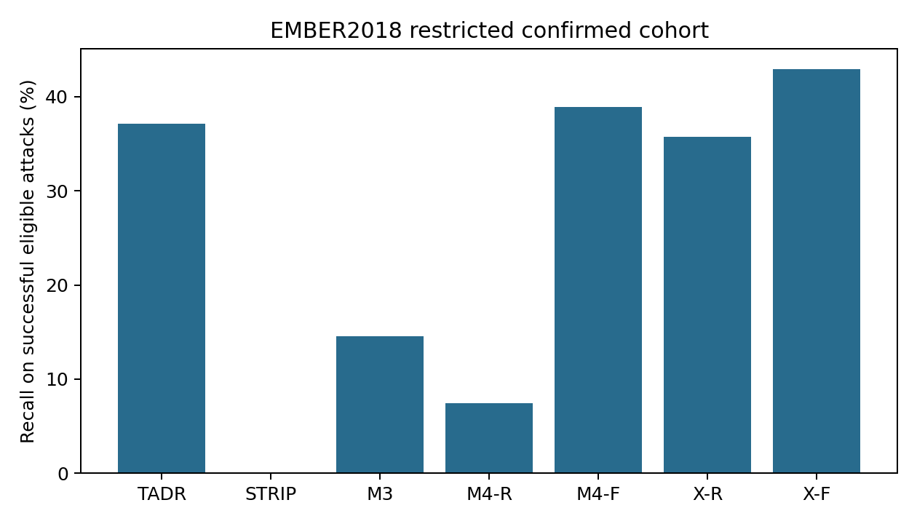
Figure 3 Component and fusion recall for EMBER2024 restricted confirmed runs
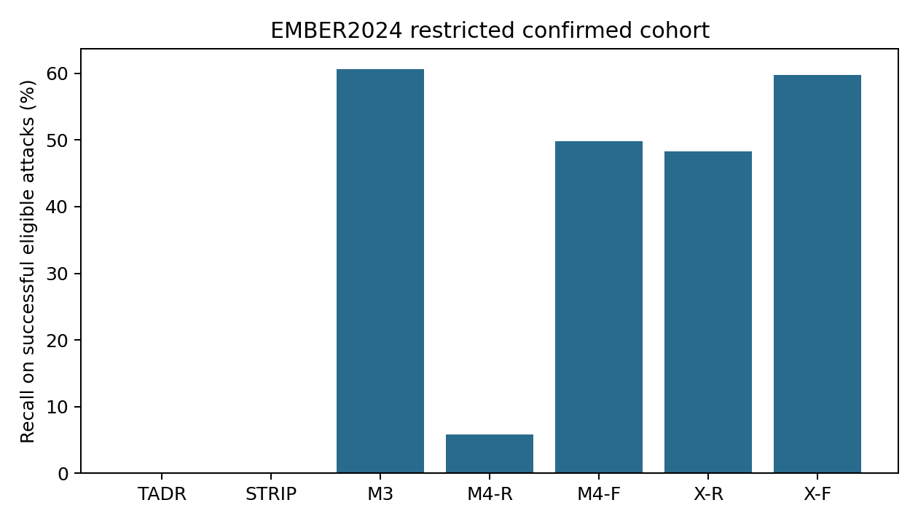

5 2 Cross view stress and complete configuration coverage
Table 8 EMBER2024 confirmed cross stress with its own scope
Method | Runs | Recall % | FPR % | ASR before % | Post ASR %
TADR | 9 | 0.00 | 0.75 | 99.51 | 99.51
M3 | 9 | 1.84 | 1.11 | 99.51 | 97.69
M4-R | 9 | 0.09 | 0.70 | 99.51 | 99.43
M4-F | 9 | 12.31 | 1.02 | 99.51 | 87.24
X-R | 9 | 0.00 | 0.75 | 99.51 | 99.51
X-F | 9 | 5.56 | 0.93 | 99.51 | 94.00

There is no confirmed EMBER2018 cross cohort. Results for weak cross configurations still appear in the full configuration appendix. Spreading numerical changes across views is a stress condition for view concentration, but these measurements do not prove that an attacker can realize the original 24-column trigger in a functioning PE binary. TADR can detect some dispersed-trigger cases; the previous exactly-zero general claim is removed.

5 3 Paired differences and complementary detections
Table 9 Source ID clustered recall contrasts on fixed models
Dataset | First | Second | Runs | Difference pp | 95% interval pp
2018 | M3 | X-R | 12 | 21.21 | 20.59 to 21.79
2018 | X-R | X-F | 12 | 7.19 | 6.60 to 7.76
2018 | M4-F | X-F | 12 | 4.05 | 3.25 to 4.93
2024 | M3 | X-R | 3 | -12.31 | -13.67 to -11.00
2024 | X-R | X-F | 3 | 11.42 | 10.05 to 12.78
2024 | M4-F | X-F | 3 | 9.96 | 8.75 to 11.13

The 1,000 bootstrap draws resample each source ID once and retain that ID across runs, so repeated inputs are not treated as independent observations. Table 9 is conditional on the observed models and chosen cohorts; it does not provide uncertainty over future seeds or attack selectors. The small EMBER2024 restricted cohort supports a descriptive conclusion for these three models, not a general factorial claim.
Table 10 TADR and M4F flags on successful eligible restricted attacks
Dataset | Runs | Occurrences | Both | TADR only | M4F only | Neither
2018 | 12 | 79941 | 11966 | 18099 | 20760 | 29116
2024 | 3 | 16483 | 0 | 0 | 8191 | 8292

Counts in Table 10 are source/model occurrences because the same malware source can appear in multiple runs. They show which inputs each comparator misses or catches; they are not unique independent samples. Per-run catch/miss and rank correlations remain in the machine-readable artifact so that illustrative examples are not substituted for complete evidence.

5 4 Parse flag sensitivity and calibration
Table 11 Largest observed changes across 27 EMBER2024 runs after filtering parse flags
Method | Runs | Abs tau change | Recall change pp | FPR change pp
M3 | 27 | 0.002 | 1.47 | 0.20
M4-F | 27 | 0.019 | 2.93 | 0.11
M4-R | 27 | 0.002 | 1.12 | 0.19
STRIP | 27 | 0.001 | 0.00 | 0.10
TADR | 27 | 0.001 | 1.14 | 0.14
X-F | 27 | 0.003 | 0.50 | 0.31
X-R | 27 | 0.006 | 3.12 | 0.12

Filtering the three final benign parse failures and filtering the two calibration parse failures are evaluated separately and jointly while holding the model, trigger and reference fixed. Table 11 reports the maximum absolute joint change across all runs rather than claiming that two records are necessarily harmless. The experiment does not retrain the fit pool and does not identify parse failures as the cause of limited recall. No non-PE archive contamination is observed in the selected source provenance.
The two original calibration records have all-zero Behavioral input but nonzero Behavioral SHAP under an audited model: signed totals are approximately 0.3460 and 0.7536. This directly refutes the implication that zero input must yield zero attribution. All 90 original parse-failure records have zero feature tails from index 696 onward. Their missing information is a data-quality observation that requires contextual analysis, not a proof of a particular performance mechanism.
Calibration scores were recomputed for every model and all old thresholds reproduced within 10⁻¹⁰. For a continuous IID order-statistic diagnostic, the exceedance probability has Beta(21,1980) uncertainty before considering the final benign count. Beta-binomial upper tails and calibration exceedance counts are provided per run. Discrete scores, ECDF ties, dependence across runs and possible train/test differences limit this diagnostic; a high observed FPR is not by itself causal proof of distribution shift.

5 5 STRIP score direction and additional clean model comparison
Figure 4 Original benign and triggered mean entropy for EMBER2018
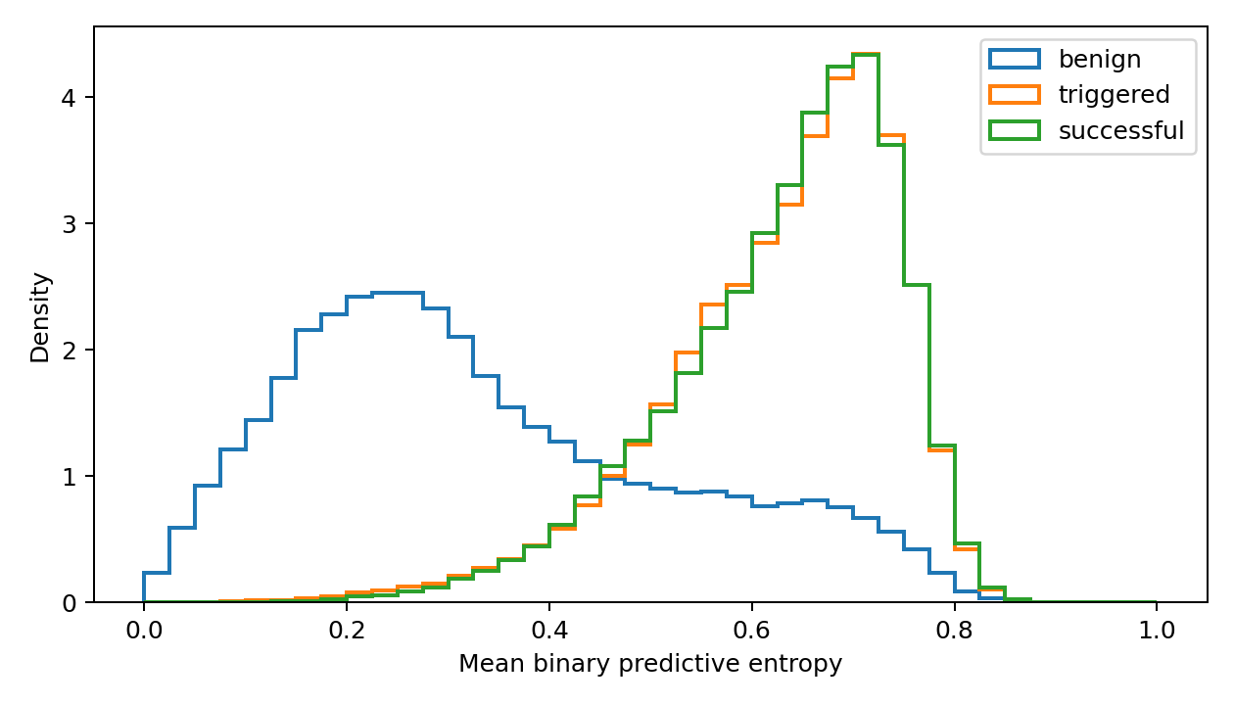
Figure 5 Original benign and triggered mean entropy for EMBER2024
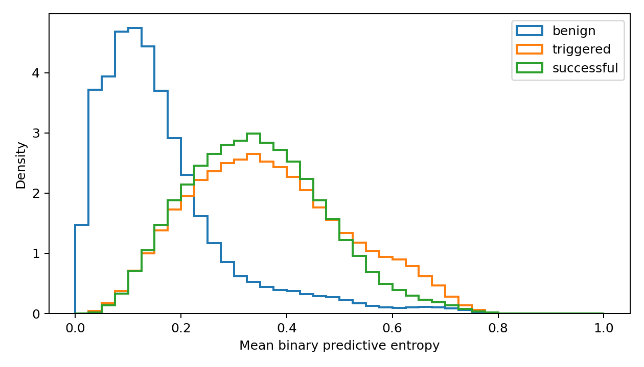
The entropy plots distinguish the observed score direction from an explanation invented after the fact. In the old confirmed cohorts, mean triggered entropy is higher than benign entropy, so low AUROC under score 1−H is not explained by both groups having identically maximal entropy. Inverse STRIP changes the ranking direction, but AUROC improvement alone does not show high recall at its own benign-calibrated threshold.
Table 12 New baselines on restricted cohorts with thresholds from original benign calibration
Dataset | Method | Runs | Old recall % | Old FPR % | Fresh recall % | Fresh FPR %
2018 | shadow | 12 | 99.99 | 1.54 | 100.00 | 1.74
2018 | strip inverse | 12 | 7.92 | 1.48 | 7.93 | 1.60
2024 | shadow | 3 | 99.98 | 0.82 | 99.80 | 0.80
2024 | strip inverse | 3 | 4.09 | 0.52 | 3.12 | 0.93

The clean shadow comparator is strong under explicitly richer access. Table 12 does not assign its capability to reduced. A clean full model at 500 rounds also has a different model budget from the 150-round Behavioral classifier; the contrast does not isolate an architectural cause. Where the shadow comparator wins, the contribution must be framed as a study of attribution signals under access restrictions, rather than a claim that adding view models produces the best defense.

5 6 Previously unused source validation and bounded adaptation
Table 13 Fresh local source IDs under frozen original attack selection
Dataset | Method | Runs | ASR before % | Recall % | FPR % | Post ASR %
2018 | TADR | 12 | 70.55 | 36.83 | 2.08 | 44.38
2018 | M3 | 12 | 70.55 | 14.35 | 0.89 | 57.63
2018 | M4-R | 12 | 70.55 | 6.38 | 1.21 | 65.76
2018 | M4-F | 12 | 70.55 | 40.11 | 0.87 | 40.91
2018 | X-R | 12 | 70.55 | 35.05 | 0.69 | 41.70
2018 | X-F | 12 | 70.55 | 42.31 | 1.21 | 36.90
2024 | TADR | 3 | 53.79 | 0.00 | 0.67 | 53.79
2024 | M3 | 3 | 53.79 | 59.81 | 0.80 | 21.50
2024 | M4-R | 3 | 53.79 | 7.27 | 1.00 | 49.88
2024 | M4-F | 3 | 53.79 | 48.28 | 1.23 | 27.86
2024 | X-R | 3 | 53.79 | 48.69 | 0.40 | 27.58
2024 | X-F | 3 | 53.79 | 57.10 | 0.90 | 22.98

The fresh pool has 1,000 benign and 1,000 malware per dataset, so FPR resolution per run is 0.1 percentage points. Successful-eligible sample counts vary by model and are saved explicitly. The original cohort membership is retained instead of selecting new favorable attacks from this pool. Table 13 is supplementary validation on new local source IDs, not a new independent training replication.
Table 14 Bounded Structural vector optimizer on fresh malware
Dataset | Runs | Eligible occurrences | Initial joint | Final joint | New joint | Max queries
2018 | 12 | 1164 | 464 | 493 | 29 | 32
2024 | 3 | 285 | 77 | 77 | 0 | 32

Joint success requires both a benign main prediction and no reduced alert. Table 14 separates already-unflagged attacks from newly achieved joint successes within the same eligible set. Occurrence counts repeat source IDs across models; they must not be read as independent attacks. The optimizer retains original trigger coordinates and stays within the 13 Structural columns. Limited new success would constrain this search only; it would not establish resilience to import padding, new poisoning selectors or stronger adaptive search.

5 7 Cost of the classifier and detector
Table 15 Mean of run level warm per input timing summaries in milliseconds
Dataset | Scope | Runs | Mean ms | Median ms | P95 ms
2018 | classifier | 27 | 0.268 | 0.269 | 0.407
2018 | core reduced | 27 | 30.631 | 30.727 | 34.115
2018 | core full | 27 | 32.165 | 32.331 | 35.840
2018 | STRIP | 27 | 2.218 | 2.176 | 2.669
2018 | suite reduced | 27 | 34.544 | 34.695 | 38.254
2018 | suite full | 27 | 35.003 | 35.113 | 38.925
2024 | classifier | 27 | 0.224 | 0.228 | 0.343
2024 | core reduced | 27 | 20.904 | 20.982 | 22.372
2024 | core full | 27 | 22.188 | 22.252 | 23.756
2024 | STRIP | 27 | 1.751 | 1.724 | 2.056
2024 | suite reduced | 27 | 24.104 | 24.181 | 25.771
2024 | suite full | 27 | 24.475 | 24.535 | 26.192

Timing uses an AMD Ryzen 7 8745H processor with 8 physical cores, 16 logical processors and approximately 15.31 GiB of reported physical memory, under Windows and four inference threads. The same 100 inputs are used within each model, after warm-up, with alternating reversed evaluation order. The component shortcut is checked against the original detector scores. Classifier, reduced core, full core, STRIP and complete suites are timed separately. The averages of per-run medians and p95 values in Table 15 are not pooled distribution percentiles. Extraction, model loading, API transport and database writes are excluded; ordinary system background load is not controlled. A 10 ms core target is assessed against its defined scope; no sub-millisecond end-to-end claim is made.

5 8 Benign executable validation
Table 16 Feature changes after byte edits to one self built benign executable
Edit | Ver. | Cases | Changed | Structural | Behavioral | Metadata | Outside pool
coff timestamp 0 | V2 | 4 / 4 | 10 | 1 | 0 | 9 | 9
coff timestamp 0 | V3 | 4 / 4 | 11 | 1 | 0 | 10 | 10
coff timestamp 2024 | V2 | 4 / 4 | 15 | 1 | 0 | 14 | 14
coff timestamp 2024 | V3 | 4 / 4 | 16 | 1 | 0 | 15 | 15
benign overlay | V2 | 4 / 4 | 236 | 1 | 0 | 235 | 235
benign overlay | V3 | 4 / 4 | 242 | 6 | 0 | 236 | 241

We compiled one reviewed unsigned .NET program that prints n²+7, without file or network operations. Copies received two COFF timestamp substitutions and a benign overlay. Each copy preserved exit code, stdout and stderr on four inputs, including an invalid input. Only these self-built benign fixtures were executed. The V3 reader uses checksum-pinned upstream parsing and its binary/raw vector parity is checked. The V2 modern-LIEF reader remains experimental because identical-binary parity with legacy LIEF 0.9 has not been established.
Even timestamp edits change byte and string-derived features outside the intended Structural coordinate, as shown in Table 16. Preserved outputs on four benign cases demonstrate a small prototype, not preservation of every behavior. This experiment does not realize the original vector triggers, validate any malicious payload or demonstrate a successful binary backdoor. It gives a concrete reason to keep these evidence levels separate.

6 Discussion and limitations
The original arithmetic can be internally consistent while the narrative is wrong. The revised method now states the formulas that actually produced the stored results. Absolute view mass is a concentration heuristic, and probability discrepancy is an additional signal under clean-model access. Neither supplies a proof of semantic inconsistency or universal backdoor presence. The failure cases and the strong shadow comparison reduce the scope of an appropriate contribution.
An apparent dataset difference is confounded by view schemas, source periods, attack viability and confirmed-family composition. EMBER2024 has only three confirmed restricted runs at one rate. Source and parse-flag audits remove a particular ambiguity in the report; they do not rule out every data or representation issue. Filtering calibration/test flags without retraining is a sensitivity experiment, not a repaired full training protocol.
Ablations show that fusion can change operating-point coverage, but a few seeds and fixed thresholds do not prove stable performance over future models. Equal reference-rank fusion is retained because it is the locked method; no weights are optimized using final outcomes. Richer baselines must be reported with their information and model budgets. The bounded adaptive optimizer covers only one declared numerical attack family and is not a complete adversarial evaluation.
References and bibliography identities have been checked against registered or primary metadata. That verification is not a claim that every cited paper has been independently replicated. Claims are limited to the particular concepts for which sources are cited. Raw malware functionality, operational alert handling, rare/packed benign cohorts, M5 effectiveness and deployment security remain outside the measured research evidence.

7 Reproducibility and conclusion
The research artifact retains all original models, triggers, thresholds and result files. Revision outputs have a separate dated namespace with code hashes, source IDs, per-input scores, calibration caches, diagnostics and new validation protocols. A reproduction package distinguishes recreating tables from saved scores from retraining models on raw data. No public repository release, DOI or external submission is implied by this local package.
The software includes a Vietnamese Streamlit demonstration, a vector API adapter and stored analysis history. Read-only V2/V3 PE uploads up to 50 MiB are connected and tested on reviewed benign fixtures. Current automated checks pass 66 tests. A PostgreSQL backup was restored into a separate test database, and interface checks passed on Windows and Linux Docker on the current physical computer. Appendix B records this deployment evidence and its timing boundaries. Authentication, deployment on a second physical computer and end-to-end scanning efficacy remain unverified; runtime integration does not establish original-dataset binary parity or a realizable malware attack.
X-SENTINEL provides measurable per-input suspicion signals with substantial misses and explicit access requirements. On the evaluated frozen models, combining attribution and view-related evidence helps in some settings but does not establish a generally strongest defense. Additional clean-model access can support a stronger simple comparator. The next research steps are independently specified binary transformations, broader adaptive tests, resource-controlled clean-model comparisons and prospective calibration checks. M5 remains an unanswered extension.

References
[1] Hyrum S. Anderson, Phil Roth, “EMBER: An Open Dataset for Training Static PE Malware Machine Learning Models,” arXiv, 2018. https://arxiv.org/abs/1804.04637v2
[2] Robert J. Joyce, Gideon Miller, Phil Roth, Richard Zak, Elliott Zaresky-Williams, Hyrum Anderson, Edward Raff, James Holt, “EMBER2024 - A Benchmark Dataset for Holistic Evaluation of Malware Classifiers,” Proceedings of the 31st ACM SIGKDD Conference on Knowledge Discovery and Data Mining V.2, 2025. https://doi.org/10.1145/3711896.3737431
[3] Limin Yang, Arridhana Ciptadi, Ihar Laziuk, Ali Ahmadzadeh, Gang Wang, “BODMAS: An Open Dataset for Learning based Temporal Analysis of PE Malware,” 2021 IEEE Security and Privacy Workshops (SPW), 2021. https://doi.org/10.1109/spw53761.2021.00020
[4] Richard Harang, Ethan M. Rudd, “SOREL-20M: A Large Scale Benchmark Dataset for Malicious PE Detection,” arXiv, 2020. https://arxiv.org/abs/2012.07634v1
[5] Daniel Arp, Michael Spreitzenbarth, Malte Hübner, Hugo Gascon, Konrad Rieck, “Drebin: Effective and Explainable Detection of Android Malware in Your Pocket,” Proceedings 2014 Network and Distributed System Security Symposium, 2014. https://doi.org/10.14722/ndss.2014.23247
[6] Guolin Ke, Qi Meng, Thomas Finley, Taifeng Wang, Wei Chen, Weidong Ma, Qiwei Ye, Tie-Yan Liu, “LightGBM: A Highly Efficient Gradient Boosting Decision Tree,” Advances in Neural Information Processing Systems 30, 2017. https://proceedings.neurips.cc/paper_files/paper/2017/hash/6449f44a102fde848669bdd9eb6b76fa-Abstract.html
[7] Scott Lundberg, Su-In Lee, “A Unified Approach to Interpreting Model Predictions,” arXiv, 2017. https://arxiv.org/abs/1705.07874v2
[8] Scott M. Lundberg, Gabriel G. Erion, Su-In Lee, “Consistent Individualized Feature Attribution for Tree Ensembles,” arXiv, 2018. https://arxiv.org/abs/1802.03888v3
[9] Scott M. Lundberg, Gabriel Erion, Hugh Chen, Alex DeGrave, Jordan M. Prutkin, Bala Nair, Ronit Katz, Jonathan Himmelfarb, Nisha Bansal, Su-In Lee, “From local explanations to global understanding with explainable AI for trees,” Nature Machine Intelligence, 2020. https://doi.org/10.1038/s42256-019-0138-9
[10] Jerome H. Friedman, “Greedy function approximation: A gradient boosting machine.,” The Annals of Statistics, 2001. https://doi.org/10.1214/aos/1013203451
[11] Marco Ribeiro, Sameer Singh, Carlos Guestrin, ““Why Should I Trust You?”: Explaining the Predictions of Any Classifier,” Proceedings of the 2016 Conference of the North American Chapter of the Association for Computational Linguistics: Demonstrations, 2016. https://doi.org/10.18653/v1/n16-3020
[12] Giorgio Severi, Jim Meyer, Scott Coull, Alina Oprea, “Explanation-Guided Backdoor Poisoning Attacks Against Malware Classifiers,” arXiv, 2020. https://arxiv.org/abs/2003.01031v3
[13] Limin Yang, Zhi Chen, Jacopo Cortellazzi, Feargus Pendlebury, Kevin Tu, Fabio Pierazzi, Lorenzo Cavallaro, Gang Wang, “Jigsaw Puzzle: Selective Backdoor Attack to Subvert Malware Classifiers,” 2023 IEEE Symposium on Security and Privacy (SP), 2023. https://doi.org/10.1109/sp46215.2023.10179347
[14] Daniel Arp, Erwin Quiring, Feargus Pendlebury, Alexander Warnecke, Fabio Pierazzi, Christian Wressnegger, Lorenzo Cavallaro, Konrad Rieck, “Dos and Don'ts of Machine Learning in Computer Security,” arXiv, 2020. https://arxiv.org/abs/2010.09470v2
[15] Feargus Pendlebury, Fabio Pierazzi, Roberto Jordaney, Johannes Kinder, Lorenzo Cavallaro, “TESSERACT: Eliminating Experimental Bias in Malware Classification across Space and Time,” arXiv, 2018. https://arxiv.org/abs/1807.07838v4
[16] Federico Barbero, Feargus Pendlebury, Fabio Pierazzi, Lorenzo Cavallaro, “Transcending TRANSCEND: Revisiting Malware Classification in the Presence of Concept Drift,” 2022 IEEE Symposium on Security and Privacy (SP), 2022. https://doi.org/10.1109/sp46214.2022.9833659
[17] Ian J. Goodfellow, Jonathon Shlens, Christian Szegedy, “Explaining and Harnessing Adversarial Examples,” arXiv, 2014. https://arxiv.org/abs/1412.6572v3
[18] Nicholas Carlini, David Wagner, “Towards Evaluating the Robustness of Neural Networks,” 2017 IEEE Symposium on Security and Privacy (SP), 2017. https://doi.org/10.1109/sp.2017.49
[19] Florian Tramer, Nicholas Carlini, Wieland Brendel, Aleksander Madry, “On Adaptive Attacks to Adversarial Example Defenses,” arXiv, 2020. https://arxiv.org/abs/2002.08347v2
[20] Anish Athalye, Nicholas Carlini, David Wagner, “Obfuscated Gradients Give a False Sense of Security: Circumventing Defenses to Adversarial Examples,” arXiv, 2018. https://arxiv.org/abs/1802.00420v4
[21] Nicolas Papernot, Patrick McDaniel, Ian Goodfellow, Somesh Jha, Z. Berkay Celik, Ananthram Swami, “Practical Black-Box Attacks against Machine Learning,” Proceedings of the 2017 ACM on Asia Conference on Computer and Communications Security, 2017. https://doi.org/10.1145/3052973.3053009
[22] Fabio Pierazzi, Feargus Pendlebury, Jacopo Cortellazzi, Lorenzo Cavallaro, “Intriguing Properties of Adversarial ML Attacks in the Problem Space,” 2020 IEEE Symposium on Security and Privacy (SP), 2020. https://doi.org/10.1109/sp40000.2020.00073
[23] Weiwei Hu, Ying Tan, “Black-Box Attacks against RNN based Malware Detection Algorithms,” arXiv, 2017. https://arxiv.org/abs/1705.08131v1
[24] Hyrum S. Anderson, Anant Kharkar, Bobby Filar, David Evans, Phil Roth, “Learning to Evade Static PE Machine Learning Malware Models via Reinforcement Learning,” arXiv, 2018. https://arxiv.org/abs/1801.08917v2
[25] Bojan Kolosnjaji, Ambra Demontis, Battista Biggio, Davide Maiorca, Giorgio Giacinto, Claudia Eckert, Fabio Roli, “Adversarial Malware Binaries: Evading Deep Learning for Malware Detection in Executables,” 2018 26th European Signal Processing Conference (EUSIPCO), 2018. https://doi.org/10.23919/eusipco.2018.8553214
[26] Luca Demetrio, Battista Biggio, Giovanni Lagorio, Fabio Roli, Alessandro Armando, “Explaining Vulnerabilities of Deep Learning to Adversarial Malware Binaries,” arXiv, 2019. https://arxiv.org/abs/1901.03583v2
[27] Luca Demetrio, Battista Biggio, Giovanni Lagorio, Fabio Roli, Alessandro Armando, “Functionality-Preserving Black-Box Optimization of Adversarial Windows Malware,” IEEE Transactions on Information Forensics and Security, 2021. https://doi.org/10.1109/tifs.2021.3082330
[28] Edward Raff, Jon Barker, Jared Sylvester, Robert Brandon, Bryan Catanzaro, Charles Nicholas, “Malware Detection by Eating a Whole EXE,” arXiv:1710.09435, 2017. https://arxiv.org/abs/1710.09435
[29] Joshua Saxe, Konstantin Berlin, “Deep neural network based malware detection using two dimensional binary program features,” 2015 10th International Conference on Malicious and Unwanted Software (MALWARE), 2015. https://doi.org/10.1109/malware.2015.7413680
[30] Tianyu Gu, Brendan Dolan-Gavitt, Siddharth Garg, “BadNets: Identifying Vulnerabilities in the Machine Learning Model Supply Chain,” arXiv, 2017. https://arxiv.org/abs/1708.06733v2
[31] Yingqi Liu, Shiqing Ma, Yousra Aafer, Wen-Chuan Lee, Juan Zhai, Weihang Wang, Xiangyu Zhang, “Trojaning Attack on Neural Networks,” Proceedings 2018 Network and Distributed System Security Symposium, 2018. https://doi.org/10.14722/ndss.2018.23291
[32] Aniruddha Saha, Akshayvarun Subramanya, Hamed Pirsiavash, “Hidden Trigger Backdoor Attacks,” Proceedings of the AAAI Conference on Artificial Intelligence, 2020. https://doi.org/10.1609/aaai.v34i07.6871
[33] Alexander Turner, Dimitris Tsipras, Aleksander Madry, “Label-Consistent Backdoor Attacks,” arXiv, 2019. https://arxiv.org/abs/1912.02771v2
[34] Ali Shafahi, W. Ronny Huang, Mahyar Najibi, Octavian Suciu, Christoph Studer, Tudor Dumitras, Tom Goldstein, “Poison Frogs! Targeted Clean-Label Poisoning Attacks on Neural Networks,” arXiv, 2018. https://arxiv.org/abs/1804.00792v2
[35] Hossein Souri, Liam Fowl, Rama Chellappa, Micah Goldblum, Tom Goldstein, “Sleeper Agent: Scalable Hidden Trigger Backdoors for Neural Networks Trained from Scratch,” Advances in Neural Information Processing Systems 35, 2022. https://doi.org/10.52202/068431-1393
[36] Yiming Li, Yong Jiang, Zhifeng Li, Shu-Tao Xia, “Backdoor Learning: A Survey,” IEEE Transactions on Neural Networks and Learning Systems, 2024. https://doi.org/10.1109/tnnls.2022.3182979
[37] Yansong Gao, Chang Xu, Derui Wang, Shiping Chen, Damith C. Ranasinghe, Surya Nepal, “STRIP: A Defence Against Trojan Attacks on Deep Neural Networks,” arXiv, 2019. https://arxiv.org/abs/1902.06531v2
[38] Brandon Tran, Jerry Li, Aleksander Madry, “Spectral Signatures in Backdoor Attacks,” arXiv, 2018. https://arxiv.org/abs/1811.00636v1
[39] Bryant Chen, Wilka Carvalho, Nathalie Baracaldo, Heiko Ludwig, Benjamin Edwards, Taesung Lee, Ian Molloy, Biplav Srivastava, “Detecting Backdoor Attacks on Deep Neural Networks by Activation Clustering,” arXiv, 2018. https://arxiv.org/abs/1811.03728v1
[40] Jonathan Hayase, Weihao Kong, Raghav Somani, Sewoong Oh, “SPECTRE: Defending Against Backdoor Attacks Using Robust Statistics,” arXiv, 2021. https://arxiv.org/abs/2104.11315v1
[41] Bolun Wang, Yuanshun Yao, Shawn Shan, Huiying Li, Bimal Viswanath, Haitao Zheng, Ben Y. Zhao, “Neural Cleanse: Identifying and Mitigating Backdoor Attacks in Neural Networks,” 2019 IEEE Symposium on Security and Privacy (SP), 2019. https://doi.org/10.1109/sp.2019.00031
[42] Kang Liu, Brendan Dolan-Gavitt, Siddharth Garg, “Fine-Pruning: Defending Against Backdooring Attacks on Deep Neural Networks,” Lecture Notes in Computer Science, 2018. https://doi.org/10.1007/978-3-030-00470-5_13
[43] Yingqi Liu, Wen-Chuan Lee, Guanhong Tao, Shiqing Ma, Yousra Aafer, Xiangyu Zhang, “ABS: Scanning Neural Networks for Back-doors by Artificial Brain Stimulation,” Proceedings of the 2019 ACM SIGSAC Conference on Computer and Communications Security, 2019. https://doi.org/10.1145/3319535.3363216
[44] Yige Li, Xixiang Lyu, Nodens Koren, Lingjuan Lyu, Bo Li, Xingjun Ma, “Anti-Backdoor Learning: Training Clean Models on Poisoned Data,” arXiv, 2021. https://arxiv.org/abs/2110.11571v3
[45] Yige Li, Xixiang Lyu, Nodens Koren, Lingjuan Lyu, Bo Li, Xingjun Ma, “Neural Attention Distillation: Erasing Backdoor Triggers from Deep Neural Networks,” arXiv, 2021. https://arxiv.org/abs/2101.05930v2
[46] Kunzhe Huang, Yiming Li, Baoyuan Wu, Zhan Qin, Kui Ren, “Backdoor Defense via Decoupling the Training Process,” arXiv, 2022. https://arxiv.org/abs/2202.03423v1
[47] Wanlun Ma, Derui Wang, Ruoxi Sun, Minhui Xue, Sheng Wen, Yang Xiang, “The Beatrix Resurrections: Robust Backdoor Detection via Gram Matrices,” Network and Distributed System Security Symposium, 2023. https://www.ndss-symposium.org/ndss-paper/the-beatrix-resurrections-robust-backdoor-detection-via-gram-matrices/
[48] Anastasios N. Angelopoulos, Stephen Bates, “A Gentle Introduction to Conformal Prediction and Distribution-Free Uncertainty Quantification,” arXiv, 2021. https://arxiv.org/abs/2107.07511v6
[49] Anastasios N. Angelopoulos, Stephen Bates, Adam Fisch, Lihua Lei, Tal Schuster, “Conformal Risk Control,” arXiv, 2022. https://arxiv.org/abs/2208.02814v4
[50] Stephen Bates, Anastasios Angelopoulos, Lihua Lei, Jitendra Malik, Michael Jordan, “Distribution-free, Risk-controlling Prediction Sets,” Journal of the ACM, 2021. https://doi.org/10.1145/3478535
[51] B. Efron, “Bootstrap Methods: Another Look at the Jackknife,” The Annals of Statistics, 1979. https://doi.org/10.1214/aos/1176344552
[52] Elizabeth R. DeLong, David M. DeLong, Daniel L. Clarke-Pearson, “Comparing the Areas under Two or More Correlated Receiver Operating Characteristic Curves: A Nonparametric Approach,” Biometrics, 1988. https://doi.org/10.2307/2531595
[53] Edwin B. Wilson, “Probable Inference, the Law of Succession, and Statistical Inference,” Journal of the American Statistical Association, 1927. https://doi.org/10.1080/01621459.1927.10502953
[54] Tom Fawcett, “An introduction to ROC analysis,” Pattern Recognition Letters, 2006. https://doi.org/10.1016/j.patrec.2005.10.010
[55] Jesse Davis, Mark Goadrich, “The relationship between Precision-Recall and ROC curves,” Proceedings of the 23rd international conference on Machine learning - ICML '06, 2006. https://doi.org/10.1145/1143844.1143874
[56] Loc Truong, Chace Jones, Brian Hutchinson, Andrew August, Brenda Praggastis, Robert Jasper, Nicole Nichols, Aaron Tuor, “Systematic Evaluation of Backdoor Data Poisoning Attacks on Image Classifiers,” 2020 IEEE/CVF Conference on Computer Vision and Pattern Recognition Workshops (CVPRW), 2020. https://doi.org/10.1109/cvprw50498.2020.00402
[57] Andrew Ilyas, Shibani Santurkar, Dimitris Tsipras, Logan Engstrom, Brandon Tran, Aleksander Madry, “Adversarial Examples Are Not Bugs, They Are Features,” arXiv, 2019. https://arxiv.org/abs/1905.02175v4
[58] Leo Breiman, “Random Forests,” Machine Learning, 2001. https://doi.org/10.1023/a:1010933404324

Appendix A Complete frozen configuration results
Each row retains an original final configuration. C, S and X denote concentrated Structural, spread Structural and cross-view stress. Poison rate is a percentage of all fit records. Confirmed means both development and separate confirmation pass the locked screen. All values below are from the original final pool and thresholds. The artifact provides all seven methods, counts, three AUROC definitions and catch/miss records per run.
Table 17 All 54 configurations with no removal of weak attacks
Dataset | Seed | Family | Rate % | Confirmed | ASR % | XR recall % | XF recall % | XF FPR %
2018 | 17 | C | 0.5 | No | 16.60 | 0.50 | 1.12 | 0.73
2018 | 17 | C | 1 | No | 29.32 | 1.45 | 3.29 | 0.63
2018 | 17 | C | 2 | Yes | 56.44 | 13.48 | 21.34 | 0.88
2018 | 17 | X | 0.5 | No | 99.61 | 0.05 | 0.00 | 0.59
2018 | 17 | X | 1 | No | 99.93 | 0.00 | 0.00 | 0.75
2018 | 17 | X | 2 | No | 99.98 | 0.01 | 0.00 | 0.63
2018 | 17 | S | 0.5 | Yes | 50.25 | 14.44 | 21.57 | 0.68
2018 | 17 | S | 1 | Yes | 69.45 | 41.23 | 47.23 | 0.74
2018 | 17 | S | 2 | Yes | 97.81 | 76.34 | 79.82 | 0.74
2018 | 29 | C | 0.5 | No | 20.94 | 0.45 | 0.99 | 0.81
2018 | 29 | C | 1 | No | 28.83 | 2.12 | 3.31 | 0.88
2018 | 29 | C | 2 | Yes | 55.33 | 11.14 | 18.79 | 0.86
2018 | 29 | X | 0.5 | No | 99.48 | 0.00 | 0.00 | 0.64
2018 | 29 | X | 1 | No | 99.96 | 0.00 | 0.00 | 0.74
2018 | 29 | X | 2 | No | 99.97 | 0.01 | 0.00 | 0.95
2018 | 29 | S | 0.5 | Yes | 55.12 | 18.79 | 25.44 | 0.66
2018 | 29 | S | 1 | Yes | 73.00 | 36.17 | 43.62 | 0.76
2018 | 29 | S | 2 | Yes | 99.42 | 77.62 | 79.31 | 0.75
2018 | 43 | C | 0.5 | No | 17.38 | 0.30 | 1.13 | 0.78
2018 | 43 | C | 1 | No | 27.91 | 1.33 | 2.37 | 0.91
2018 | 43 | C | 2 | Yes | 52.70 | 11.72 | 19.72 | 0.88
2018 | 43 | X | 0.5 | No | 99.51 | 0.07 | 0.00 | 0.69
2018 | 43 | X | 1 | No | 99.95 | 0.00 | 0.00 | 0.71
2018 | 43 | X | 2 | No | 100.00 | 0.00 | 0.00 | 0.97
2018 | 43 | S | 0.5 | Yes | 53.63 | 23.10 | 31.26 | 0.79
2018 | 43 | S | 1 | Yes | 66.97 | 33.72 | 48.83 | 0.94
2018 | 43 | S | 2 | Yes | 98.36 | 71.20 | 78.35 | 0.69
2024 | 17 | C | 0.5 | No | 14.67 | 7.98 | 7.34 | 0.91
2024 | 17 | C | 1 | No | 25.34 | 21.42 | 17.13 | 0.96
2024 | 17 | C | 2 | No | 48.86 | 45.94 | 54.93 | 0.85
2024 | 17 | X | 0.5 | Yes | 97.94 | 0.00 | 12.49 | 0.82
2024 | 17 | X | 1 | Yes | 99.87 | 0.00 | 8.38 | 0.51
2024 | 17 | X | 2 | Yes | 100.00 | 0.00 | 4.74 | 0.69
2024 | 17 | S | 0.5 | No | 31.51 | 22.26 | 24.20 | 1.29
2024 | 17 | S | 1 | No | 41.49 | 33.89 | 39.01 | 0.87
2024 | 17 | S | 2 | Yes | 59.39 | 48.85 | 62.79 | 0.61
2024 | 29 | C | 0.5 | No | 15.51 | 8.14 | 6.20 | 0.68
2024 | 29 | C | 1 | No | 23.14 | 16.27 | 13.86 | 0.82
2024 | 29 | C | 2 | No | 48.01 | 54.08 | 50.81 | 1.41
2024 | 29 | X | 0.5 | Yes | 99.42 | 0.00 | 1.10 | 0.83
2024 | 29 | X | 1 | Yes | 100.00 | 0.00 | 2.01 | 0.72
2024 | 29 | X | 2 | Yes | 100.00 | 0.00 | 0.03 | 2.27
2024 | 29 | S | 0.5 | No | 33.92 | 31.90 | 29.19 | 0.63
2024 | 29 | S | 1 | No | 44.26 | 47.04 | 46.41 | 0.75
2024 | 29 | S | 2 | Yes | 57.84 | 48.86 | 63.67 | 0.71
2024 | 43 | C | 0.5 | No | 11.02 | 4.79 | 3.57 | 0.82
2024 | 43 | C | 1 | No | 29.03 | 27.39 | 26.28 | 0.75
2024 | 43 | C | 2 | No | 44.70 | 43.58 | 53.33 | 1.12
2024 | 43 | X | 0.5 | Yes | 99.29 | 0.00 | 11.72 | 0.74
2024 | 43 | X | 1 | Yes | 99.41 | 0.01 | 6.68 | 0.76
2024 | 43 | X | 2 | Yes | 99.68 | 0.00 | 2.87 | 1.03
2024 | 43 | S | 0.5 | No | 28.54 | 25.10 | 22.67 | 0.84
2024 | 43 | S | 1 | No | 49.30 | 44.75 | 54.66 | 0.78
2024 | 43 | S | 2 | Yes | 53.42 | 47.27 | 52.79 | 1.16

Source audit, four parse-flag conditions, the original versus fresh comparisons, rank correlations and withdrawn preliminary adaptive implementation are recorded in the revision artifact. Corresponding-author designation, ORCID, target venue and course requirements for the earlier M5 question require author or teacher confirmation and are not invented in this manuscript.

Appendix B. Deployment and demonstration verification
This appendix records the system changes verified on 14 October 2026. The preceding research results, fixed LightGBM models and thresholds remain the basis of the scientific claims. Product verification below does not extend the attack-validity or detection-efficacy evidence.

B.1. Demonstration workflow
The Vietnamese interface provides Analysis, History and Research views. Analysis accepts a PE file or a labelled reference-vector demo. Research retains method, experiment and reduced/full selections as well as vector/raw-JSON inputs. The upload limit is consistently 50 MiB (52,428,800 bytes), displayed as 50 MB. PE inputs are parsed without execution.
The result displays two separate decisions: the main model classification and the selected method's trigger alert. The explanation compares the existing score with its fixed threshold and describes available component signals. Opening SHAP/view contributions or research details reuses the saved result; it does not invoke another prediction. No alert is not an assurance that a file is safe.
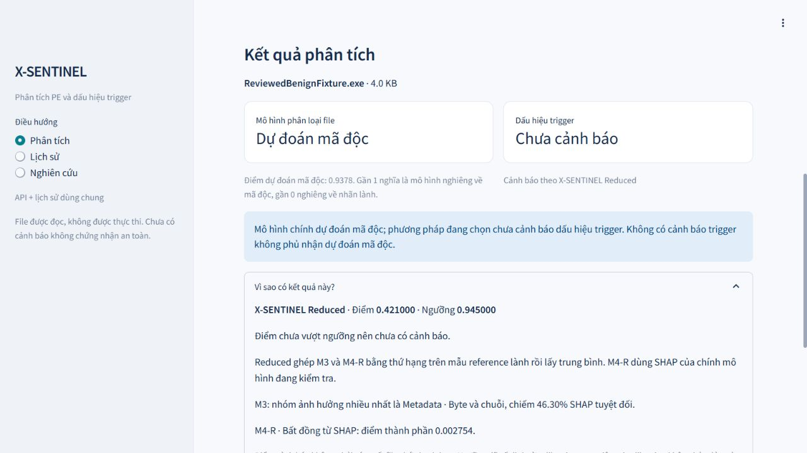
Figure B1. Actual browser view of the revised result interface, using a reviewed benign fixture; model outputs are predictions rather than ground-truth labels.
For this benign fixture, the selected V3 model predicts malware. This is a false-positive classification in the fixture check, not evidence of malware or a successful detector attack. The screenshot establishes the operational workflow only.

B.2. Verification and timing boundaries
Check | Observed outcome
Automated regression tests | 66 passed; the recorded run includes PE/schema, result-reuse and service checks.
PE → API → history | 4 dataset/variant cases passed, including metadata, score equality and retry compatibility.
Interface runtime | Four demo cases on Windows and four in Linux Docker on the same physical computer.
Above the old upload limit | A 21 MiB padded, reviewed PE fixture was parsed successfully by V3. Exact 50 MiB and over-limit checks validate the size guard; a 50 MiB binary integration run is not claimed.
Scientific artifact preservation | 708 frozen primary files retain the original SHA-256 hashes. All 44 before/after smoke input results match exactly.
Table B1. System acceptance checks. Runtime tests are not a second-machine deployment test. V3 fixture parsing does not establish parity with original dataset binaries or preserve malware functionality under a real binary attack.
Smoke configuration | Before (ms) | After (ms)
EMBER2018 / reduced | 21.19 | 20.46
EMBER2018 / full | 22.57 | 20.82
EMBER2024 / reduced | 19.51 | 19.64
EMBER2024 / full | 19.28 | 27.28
Table B2. Mean warm prediction time for 11 inputs per configuration: one fixture and ten saved benign reference vectors. The operation calculates the available methods including STRIP. These 44 observations do not replace the 54-cell research latency evaluation or establish a statistically reliable speedup.
The interface separates file extraction, model prediction, the grouped API/prediction/storage round trip and application work after the click. Application timing excludes upload and browser rendering; Streamlit AppTest adds its own overhead. First-load time is separate from warm prediction. Larger files can take seconds to parse. The research target of 10 ms remains unmet; a core timing near 28 ms is not the full upload-to-screen latency.

B.3. Persistence, restoration and remaining acceptance
History now retains declared input metadata: display filename, size, kind, file SHA-256, schema, extractor and extraction time. The original file checksum is distinct from the vector checksum. Existing records without this metadata still display. The API receives feature vectors, so metadata is client-declared rather than independent backend verification of binary bytes.
A PostgreSQL dump was restored into the new isolated database xsentinel_restore_20261014_1b6c8e5f1893. Every mapped table's row count and canonical-row SHA-256 match the live snapshot (model_versions: 4, roles: 3, users: 0, analysis_jobs: 116, audit_events: 116, experiment_runs: 0, user_roles: 0, alerts: 7, analysis_results: 116, artifacts: 0, detector_scores: 676). API history and 100 result-detail responses also match. The live database was not overwritten. The backup is retained locally and is excluded from the peer deployment package.
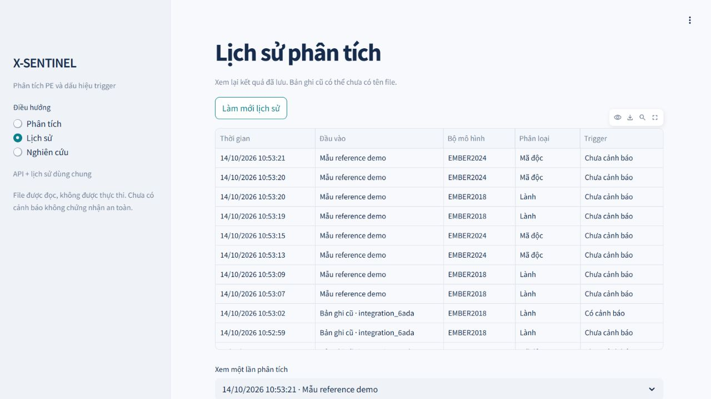
Figure B2. Actual history interface. A named test input can be reopened with the explanation from its stored result.
Acceptance on another physical computer is pending. The user deferred this step to 15 October 2026, when a teammate will build and test the supplied Docker package. Windows and Linux Docker checks on the current computer must not be reported as that independent test.
The deployment remains a local shared-history demonstration without per-user authentication. M5, new attack experiments and full fit-filter/retraining runs remain conditional extensions. The dependency fixes support the existing V3 runtime and retain NumPy 1.26.4; they do not modify method formulas or detection thresholds.

