Part 1

* Name:Tiffany

_______________________

* Student ID:201619040106

_______________________

* Course and Course ID:

Mobile Application Development Lab 11

_______________________

* Date28/05/2019

_______________________

Please Write below What you personally have learned in the lab and specify if there are parts of the lab that you could not finish or could not understand:

What we learned in this class is how to build a restful API, and then connect it to the database that we did last time, and then you can operate on the database, you can add or delete data to the database, you can get the data that exists in the database.Because of the large amount of code, I did not complete the whole experiment in the experimental class, and I have not finished the code.Some code do not understand, such as json statement, although the code is written in, but I do not understand enough, there is no way to imitate to write code. Index file, the error statement can not understand, do not know what the code will execute results.

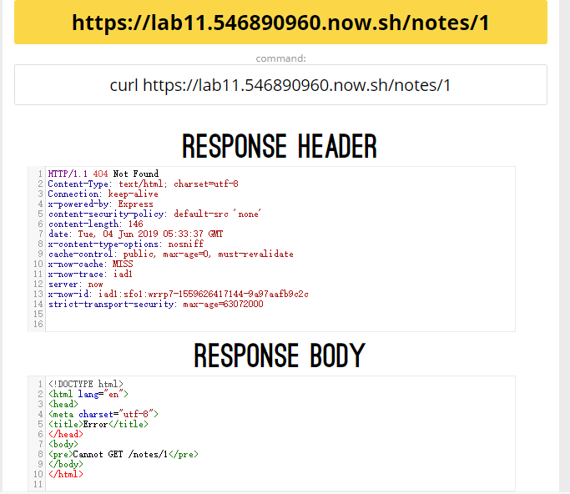

Part 2

Pleas write below an analysis of a part of the code that you produced, specifying why you have chosen this part, and what it means for the program as a whole:

1.

const CONNECTION_URL = "mongodb+srv://calloppa:<hyt19980519***>

@tiffanylab10-awd1d.mongodb.net/test?retryWrites=true";

const DATABASE_ NAME = "TiffanyLab10" ;

I think this code is basic, it allows us to connect to the database, which is necessary to connect to the database..

2.

app.get("/notes", (request, response) =>

app.get("/notes/:id",(request,response) =>

Both of these statements are similar to the initial "/ hi "test statements, both of which require a path such as "/notes" or "notes/1" to view.

3.

var numberID = parseInt (request.params.id);

if (numberID >= result.length)

response.send("Not enough elements in database")

else

response.send(result[numberID]);

The code parse the request into a number. It is the "0" of "notes/0" and only return a response if it is valid. If this number is larger than the number of entries in the current database, "Not enough elements in database" is showed. Otherwise, the corresponding content under the corresponding number is displayed.

Part 3

Please write about a part of the lab that you liked and why:

At the beginning, I found a lot of codes in index, and I felt that I could not understand them. However, I found that I could understand some of them after I settled down and looked up materials. I learned some new code in this class.

Part 4

Please write about a part of the lab that you didn’t like and why:

The results of the experiment showed that there was a mistake, and I did not know how to correct it or how to find the source of the mistake.