Monday 01/10/18 @ 1410-1540
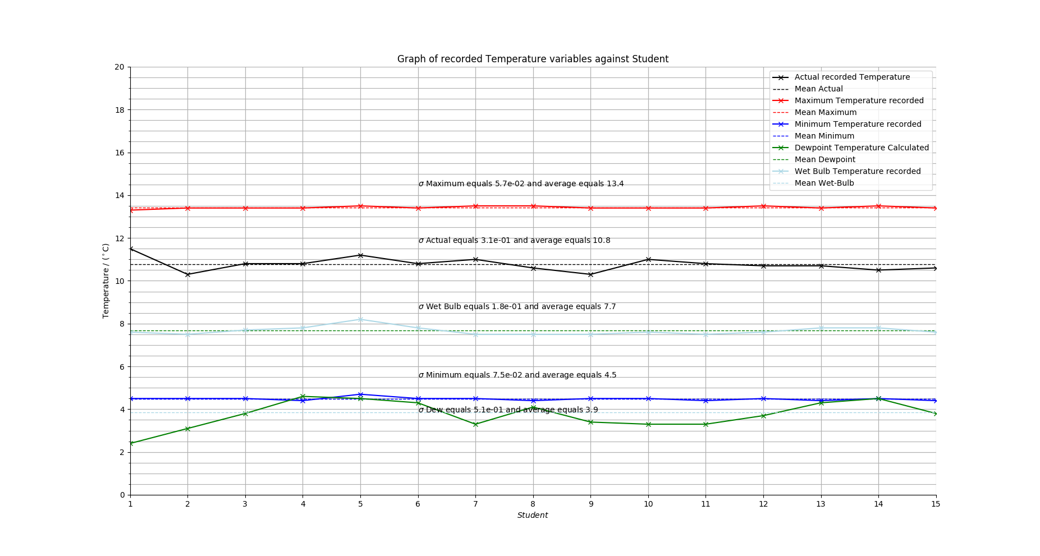
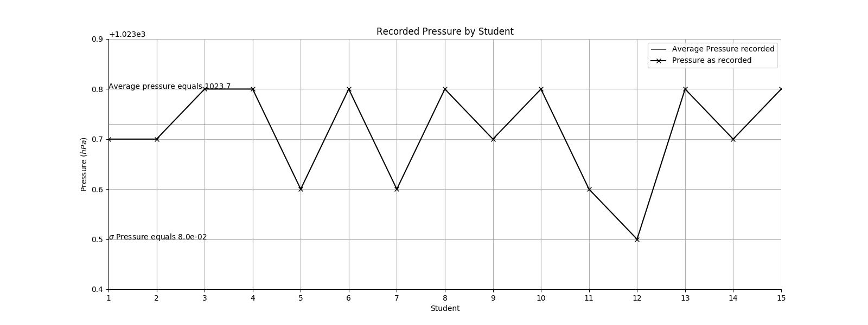
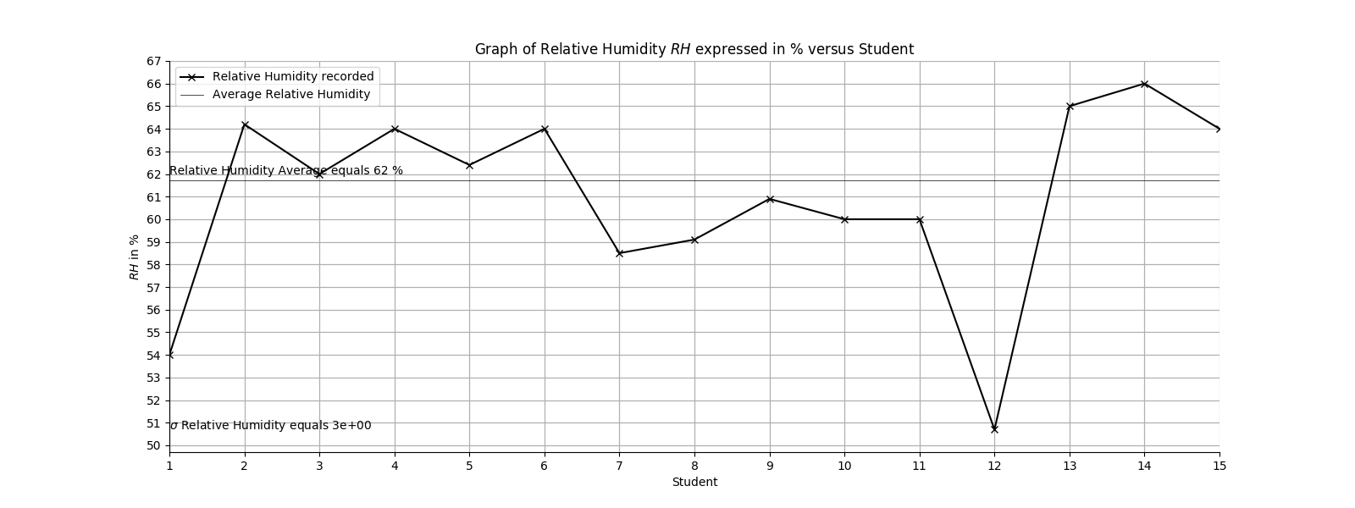

Tuesday 02/10/18 @ 1000-1130
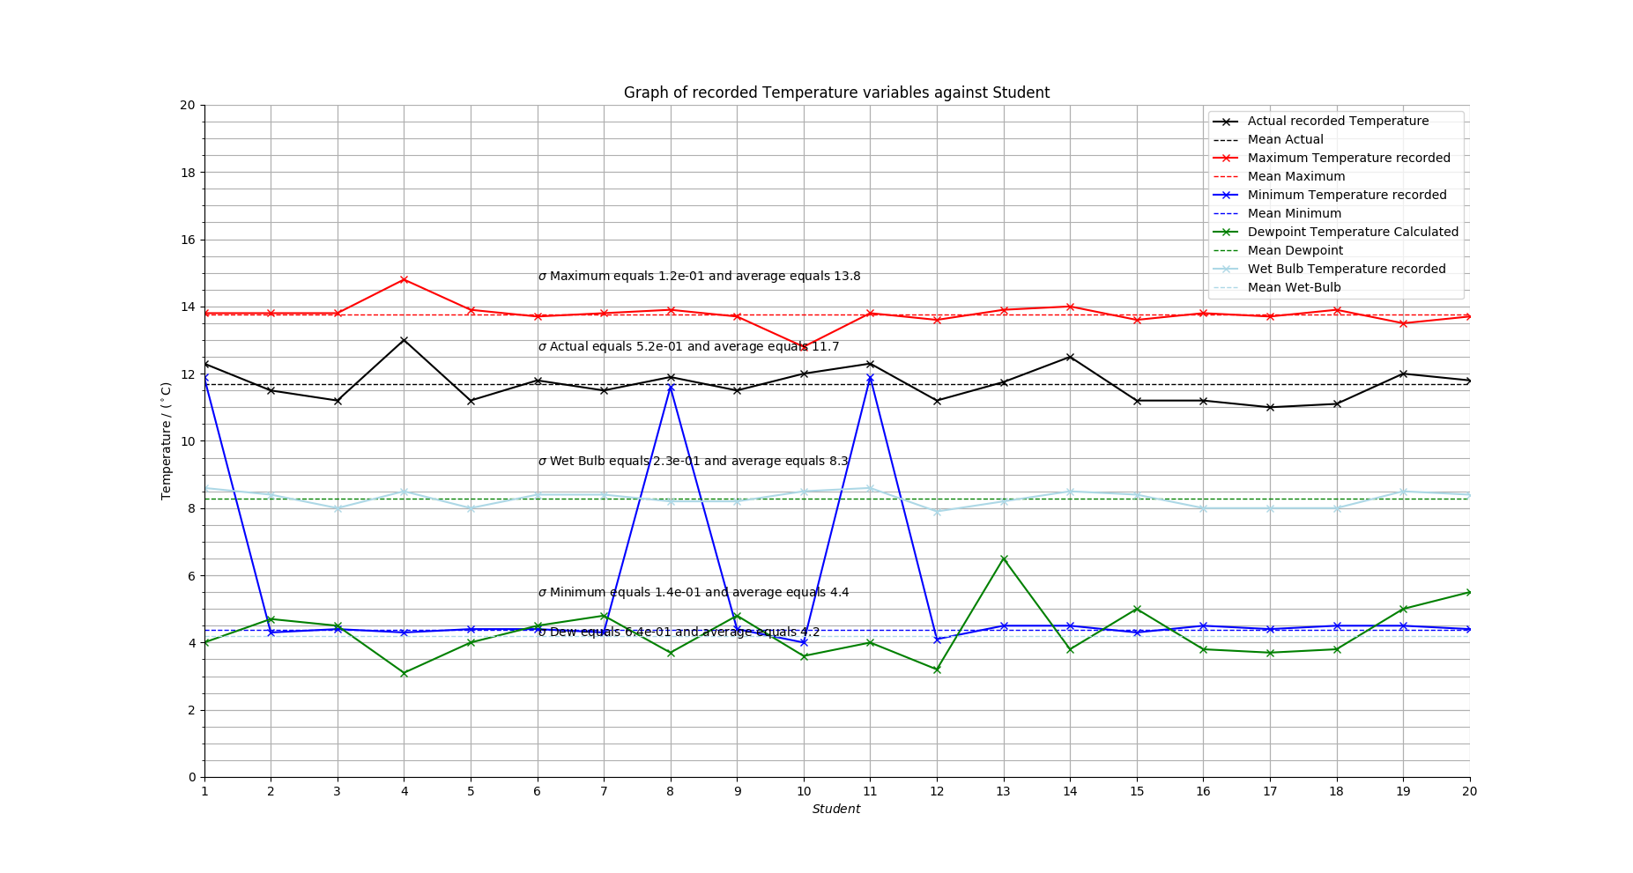
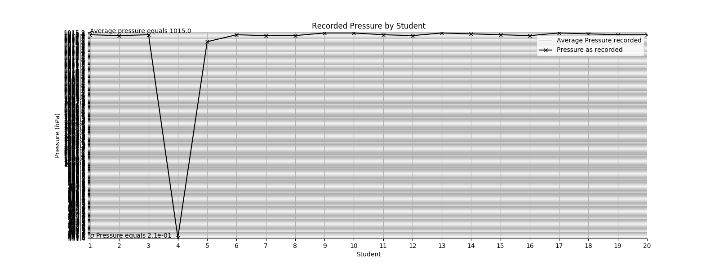
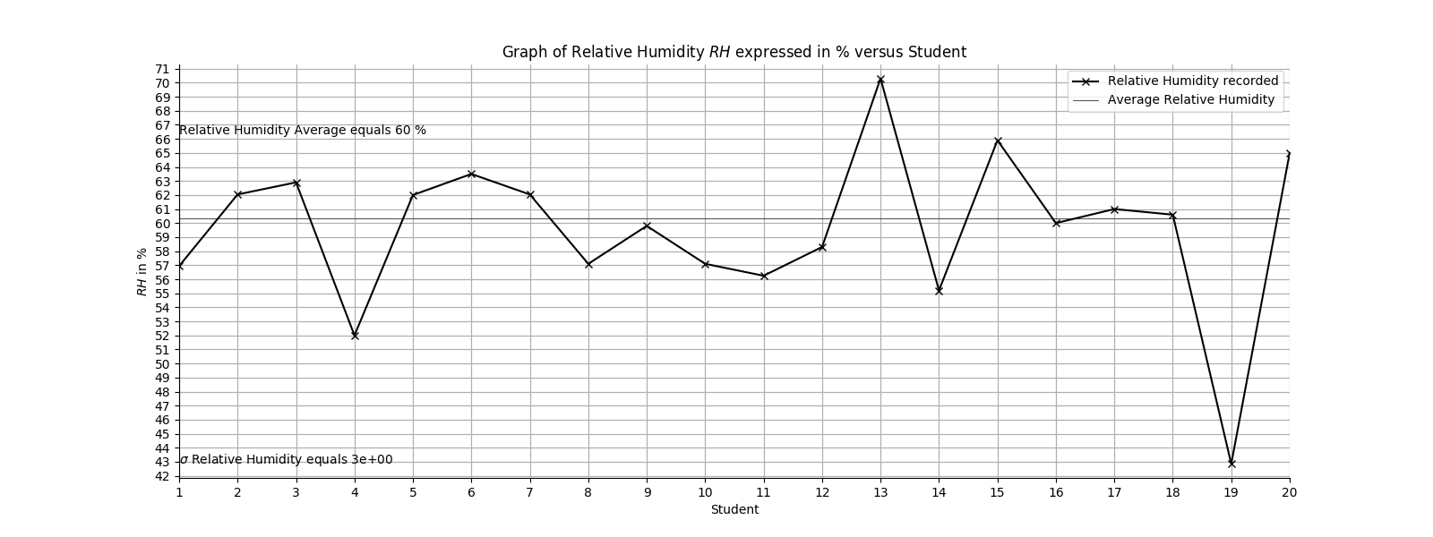

Thursday 04/10/18 @ 1410-1540
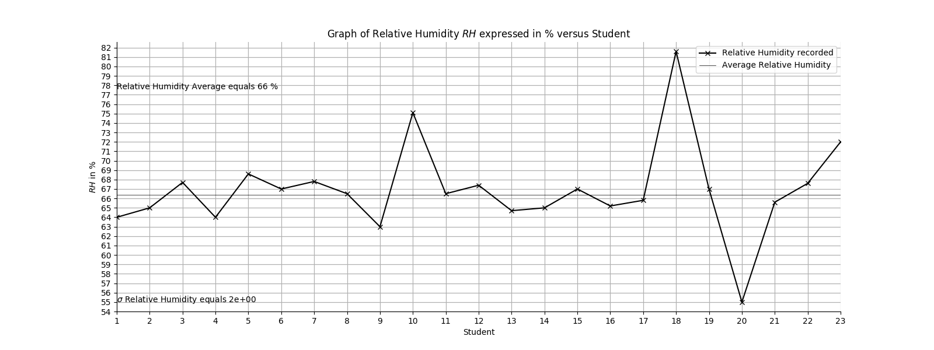
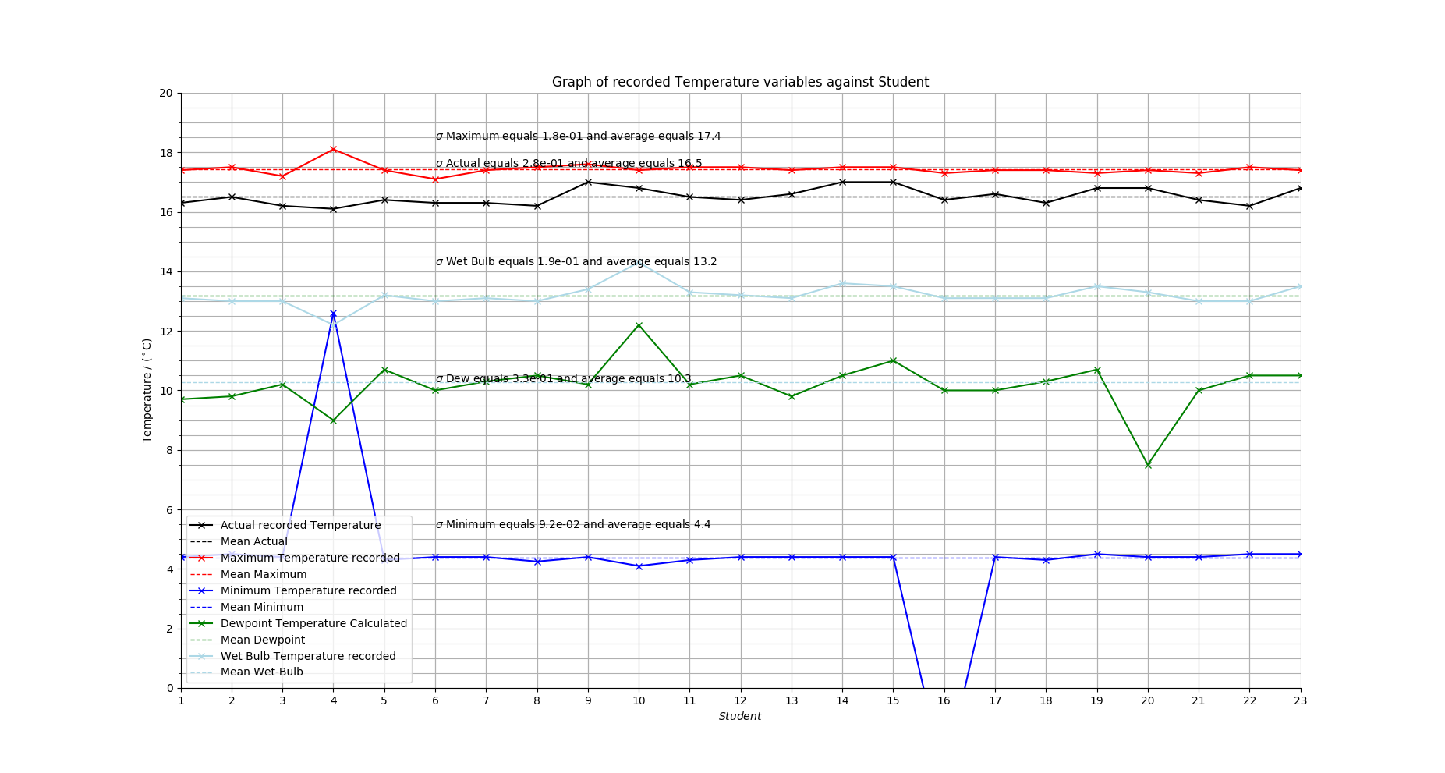
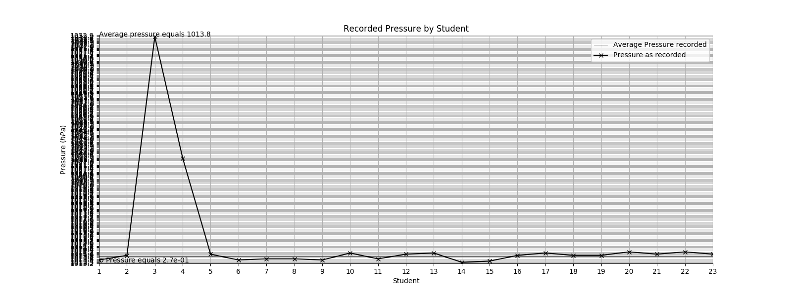
Note* Graphical errors on Pressure Graphs are due to the .py I wrote misbehaving when there is a large range in values. Similar to how the station plots mess up below 950/past 1050, it didn’t work out. Either ways, the graph still works for showing the trends, which is what is important.

Question 1. TABULATED ON THE NEXT PAGE!!!

Monday:
Temperature:
- Student 1 has a markedly lower dewpoint than the other students. Based on using a psychrometric equation, it should be ~3.6, not the 2.4 shown. Thus they must have incorrectly calculated dewpoint.
Relative Humidity:
- Students 1 and 12 have relative humidities that stride pretty far from the average: for 1, this can be explained by calculation using the incorrect dewpoint, and similarly for 12.
Pressure:
- Student 12 is the only one with a markedly significant deviation from the average per measurement error.

Tuesday:
Temperature:
- All wet-bulb temperatures follow pretty close to the average.
- Students 4 and 10 have higher and lower than average maximum temperatures, per measurement error.
- Student 4 has a pretty high actual temperature, far from the average, measurement error or perhaps a reading taken after a period of the S.Screen having been open (heating per external factors?)
- Students 1, 8 and 11 have abnormally high minimum temperatures, measurement error.
- Students 4 and 13 have dewpoints that are respectively quite low and high. 13 can be explained by calculation error, and 4 is an obvious calculation error based on the fact that though temperature rises, dewpoint actually decreases heavily.
Relative Humidity:
- Students 4, 13 and 19 have the most significant deviation. Others show quite a bit too, but these are the most blatant (15 is a close contender to 13, but 13 still wins by a factor of ~1.5). 13 is due to calculation error, 4 due to (possible) measurement error and 19 due to calculation error.
Pressure:
- Student 4 has a bodaciously low recorded pressure, low enough to make the axes of my graph play pelvic peanuckle to decide how many minors the Y should have. Measurement error. Either that or calculation from their unadjusted pressure with a reversed-sign scale height.

Thursday
Temperature:
- All actual temperatures follow quite close to the average, as do the maxima.
- Students 16 and 4 have abnormally low and high (respectively) minima, with 16 actually going into the negatives. Measurement error most likely.
- Students 4 and 10 have wet-bulb temperatures that lie moderately far from the average, low and high respectively, lending to measurement error most likely.
- Dewpoints for 4 and 10 are skewed appropriately (lower and higher) per their initial measurement error. Student 20 has an abnormally low dewpoint, due to calculation error.
Relative Humidity:
- Students 10, 18 and 20 have RH’s that deviate pretty significantly. 10 will be due to the measurement error initially, hence a higher e from following the psychrometric gradient, hence a higher e/e_{s}; 18 is due to calculation error most likely. 20 is definitely due to calculation error, following their low dewpoint.
Pressure:
- 3 had an abnormally high pressure recorded, one which definitely pushed the average pressure higher than it should have been, and again made my graph script decide to give up.

Monday
Student Nº | Temperature Error | Pressure Error | Humidity Error
1 | Dewpoint too low. Calculation. |  | Follows from Dewpoint.
12 |  | Too low. Measurement. | Calculation Error

Tuesday
Student Nº | Temperature Error | Pressure Error | Humidity Error
1 | Minimum too high. Measurement.
4 | Maximum too high. Measurement.  Actual appears high. Measurement.  Dewpoint too low. Calculation. | Far too low. Measurement. | Humidity too low, leads from the calculation error.
8 | Minimum too high. Measurement.
10 | Maximum too low. Measurement.
11 | Minimum too high. Measurement.
13 | Dewpoint too high. Calculation. |  | Too high. Calculation.
19 |  |  | Too low. Calculation.

Thursday
Student Nº | Temperature Error | Pressure Error | Humidity Error
3 |  | Too high. Measurement.
4 | Too low wet bulb. Measurement.  Too high minimum. Measurement. | Too high. Measurement. | Too low dewpoint, leads from measurement error.
10 | Too high wet bulb. Measurement. |  | Too high dewpoint, leads from measurement error.  Too high humidity, leads from measurement error.
16 | Too low minimum. Measurement.
18 |  |  | Too high. Calculation error.
20 | Too low dewpoint. Calculation. |  | Too low, follows calculation-error dewpoint.

*Tabulated for ease of viewing. Logic is above.

Question 2 (a)
The graphs have all standard deviations and averages printed on them, but I’ll tabulate them here because zooming in would be a bother… also note that the averages and st.deviations shown graphically are the ones taken with correction. The first time round I did it without, then realised the error of my ways, and went back to correct the program to account for the erroneous data (I formatted a new XL document for that and substituted values of 0, and had the script eliminate values of 0 from the tupled lists that followed when processing the data)
Erroneous  Space |  | Variables
 |  | Actual Recorded Temperature  (ºC) | Maximum  Temperature  (ºC) | Minimum Temperature  (ºC) | Dewpoint  Temperature  (ºC) | Wet Bulb Temperature  (ºC) | Pressure  (hPa) | Relative Humidity (%)
Monday  14:10→  15:40 | Average | 10.8 | 13.4 | 4.5 | 3.9 | 7.7 | 1023.7 | 62
Monday  14:10→  15:40 | St.  Devi. | 0.31 | 0.06 | 0.08 | 0.51 | 0.18 | 0.08 | 3
Tuesday  10:00→  11:30 | Average | 11.7 | 13.8 | 4.4 | 4.2 | 8.3 | 1015 | 60
Tuesday  10:00→  11:30 | St.  Devi. | 0.52 | 0.12 | 0.14 | 0.64 | 0.23 | 0.21 | 3
Thursday  14:10→  15:40 | Average | 16.5 | 17.4 | 4.4 | 10.3 | 13.2 | 1013.8 | 66
Thursday  14:10→  15:40 | St.  Devi. | 0.28 | 0.18 | 0.09 | 0.33 | 0.19 | 0.27 | 2

(b)
The reason that there is a larger spread for certain values is dependent on what kind of quantity it is. An example could be the Actual Recorded Temperature. It’s a measured quantity, and hence subject to all sorts of measurement-related error: Parallax Error, Environmental Error (what I’ll term when the Stevenson Screen may be left open leading to random heating of the thermometer, etc), and others to boot. As a result, you can expect a large random range for this quantity, regardless of the lab group that takes it, which is shown in the table. It can also fluctuate pretty frequently based on other environmental conditions, especially over the measurement time scales we’re considering, i.e. cloud-shading and wind variations and their effects on recorded temperatures, but we won’t consider that possibility and assume a short period of measurement, though that’s a shoddy assumption.

Other measured values are less subject to such variation. Parallax may exist, however it is unlikely that the Minimum Temperature, for example, would vary significantly (if at all) during the period of the measurements, since the environmental temperature >> the minimum, and hence the measure wouldn’t proactively move during the measurement period of the lab group. Thus the smaller range for minimum and maximum temperatures. Any error from that is going to be less random, as we saw, and the measurement errors for this quantity (and indeed the Maximum Temperature) were less than those openly subject to variation such as the Actual Recorded Temperature. This all assumes that a cold front straight from Jack Frost doesn’t rip through over the period and drop the temperature, then you’ll meet a pretty fast change, but I’m primarily considering just the general case of an environmental change that may occur due to the observers interrupting the equilibria that the thermometers may occupy.

Calculated quantities depend on the measured quantities. If there is a large spread for them, one can expect a large spread for the calculated quantities. An example is dewpoint. It depends on Dry Bulb and Wet Bulb. For Monday and Thursday, Actual and Wet Bulb temperature st. deviation values are less than that of Tuesday, and as a result, we could expect a smaller st. deviation for the Dewpoint range, per the fact that it’s a calculated quantity dependent on these two variables. The larger deviation than Tuesday and Thursday is observed, too. Calculation itself, at least for this case, has error associated with it too, especially since Dewpoint was calculated graphically and not formulaically based on the situation, and that error overall contributes to the errors from the variables going into the actual calculation.
Lab-group specifically, we can compare the sets of values that each group has gathered. The st. deviation for Actual Recorded Temperature is roughly equal for the Monday and Thursday groups, but significantly (~0.2) larger for the Tuesday group. Wet-bulb temperature st.deviation was also similar for the former groups, and larger (~0.04 max.) for the latter. This will have lent itself to the larger range of values that the Tuesday group had for Dewpoint Temperature at roughly a st.deviation of (~0.64). Surprisingly, Monday had a considerably st.deviation of (~0.55) for this quantity, with Thursday trailing far below at (~0.33); this seems to illustrate, at least in my opinion, the idea I put forward about errors stemming from the method of calculating dewpoint that we used, with error in actually using a graphical method on the Clausius-Clapeyron curve.

The AWS chart for Dry-bulb Air Temperature (as I termed it, Actual Recorded Temperature) shows heavy variation over the days of the labs, as you’d expect, and so it’s not unreasonable to assume that over the period of a lab one could expect a large range of values for the Dry-bulb Temperature or Wet-bulb Temperature, with the latter depending on the Relative Humidity, which the AWS also shows heavy variation of over the periods stated. This exemplifies my point about environmental fluctuations rather than short-term observer-induced changes in the environment of the thermometers, i.e. winds and changes in surface temperature versus exposure to light due to prolonged use of the Stevenson Screen.

Groups all shared reasonably low measurement errors for Maximum and Minimum temperatures, which also illustrates my point about the environment effecting the values of the temperature: the largest st.deviation for these groups was (~0.18) on Thursday for Maximum Temperature, which is still smaller than the smallest standard deviation for Actual Recorded Temperature (~0.28). The significance of this is that, since we can assume that the spread caused by observer error in checking thermometers is roughly constant yet the spread was still larger for the Actual Recorded Temperature, there must have been actual variation in this, possibly by the environmental reasoning I discussed above.
All quantities stated are in ºC.

Errors in Pressure can be seen obviously for the Tuesday and Thursday groups, with Thursday’s actually being upwards of triple the error seen by Monday’s (~0.08); pressure may well have actively changed over the period shown for Monday as the pressure chart posted on the PDF, as recorded by the Kings’ AWS, does show a dive in pressure over the entire day, (~1015) to (~1001). Correcting to sea-level w/ H equal to about eight kilometres, around (~0.6) per hour. So getting a significant range for the pressure wouldn’t be uncommon, at least based on the variation shown by the AWS. We can see that results must have been taken over a short period, or luck played its hand, as there was little variation in comparison to the overall rate of the changes that occurred over the days of the labs in question.
All quantities stated are in hPa

Surprisingly, once you factor out anomalous results for Relative Humidity, there is a very minor variation in the spread of results for any of the sets of data.

Question 3
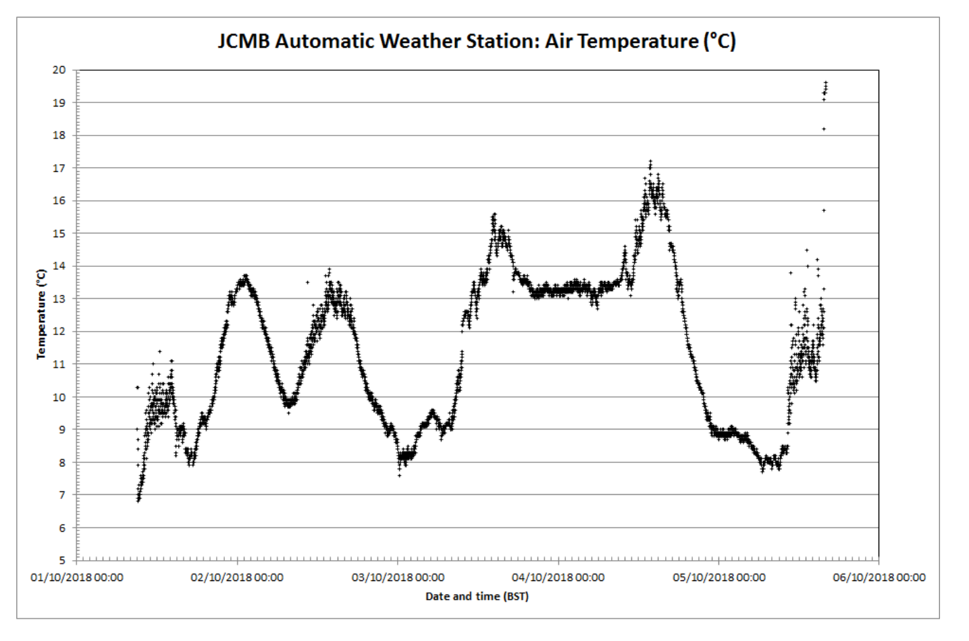

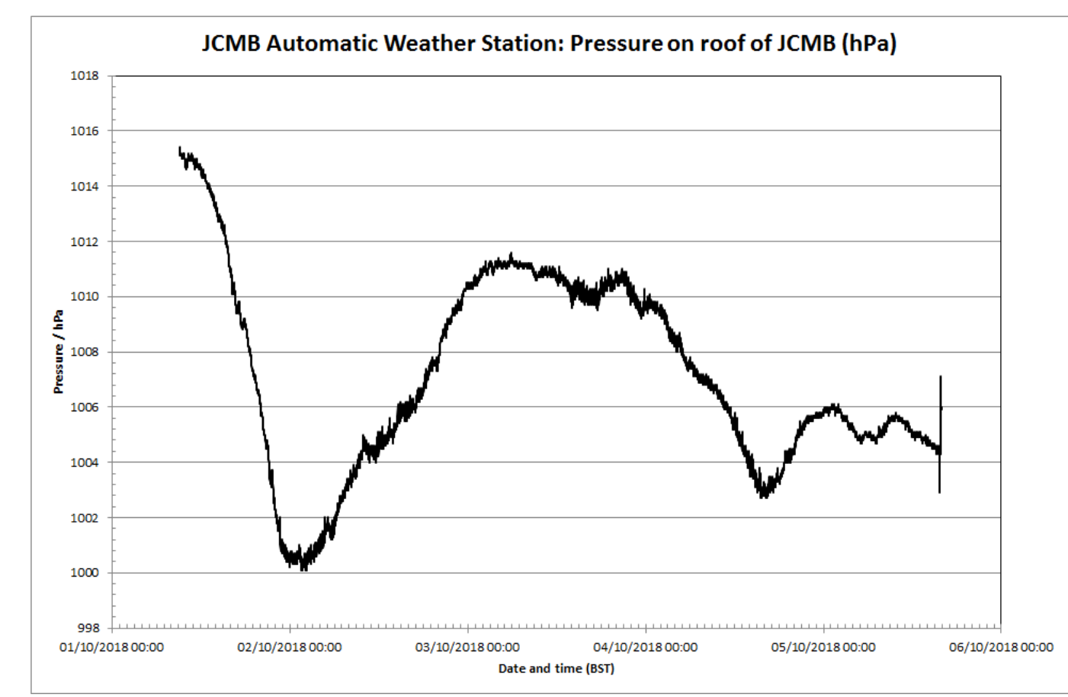

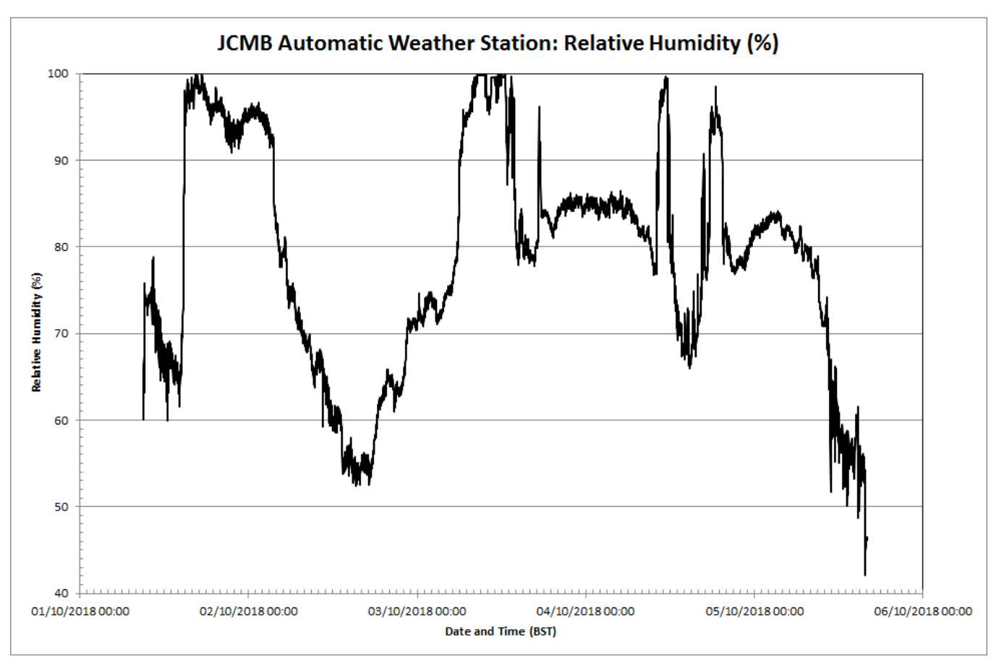

Time Range:
Monday, Thursday: 2→3 PM
Tuesday: 10→11 AM
Table for the AWS and recorded ranges/variable values over lab periods (a)
Day  Time | Type | Variable Title
Day  Time | Type | Actual Temperature/Dry Bulb (ºC) | Pressure/  (hPa) | Relative Humidity/  (%)
Monday  1400→1500 Z | Maximum | 11.1 | 1013.4 | 70
Monday  1400→1500 Z | Minimum | 8.2 | 1012.0 | 65
Monday  1400→1500 Z | Range | 2.9 | 1.4 | 5
Tuesday  1000→1100 Z | Maximum | 11.8 | 1004.8 | 66
Tuesday  1000→1100 Z | Minimum | 10.8 | 1004.0 | 64
Tuesday  1000→1100 Z | Range | 1.0 | 0.8 | 2
Thursday  1400→1500 Z | Maximum | 17.1 | 1004.4 | 73
Thursday  1400→1500 Z | Minimum | 15.5 | 1003.4 | 68
Thursday  1400→1500 Z | Range | 1.6 | 1.0 | 5
* For the comparison I’ll be referring to my graphs and the apparent ranges on them… Thought hard and long, and though standard deviation is great, it might not be suitable for comparing to a range of values…?
(b)
Monday
The Dry-bulb temperature range was roughly (~1.3 ºC), which was far less than the range recorded by the AWS, at about (~2.9 ºC). An explanation for this may be that the results were taken within a short range, less than the whole hour. I can speak from experience that most results were gathered in the first 15,30 minutes, and with little measurement error.

Pressure range was roughly (~0.3 hPa), which again was significantly less than the range recorded by the AWS at (~1.4 hPa). The range includes the anomaly. Again, the reasoning if the same: the results were most likely taken over a short time period rather than the whole hour. Another possible explanation may be that the AWS is directly exposed to pressure changes, i.e. it’s outside. The aneroid barometer used is inside. Any change outside would take time to cause a change inside, since it’d have to “move” through the door, i.e. air would move inside, out, etc. That’s just based on idle thoughts, though… like a room insulates heat and has a smaller temperature range, It would make sense to have a smaller pressure range, too.

Relative Humidity varied by about (~15 %) when you include the anomalies and about (~7 %) without. Compared to the range recorded at about (~5 %) by the AWS, we have a larger range by the students. This may be due to the graphical method we used to derive RH and Dewpoint, as already discussed.

Tuesday
Dry-bulb temperature range was roughly (~2.0 ºC ) for the students, with the AWS showing a smaller range of (~1.0 ºC); the range shown by the students was most likely due to measurement-related error rather than significant environmental variation over the period, i.e. exposure of the thermometer to external light, winds, etc.

Pressure range as recorded by the AWS was (~0.8 hPa) which was slightly less than the student range of (~1.0 hPa) once anomalies are accounted for. The ranges are quite similar, so the range in the measurements taken could be chalked up against environmental change. However, my previous argument regarding slower pressure variation still stands for the room, thus I’m nonplussed as to which phenomena may be responsible.

Relative Humidity varied by about (~11 %) for the students, with the AWS recording a range of a paltry (~2 %); the moderate spread could be accounted for by the range in recorded Dry-bulb temperature leading to a spread of final calculated RH values, though the large range (~11 %) indicates a stronger variation, i.e. due to calculation errors along the way.
Thursday
Dry-bulb temperature range was in the range of (~0.8 ºC) with the AWS showing a range of (~1.6 ºC); the range recorded by the students was about half that of the AWS, indicating that there was little measurement error taken by the students and the measurements were taken over a period less than the time-range stated.
Pressure range for this set of students was roughly (~0.9 hPa) with anomalies removed, with the AWS showing a range of (~1.0 hPa); the ranges were similar.
Relative Humidity varied by roughly (~9 %) once anomalies are factored out. The AWS showed a minor change of (~5 %); it’s safe to chalk up the slightly higher range for RH by the students as being due to the slight range in values they recorded and the calculation differences associated.
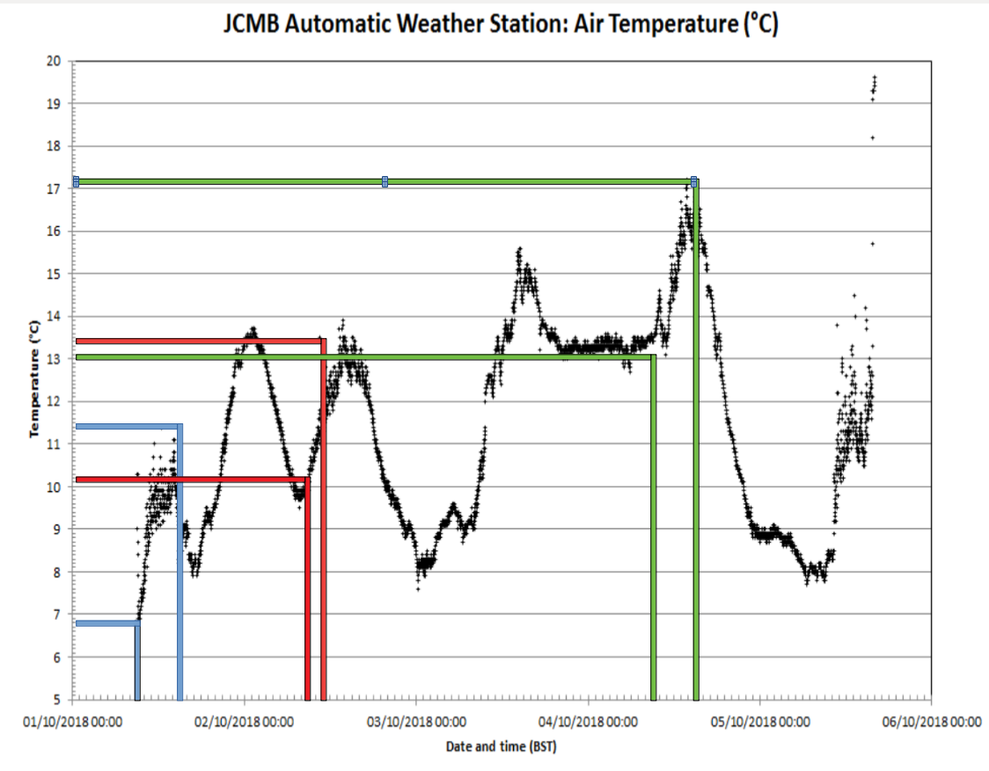
Question 4

Day | Variable
Day | Minimum Temperature (ºC) | Maximum Temperature (ºC)
Monday | 6.8 | 11.4
Tuesday | 10.1 | 13.4
Thursday | 13.0 | 17.2

* Method was to start at 9AM for each day, take the lowest up until the lab times specified (i.e. 11AM and 3PM) and the largest until these lab times, too. The lowest and largest in the range from 9AM to that time would give the minimum and maximum for that day/period (they’re reset at 9 AM, and hence pick up the minimum and maximum since then on that same day, unless I’ve misunderstood the periodicity of their resets)

Question 5...
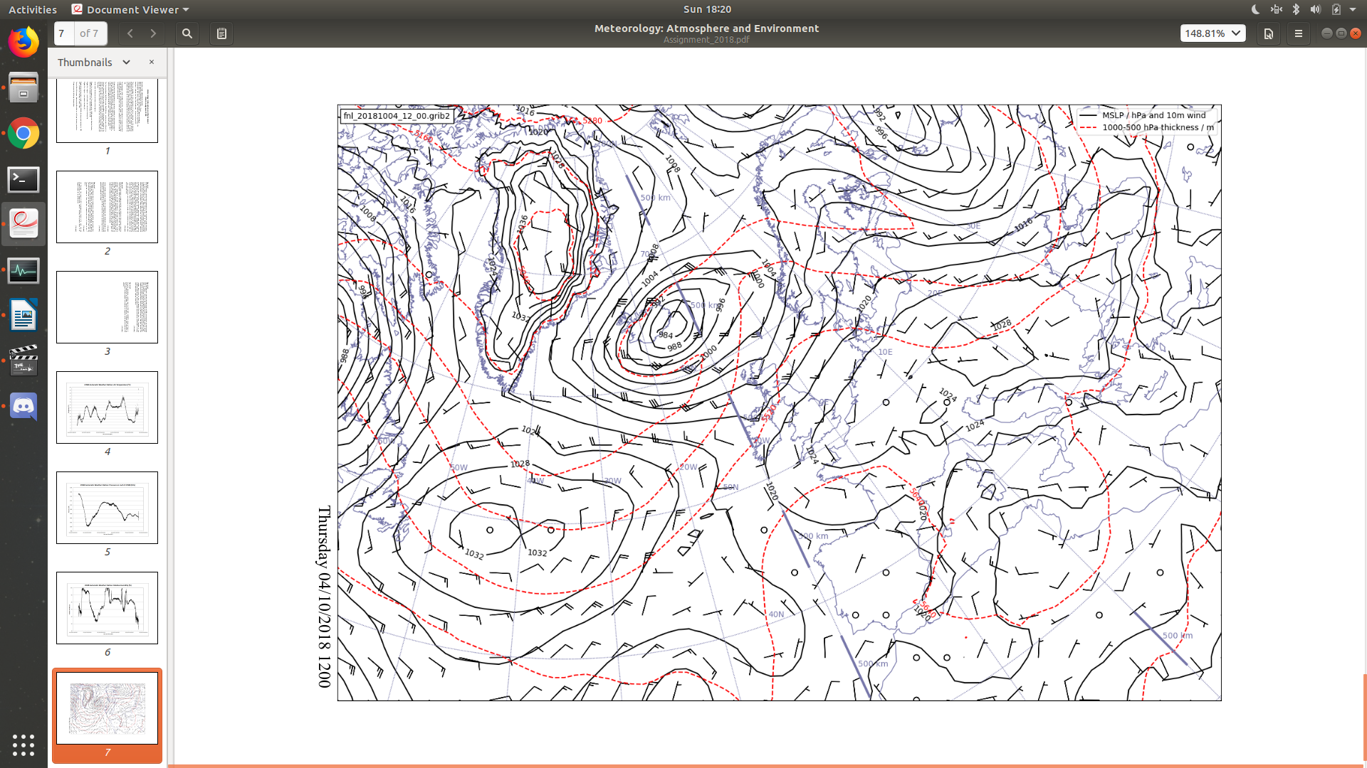

Random Ramblings, preferably not marked...
- Cold polar maritime airmass is being wound round the depression over Iceland
- Warmer airmass is being wound round in front, evidenced by higher geopotential thickness of 500-1000 hPa layer
- Result is that as time progresses and the cyclone progresses, colder air will be brought along through the central belt of Scotland, i.e. a cold front will pass through
- This will most likely bring typical weather, i.e. rain
- Also worth considering is the tropical continental airmass to the south, bringing warmer air in, hence the most likely warmer weather down south.
- Either way, the cold Pm airmass will be swept through due to the winding of the cyclone over Iceland and result in cooler temperatures and most likely some rainfall.
- Is it seen… at about 11AM on the Thursday there is an ominous rapid dip in temperature…
- There’s also a dip in pressure during the day, albeit quite a bit later, possibly indicating a front passing…
- At about 11AM there is a hell of a spike in Relative Humidity, followed by quite a dip around 3-4ish, and then another spike around 7PM…
- So a moist airmass which caused a random depression in temperature… Pm.
- Passes over Northern Scotland. Topography means that you’d most likely get rain due to the cold moist air rising and cooling… Whether the rain would reach Edinburgh depends on the actual properties of the airmass…
- If you imagine rolling back time, the warmer airmasses down south will have impuned deeper over Scotland, hence the warmer weather the previous day… so…
- Prediction: Cold Pm airmass moves in, moves over topography of Northern Scotland, produces heavy cloud cover deeper in the highlands which thins out as rain is produced up north to thinner cloud cover, which then shifts its way across the central belt of Scotland to Edinburgh, possibly producing rain along the way, dependent on just how saturated that Pm airmass is.

TOTAL:
- Sharp ranges in humidity, most likely rainfall of some kind per dip in temperatures, too, causing cloud development.
- Spontaneous temp dip in early afternoon (11-12) indicates cold front, i.e. per the above point.

Question 5 Continued

Using the above data, and the chart for 1200 GMT (1300 BST) shown in Figure 4,
write a summary of the weather that occurred over Scotland early afternoon on
Thursday 4 October suitable for broadcast to the public on the radio (maximum 100
words).

Occurred, past tense, implies happened… I’ve never heard of a summary of the days weather in the past tense being broadcast to the public. ;-;

Also, I’ll need to watch some forecasts… but I assume I can talk about fronts, but not about stuff like humidity and such.

Summary: (Do mark this! It’s my answer to 5!!!!!!!!!)
The weather over Thursday afternoon consisted of moderately cloudy weather brought about by an incoming Polar Maritime front over the central belt of Scotland, due in part to a depression over Iceland. The front passed over during the early afternoon, bringing cold moist air over Edinburgh. Having previously passed over the central belt of Scotland, the airmass was pushed higher into the atmosphere by the topography, leading to the spat of clouds that were seen as it cooled further and condensed. Rain was also seen earlier on in the afternoon, alongside gusty winds at around 46 km/h slightly past noon.

*I assume rain was produced, if only a little. I mean, based on what I know, if it is a Pm airmass and it is passing over C-Scotland, one could expect at least a little bit of drizzle or something from the clouds that ensue.
*I also assume clouds. Same reasoning… I mean, there has to have been some cloud! ;-;
*I also judge the variations in humidity as an indicator of some sort of rainfall… I mean, the initial spike may have been due to the frontal surface collecting humidity from the warmer front it’s ploughing in to… the second? Probably rain that lands and evaporates.
*Sorry for the pathetic weather review/forecast… this isn’t my strongpoint ;-;
*Please tell me if the winds actually increased past the 46 km/h. I mean, as the depression spins up, I imagine they do, but I’d love an actual comment about that…

Thanks for marking my poorly structured, nonsense-filled assignment! I’ve tried to mark the stuff off that I want taken as the answer. Have a nice day! (Also sorry for the block of code… I saw this thing about proving that the work was yours and not copied from someone, so I had to include it just to be sure that I’m not told that I plagiarised someone or something like that… I mean I could just copy-paste it from the web, so.. just trust me I wrote it myself! I’m new to Python but it sure as hell beats drawing the graphs and manually calculating Standard Deviation! Though that also means there are most likely errors and worst case scenario, I spent an entire Saturday learning how to use openpyxl just to botch the formulae I used and totally failed the assignment But hey, I can live with failing this. I had fun and learned some new things, which is what counts in life. Though not failing would be nice too.

import matplotlib.pyplot as plt
import numpy as np
import time
import random
import sys
import matplotlib.ticker as pltick
from openpyxl import Workbook
from openpyxl import load_workbook

# Load the workbook in question.
wb1 = load_workbook('Obs2018.xlsx')

def iter_rows(ws): # This defines iter_rows(ws), w/ ws being the worksheet in question.
result = [] # The result, a list of lists, each sublist being a row, [[1,2,3],[4,5,6]...]
for row in ws.iter_rows(): # Iteration for each row: row is an object that is called for iter_rows()
rowlist = [] # Each row list [1,2,3]
for cell in row: # Takes the cells for each row: cell is an object called for the object row.
rowlist.append(cell.value) # This appends the value of each cell object.
result.append(rowlist) # Appends the rowlist to the result as a list of lists.
return result # Returns the list of lists for the document.

def myround(x):
return round(x, 1)

def standard_deviation(list):
list_sum = sum(list)
average = (1/len(list))*list_sum
dif_square_list = [(d - average)**2 for d in list]
list_dif_square_sum = sum(dif_square_list)
sigma = np.sqrt((1/len(list))*list_dif_square_sum)
return sigma, average

def tuple_sort(list):
sorted_list = list.sort(key=lambda x: x[1]) # Sorts tuple by second value
return sorted_list

# We're going to need graphs that have the standard deviation provided.
# Temperature max, min, time_taken, and dewpoint, can all be plotted on one graph.

# Next step is correction for erroneous data. I can't automate this.
# Load the workbook in question.
wb2 = load_workbook('correctedObs2018.xlsx') # Loads corrected value excel, with erroneous data set to "0" (or you could set it to some other letter, I chose 0 for ease)

def graph_graph(length, actual, maxi, mini, dew, wet, rel, seap, corrected_sheet):

# This is the temperature grapher.

fig = plt.figure(111, figsize=(16,12))
ax = plt.subplot(111)
ax.set(xlim=[1,len(length)], ylim=[0, 20], xlabel=(r'$\it{Student}$'), ylabel=("Temperature / ($^\circ$C)"), title=("Graph of recorded Temperature variables against Student"))

ax.plot(length, actual, label="Actual recorded Temperature", color='black', marker='x')
a_a = []
for d in range(1, len(length) + 1):
a_a.append(standard_deviation(corrected_sheet[1])[1])
ax.plot(length, a_a, label="Mean Actual", color='black', linewidth=1, linestyle="--")

ax.plot(length, maxi, label="Maximum Temperature recorded", color='red', marker='x')
m_m = []
for d in range(1, len(length) + 1):
m_m.append(standard_deviation(corrected_sheet[2])[1])
ax.plot(length, m_m, label="Mean Maximum", color='red', linewidth=1, linestyle="--")

ax.plot(length, mini, label="Minimum Temperature recorded", color='blue', marker='x')
mi_mi = []
for d in range(1, len(length) + 1):
mi_mi.append(standard_deviation(corrected_sheet[3])[1])
ax.plot(length, mi_mi, label="Mean Minimum", color='blue', linewidth=1, linestyle="--")

ax.plot(length, dew, label="Dewpoint Temperature Calculated", color='green', marker='x')
d_d = []
for d in range(1, len(length) + 1):
d_d.append(standard_deviation(corrected_sheet[5])[1])
ax.plot(length, d_d, label="Mean Dewpoint", color='green', linewidth=1, linestyle="--")

ax.plot(length, wet, label="Wet Bulb Temperature recorded", color='lightblue', marker='x')
w_w = []
for d in range(1, len(length) + 1):
w_w.append(standard_deviation(corrected_sheet[4])[1])
ax.plot(length, w_w, label="Mean Wet-Bulb", color='lightblue', linewidth=1, linestyle="--")

ax.text(6, standard_deviation(corrected_sheet[1])[1] + 1, ("{1} Actual equals {0:.1e} and average equals {2:.1f}").format(standard_deviation(corrected_sheet[1])[0], r'$\it\sigma$', myround(standard_deviation(corrected_sheet[1])[1])))
ax.text(6, standard_deviation(corrected_sheet[2])[1] + 1, ("{1} Maximum equals {0:.1e} and average equals {2:.1f}").format(standard_deviation(corrected_sheet[2])[0], r'$\it\sigma$', myround(standard_deviation(corrected_sheet[2])[1])))
ax.text(6, standard_deviation(corrected_sheet[3])[1] + 1, ("{1} Minimum equals {0:.1e} and average equals {2:.1f}").format(standard_deviation(corrected_sheet[3])[0], r'$\it\sigma$', myround(standard_deviation(corrected_sheet[3])[1])))
ax.text(6, standard_deviation(corrected_sheet[5])[1] + 1, ("{1} Wet Bulb equals {0:.1e} and average equals {2:.1f}").format(standard_deviation(corrected_sheet[5])[0], r'$\it\sigma$', myround(standard_deviation(corrected_sheet[5])[1])))
ax.text(6, standard_deviation(corrected_sheet[4])[1], ("{1} Dew equals {0:.1e} and average equals {2:.1f}").format(standard_deviation(corrected_sheet[4])[0], r'$\it\sigma$', myround(standard_deviation(corrected_sheet[4])[1])))

ax.grid(True, which='major')
ax.grid(True, which='minor')
ax.minorticks_on()

majorticks_student = pltick.MultipleLocator(1)
majorticks_temp = pltick.MultipleLocator(2)
minorticks_student = pltick.MultipleLocator(1)
minorticks_temp = pltick.MultipleLocator(0.5)

ax.xaxis.set_major_locator(majorticks_student)
ax.yaxis.set_major_locator(majorticks_temp)
ax.xaxis.set_minor_locator(minorticks_student)
ax.yaxis.set_minor_locator(minorticks_temp)

ax.spines['right'].set_visible(False)
ax.spines['top'].set_visible(False)
plt.legend()
plt.show()
fig.savefig(("temperature{}.png").format(str(dew[1])))

# This is the pressure grapher

fig1 = plt.figure(222, figsize=(16, 6))
ax1 = plt.subplot(111)

ax1.set(xlim=[1, len(length)], ylim=[min(seap) - 0.1,max(seap) + 0.1], xlabel="Student", ylabel="Pressure ($\it{hPa}$)", title="Recorded Pressure by Student")

seap_avg = []
for d in range(0, len(seap)):
seap_avg.append(standard_deviation(corrected_sheet[7])[1])

ax1.plot(length, seap_avg, color='black', linewidth=0.5, label="Average Pressure recorded")
ax1.plot(length, seap, label="Pressure as recorded", color='black', marker='x')

ax1.grid(True, which='major')
ax1.grid(True, which='minor')
majors = pltick.MultipleLocator(1)
minors = pltick.MultipleLocator(0.1)
ax1.xaxis.set_major_locator(majors)
ax1.xaxis.set_minor_locator(majors)
ax1.yaxis.set_major_locator(minors)
ax1.text(1, min(seap), ("{1} Pressure equals {0:.1e}").format(standard_deviation(corrected_sheet[7])[0], "$\it\sigma$"))
ax1.spines['right'].set_visible(False)
ax1.spines['top'].set_visible(False)
ax1.margins(0, 16)
ax1.text(1, max(seap), ("Average pressure equals {0:.1f}").format(myround(standard_deviation(corrected_sheet[7])[1])))

plt.legend()
plt.show()
fig1.savefig(("pressure{}.png").format(str(dew[1])))

# This is the humidity grapher

fig2 = plt.figure(333, figsize=(16,6))
ax2 = plt.subplot(111)

ax2.set(xlim=[1, len(length)], ylim=[min(rel) - 1, max(rel) + 1], title="Graph of Relative Humidity $\it{RH}$ expressed in % versus Student", xlabel="Student", ylabel="$\it{RH}$ in %")
ax2.plot(length, rel, label="Relative Humidity recorded", color="black", marker="x")

avgg = []
for d in range(0, len(rel)):
avgg.append(standard_deviation(corrected_sheet[6])[1])
ax2.plot(length, avgg, label="Average Relative Humidity", color='black', linewidth=0.5)

ax2.grid(True, which='major', axis='both')
ax2.grid(True, which='minor', axis='both')
ax2.text(1, min(rel), ("{1} Relative Humidity equals {0:.0e}").format(standard_deviation(corrected_sheet[6])[0], "$\it\sigma$"))
ax2.text(1, max(rel) - 4, ("Relative Humidity Average equals {0:d} %").format(round(standard_deviation(corrected_sheet[6])[1]), "$\it\sigma$"))

ax2.minorticks_on()
ax2.xaxis.set_major_locator(pltick.MultipleLocator(1))
ax2.xaxis.set_minor_locator(pltick.MultipleLocator(1))
ax2.yaxis.set_minor_locator(pltick.MultipleLocator(1))
ax2.yaxis.set_major_locator(pltick.MultipleLocator(1))
ax2.spines['right'].set_visible(False)
ax2.spines['top'].set_visible(False)
ax2.margins(0,0)
ax2.spines['bottom'].set_visible(True)
plt.legend()

plt.show()
fig2.savefig(("relativehumidity{}.png").format(str(dew[1])))

# Now to do the pressure and relative humidity graphs.
# ws.iter_rows() gets you raw data which can be called by the 'row' and then by the 'cell' of each row. I.e. for a row 4 and cell E, you'd get 4:E. You can't directly use ws.iter_rows() for formatting, so you need to convert it into a list of lists, each list for each row. That's what this does.
# So, we have a list of lists... we need to isolate the elements of each column.
# Starting row: 4
# Columns: 1: Student N0, 2: Air Temp, 3: Max Temp, 4: Min Temp, 5: Dew Point, 6: Relative Hum, 7: Mean Sea Level Pressure
# Let's do this function-wise.

wb2 = load_workbook("correctedObs2018.xlsx")

def erroneous_corrector(sheet_label):
sheet = wb2[sheet_label]
list_ol = iter_rows(sheet) # Gets you a list of lists, of all elements
new_list_ol = list_ol[4:len(list_ol)] # Cuts off first four rows, i.e. starts from 4. list_ol[0,1,2,3] are all bad elements, 4 is row 5.
length = []
for d in range(0, len(new_list_ol)):
length.append(d + 1) # Marks the number in this length list

dry = []
maxi = []
mini = []
wet = []
dew = []
rel = []
seap = []

for col in new_list_ol: # Calls the columns of the list.

dry.append(col[1]) # First column is the dry.
maxi.append(col[2])
mini.append(col[3])
wet.append(col[4])
dew.append(col[5])
rel.append(col[6])
seap.append(col[7])

return length, dry, maxi, mini, dew, wet, rel, seap

# We have all the lists, uncorrected. Now, to correct.
def zero_remover(listo):
new = []
for d in listo: # It's a nested list. So treat each d as a list of its own.
d = list(filter((0).__ne__, d)) # Use list notation.
new.append(d)
return(new)

def sheet_tabulator(sheet_label):
sheet = wb1[sheet_label]
max_row = sheet.max_row
max_column = sheet.max_column
list_ol = iter_rows(sheet) # We need to isolate off the first four rows.
new_list_ol = list_ol[4:len(list_ol)] # Selects from row 5 (4+1) to length.

name = [] # Fucked up (A5 + 1) bullshit.

realname = []
for d in range(0,len(new_list_ol)):
realname.append(d + 1)

dry = []
maxi = []
mini = []
wet = []
dew = []
rel = []
seap = []

for col in new_list_ol: # Calls the columns of the list of lists... i.e. when stacked,
# The element of each column [0] is the start of it...
name.append(col[0])
dry.append(col[1])
maxi.append(col[2])
mini.append(col[3])
wet.append(col[4])
dew.append(col[5])
rel.append(col[6])
seap.append(col[7])

new_sheet = erroneous_corrector(sheet_label)
zeroed_sheet = zero_remover(new_sheet)
corrected_sheet = zeroed_sheet
print(zeroed_sheet[7])
graph_graph(realname, dry, maxi, mini, dew, wet, rel, seap, corrected_sheet) # Incase you need to graph it using our grapher.

return realname, dry, maxi, mini, dew, wet, rel, seap

sheet_tabulator("Monday")
sheet_tabulator("Tuesday")
sheet_tabulator("Thursday")

