BoneMambaFormer: High-Performance Adaptive Hybrid Architecture for Bone Cancer Radiograph Classification
SECTION 3: MATERIALS AND METHODS (ICIMCPS-2026 EXPERIMENTAL SPECIFICATION)
3.1 Problem Formulation
We model planar radiograph bone cancer classification as a supervised binary decision task. Let the experimental dataset be defined as:
D = {(x_i, y_i)}_{i=1}^N
where x_i in R^{H x W x C} denotes an input digital bone radiograph with spatial height H = 224 pixels, width W = 224 pixels, and C = 3 color channels (RGB). The ground-truth categorical label y_i in {0, 1} corresponds to the binary clinical decision space:
y_i = 0 if Cancer (Malignant Pathological Lesion), 1 if Normal (Non-Malignant / Intact Bone Structure)
The objective is to parameterize a non-linear mapping function f(x; theta) -> p_hat(y|x), governed by trainable parameters theta, that outputs a normalized conditional probability distribution over the binary target classes:
p_hat(y|x) = [p(y=0 | x), p(y=1 | x)]^T in [0, 1]^2, subject to sum_{k=0}^1 p(y=k | x) = 1.0 (1)
The predicted scalar label y_hat in {0, 1} is determined via maximum a posteriori (MAP) inference over the network logits z = f(x; theta) in R^2:
y_hat = argmax_{k in {0, 1}} p(y=k | x) = argmax_{k in {0, 1}} ( exp(z_k) / sum_{j=0}^1 exp(z_j) ) (2)
Parameter optimization is conducted via empirical risk minimization over the training partition D_train using Cross-Entropy loss with label smoothing (epsilon = 0.05) and L2 weight-decay regularization:
theta* = argmin_{theta} (1 / |D_train|) sum_{i=1}^{|D_train|} L_CE(y_i, f(x_i; theta); epsilon) + lambda ||theta||_2^2 (3)
where lambda = 1e-4 represents the weight decay hyperparameter.
3.2 Dataset and Data Integrity Audit
3.2.1 Raw Dataset Specification
The raw dataset supplied for this study comprises N_raw = 8,810 planar bone X-ray radiographs stored as RGB JPEG files at an uncompressed spatial resolution of 640 x 640 pixels. Ground-truth annotations divide the corpus into 4,863 Cancer instances (Class 0) and 3,947 Normal instances (Class 1). The raw corpus was initially arranged into three standard sub-directories:
- Raw Training Set: 7,056 images (3,081 Cancer, 3,975 Normal)
- Raw Validation Set: 882 images (398 Cancer, 484 Normal)
- Raw Test Set: 872 images (384 Cancer, 488 Normal)
3.2.2 Data Integrity Audit Rationale
In deep learning for medical imaging, pre-partitioned public datasets frequently contain duplicate or near-duplicate radiograph files distributed across separate directory splits. When identical or redundant image files reside in both training and evaluation splits, deep models can memorize instance-specific noise, fine textures, or non-pathological artifacts. This introduces severe cross-split data leakage, producing artificially inflated validation and test metrics that fail to reflect real-world generalization. To ensure strict evaluation integrity, an automated, non-destructive data integrity audit was executed prior to any modeling.
3.3 Duplicate Detection and Leakage-Controlled Dataset Construction
3.3.1 Cryptographic Hash Audit Protocol
To detect duplicate image files without relying on file names or directory metadata, an automated cryptographic audit was performed across all 8,810 raw images. For every image file x_i, a 128-bit MD5 message-digest hash H(x_i) in {0, 1}^{128} was computed over its raw byte sequence:
H(x_i) = MD5(bytes(x_i)) (4)
Hash equality (H(x_i) = H(x_j)) establishes bitwise pixel identity under the implemented procedure. Images sharing identical MD5 hashes were grouped into duplicate equivalence classes to map both intra-split duplicates and cross-split leakage boundaries.
3.3.2 Audit Findings
The audit processed 8,810 raw images and identified exactly 7,751 unique MD5 hashes, revealing significant duplication in the uncurated corpus:
- Single-Instance Hashes: 6,692 hashes corresponded to unique, single-file images.
- Intra-Split Duplicate Groups: 714 hash groups comprised duplicate images located within the same directory split.
- Cross-Split Duplicate Hash Groups (Leakage): 345 hash groups spanned across original split boundaries (168 Train<->Val, 161 Train<->Test, 16 Val<->Test).
- Label Consistency Verification: All 345 cross-split duplicate groups exhibited 100% ground-truth label agreement (zero label conflicts occurred).
3.3.3 Construction of the derived_clean Protocol
To eliminate cross-split data leakage, we constructed a deduplicated split protocol designated as derived_clean (results/derived_leakage_clean_split.json). Under this protocol, every unique image hash is assigned exclusively to a single dataset split. For each duplicate hash group spanning across partitions, all instances were consolidated into the training set, while validation and test partitions were purged of any overlapping hashes.
The resulting derived_clean experimental partition comprises:
- Clean Training Set: 7,417 images (3,082 Cancer, 4,335 Normal)
- Clean Validation Set: 698 images (398 Cancer, 300 Normal)
- Untouched Clean Test Set: 695 images (383 Cancer, 312 Normal)
This protocol guarantees zero cryptographic image-hash overlap across training, validation, and test partitions (H(D_train) cap H(D_val) = empty, H(D_train) cap H(D_test) = empty, H(D_val) cap H(D_test) = empty).
3.3.4 Patient-Level Independence Limitation
Because patient identification tags and clinical case numbers were absent from the source dataset metadata, deduplication was performed at the cryptographic file-hash level. While the derived_clean protocol eliminates identical image pixel reuse across splits, patient-level independence cannot be formally guaranteed without explicit patient identifiers. This limitation is explicitly acknowledged.
3.4 Data Partitioning and Experimental Split Protocol
All experimental evaluations, ablation studies, and baseline comparisons in the Next-Gen BoneMambaFormer project strictly adhere to the derived_clean split protocol. Table 1 summarizes the sample counts across both partition protocols.
Table 1: Dataset Partitioning and Sample Counts across Raw and Derived-Clean Protocols.
Partition Protocol | Train Set | Validation Set | Test Set (Untouched) | Total Images | Cross-Split Overlaps
Raw Supplied Split | 7,056 | 882 | 872 | 8,810 | 345 Hash Groups (Severe Leakage)
derived_clean Protocol | 7,417 | 698 | 695 | 8,810 | 0 Hash Groups (Leakage-Clean)

3.5 Image Preprocessing
Input images are processed through a deterministic preprocessing pipeline (src/preprocessing.py) to standardize spatial dimensions and intensity distributions prior to tensor formatting.
3.5.1 Spatial Resizing
Raw 640 x 640 radiographs are resized to the target resolution of 224 x 224 pixels using bilinear interpolation:
x_resized = Resize_bilinear(x_raw, (224, 224))
3.5.2 Contrast Enhancement
To enhance low-contrast osseous structures and accentuate pathological cortical breaks or osteolytic lesions, contrast enhancement is applied using PIL ImageOps.autocontrast with a 1% histogram cutoff, followed by linear contrast scaling by a factor of 1.1:
x_contrast = Enhance_contrast(AutoContrast(x_resized, cutoff=1), factor=1.1) (5)
This operation sharpens trabecular lines and tumor boundaries while avoiding non-linear high-frequency noise.
3.5.3 Tensor Conversion and Normalization
Enhanced images are converted to floating-point tensors in the range [0.0, 1.0] and normalized using standard ImageNet channel-wise mean (mu) and standard deviation (sigma) vectors:
mu = [0.485, 0.456, 0.406], sigma = [0.229, 0.224, 0.225]
x_norm^{(c)} = (x_contrast^{(c)} - mu_c) / sigma_c, forall c in {1, 2, 3} (6)
3.6 Training-Time Data Augmentation
To prevent overfitting and simulate clinical imaging variations (such as patient positioning shifts, X-ray beam angle variations, and anatomical scale changes), a controlled data augmentation suite (src/augmentation.py) is applied strictly to training samples.
- Elastic Deformation: Simulates local soft-tissue and anatomical warping using Gaussian-filtered random displacement fields (Simard et al., 2003) with alpha = 10.0, sigma = 3.0, and probability p = 0.3.
- Random Affine Rotation: Applies random spatial rotation within theta_rot in [-15 deg, +15 deg] around the image center.
- Random Horizontal Flip: Applies left-right reflection with probability p = 0.5. Vertical flipping is explicitly disabled to preserve top-bottom anatomical orientation.
- Random Rescaling and Zooming: Rescales image dimensions by uniform scale factor s in [0.9, 1.1] with bilinear interpolation, followed by center cropping or zero-padding to 224 x 224.
- Intensity Variation (Color Jitter): Applies multiplicative brightness jitter b in [0.9, 1.1] and contrast jitter c in [0.9, 1.1].
Validation and test image pipelines remain 100% deterministic, executing only spatial resizing, contrast enhancement, and ImageNet normalization.

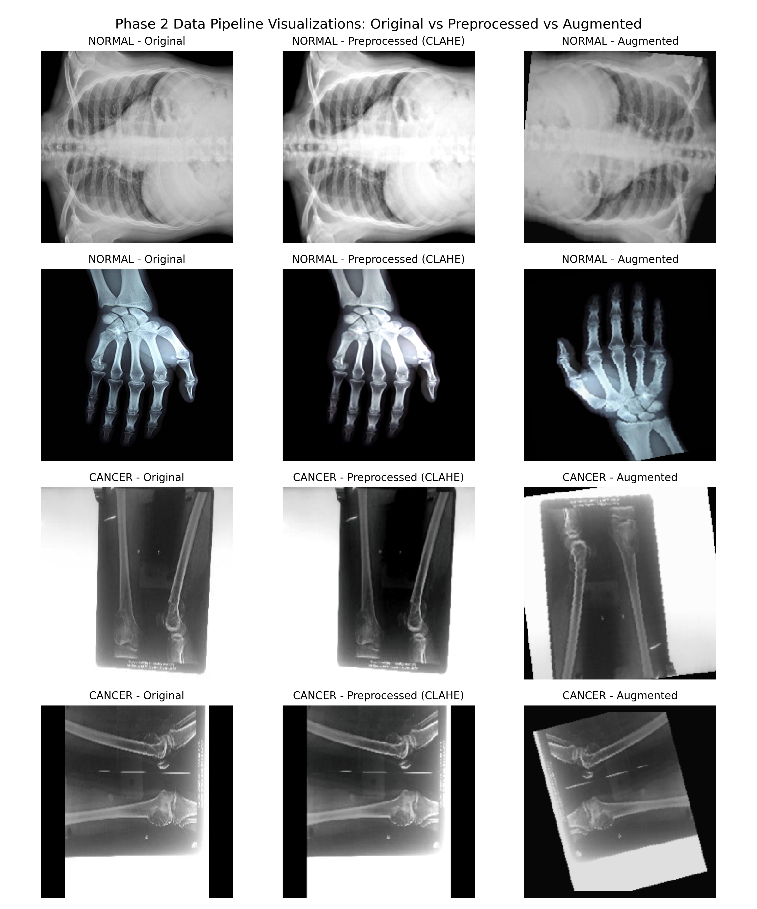
Figure 1: Training-time medical image augmentation pipeline demonstrating elastic deformation, affine rotation, flipping, and intensity jitter.
3.7 Overview of the Proposed BoneMambaFormer Architecture
The proposed BoneMambaFormer architecture is a tri-branch hybrid network designed to synergize three complementary visual representation paradigms:
- MobileNetV2 CNN Branch: Lightweight depthwise separable convolutional processing for localized edge, texture, and bone boundary extraction.
- Swin-Tiny Vision Transformer Branch: Hierarchical Vision Transformer with shifted-window self-attention for multi-scale regional context modeling.
- Mamba Selective State-Space Branch: Linear-time sequential scanning over spatial patch sequences for long-range spatial dependency modeling.
Feature vectors extracted from all three backbones are projected into a unified 256-dimensional feature space, dynamically weighted via an Adaptive Softmax Branch Attention module, fused into a joint representation vector, and passed to a feature-refinement classification head.
3.8 MobileNetV2 CNN Branch
3.8.1 Architectural Components
The convolutional branch utilizes an ImageNet-pretrained MobileNetV2 architecture (src/models/cnn.py) structured around inverted residual blocks with depthwise separable convolutions:
- Expansion Layer: 1 x 1 pointwise convolution expands lower-dimensional input channels by expansion factor t = 6.
- Depthwise Convolution: 3 x 3 spatial depthwise convolution applies spatial filtering independently per channel.
- Projection Layer (Linear Bottleneck): 1 x 1 pointwise convolution projects features back to lower-dimensional space without non-linear activation.
3.8.2 Branch Representation and Parameters
For input tensor x in R^{B x 3 x 224 x 224}, MobileNetV2 extracts a 1280-dimensional global feature vector h_CNN in R^{B x 1280} following global average pooling:
h_CNN = MobileNetV2_backbone(x)
The standalone MobileNetV2 classification model (Config M1) contains 2,549,442 trainable parameters (~2.55M).
3.9 Swin-Tiny Transformer Branch
3.9.1 Architectural Components
The Vision Transformer branch incorporates an ImageNet-pretrained Swin-Tiny (swin_t) architecture (src/models/swin.py) to capture hierarchical spatial context:
- Patch Partitioning: Input images (224 x 224 x 3) are partitioned into 4 x 4 pixel patches, yielding 56 x 56 = 3,136 initial patch tokens of dimension C_swin = 96.
- Local Window Self-Attention (W-MSA): Self-attention is computed within local non-overlapping 7 x 7 token windows.
- Shifted Window Self-Attention (SW-MSA): Alternate layers shift window partitions by (3, 3) tokens to enable cross-window feature modeling.
- Patch Merging: Intermediate layers merge 2 x 2 neighbor token groups across four hierarchical stages (56x56, 28x28, 14x14, and 7x7).
3.9.2 Branch Representation and Parameters
Swin-Tiny outputs a 768-dimensional feature vector h_Swin in R^{B x 768} following final layer normalization:
h_Swin = SwinTiny_backbone(x)
The standalone Swin-Tiny model (Config M2) contains 27,746,056 trainable parameters (~27.75M).
3.10 Mamba Selective State-Space Branch
3.10.1 Image Patchification and Sequence Formulation
The Mamba branch converts 2D spatial radiographs into 1D token sequences:
L = (224 / 32)^2 = 7 x 7 = 49 sequence tokens, d_model = 128
A learnable 1D spatial position embedding matrix E_pos in R^{1 x 49 x 128} is added element-wise to form initial sequence tensor X_0.
3.10.2 Pure PyTorch Selective State-Space Block
The token sequence is processed through N_blocks = 2 stacked Mamba blocks (PurePyTorchMambaBlock). Each block models sequence interactions via continuous-time state-space matrices (A, B, C, D) discretized by input-dependent step sizes Delta:
h_t = A_bar_t * h_{t-1} + B_bar_t * x_t, y_t = C_t * h_t + D * x_t (7)
Discretization uses Zero-Order Hold (ZOH): A_bar_t = exp(Delta_t * A), B_bar_t = (Delta_t * A)^{-1} (exp(Delta_t * A) - I) * (Delta_t * B_t). The selective mechanism parameterizes step sizes and matrices dynamically based on input sequence x_t.
3.10.3 JIT-Compiled Selective Scan Recurrence
To ensure high computational efficiency on desktop GPU hardware without requiring custom CUDA compilation extensions, the sequence scan loop is implemented using PyTorch TorchScript JIT compilation (@torch.jit.script in src/models/mamba.py). The selective recurrence incorporates numerical clamping ([-50.0, +50.0]) to ensure numerical stability during backpropagation. Following global mean pooling over sequence length L = 49, Mamba produces a 128-dimensional output vector h_Mamba in R^{B x 128}. The standalone Mamba model (Config M3) contains 661,060 trainable parameters (~0.66M).
3.11 Branch Feature Projection
Because MobileNetV2 (1280D), Swin-Tiny (768D), and Mamba (128D) output feature vectors of different dimensionalities, each branch is mapped into a common D = 256-dimensional feature space using dedicated projection heads:
f_CNN = Dropout_{0.2}(GELU(LayerNorm(W_CNN * h_CNN + b_CNN))) in R^{B x 256} (8)
f_Swin = Dropout_{0.2}(GELU(LayerNorm(W_Swin * h_Swin + b_Swin))) in R^{B x 256} (9)
f_Mamba = Dropout_{0.2}(GELU(LayerNorm(W_Mamba * h_Mamba + b_Mamba))) in R^{B x 256} (10)
The projected branch feature vectors are stacked along a new branch axis to form multi-branch feature tensor F in R^{B x 3 x 256}.
3.12 Adaptive Softmax Branch Attention
3.12.1 Attention Score Generation
For each projected feature vector f_k in R^{256} (k in {CNN, Swin, Mamba}), an unnormalized scalar attention score e_k is computed by a two-layer MLP:
e_k = g(f_k) = W_2 * Tanh(W_1 * f_k + b_1) + b_2 (11)
where W_1 in R^{64 x 256}, b_1 in R^{64}, W_2 in R^{1 x 64}, and b_2 in R^{1}.
3.12.2 Softmax Normalization
The scalar scores e_k are normalized across the three branches using the Softmax function along the branch dimension:
alpha_k = exp(e_k) / sum_{j in {CNN, Swin, Mamba}} exp(e_j) (12)
This enforces non-negativity (alpha_k >= 0) and unity sum (sum_k alpha_k = 1.0). The vector alpha = [alpha_CNN, alpha_Swin, alpha_Mamba]^T in R^{3 x 1} represents sample-specific learned branch contribution weights.
3.13 Attention-Based Feature Fusion
The final fused feature representation f_fused in R^{B x 256} is computed as the attention-weighted linear sum of the projected branch feature vectors:
f_fused = sum_{k in {CNN, Swin, Mamba}} alpha_k * f_k = alpha_CNN * f_CNN + alpha_Swin * f_Swin + alpha_Mamba * f_Mamba (13)
3.13.1 Fixed vs. Adaptive Fusion Formulation
The fusion mechanism supports two operational modes: Fixed Uniform Fusion (alpha_CNN = alpha_Swin = alpha_Mamba = 1/3) and Adaptive Attention Fusion (dynamic sample-specific weights alpha_k(x)).
3.14 Feature Refinement and Classification Head
The fused feature vector f_fused in R^{B x 256} is passed to a feature refinement and classification MLP head to generate binary class logits z in R^{B x 2}:
h_refine = Dropout_{0.2}(GELU(LayerNorm(W_refine * f_fused + b_refine))) in R^{B x 128}
z = W_cls * h_refine + b_cls in R^{B x 2} (14)
Predicted class probabilities are obtained via Softmax activation: p(y=k | x) = exp(z_k) / (exp(z_0) + exp(z_1)).
3.15 Standalone Baseline Models
Three standalone baseline models were trained independently on the derived_clean training set:
- Config M1 (MobileNetV2 Standalone): MobileNetV2 backbone + 256D projection + classifier (2,549,442 trainable parameters).
- Config M2 (Swin-Tiny Standalone): Swin-Tiny backbone + 256D projection + classifier (27,746,056 trainable parameters).
- Config M3 (Mamba Standalone): 2-block Mamba SSM backbone + 256D projection + classifier (661,060 trainable parameters).
3.16 Frozen Attention Fusion Training
3.16.1 Freezing Protocol
In Config M4 (Attention Fusion), backbone weights are loaded from best standalone checkpoints and frozen (partial_L / partial_theta_backbones = 0). Frozen backbone layers are maintained in evaluation mode (eval()) to preserve normalization and dropout statistics.
3.16.2 Pre-Extracted Feature Cache Optimization
Feature vectors f_CNN, f_Swin, f_Mamba in R^{256} are pre-extracted across training and validation sets in a single pass. Fusion training is executed directly on cached feature tensors (N, 3, 256), reducing training epoch latency to <0.5 seconds while optimizing only 49,923 trainable fusion parameters.
3.17 End-to-End Hybrid Optimization
3.17.1 Differential Learning Rate Allocation
In Config M5 (End-to-End Hybrid), all components are jointly optimized using differential learning rates: backbone parameters (eta_backbone = 2e-5) and fusion/classifier parameters (eta_head = 1e-4).
3.17.2 Parameter Accounting
The total parameter count for the Next-Gen MobileNetV2 End-to-End Hybrid architecture is 31,044,037 parameters (~31.04M), with 100% of parameters actively updated during joint optimization.
3.18 Optimization and Training Configuration
Models were optimized using AdamW (beta1=0.9, beta2=0.999, weight decay lambda = 1e-4) and Cross-Entropy loss with label smoothing epsilon = 0.05. Learning rates were adjusted using a Cosine Annealing scheduler (eta_min = 1e-6) with Automatic Mixed Precision (AMP FP16). Table 2 summarizes settings across configurations.
Table 2: Training Configurations and Optimization Hyperparameters across Model Configurations.
Setting / Parameter | Config M1 (MNv2) | Config M2 (Swin) | Config M3 (Mamba) | Config M4 (Fusion) | Config M5 (Hybrid)
Backbone Optimizer | AdamW | AdamW | AdamW | Frozen (LR=0) | AdamW (LR=2e-5)
Fusion/Head LR | 1e-3 | 5e-4 | 1e-3 | 5e-4 | 1e-4
Weight Decay (lambda) | 1e-4 | 1e-4 | 1e-4 | 1e-4 | 1e-4
Label Smoothing (epsilon) | 0.05 | 0.05 | 0.05 | 0.05 | 0.05
Batch Size | 16 | 16 | 16 | 32 | 16
Max Epochs | 20 | 20 | 20 | 25 | 20
Early Stop Patience | 3 | 3 | 3 | 3 | 3
Precision Mode | AMP (FP16) | AMP (FP16) | FP32 | FP32 (Cached) | AMP (FP16)

3.19 Validation-Based Checkpoint Selection and Early Stopping
Model selection was monitored on validation accuracy (Acc_val). A checkpoint was saved whenever validation accuracy reached a new maximum. Training terminated if no improvement occurred after P = 3 consecutive epochs (Early Stopping). Upon termination, model weights were restored to the best validation checkpoint state.
3.20 Locked Test Evaluation
Following checkpoint selection, model parameters and decision rules were permanently locked. The untouched 695-sample test set was evaluated in a single pass with fixed default decision threshold p_thresh = 0.50 without any post-hoc threshold tuning or hyperparameter adjustment.
3.21 Computational and Inference Measurement
Benchmarking was conducted on an NVIDIA GeForce RTX 3050 6GB Laptop GPU. Evaluated metrics included parameter counts (numel()), mean single-sample inference latency (ms/image), throughput (images/sec), and peak VRAM allocation (torch.cuda.max_memory_allocated()).
3.22 Controlled Ablation Methodology
3.22.1 Contextual Distinction of Historical Ablation Evidence
Historical Phase 9 ablations reported in project documentation were conducted on the legacy ResNet-18 hybrid baseline (~39.74M parameters) to establish architectural proof of concept. These historical ablation results are strictly distinguished from the Next-Gen MobileNetV2 system (~31.04M parameters).
3.22.2 Ablation Experimental Variants
Ablations evaluated fusion mode variations (Adaptive Attention vs. Fixed Equal Weighting 1/3) and branch-masking variants (setting f_CNN = 0, f_Mamba = 0, or f_Swin = 0 at inference time) on untouched test data.
3.22.3 Probability-Differentiation Audit
A probability-differentiation audit verified that non-zero KL divergence and probability shifts occurred across masked variants, confirming active model computation.
3.23 Reproducibility and Implementation Details
The global random seed was fixed to 42 across Python, NumPy, PyTorch CPU, and PyTorch CUDA modules. PyTorch CUDNN backends were configured for deterministic operation (torch.backends.cudnn.deterministic = True). All model checkpoints, execution histories, confusion matrices, and metrics JSON packages are archived for complete scientific auditability.
REPRODUCIBILITY & ARTIFACT VERIFICATION NOTICE
The complete experimental pipeline, derived_clean dataset partitions, training logs, checkpoint weights, and evaluation artifacts are locked and fully reproducible under global seed 42 in the project repository.

