Additional Material for: Biogeography shapes sea urchin responses to ocean acidification across CO₂ seeps.

Figures 1-24. Bayesian model diagnostic plots for all traits and model formulations.
Upper panels show posterior distributions (left) and MCMC trace plots (right) for all model parameters, including fixed effects, group-level standard deviations, and residual error (σ). Well-behaved posterior distributions should be smooth and unimodal, while good chain convergence is indicated by trace plots that mix well, overlap across chains, and show no trends or drift across iterations (R̂ ≈ 1 for all parameters). The lower panel shows posterior predictive checks comparing the observed data distribution (dark line) to replicated datasets generated from the fitted model (light lines). Good model fit is indicated when simulated data closely reproduce the shape and spread of the observed distribution. All models were fitted using Hamiltonian Monte Carlo with three chains, 4,000 iterations per chain, and conservative sampling controls (adapt_delta = 0.99, max_treedepth = 15).
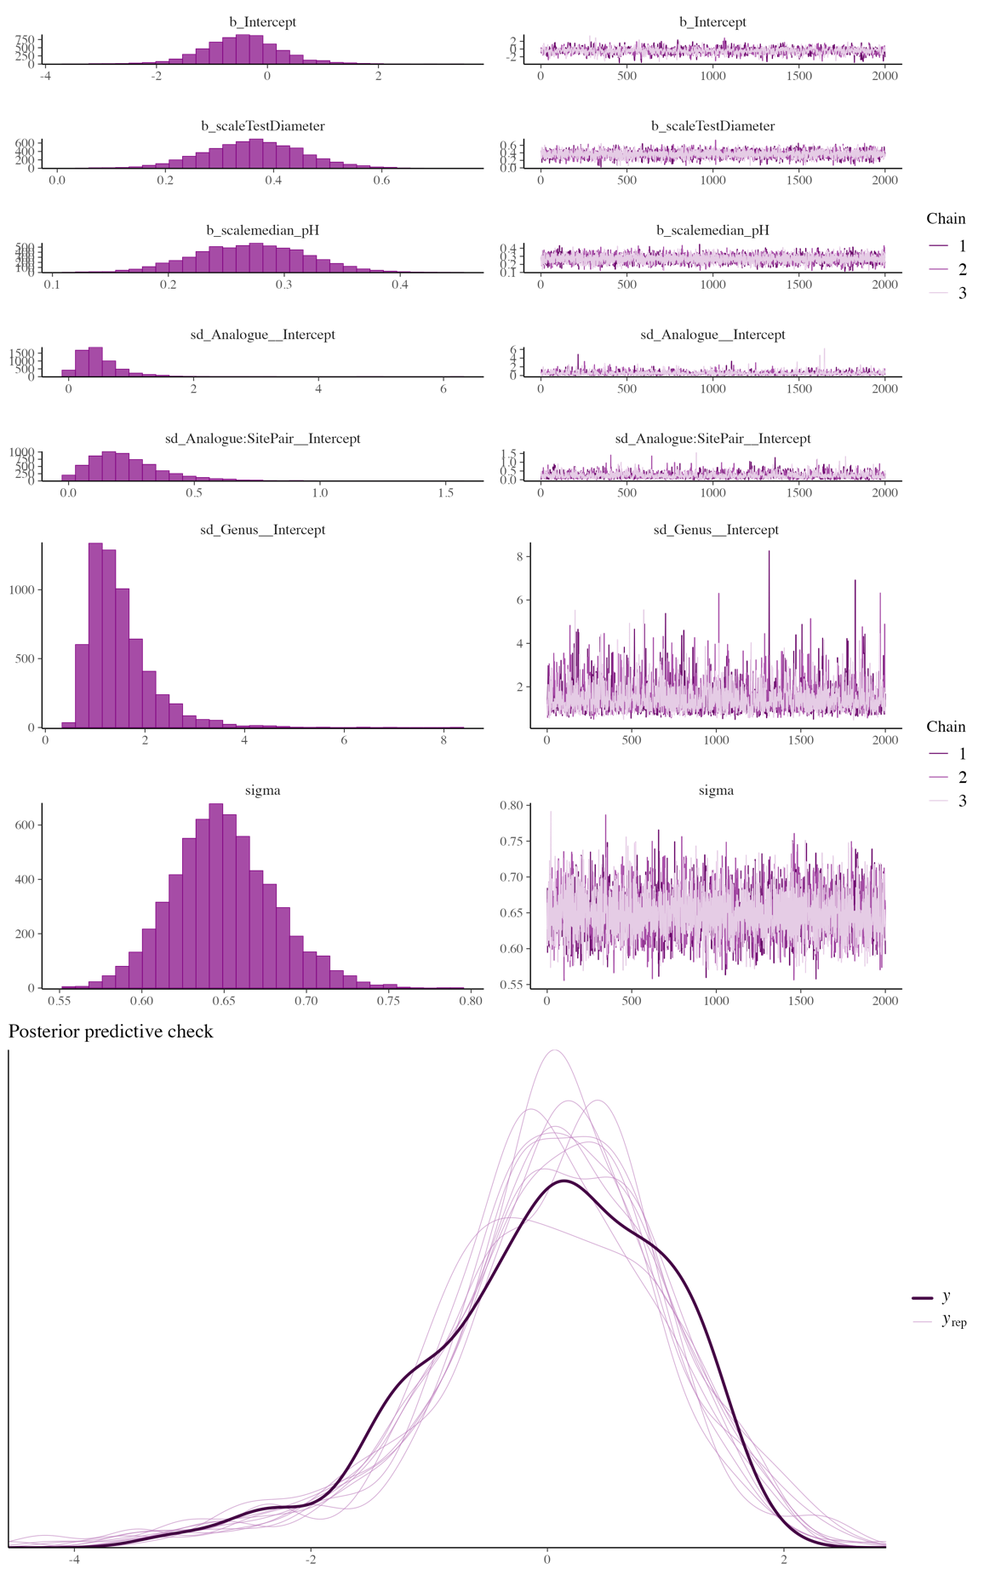
Fig 1. Bayesian model diagnostics for the pH main-effect model fitted to test biomineral content (%).
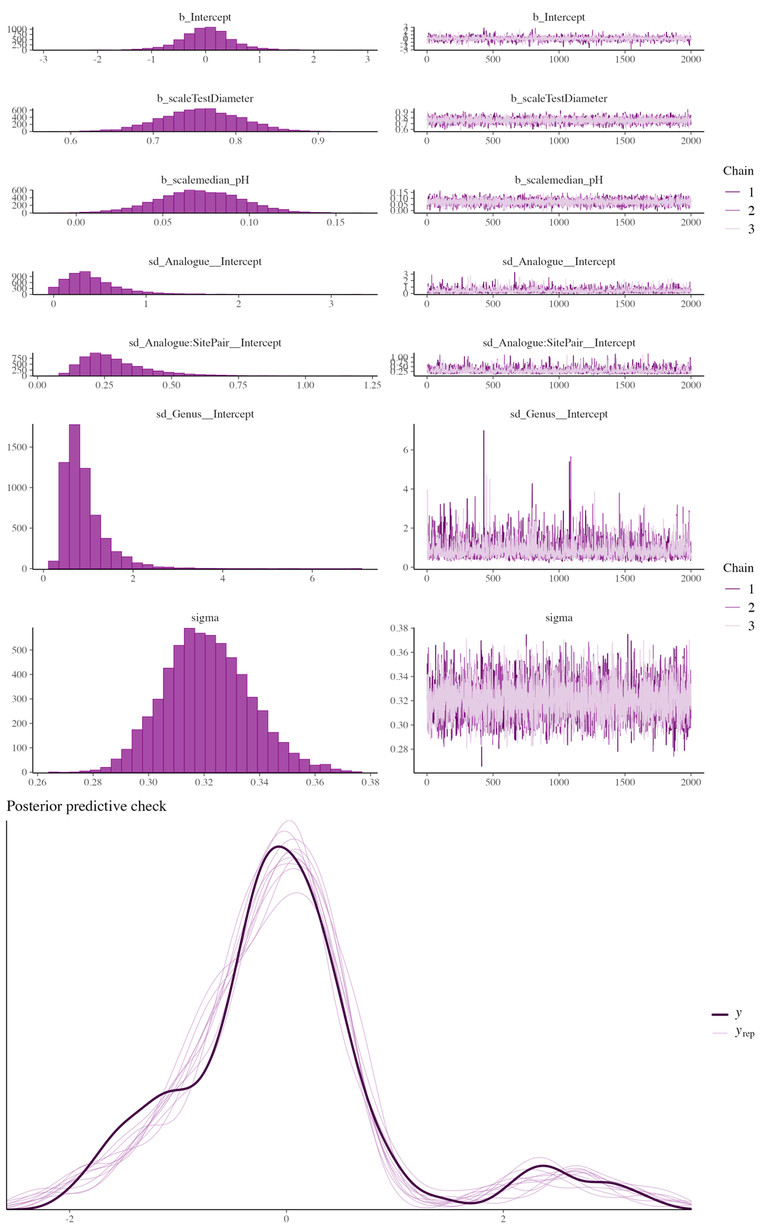
Fig 2. Bayesian model diagnostics for the pH main-effect model fitted to test thickness (μm).
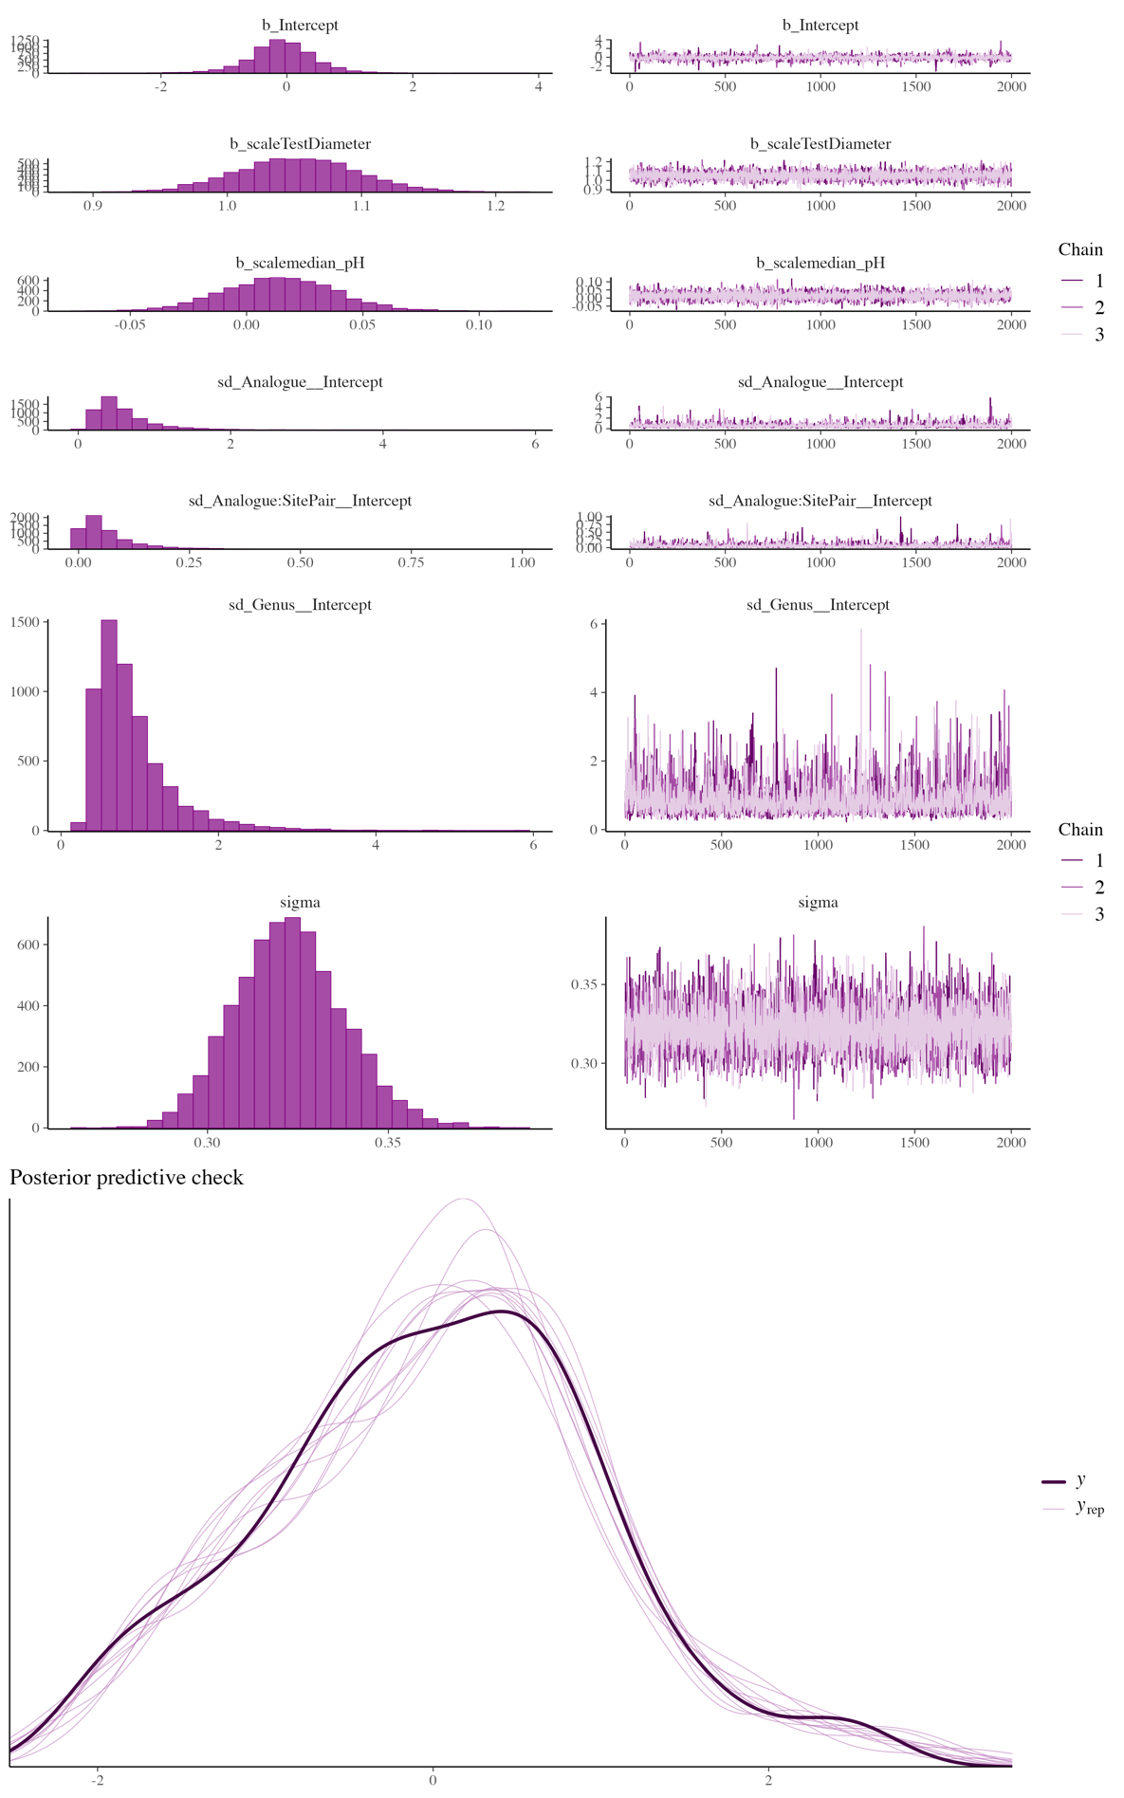
Fig 3. Bayesian model diagnostics for the pH main-effect model fitted to jaw length (mm).
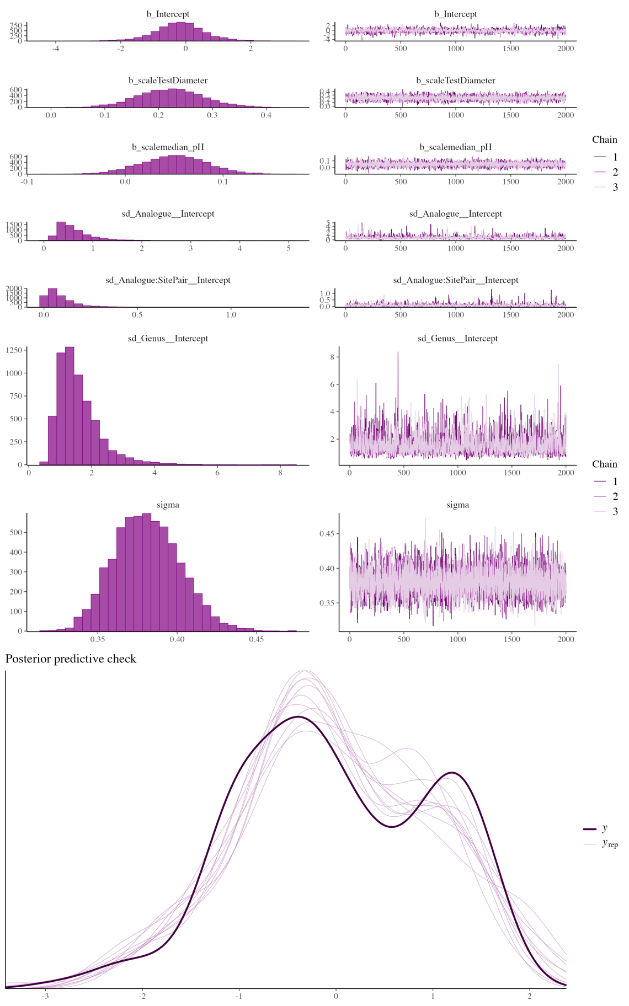
Fig 4. Bayesian model diagnostics for the pH main-effect model fitted to spine biomineral content (%).
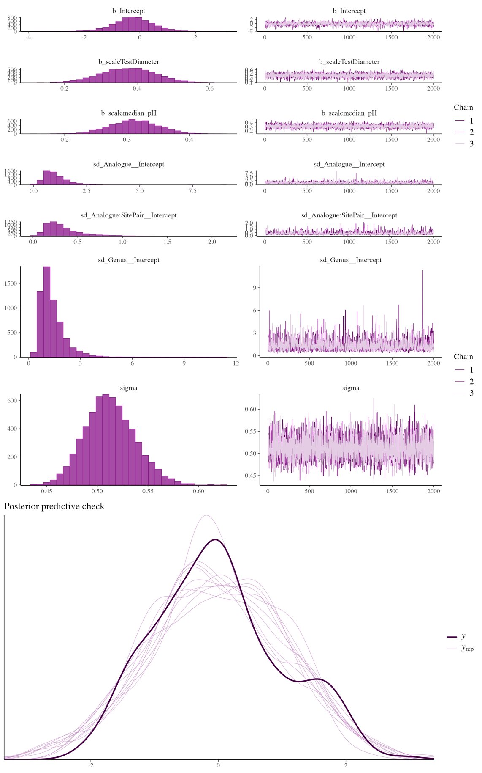
Fig 5. Bayesian model diagnostics for the pH main-effect model fitted to spine thickness (μm).
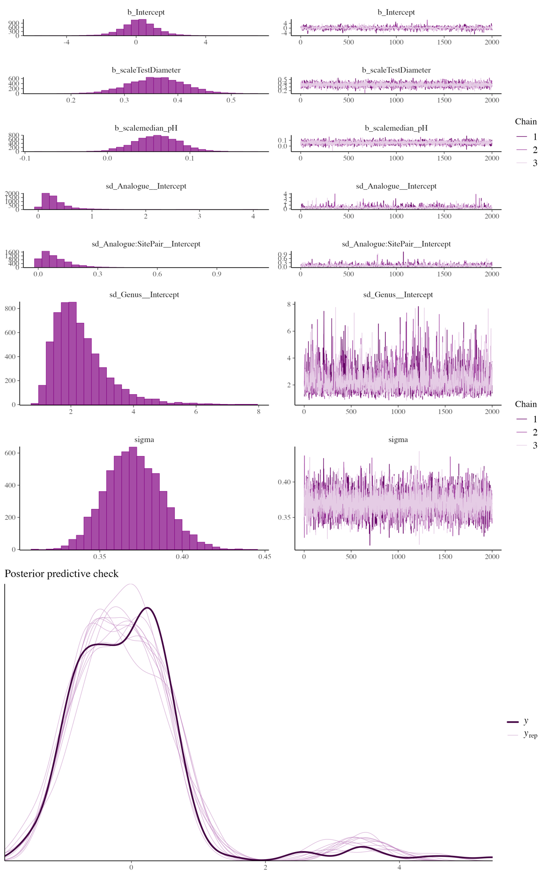
Fig 6. Bayesian model diagnostics for the pH main-effect model fitted to spine length (mm).
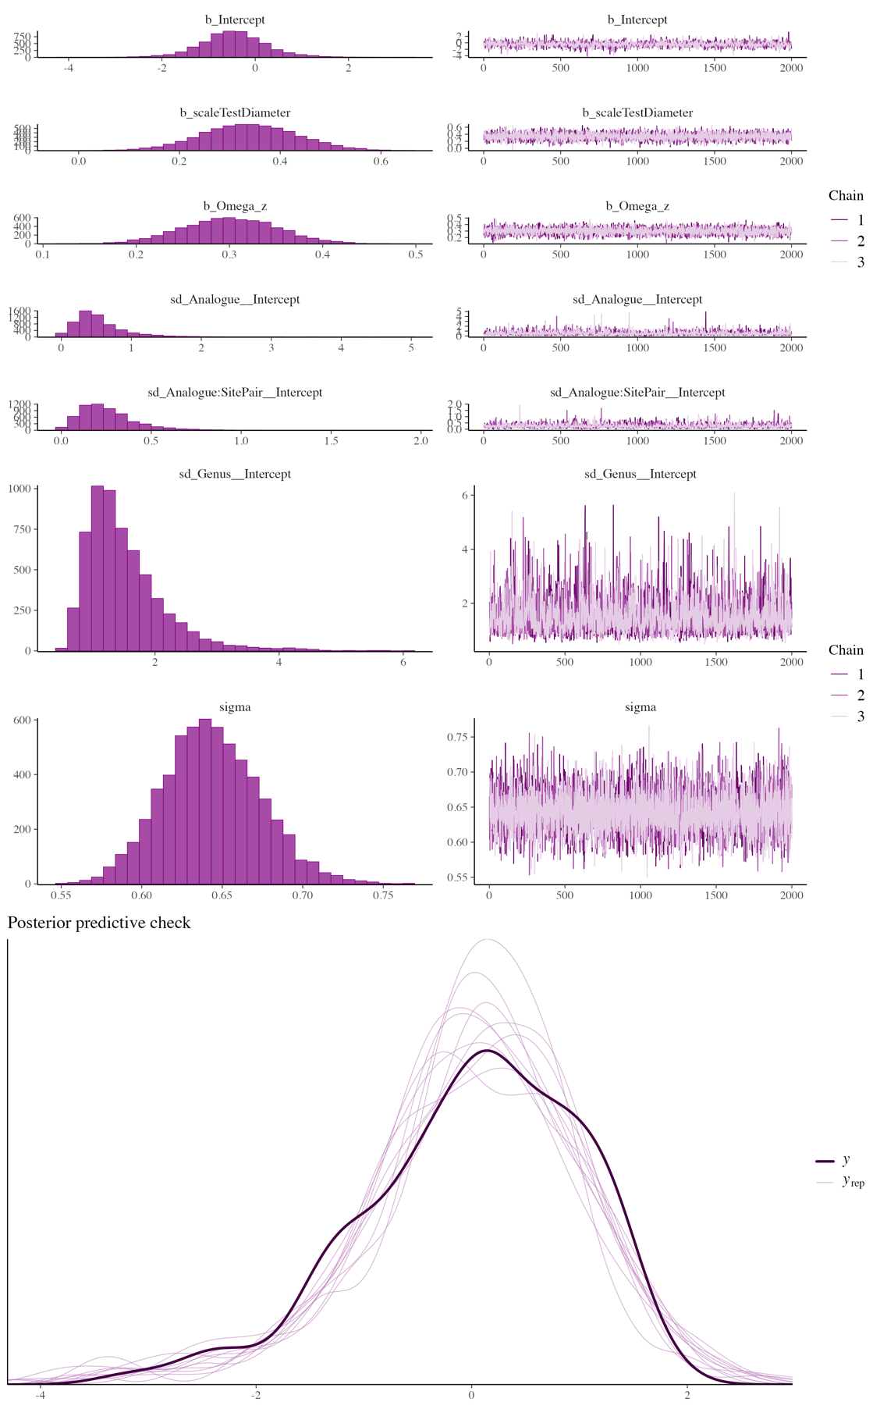
Fig 7. Bayesian model diagnostics for the Ω_{Mg-calcite} main-effect model fitted to test biomineral content (%).
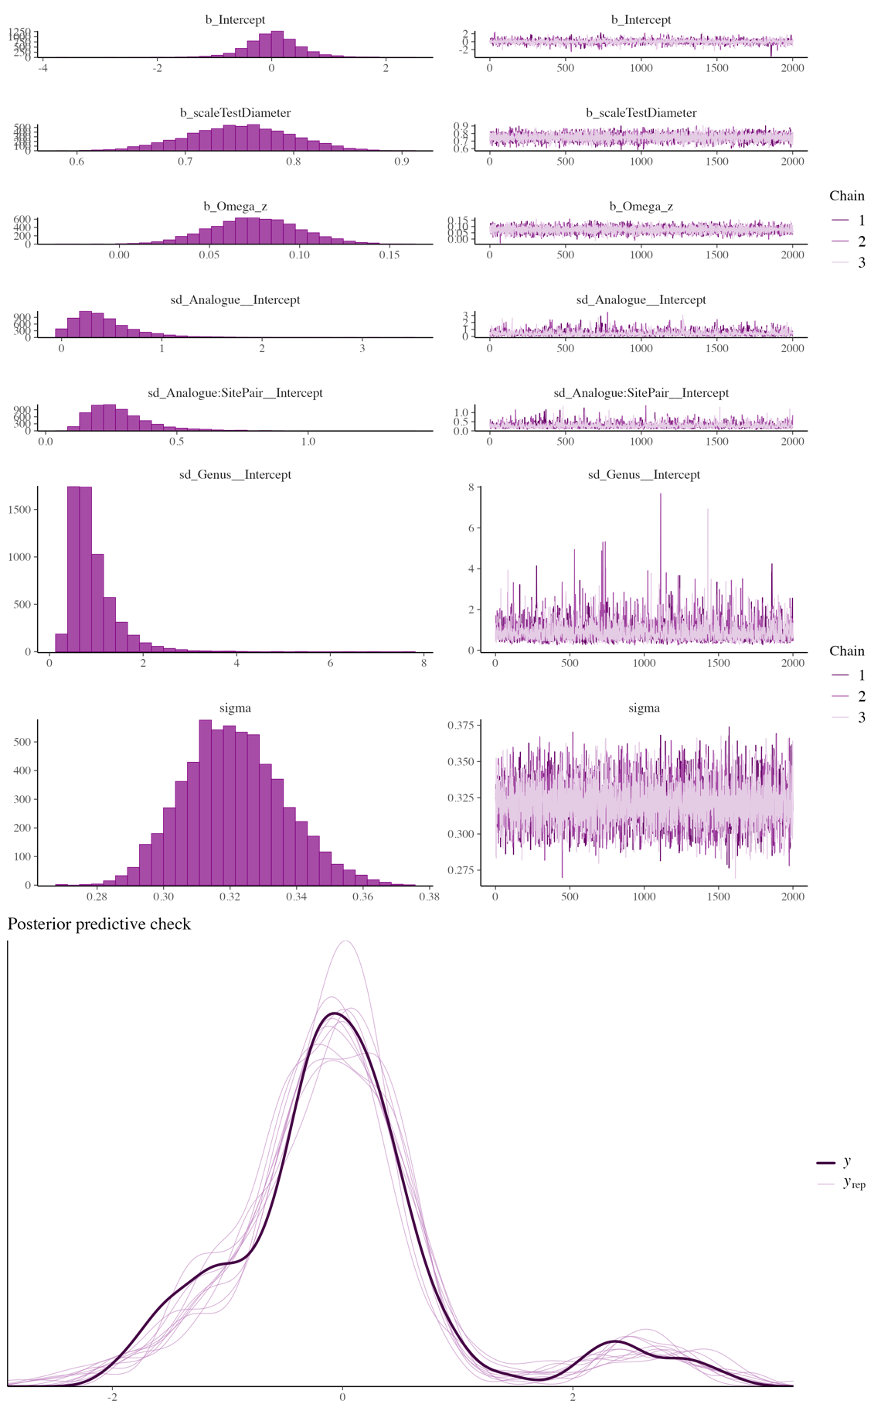
Fig 8. Bayesian model diagnostics for the Ω_{Mg-calcite} main-effect model fitted to test thickness (μm).
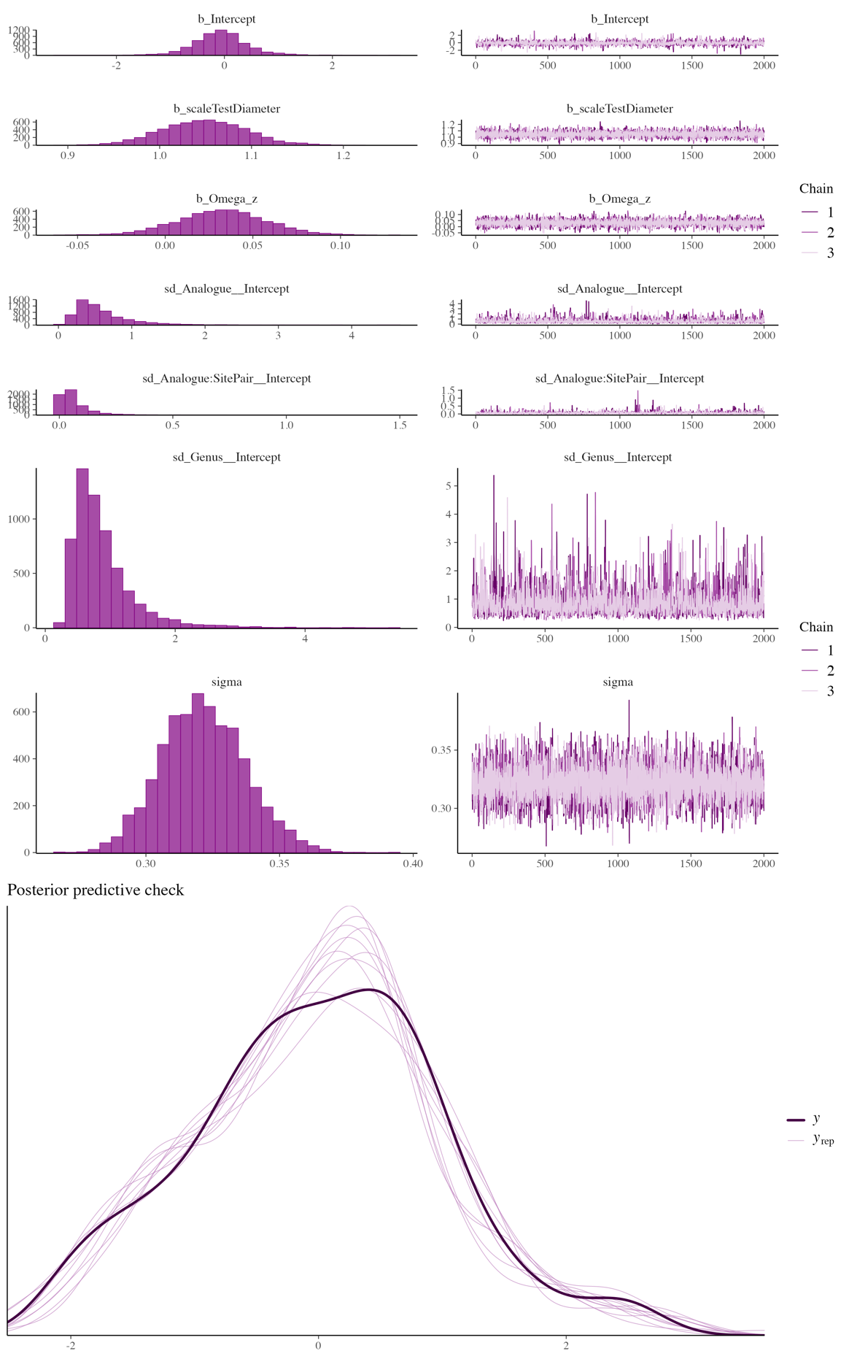
Fig 9. Bayesian model diagnostics for the Ω_{Mg-calcite} main-effect model fitted to jaw length (mm).
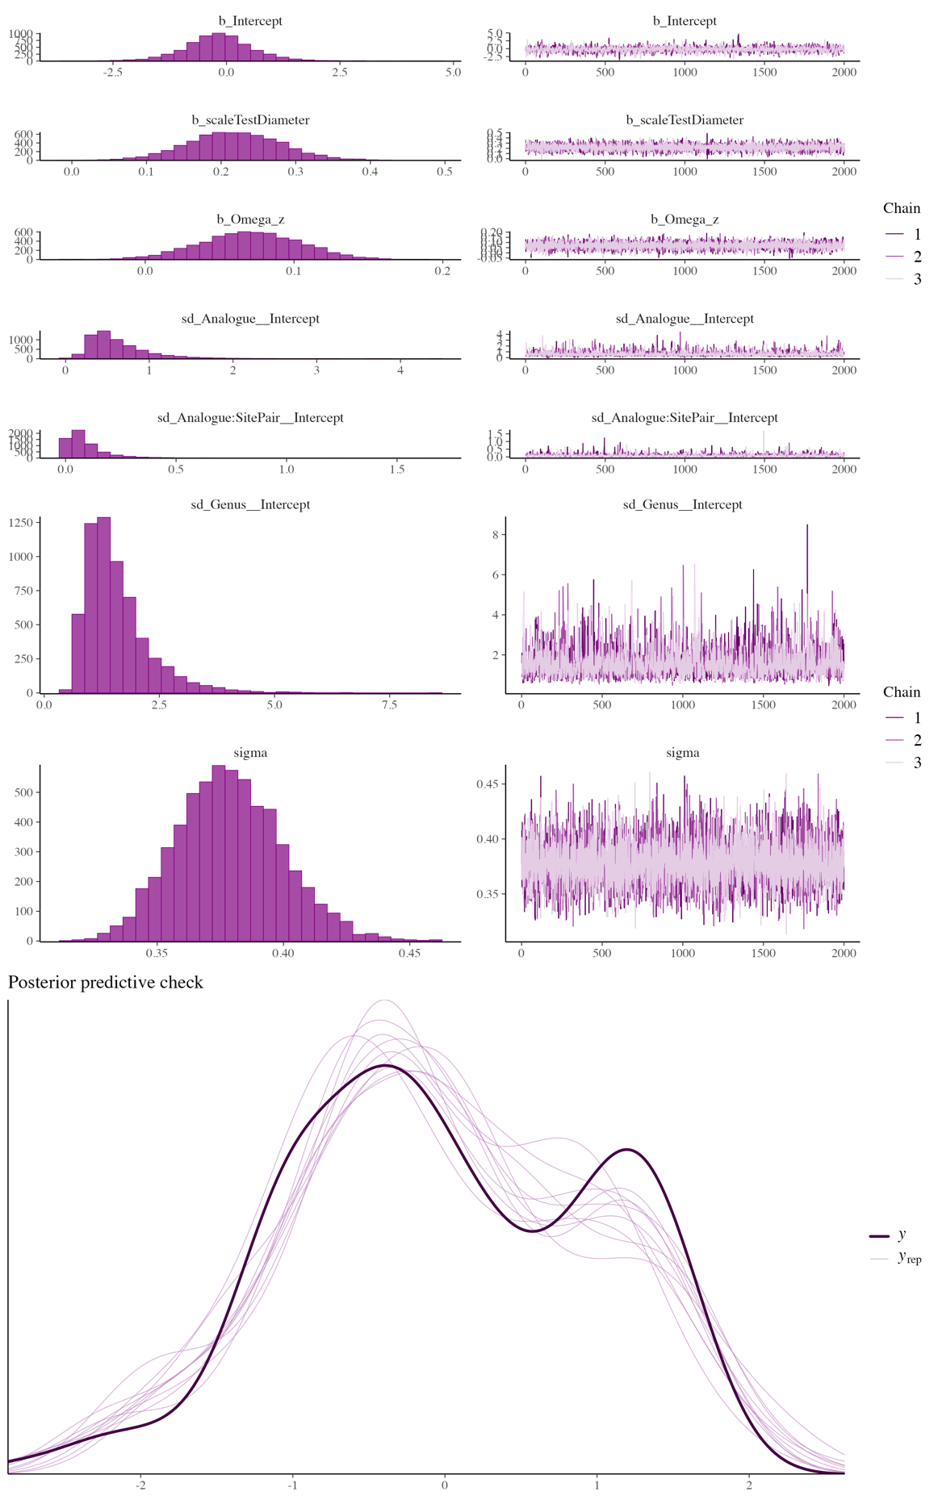
Fig 10. Bayesian model diagnostics for the Ω_{Mg-calcite} main-effect model fitted to spine biomineral content (%).
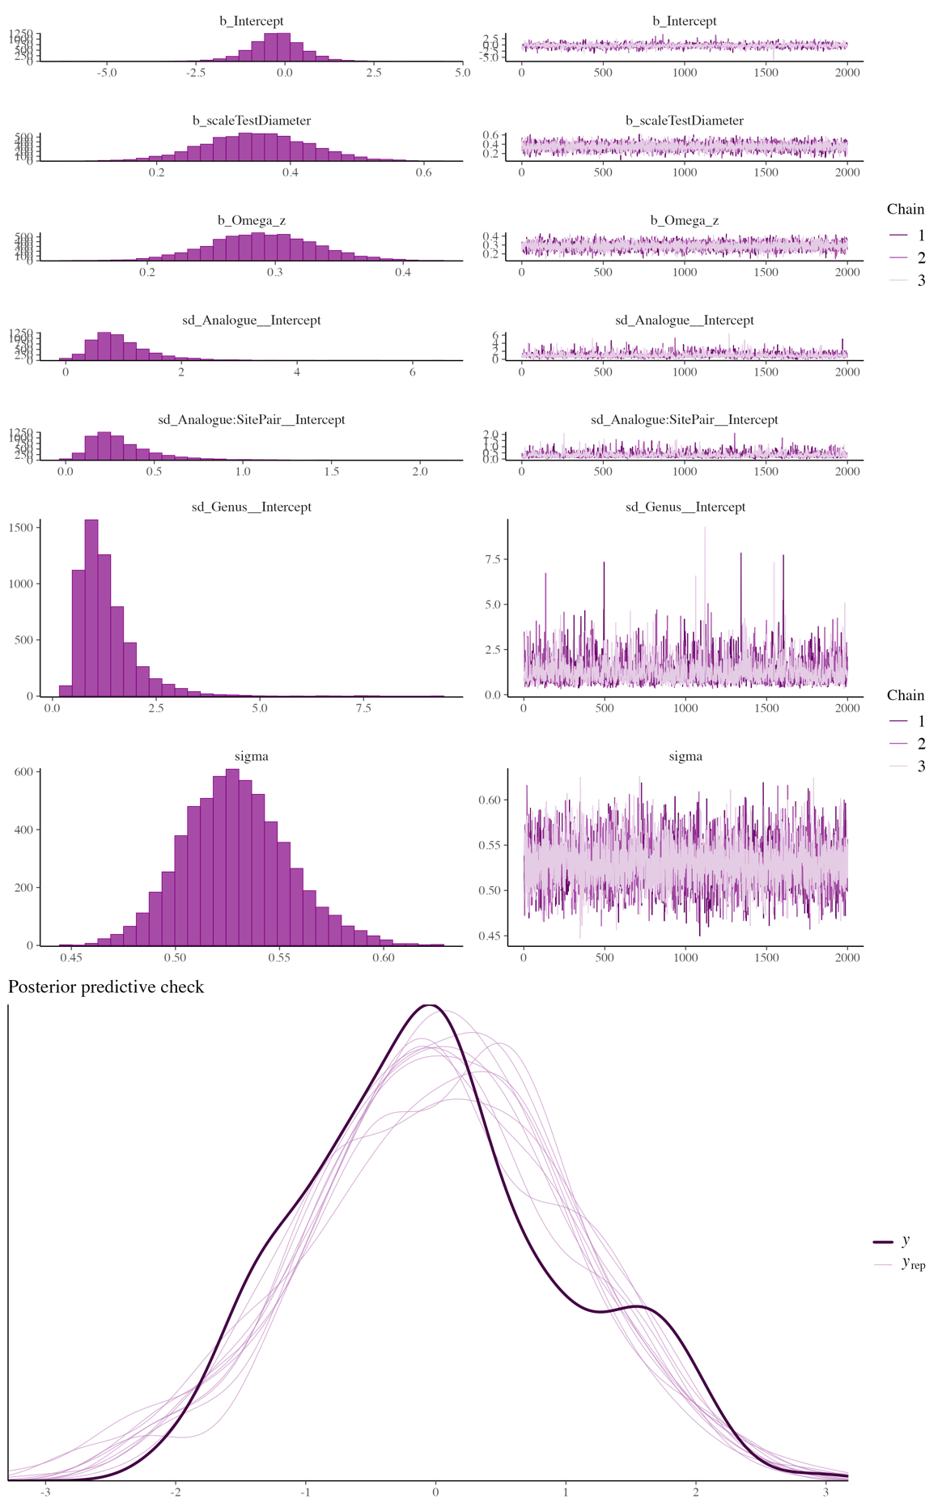
Fig 11. Bayesian model diagnostics for the Ω_{Mg-calcite} main-effect model fitted to spine thickness (μm).
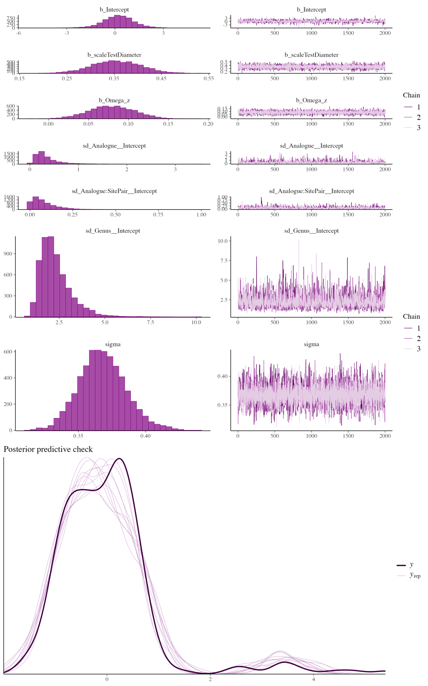
Fig 12. Bayesian model diagnostics for the Ω_{Mg-calcite} main-effect model fitted to spine length (mm).
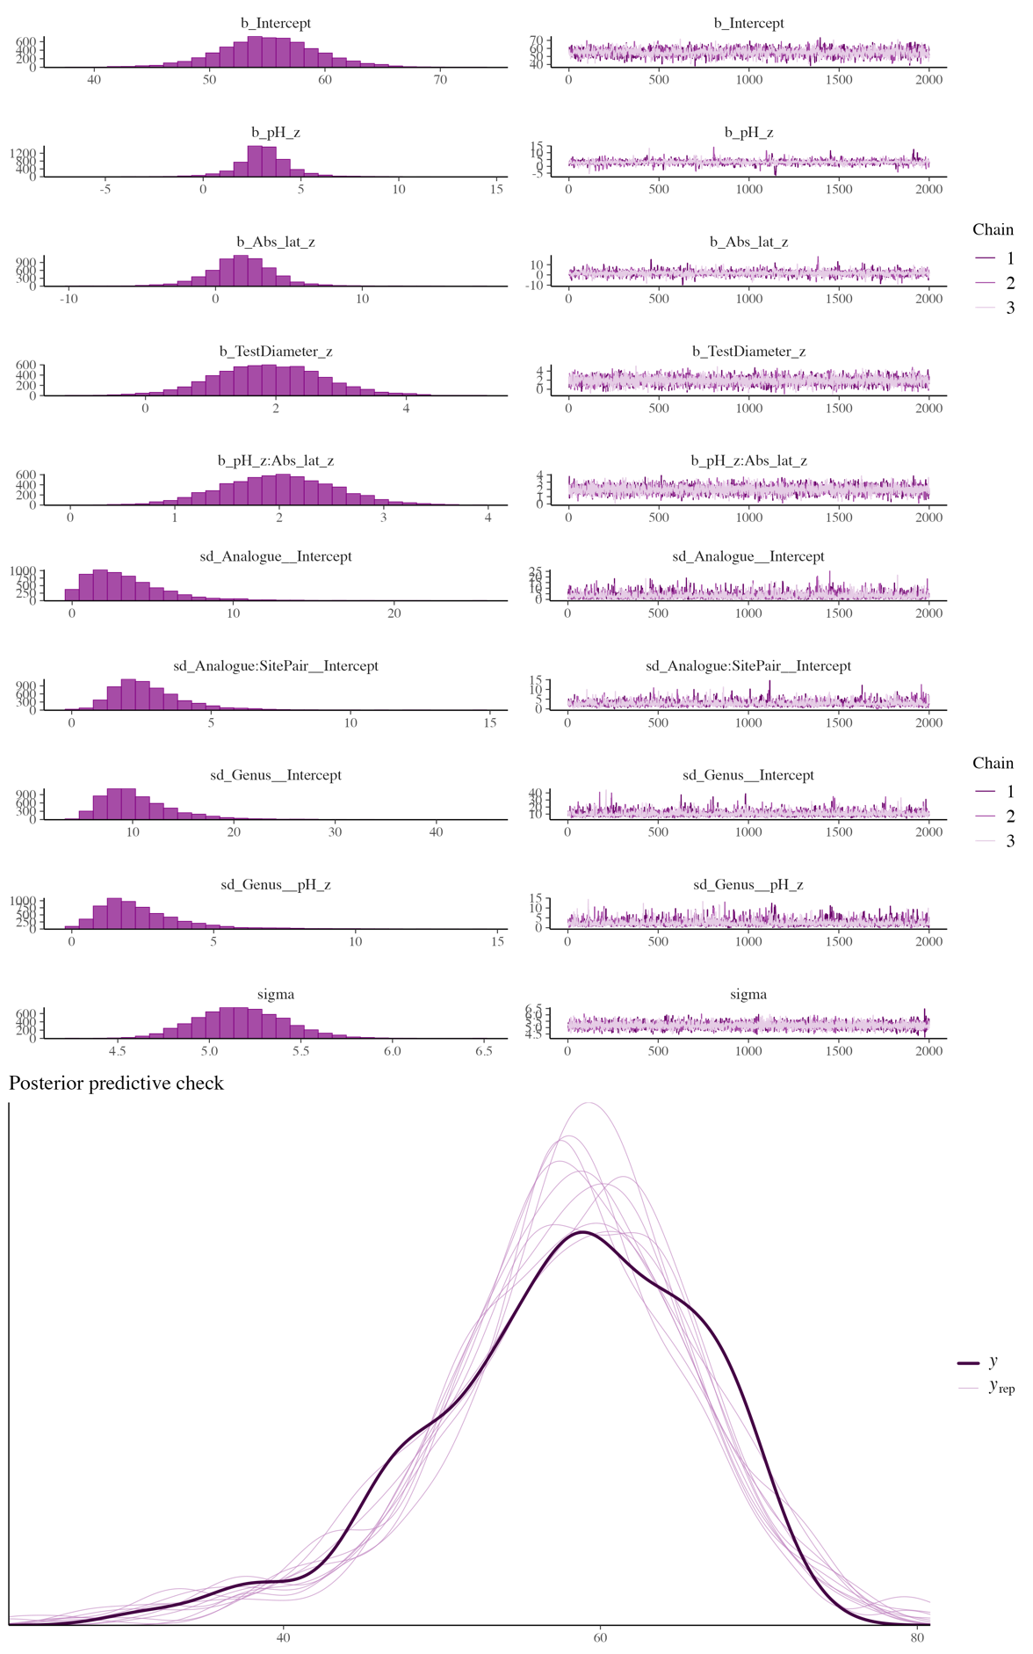
Fig 13. Bayesian model diagnostics for the pH × Absolute Latitude interaction model fitted to test biomineral content (%).
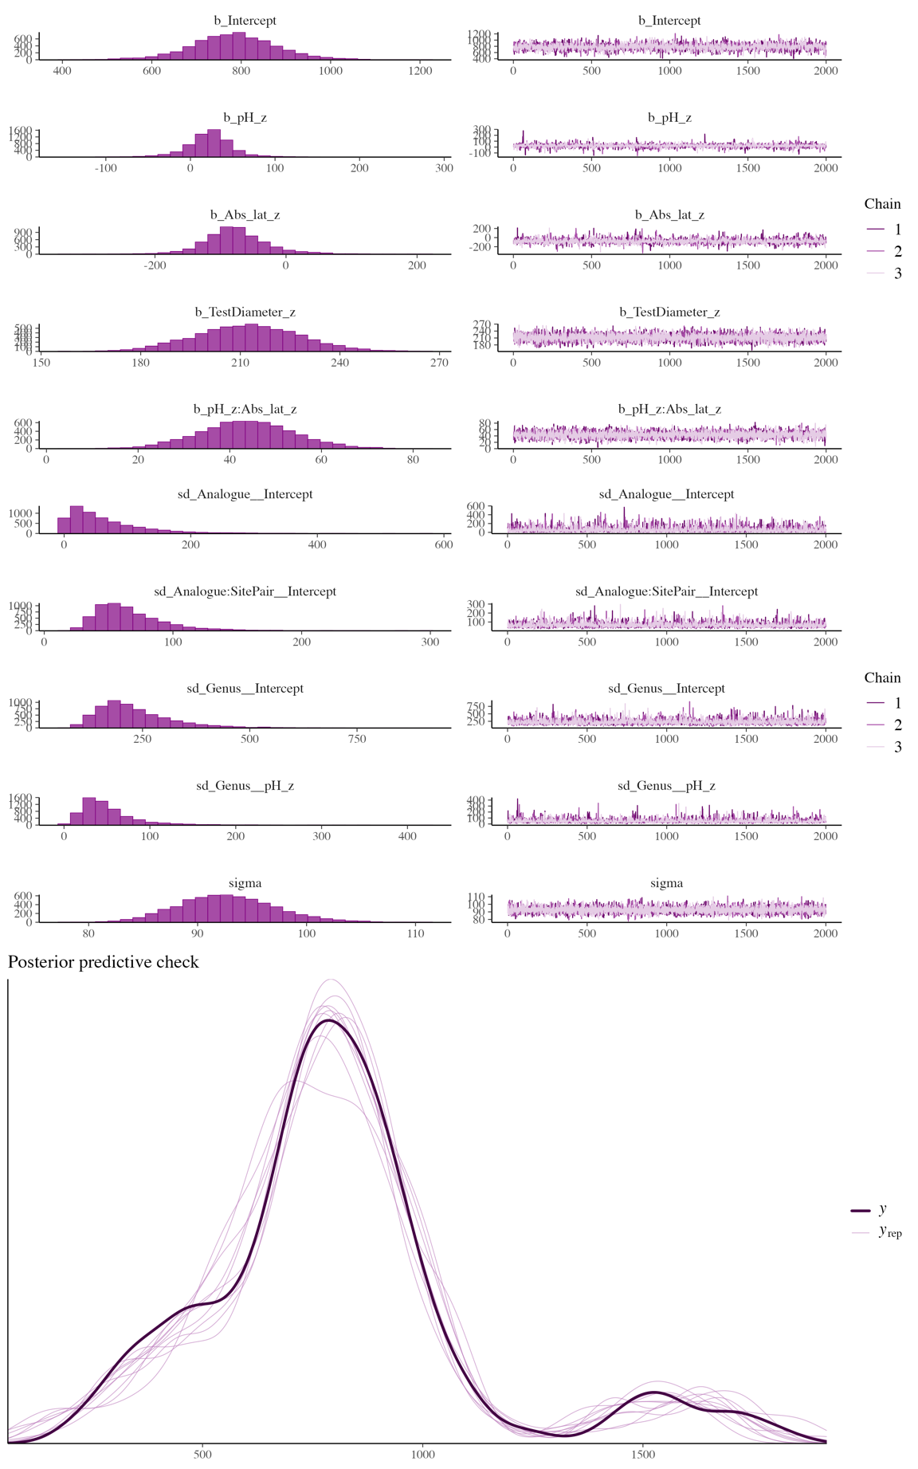
Fig 14. Bayesian model diagnostics for the pH × Absolute Latitude interaction model fitted to test thickness (μm).
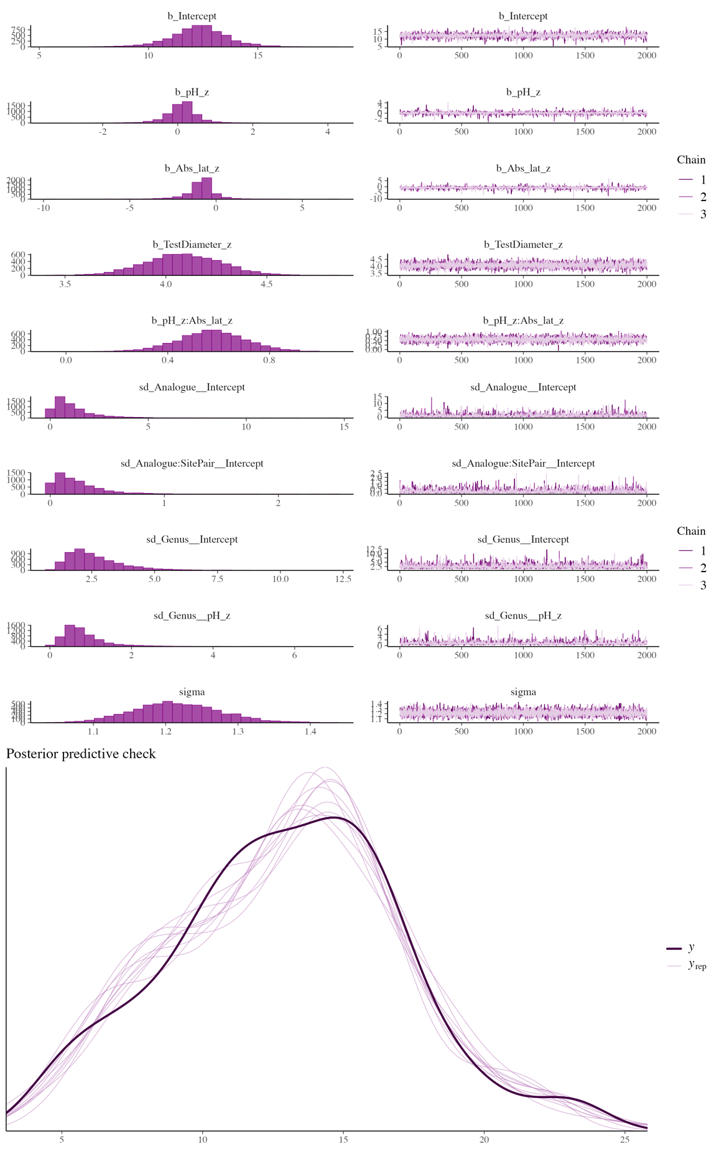
Fig 15. Bayesian model diagnostics for the pH × Absolute Latitude interaction model fitted to jaw length (mm).
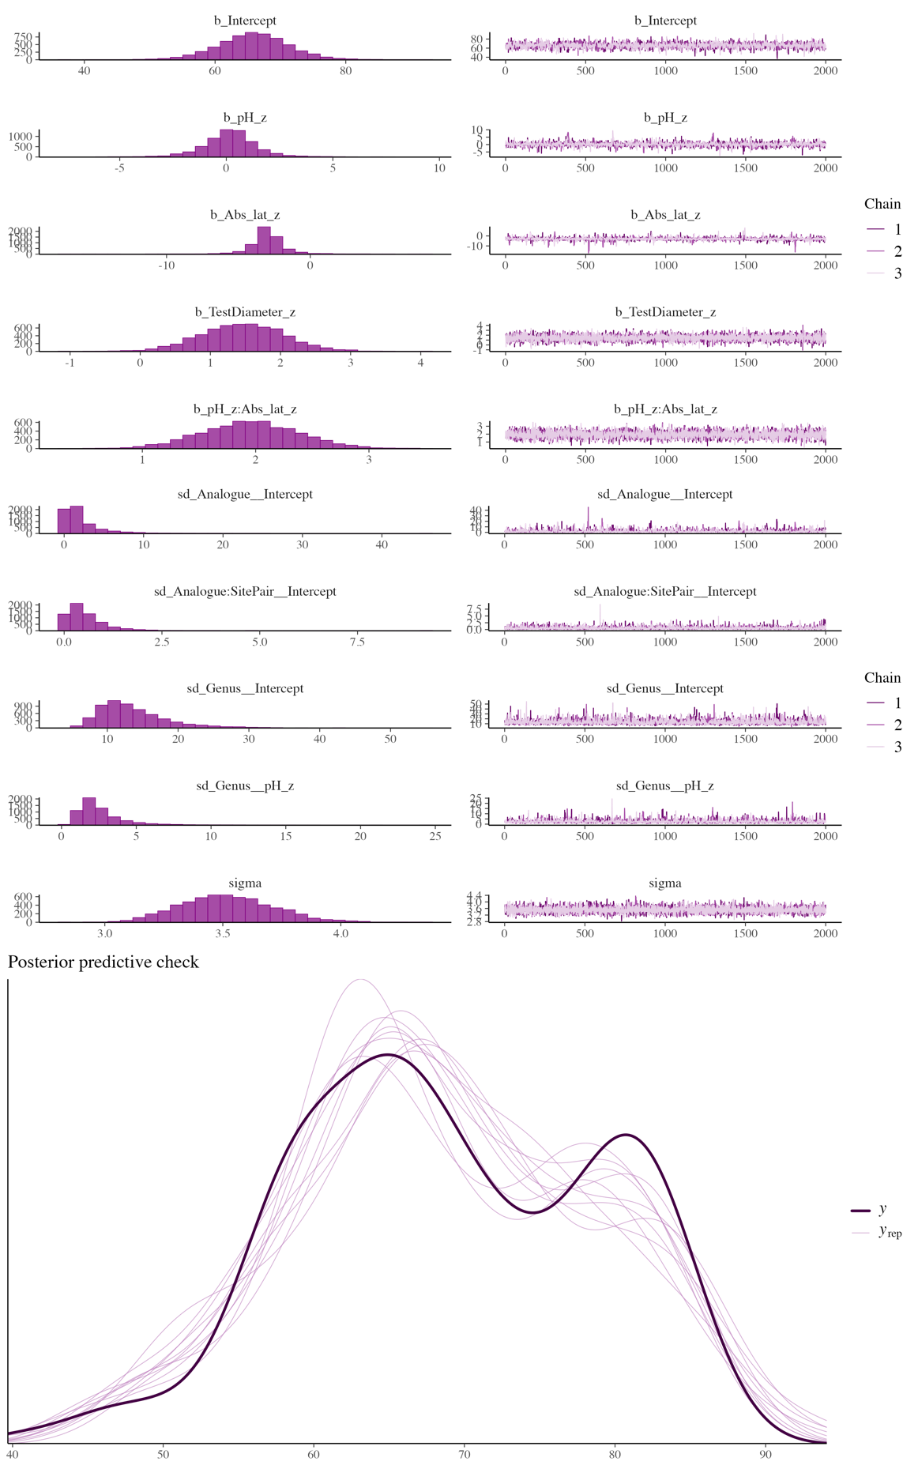
Fig 16. Bayesian model diagnostics for the pH × Absolute Latitude interaction model fitted to spine biomineral content (%).
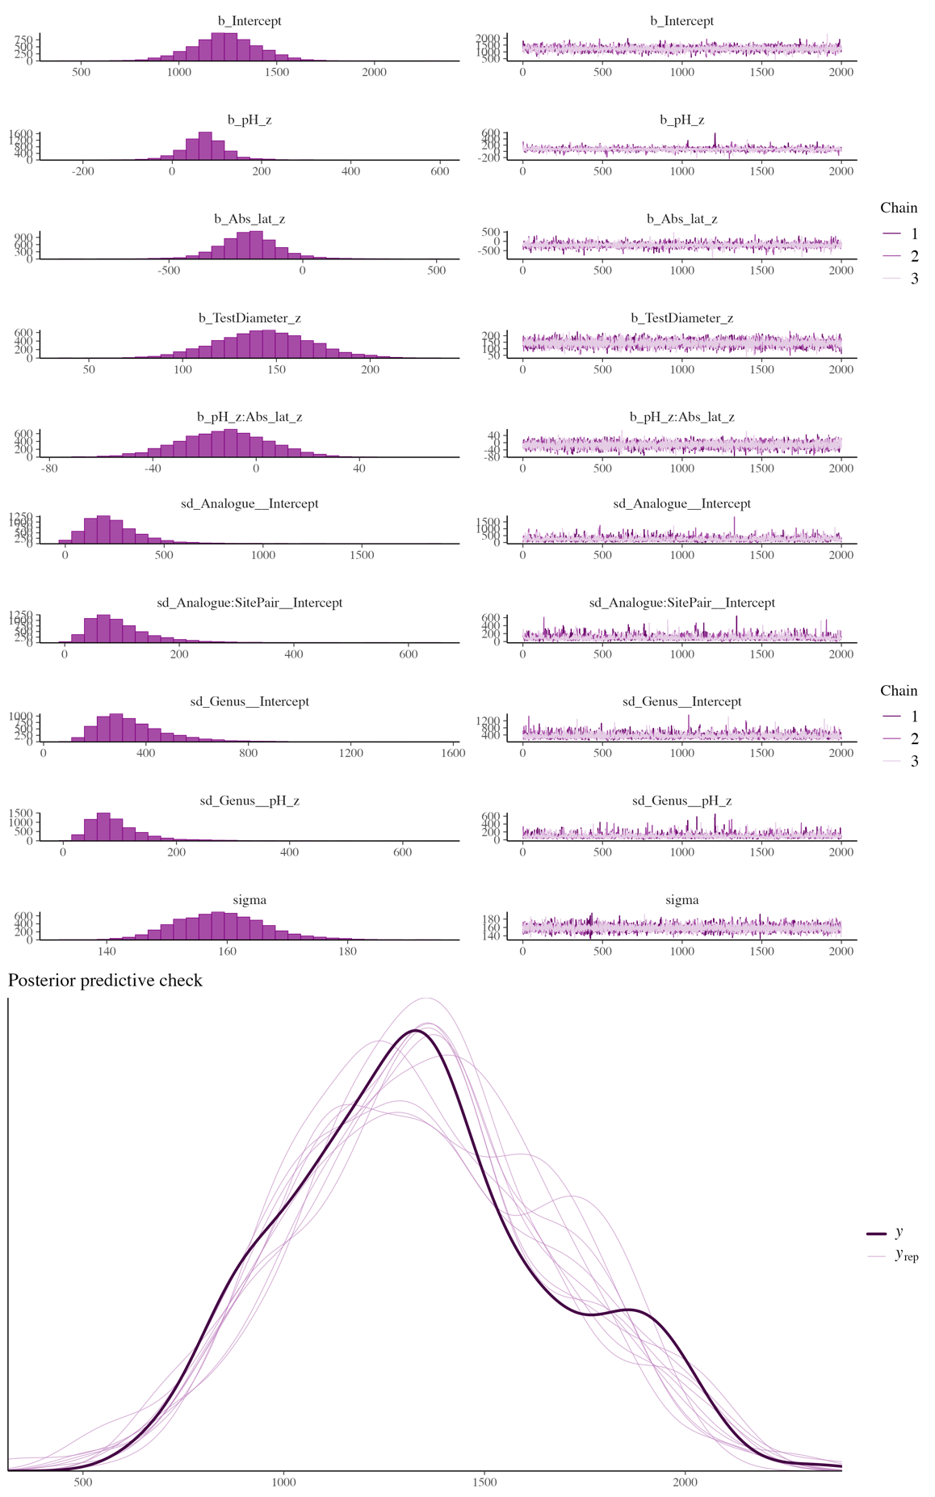
Fig 17. Bayesian model diagnostics for the pH × Absolute Latitude interaction model fitted to spine thickness (μm).
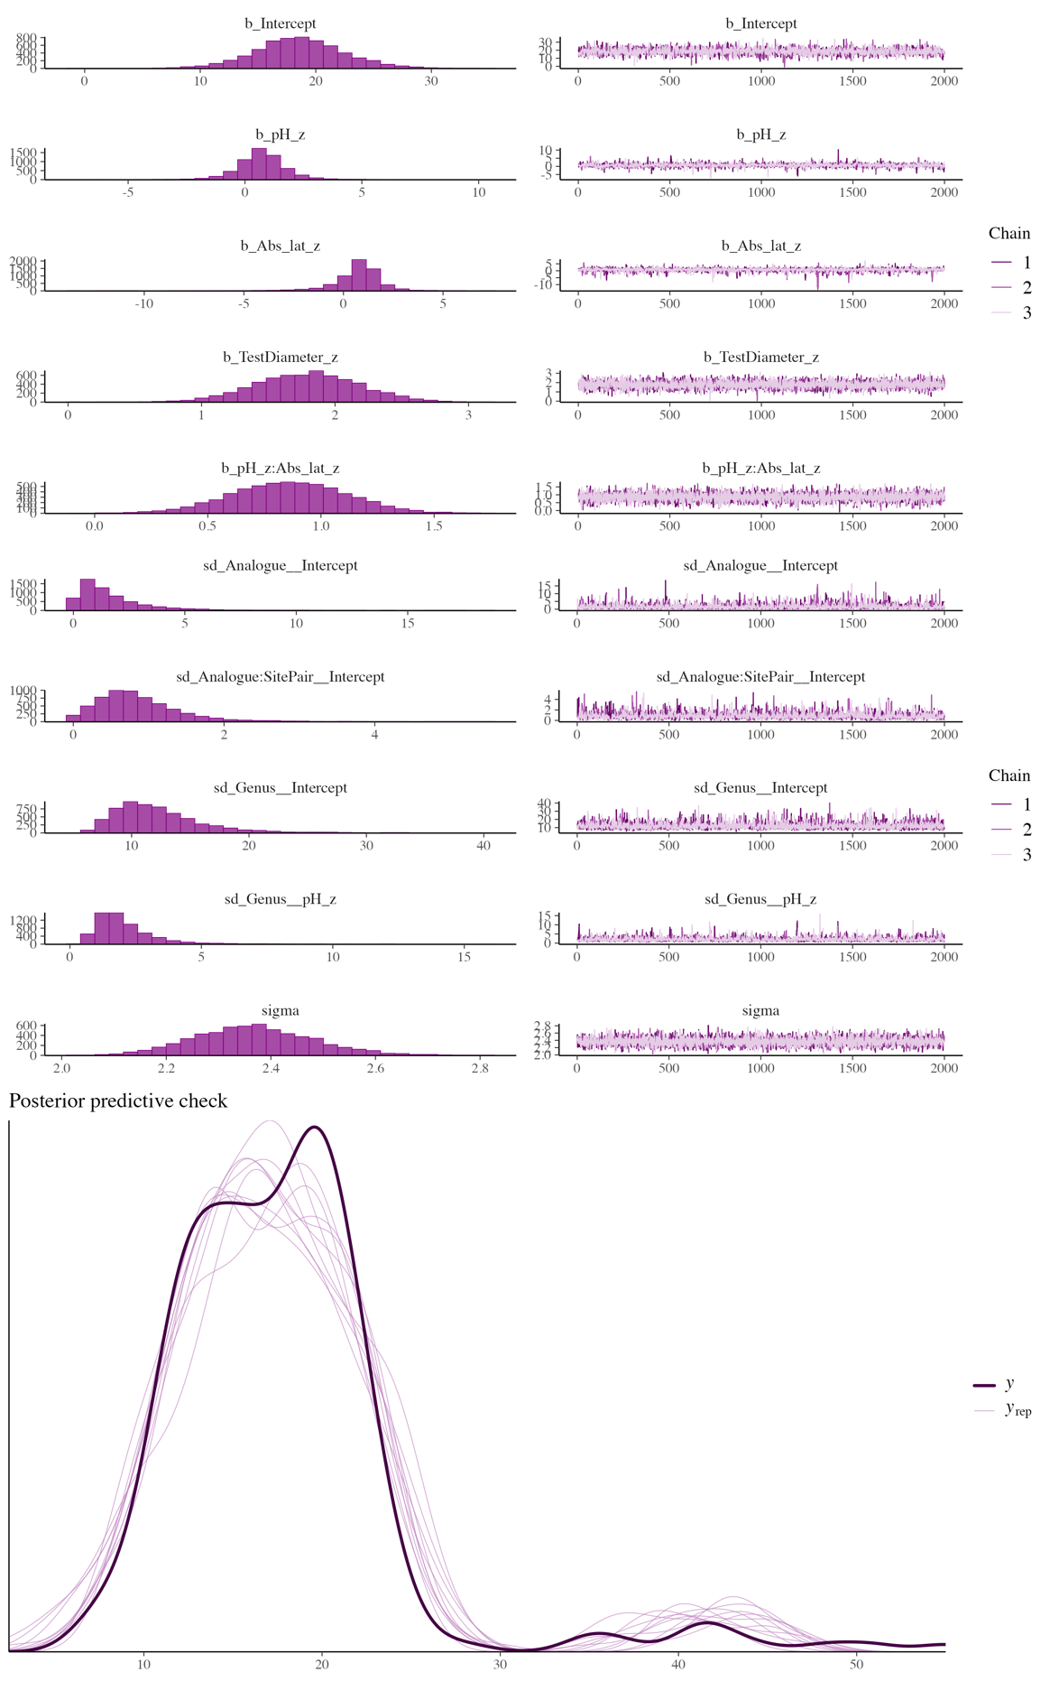
Fig 18. Bayesian model diagnostics for the pH × Absolute Latitude interaction model fitted to spine length (mm).
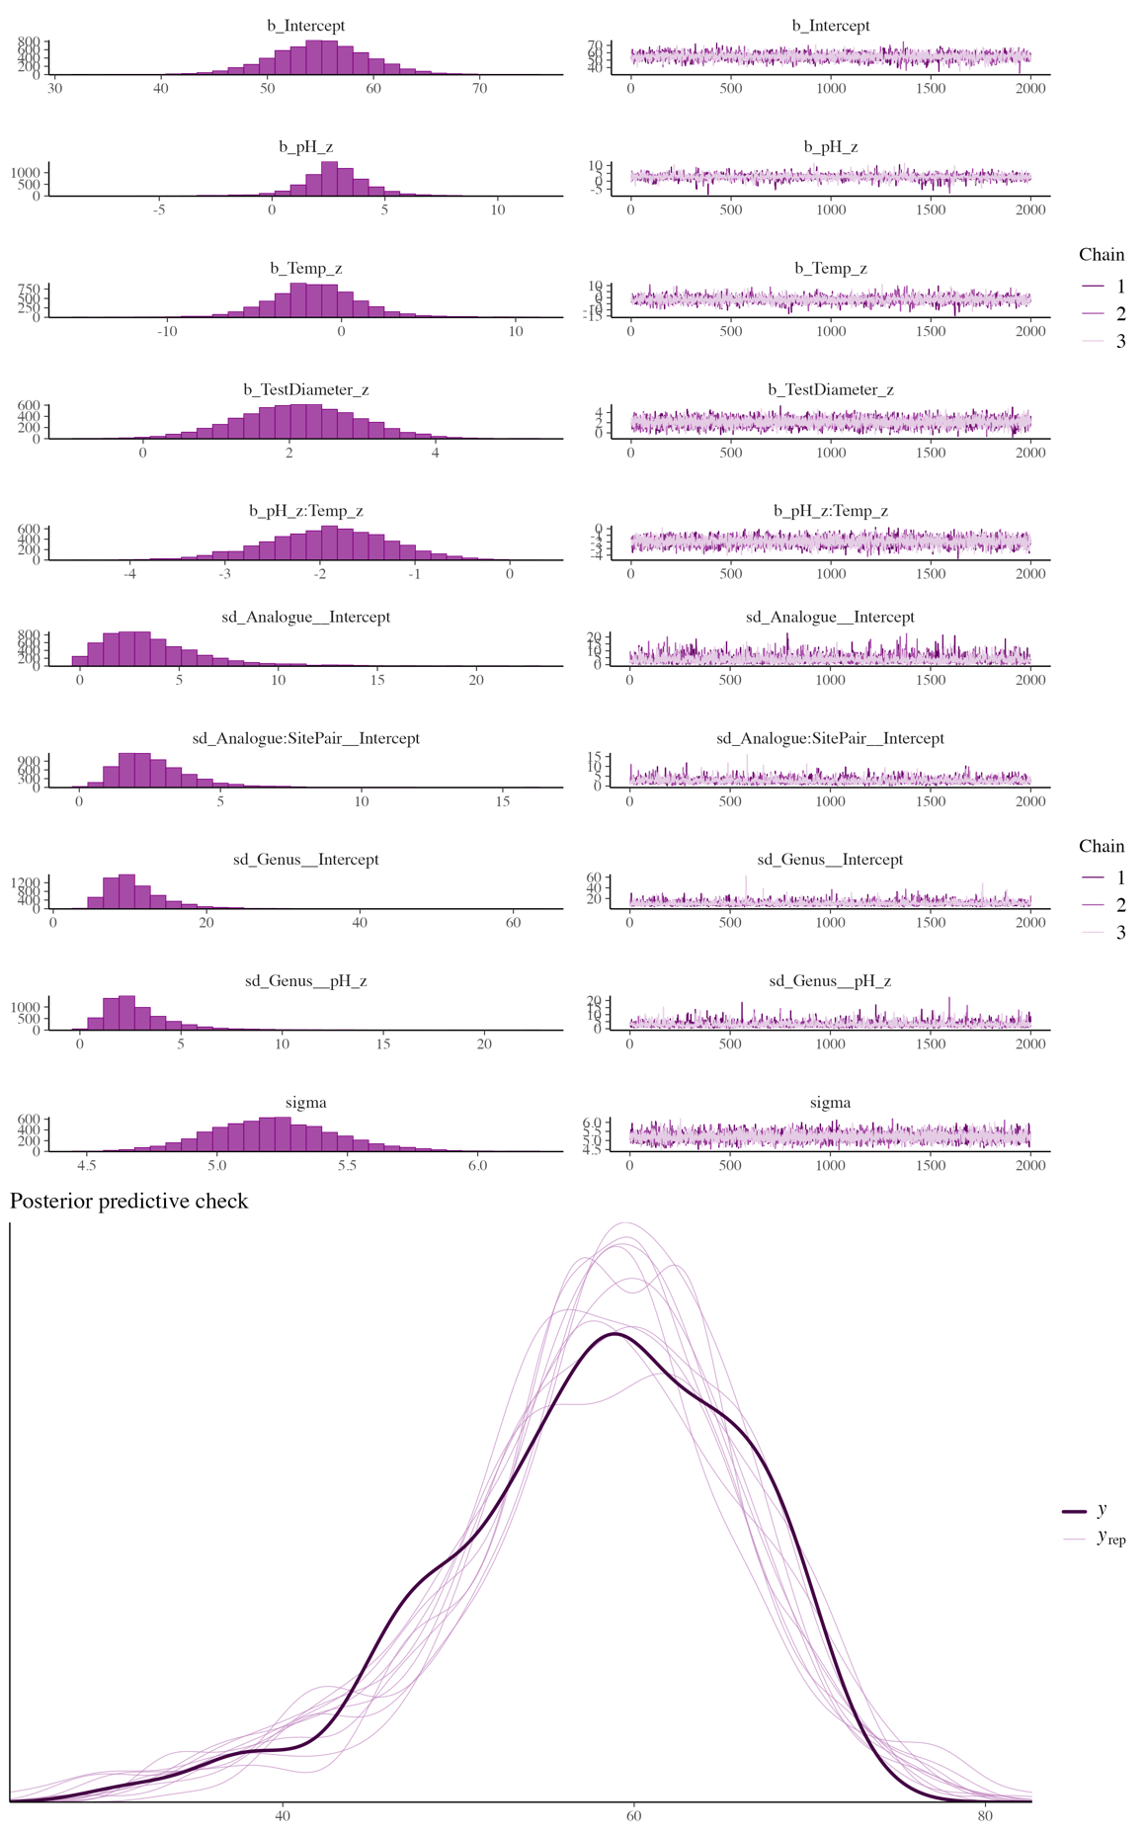
Fig 19. Bayesian model diagnostics for the pH × SST interaction model fitted to test biomineral content (%).
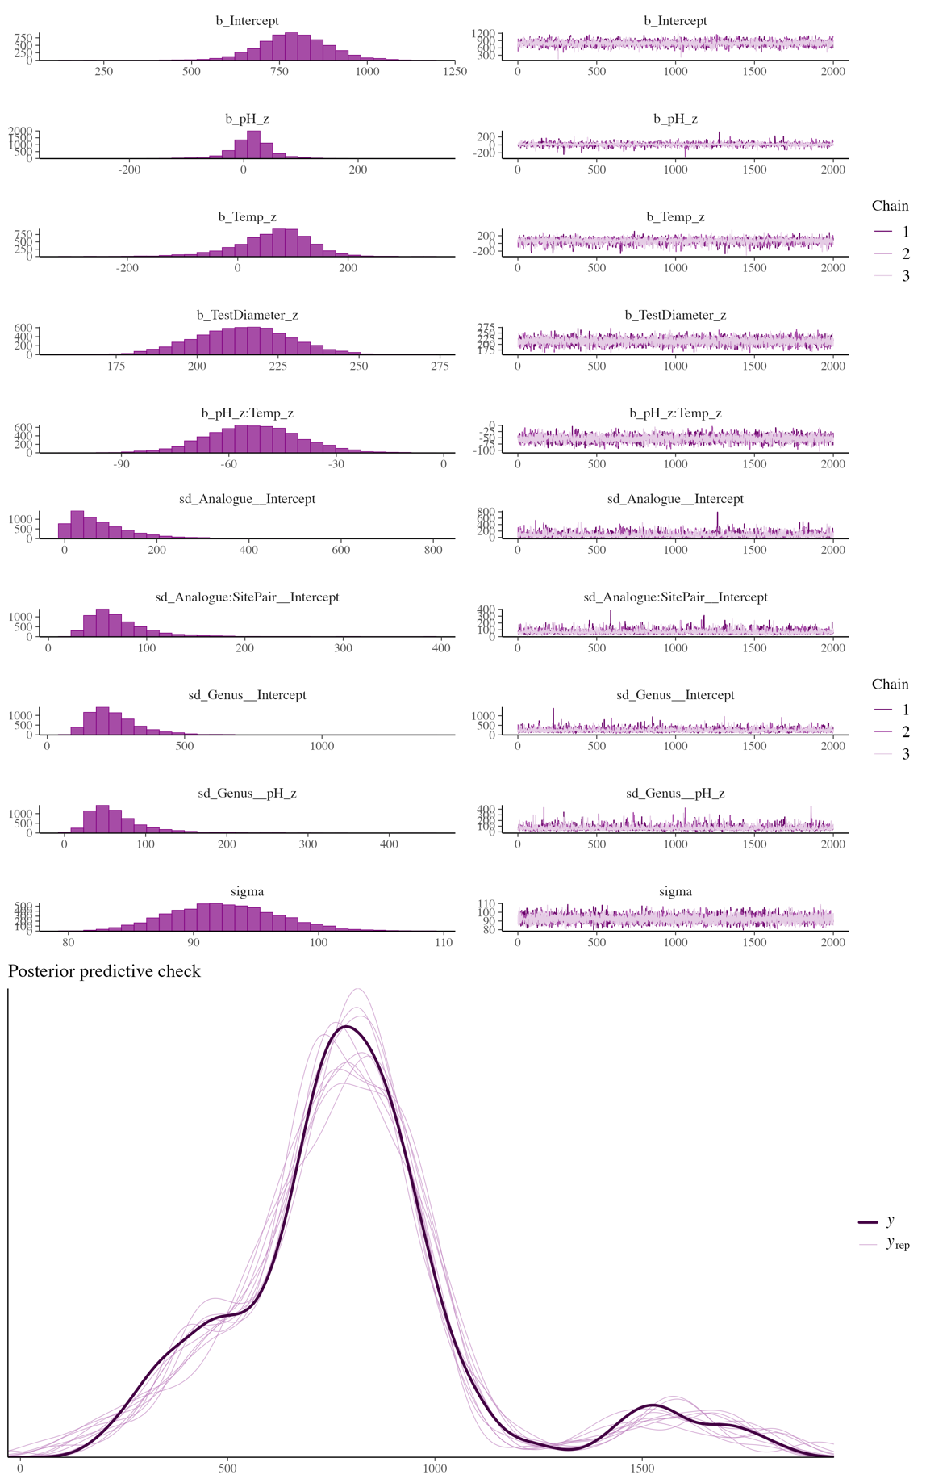
Fig 20. Bayesian model diagnostics for the pH × SST interaction model fitted to test thickness (μm).
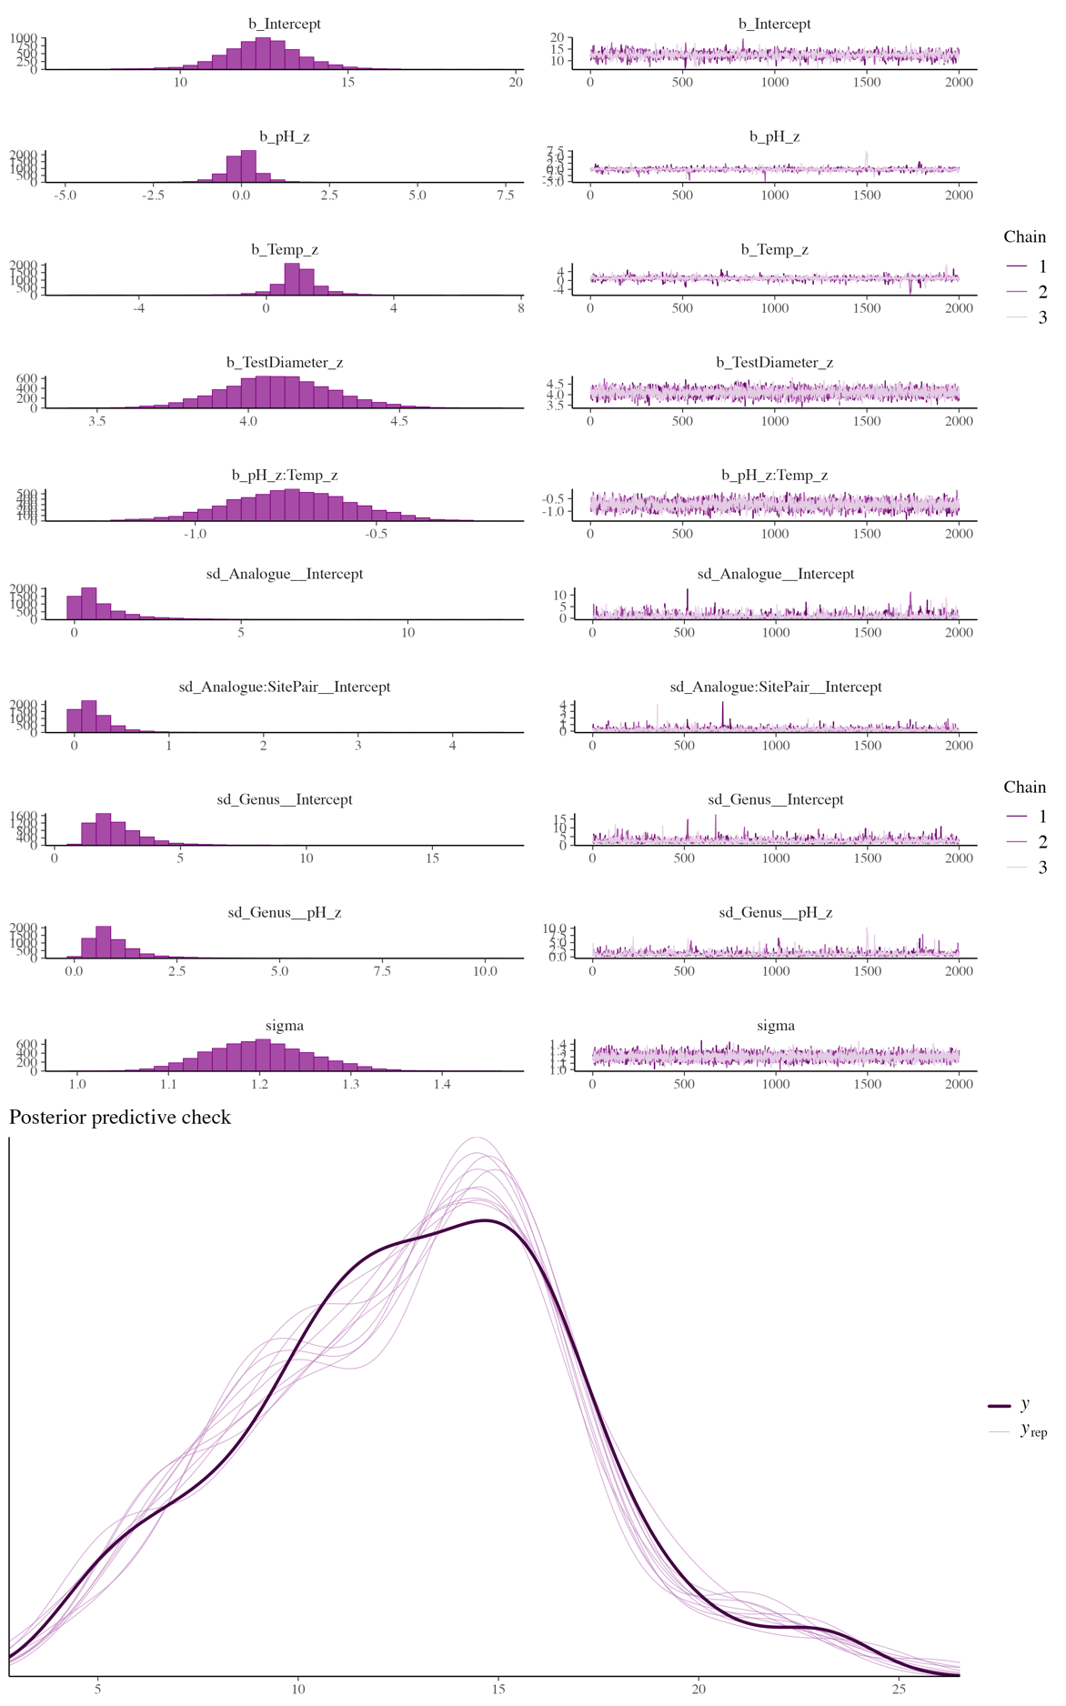
Fig 21. Bayesian model diagnostics for the pH × SST interaction model fitted to jaw length (mm).
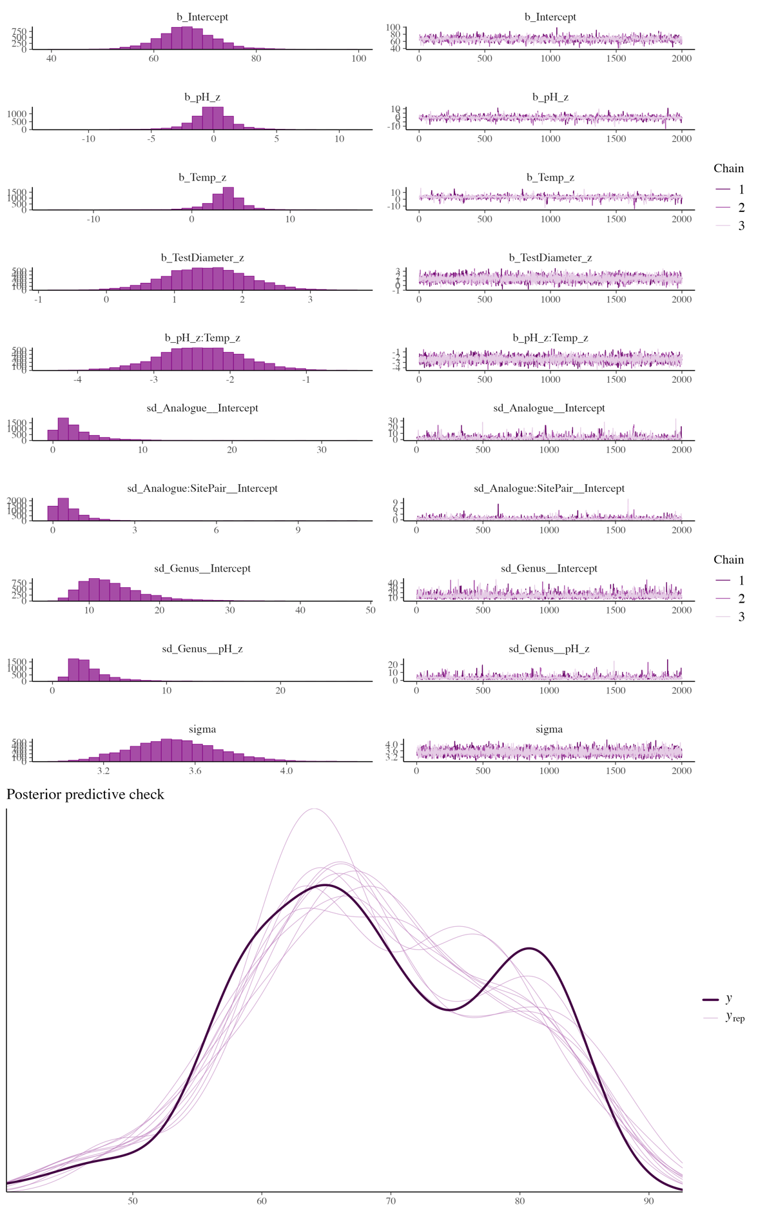
Fig 22. Bayesian model diagnostics for the pH × SST interaction model fitted to spine biomineral content (%).
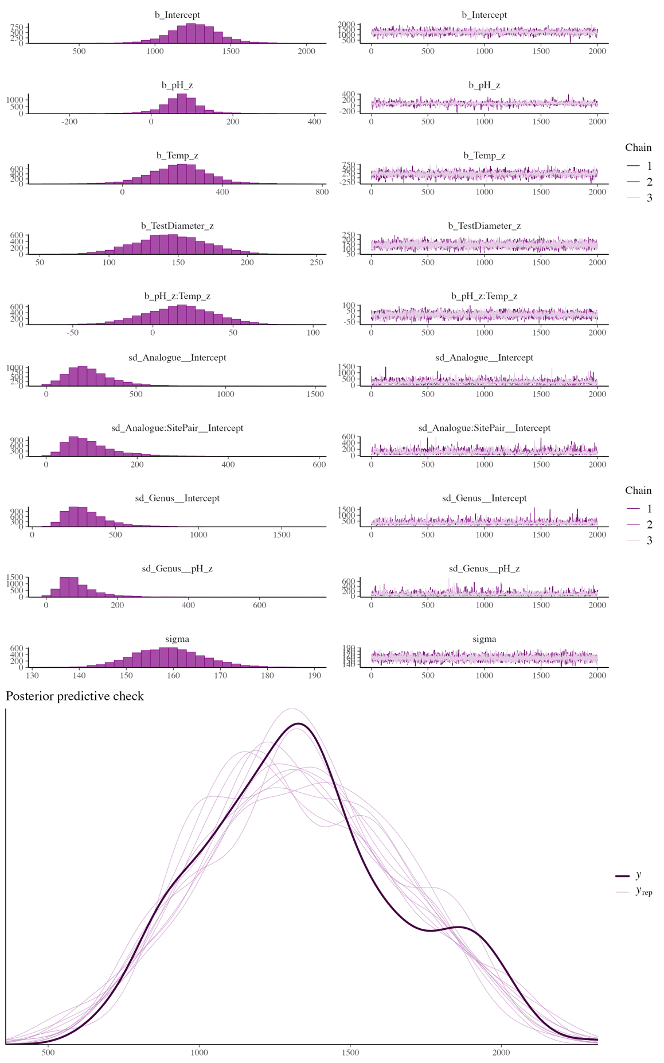
Fig 23. Bayesian model diagnostics for the pH × SST interaction model fitted to spine thickness (μm).
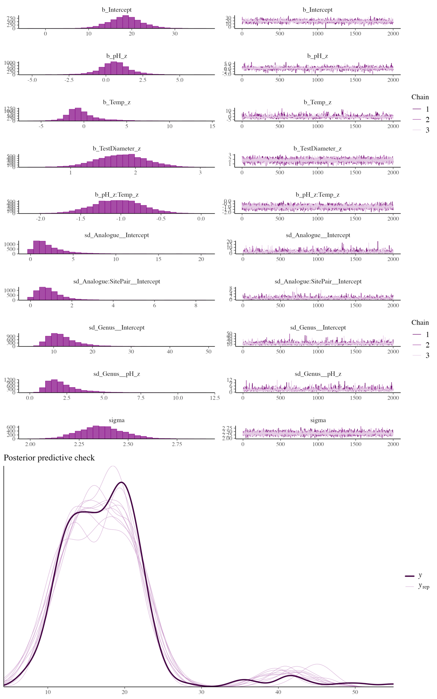
Fig 24. Bayesian model diagnostics for the pH × SST interaction model fitted to spine length (mm).

