FitterBit

Callum Boyd 2078476b, Peter Maitland 2200049m, Lukas Backis 2145673B

team_Name

# ABSTRACT

FitterBit is a simple web application targeted at joggers of all levels. Its goal is to let joggers track their own statistics to improve their results and to look at friend's runs. As long as the users use tracking technology that outputs .gpx files for their runs, they can use FitterBit to its full potential. When a user accesses FitterBit, they will be shown the various stats of their last run as well as look at the route they've taken. They can also look at their previous runs and see the same data for those and can also look at the runs their friends shared, to both follow how they are doing and look into new routes they may want to run. The application was partly implemented, with some features not being finished or put into effect, but doing the essence of what it was supposed to. The application was still well received and rated well, especially on its design/ease of use and practicality.

# INTRODUCTION

As part of our coursework for the Interactive Systems Honours course, we were required to design a web application that worked with gpx files and that filled some kind of purpose. We started by brainstorming to find an idea for a useful, but also somewhat simple application, as the time allocated to create the application would not allow for very complex ideas to be implemented in time. A few ideas were explored: one was to draw the route from multiple gpx files on a map, and change the color scheming of the route according to the speed of the jogger. With enough gpx files, you could then see which streets have you stop or slow down often(uphill slopes were assumed to be canceled out by people running them downhill) and which were faster, allowing you to create more efficient routes for yourself. This idea was however dismissed due to the high number of gpx files required, which we did not unfortunately have. Another idea was for a personal trainer type of application, where the user would upload a number of gpx files, the application would analyse it and then give the user advice according to his/her own goals (e.g. if the user decided that he wanted to be an “all around good runner”, the app would suggest him/her to run more sprints if he mostly ran long distances). This, however, seemed quite complicated to develop and also required more gpx files than we had access to. In the end, we ended up opting for a less original, but more feasible idea – a simple social stat tracker application, where you uploaded your gpx files and showed them on a map and could also share your data with friends and see your friends' data. In the hands of a capable user, this application would fulfill the role of both the aforementioned applications, as the user could look at their friend's routes and see how they went and also analyse their own data. It also did not require many gpx files to be useful. User personas were then created to understand the requirements users may have better. After that, it was decided that Callum and Peter would focus on the project's functionality, while Lukas would work on the visual aspect more, with a high degree flexibility. The app was developed to most of its requirements and was rated well by users on Friday the 24th of November, despite missing a key feature at the time.

# Project Concept

Our web application's main aim is to allow runners, who use wearable technology to track their stats, to upload their gpx files and view these in a user friendly way. Users will be able to view their most recent run on Google maps, as well as see statistics such as speed, distance, time taken, heart rate and elevation about this run. Users can also view past runs under 'Your Activities' as well as their friends runs under 'Friends Activities'. Users are also able to view their statistics over all the runs they have uploaded to see whether they are improving upon previous runs. While not currently implemented, in future iterations we would look to fully implement user profiles to accurately keep track of all uploaded files from a particular user. This would also allow us to implement privacy settings to choose whether you want to share runs as well as be able to add friends to view their runs.

## Implementation

*Provide a technical overview of how the system is implemented. You may find it helpful to include diagrams providing an overview of the architecture.*

## Peer Assessment

The peer assessment was positive regarding the idea of the application and rather good regarding user personas, however, it was negative regarding the format of our submission (we had opted to write personas and scenarios/storyboards as on in a story format, but it seems like it ended up just being confusing). One particular piece of feedback noted that graphs would be nice to show user statistics and we ended up implementing that as we thought it would be a good addition to the application. Two things we decided to not do were user settings and user login, as these would require a back-end, which was not required nor reasonably possible to implement in such a short time.

# Evaluation

*Provide a detailed description of how you completed the evaluation of your prototype. You are expected to include a combination of quantitative and qualitative results.*

## Results

Here are results for all quantitative questions:

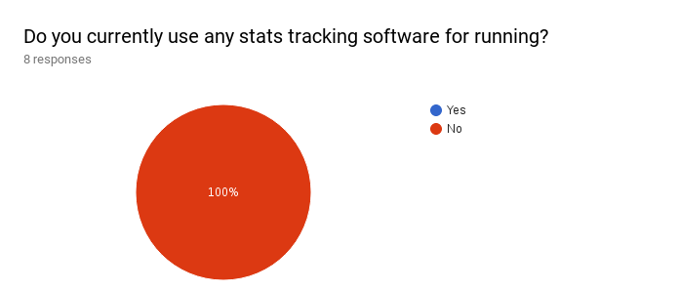

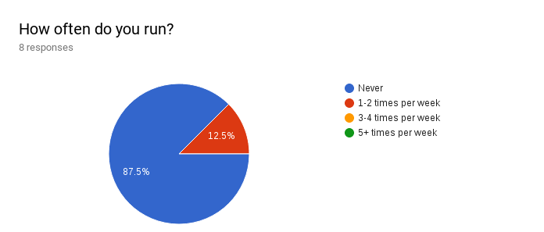

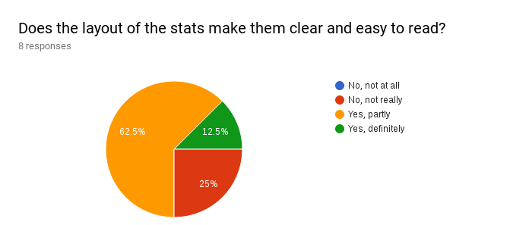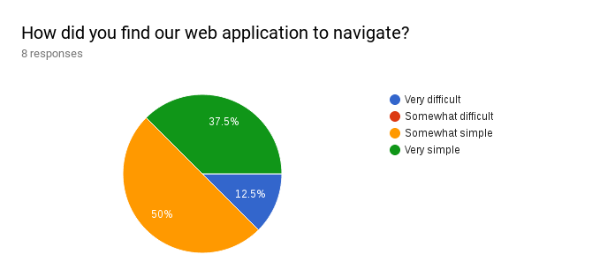

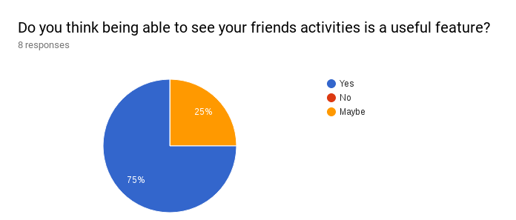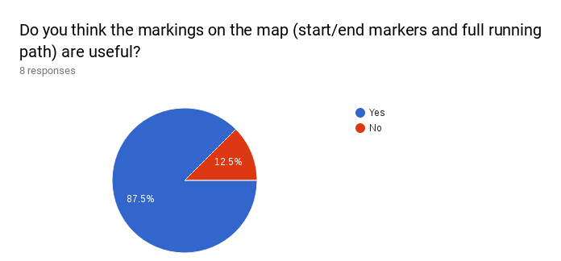

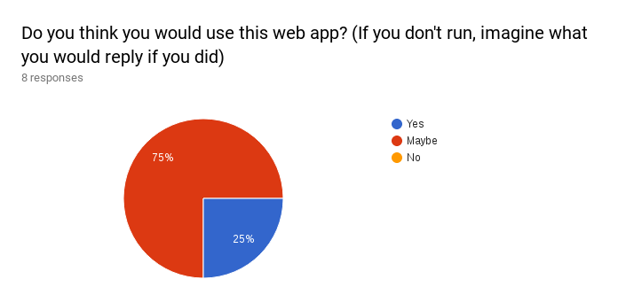

Here are some answers of the qualitative questions:

Q1. What did you like about the application?

“It's a good way of keeping track of your stats. Types of statistics are very clear. Overall stats of all GPX files uploaded is a good feature.”

“The colour scheme is lovely.”

“Simple and easy to use layout, not overloaded”

“Being able to see how long other runs take sounds like a good idea”

Q2. What did you not like about the application?

“Upload button doesn't work” (It did not at the time)

“The stats look like buttons, no good. Also choose a different shade of pink, looks like it is the 'Paint' default pink.” (changed to look different, whole color scheme changed to blue based instead of pink)

“Your stats page is a bit empty, not very useful just now”

# DIscussion

Overall, the feedback is positive. Some of the negative feedback was taken into account to optimise the user experience. There is obviously still a lot to be done and the questions did not necessarily provide participants total freedom to express their feelings about the project. Still, the site now looks and feels rather different (arguably in a positive way) than it did before the evaluation and probably would look even more different if we went through this process again and added some questions as it went on.

# Conclusion

FitterBit was developed as a stat tracker for gpx files generated by joggers. It succeeds in meeting a good portion of its ambitious initial requirements, which we judge to be a satisfying result considering the limited amount of time available for development. The feedback was relatively positive and the negative feedback helped us improve the application further. The project was a positive experience and we look forward to working on similar projects in the future.

# REFERENCES

You may find it helpful to include references to any material that has informed your design or your evaluation. Use citations as a way to support decisions you have made during the design and to support your approach to evaluating and analyzing your project.

1. @_CHINOSAUR. 2014. VENUE IS TOO COLD. #BINGO #CHI2016. Tweet. (1 May, 2014). Retrieved February 2, 2014 from https://twitter.com/_CHINOSAUR/status/461864317415989248

**Columns on the last page should be of approximately equal length. Remove this line before submission.**