Image Formation

Separating the scene into elements leads to a simpler API, faster hardware implementation, and 2D graphics becomes a simple case of 3D graphics.

Elements:
Objects
- independent of any process and/or viewer
- a set of vertices in space defines the object’s structure

Viewer
- the perspective from which an image of the scene is taken

Light Sources
- without light, the image would be black
- emit either as a set of discrete frequencies, or continuously.
- light travels in a straight line
- ideal source emits from a single point equally in all directions.

Characterised by
- intensity of light at each frequency (colour)
- direction of emission

Attributes: govern how light interacts with the material in the scene.

Ray Tracing:
Follow rays of light from the source to see if they interact with the camera.

Luminance Images – monochromatic grey scale, analogous to working in black and white film/TV.

Colour Images:
- Hue: colour (wavelength/frequency of light)
- Saturation (chroma): intensity or purity of hue, 100% = no grey.
- Lightness (value): degree of black and white

Imaging System
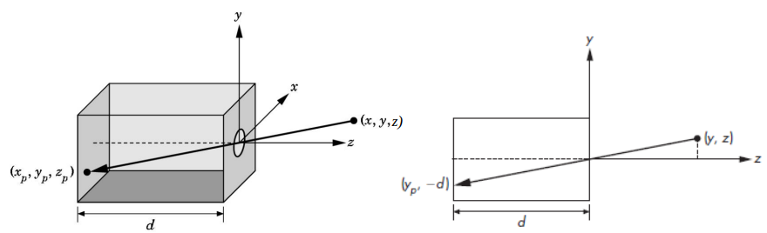
Pinhole camera
- field or angle of view is made by the largest object the camera can image on its film plane
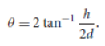

- ideal pinhole camera has infinite depth of field (distance between nearest and farthest objects)
- only admits a single ray from point source, not much light enters camera
- cannot be field adjusted

Human Visual System:
- Rods – monochromatic, night vision
- Cones – colour sensitive, three stimulus values sent to the brain, therefor we only need to match these three colours

Additive Colour – add amounts of red, green, blue to form colours (CRTs, projection, positive film)
Subtractive Colour – filter white light using amounts of magenta, yellow and cyan. (negative fim, printing, light-material interactions).

Synthetic Camera Model:
- OpenGL uses this
- image is flipped, so we draw another plane in front of lens, onto which the image is taken.
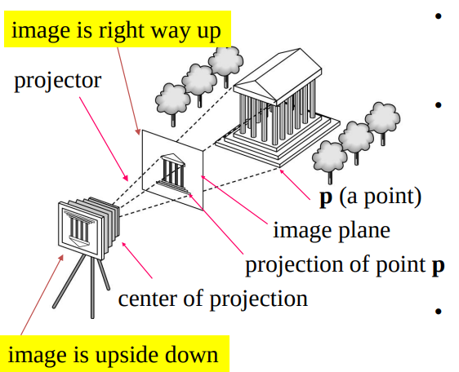

OpenGL
API for graphics, close to the hardware for performance, links low level graphics hardware to high level API, easy to use.
