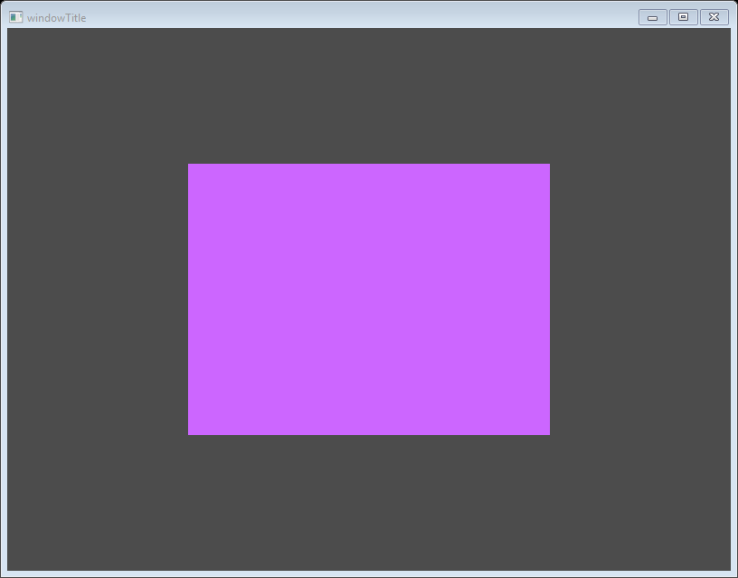

|  |  |
| --- | --- |
| https://learnopengl.com/img/getting-started/perspective_orthographic.png | https://learnopengl.com/img/getting-started/perspective_orthographic.png |
| https://learnopengl.com/img/getting-started/orthographic_frustum.png | https://learnopengl.com/img/getting-started/perspective_frustum.png |

