3.3 Visualize Wi-Fi RSS heat maps of 3 Wi-Fi APs

In this secion, we choose the dataset of floor 3 of site 1 for the task and we randomly selected three Wi-Fi Aps to visualise the heat maps.

For the data preparation part, we set the global variable ‘floor_data_dir’ to ‘/data/site1/F3’ and the path for the output directory is set to ‘./output/site1/F3’ accordingly. The Wi-Fi dataset is extracted from the trace files and calibrated with the function calibrate_magnetic_wifi_ibeacon_to_position(path_file_list), in which the path_file_list is passed with the full path by concatenating with the ‘floor_data_dir’ and ‘/path_data_files’.

For the visualization part, we defined a function wifi_heatmap(position, value, floor_plan_filename, width_meter, height_meter,target) to visualize the heat map of a Wi-Fi AP. The positions and RSSI data is extracted from the dataset as the first 2 arguments, together with the floor plan information and the AP as the rest arguments. The function calls the pyplot to plot the heat map when the MAC address of a specific AP is passed.

In this task, we randomly selected below three Wi-Fi APs for the visualization:

12:74:9c:2e:b7:ab

16:74:9c:2e:b7:ab

c4:86:e9:d1:5b:14

The heat maps of the Wi-Fi APs are illustrated as below:

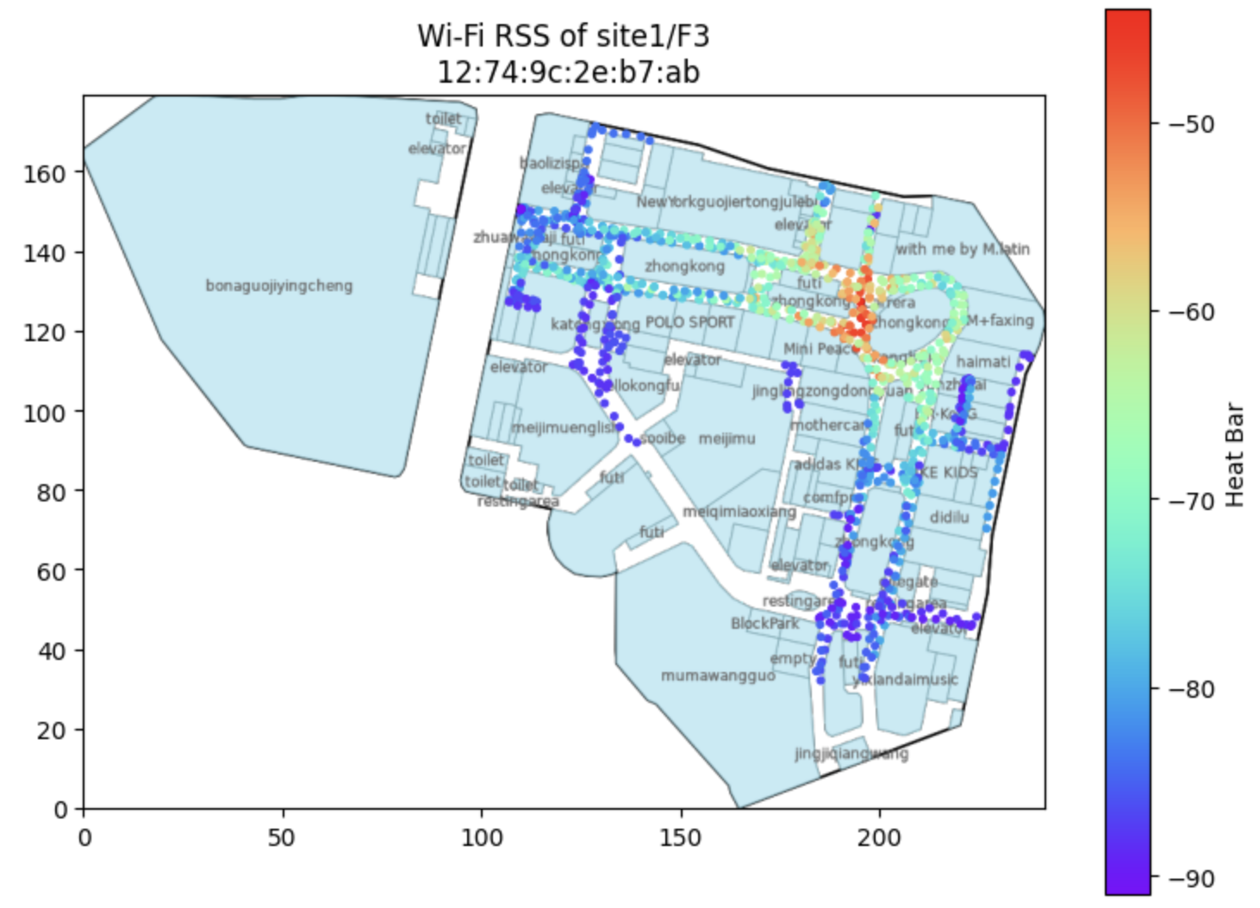

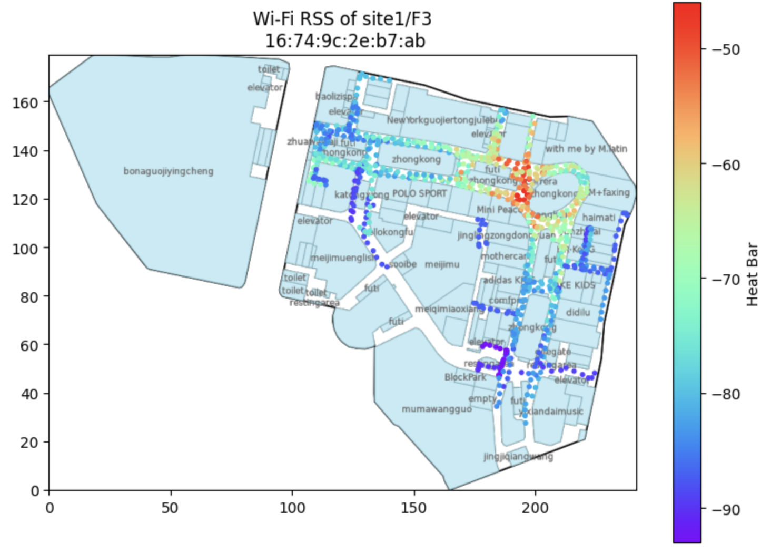

The points of each figure above indicate the locations where signals of the specific AP are detected and the colors of the point reflect different strengths of the signals. For a specific AP, due to the power of the device and the space layouts, the signals detected at different locations are different, and the signal is weaker the further the distance.

The first 2 APs have got much biger coverage of the floor than the third one, indication a more powerful devices. The first 2 APs may be deployed within this floor and the locations may be around the red area. The 3rd AP, may not be deployed within this floor and the location is around top right cornor of the building. The first 2 APs may be the same model due to similar MAC addresses.

To prove the assumption, we generated the heat maps of the same APs of floor 1 and floor 2 as well. From the below figure, the patterns of signals of the 2 APs are highly alike, and the strengths and coverage indicating that they may be deployed on floor 2. While the 3rd AP has less coverage, indicating different model with lower power, and the location of deployment should be under floor 2. By checking the SSIDs of the 3 APs, this assuption is also confirmed, that the 3rd one has got the name ‘LNO’, a merchant of the while the 2nd one has ‘intime_lease’ which is the name of the mall operator.

