Callum McFarlane

CSY1018 – Web Development

Javascript assignment

|  |  |
| --- | --- |
| **Feature** | **Implemented** |
| When the start button is pressed the game should begin and the start button should no longer be visible | Yes |
| Bombs get created at a random position at the top of the screen | Yes |
| Bombs fall down the screen towards the player | Yes |
| When the bomb hits the ground (green grass area) it explodes | Yes |
| If the player is in the radius of the bomb, print “game over” and set the player’s animation to dead (css class “character dead”) | Yes |
| The bombs should explode at random points on the grass, not all at the same height. | Yes |
| The player will have three lives signified at the top right | Yes |
| Each time the player gets hit by a bomb the player loses a life and display the “hit” animation (css class, e.g. “character hit left”). The life should be removed from the panel in the top right. | Yes |
| If the player loses all three lives, display the character dead animation and print “Game over” to the screen | Yes |
| Display a “play again?” message to allow the player to restart the game if they lose | Yes |
| Implement a scoring system with high scores. Count the number of bombs the player managed to avoid and when they die have them enter their name. When the game ends, ask their name and log the score using Local Storage. When the game ends display the high scores. | Yes |
| Make the game more difficult by randomizing the bomb’s speed and frequency at which they are dropped. | No |
| Make the bombs fall at different angles rather than straight down. | Yes |
| Add levels of increasing difficulty. For example, 10 slow bombs in level 1, 15 bombs in level 2, etc. Extra marks are available if there are an infinite number of levels that gradually increase in difficulty. | Yes |
| There is an “arrow” class and a “fire” animation for the player. Make it so the player can fire up and destroy the bombs before they hit the ground by pressing the space key. When the key is pressed: | No |

**Evaluation**

**Bugs and Weaknesses**

Currently there are very few bugs in the game, however one bug that has been in the game since the beginning is the ability for the player to leave the grass area. This can be done by the player holding either the right or left direction keys and the up key at the same time, allowing the player to leave walk into the sky and out of range of the bombs explosions. This is likely due to some issue in the way that the move function is structured, when both keys are held the line to check if the area above the player is not the sky is being skipped over in favour of the move command.

Another potential weakness is the first initial levels of the game being very slow and tedious to play through for the player. As in order for the game to have a large scaling number of levels the initial levels must be very simple and easy, with a low number of bombs dropping and a slow speed on these bombs. However, this ease is eventually reduced by an increasing number of bombs dropping.

There is also a potential issue with the bomb detection using px to define the area that the bombs can explode, if the users resolution is not 1920x1080, the bombs will not explode in the correct place.

Lastly, it is possible for the player to eventually reach a point where bombs will drop so fast that they no longer explode. If the player reaches a high enough level, the interval of the bomb dropping function can become so high that the function can not detect the bomb in the explosion area.

**What Works Well?**

Many features of the game currently work well, currently I believe that the player lives feature works very well and needs very little improvement. The feature is able to remove lives from the player only when they are hit by a bomb, and has no issues restoring these lives when the player restarts the game. The local storage leader board is also a feature that works well in its current state, able to load the previous scores onto the scoreboard at the beginning of the game, and store the end score of the player.

The increasing levels system works well as well, having no predetermined level that the game can be ‘won’ at, although it is possible for the player to reach a point where the speed of the bombs becomes negative, this is unlikely due to the number of bombs that begin to be dropped at the later levels and the limited number of lives available.

**Improvements**

Improvements could be made to the current issues within the game. For example, the level system could have a cap on the speed so that it does not go into negative numbers, only increasing the number of bombs dropped after a certain point. The system of using pixels to calculate the area that bombs can explode could also be changed to use viewer height, allowing it to be consistent in multiple screen resolutions.

**Additions**

If more time were available, there are several additions that I would like to add to the existing game. The first of these would be some kind of mechanism to allow the player to gain lives after losing them, giving them more opportunity to reach the higher levels. This would be done by either giving the player a life every time they complete a level, or by adding pickups that spawn on the grass area that will provide the player with a life if they move over it. Importantly, the maximum number of lives would still be three.

I would also like to have a more robust leader board, with the ability to sort it from highest score to lowest, as well as add additional information to it, such as the amount of time the player survived and the level they reached. This could also be expanded to include the number of bombs destroyed if the arrow firing feature was added.

**Ease of Adding Functionality**

Due to the structure of the code, adding additional functionality to the game will be simple, as everything is organised into functions that are called when certain conditions are met, adding features will be as simple as adding additional functions, and calling them when necessary.

**Rebuilding**

If I had the opportunity to remake the game in the future, I would likely use a different method to drop the bombs, as the current method of dropping every bomb in the array at the same time has made it difficult to randomise the speed and frequency of individual bombs.

**Testing**

The majority of the testing for the game was done during development, so many of the bugs that existed within the game have been fixed. Most of this testing was done through the use of the console, for example, to test if the level increasing feature was working, the console would log the speed value every time the level increased.

In order to test the game efficiently, it was necessary to test specific functions without the requirements being met for it, this was done by implementing action listeners on these functions to specific key presses. So to test the increasing of levels, an action listener would be added that if the ‘~’ key is pressed, the level would increase.

Several tests have been performed upon completion of the game to test the current features, these can be found below.

**Leader board**

|  |  |  |  |
| --- | --- | --- | --- |
| Test Number | Expected Outcome | Actual Outcome | Pass/Fail? |
| 1 | Users input is added to the leader board | Users input is added to the leader board | PASS |
|  |  |  |  |

Leader board on start

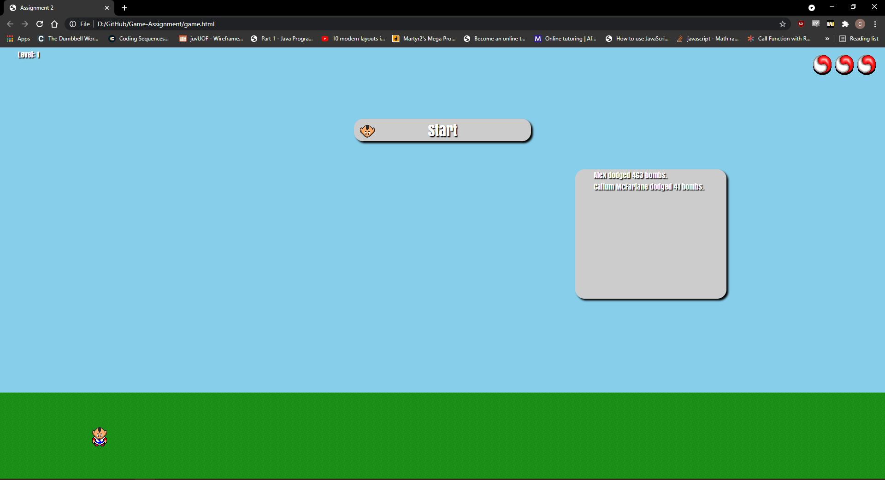

Leader board after inputting name

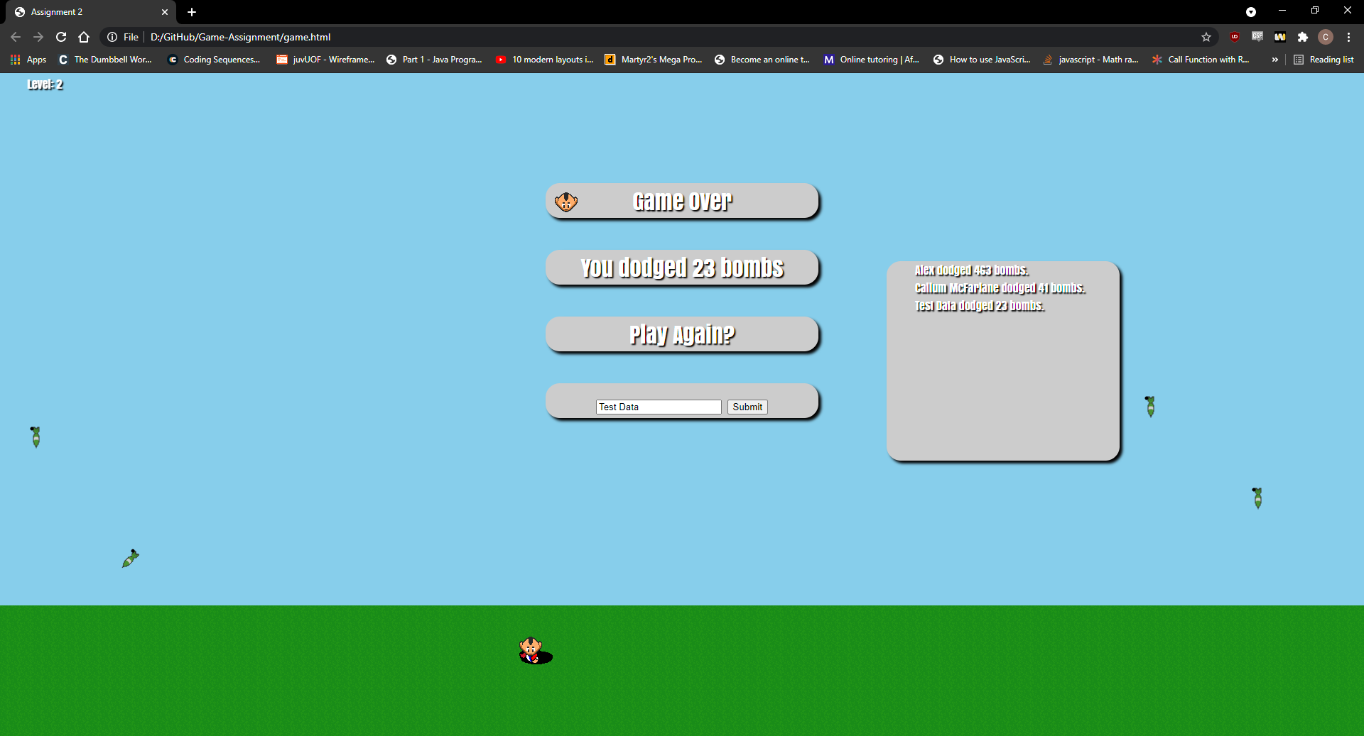

Leader board on refresh

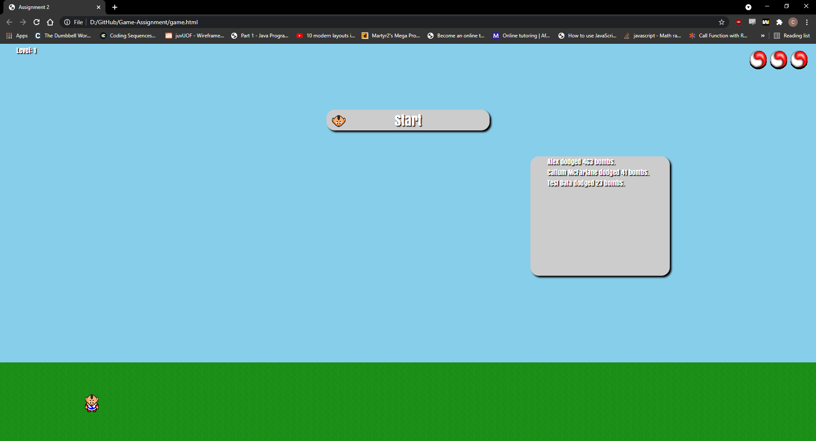

**Player Lives**

|  |  |  |  |
| --- | --- | --- | --- |
| Test Number | Expected Outcome | Actual Outcome | Pass/Fail? |
| 1 | Player loses one life on hit | Player loses one life on hit | PASS |
|  |  |  |  |

Player Lives on Start



Console displaying lives remaining

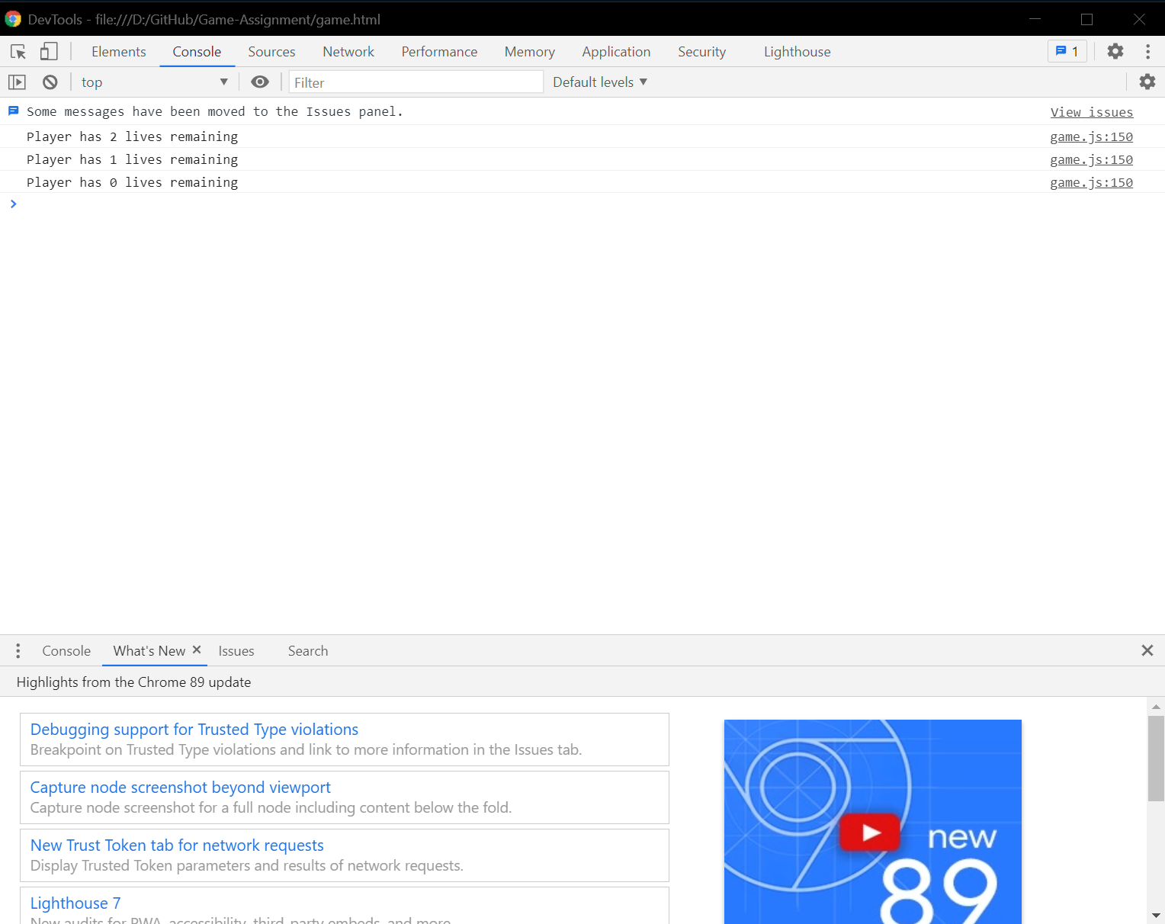

Player has no lives remaining in the top right

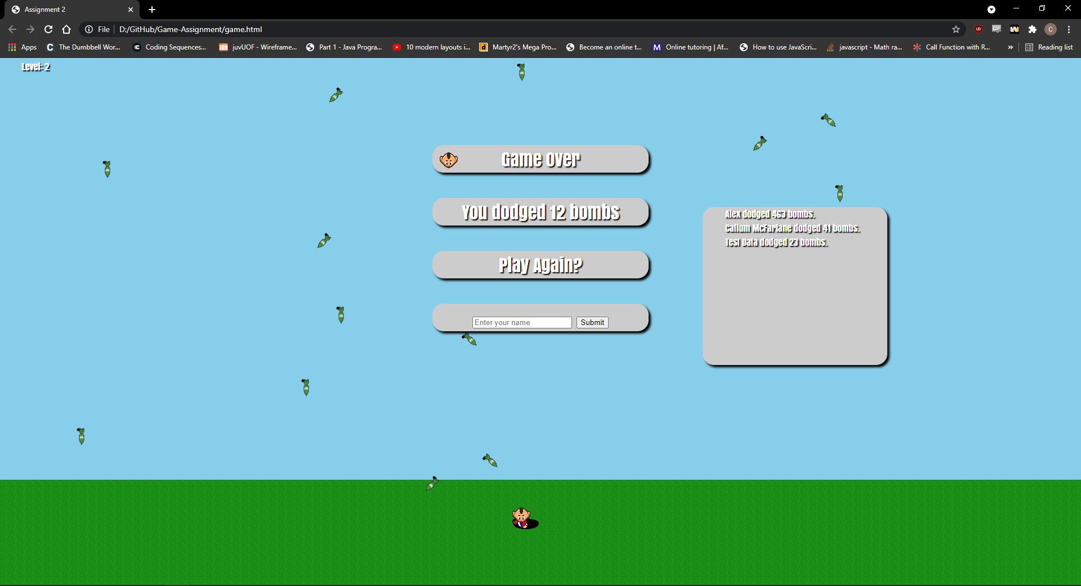

**Restarting Game**

|  |  |  |  |
| --- | --- | --- | --- |
| Test Number | Expected Outcome | Actual Outcome | Pass/Fail? |
| 1 | Game is reset | Game is reset | PASS |
|  |  |  |  |

Game over Screen, level is 2 and bombs are currently on the screen mid fall



Game has been reset, level is reset to 1, bombs have been removed and lives restored

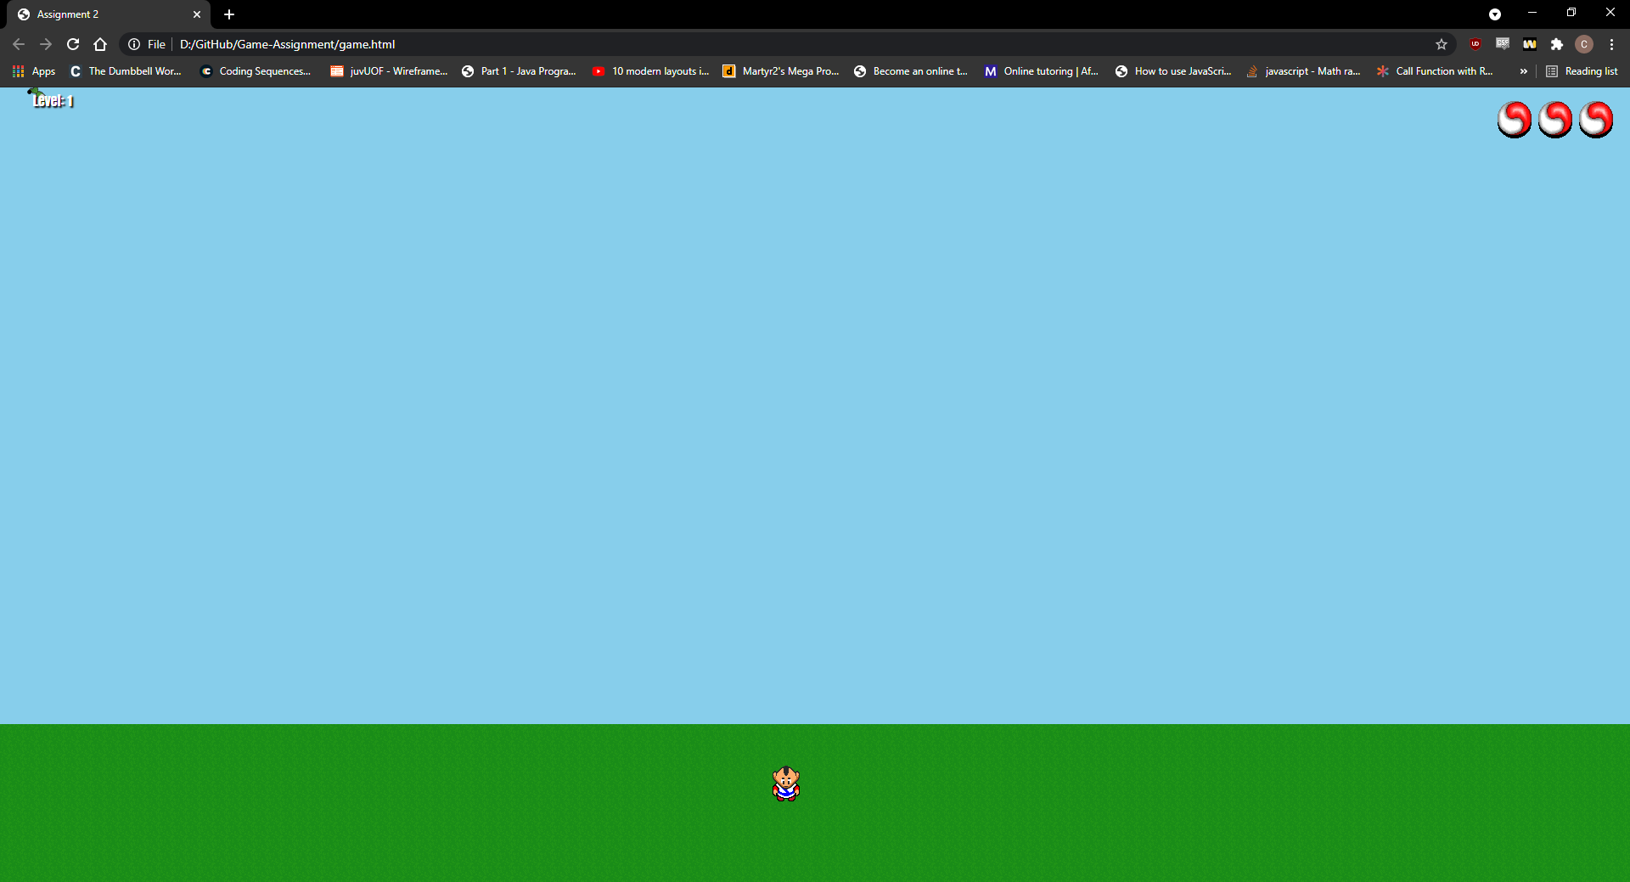

**Increasing Levels**

|  |  |  |  |
| --- | --- | --- | --- |
| Test Number | Expected Outcome | Actual Outcome | Pass/Fail? |
| 1 | Bombs dropped and speed are increased | Bombs dropped and speed are increased | PASS |
|  |  |  |  |

Level is set to 1

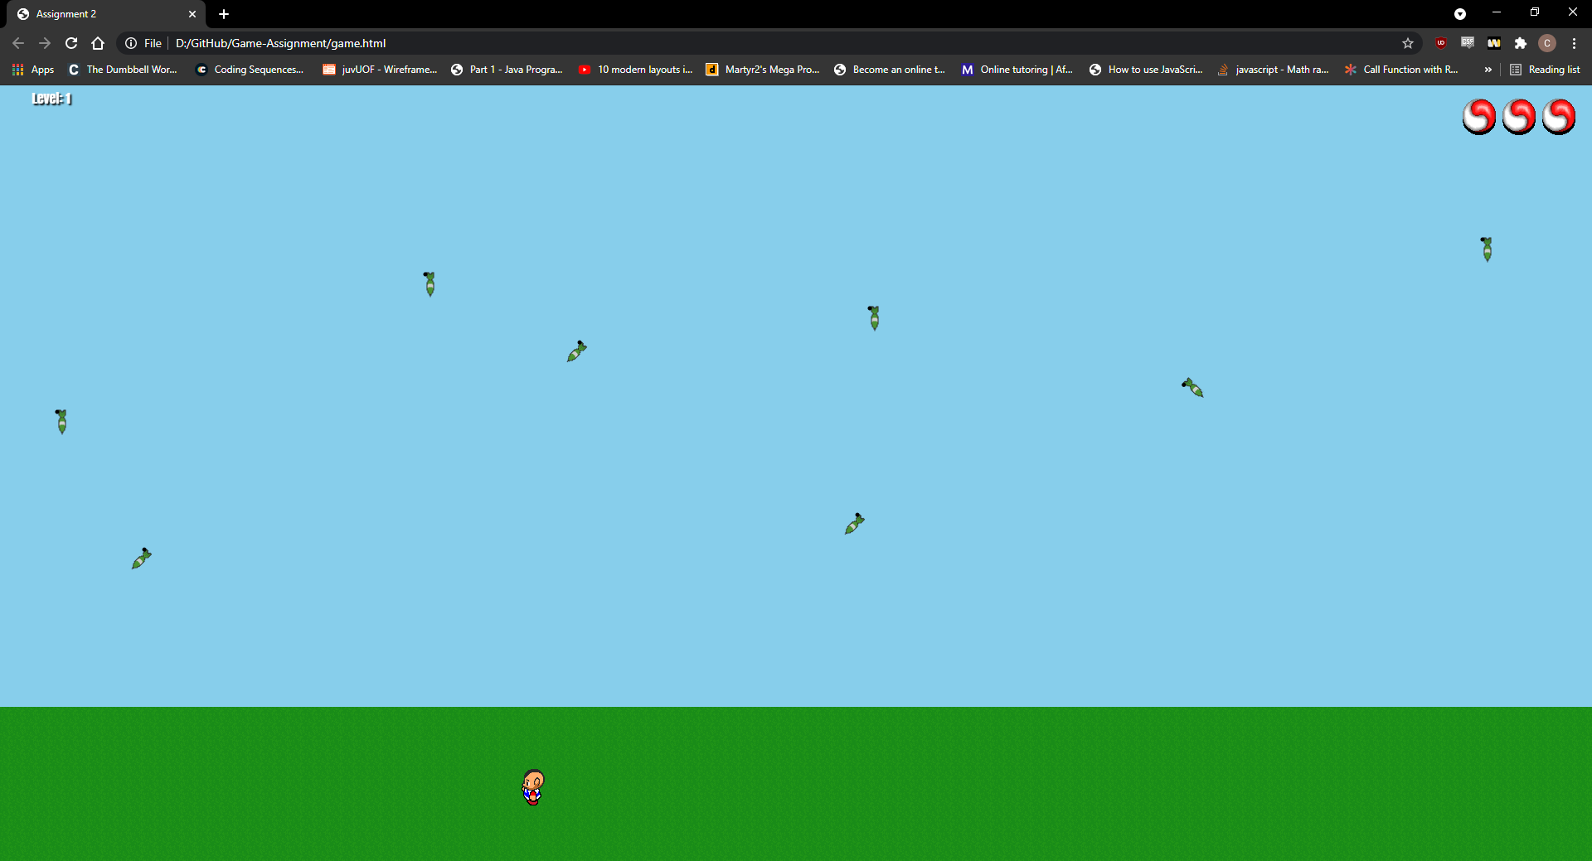

Level has turned to level 2

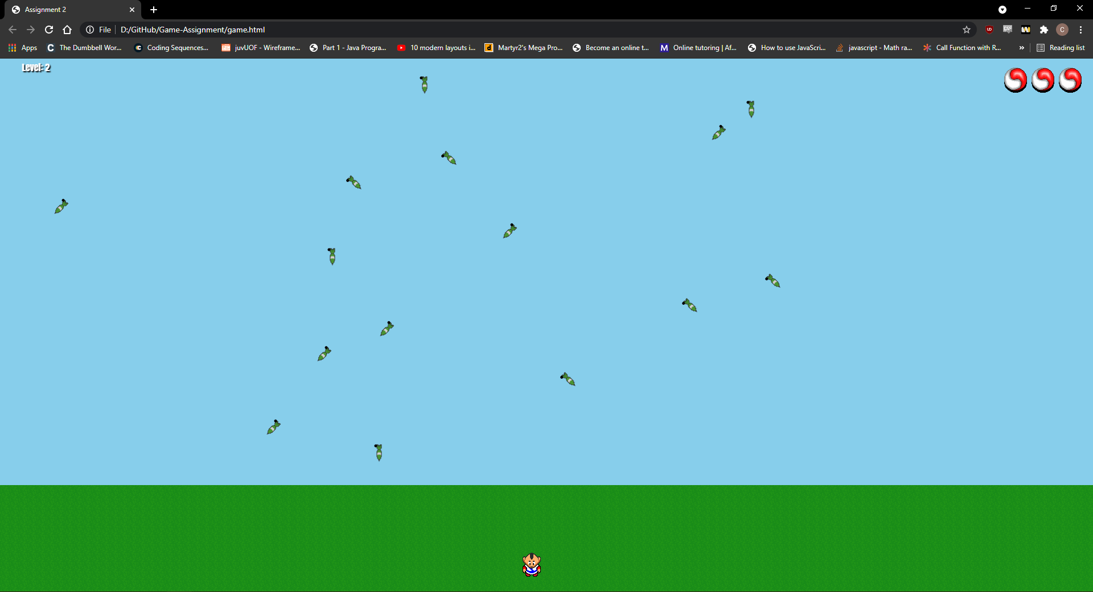

Drop rate and bomb speed has increased with each level

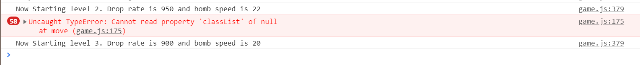

**Bugs**

As previously mentioned, there is only currently one bug that has been found within the game, this being the ability for the player to walk into the sky. Although there have been several bugs that have existed throughout development that have since been fixed. Fixing this would likely involve changing the way that movement works in the game.

Below is a list of bugs that have since been fixed:

* Leader board duplicating listings
* Leader board logging previous names
* Player can turn while dead
* Bombs from previous rounds persist after pressing play again
* Player lives icon would not reappear on pressing play again
* Level would not start from 1 again when pressing play again
* Level would increase after bombs were created instead of when they had exploded
* Explosions would remain permanently after bombs exploded
* Bomb drop speed would not increase on level increase

**References**

getRandomFunction from <https://stackoverflow.com/questions/18921134/math-random-numbers-between-50-and-80> (Accessed on 04/03/2021)

Learned Local Storage from <https://blog.logrocket.com/localstorage-javascript-complete-guide/> (Accessed on 10/03/2021)

Tom Butlers Lecture Slides