Quarto Book Prototype

ASKCR

2023-04-26

Table of contents

# 1. Title: Quarto Book Prototype

Author: Anna SKC Rahr

ORCID:

Date: 2023-04-26

DOI: 10.5281/zenodo.7852205

Repository URL: https://github.com/calnfynn/catalogue-003

## 1.1 Based on Baroque AI: Publication Prototype

## 1.2 Part of the series: Baroque TOC

[Programme instructions](https://nfdi4culture.github.io/class-ADA-CP-pipeline/)

2023-03-17

This work is licensed under a Creative Commons Attribution-ShareAlike 4.0 International License.

Book cover: Reworking of [Waves](https://commons.wikimedia.org/wiki/File:Munch_-_Waves,_1908,_MM.M.00438.jpg). Creative Commons CC0 1.0 Universal Public Domain Dedication. This file was donated to Wikimedia Commons as part of a project by the Metropolitan Museum of Art.

This work is licensed under a Creative Commons Attribution-ShareAlike 4.0 International License.

# 2. Colophon

Fork title: Quarto Book Prototype

Author: Anna SKC Rahr

Date: 2023-04-26

DOI: 10.5281/zenodo.7852205

Repository: https://github.com/calnfynn/catalogue-003

PUBLISHING FROM COLLECTIONS USES OF COMPUTATIONAL PUBLISHIGN AND LINKEDOPEN DATA

Open Science Lab - TIB Hannnover

First published 2023-03-30

Copyright © The Authors 2023 Licensed as https://creativecommons.org/licenses/by-sa/4.0/

DOI: https://doi.org/10.5281/zenodo.7701161

# 3. Exploring the Dimensional Realm: An Introduction to Stereoscopy in Photography

Source: ChatGPT

## 3.1 Introduction

Photography has long been cherished for its ability to capture moments and freeze them in time. However, there exists a remarkable technique that goes beyond mere two-dimensional representations. Stereoscopy, a captivating field of photography, allows us to perceive images in three dimensions, recreating depth and enhancing the immersive experience. In this article, we will delve into the intricacies of stereoscopy and explore how it has revolutionized the way we view and appreciate photographs.

## 3.2 Understanding Stereoscopy

At its core, stereoscopy aims to mimic the way our eyes perceive the world. It relies on the concept of binocular vision, where each eye captures a slightly different image, and our brain combines these two perspectives to create a sense of depth. Similarly, stereoscopy captures two offset images and presents them in such a way that our brain fuses them together, resulting in a perception of depth and realism.

## 3.3 The Stereoscopic Effect

The key to creating a stereoscopic effect lies in the separation of the two images. Photographers achieve this by using specialized equipment like dual-lens cameras or by taking two separate shots, mimicking the disparity between the perspectives of our eyes. These images, known as “stereopairs” or “stereographs,” are then presented in a way that allows the viewer to experience the depth of the scene.

## 3.4 Types of Stereoscopic Photography

Stereoscopic photography encompasses various techniques and formats. One such example is anaglyph 3D, where images are composed of two color channels (typically red and cyan) that, when viewed through color-filtered glasses, merge to form a 3D image. Another popular technique is polarized 3D, which employs polarized filters on both the camera lenses and the viewing glasses to separate and recombine the images, creating a three-dimensional effect. Other methods include cross-viewing (also known as freeviewing), where viewers train their eyes to focus differently, and autostereograms, which use repeating patterns to create hidden 3D images.

## 3.5 Applications of Stereoscopy

Stereoscopy has found its way into various fields beyond photography. In medicine, it aids in visualizing complex anatomical structures, enabling surgeons to plan procedures and enhance their precision. Archaeologists and historians also employ stereoscopy to analyze artifacts and explore ancient sites in virtual three-dimensional environments. Additionally, stereoscopic imagery has gained popularity in entertainment, with movies and video games utilizing the technique to provide viewers with a more immersive experience.

## 3.6 Conclusion

Stereoscopy in photography opens a door to a world beyond the constraints of flat images, allowing us to explore depth, perspective, and realism. It offers a unique way to engage with photographs and enhances our understanding and appreciation of the visual medium. As technology advances, the potential for stereoscopy continues to grow, promising even more exciting applications and experiences for both creators and viewers alike.

# 4. A Catalogue of Stereoscopic Images

## 4.1 Schliersee und Tegernsee

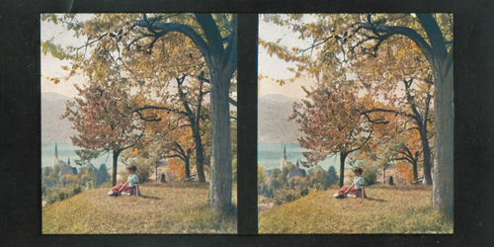

Wikidata link: <http://www.wikidata.org/entity/Q118720298>

Materials: cardboard

Year: 1907

Location: Adolf-Würth-Zentrum für Geschichte der Psychologie

## 4.2 [Mainufer in Würzburg]

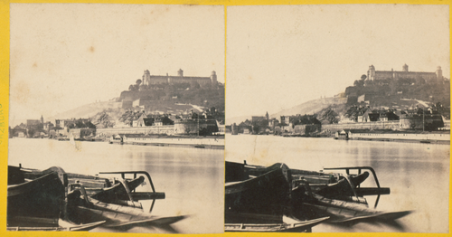

Wikidata link: <http://www.wikidata.org/entity/Q118720301>

Materials: cardboard, albumin paper

Year: 1860

Location: Adolf-Würth-Zentrum für Geschichte der Psychologie

## 4.3 Dolomiten II

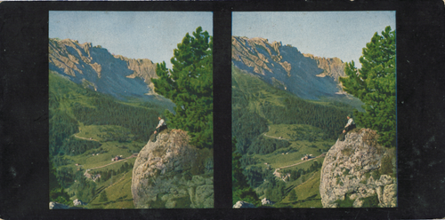

Wikidata link: <http://www.wikidata.org/entity/Q118720297>

Materials: cardboard

Year: 1907

Location: Adolf-Würth-Zentrum für Geschichte der Psychologie

## 4.4 Mondkugel

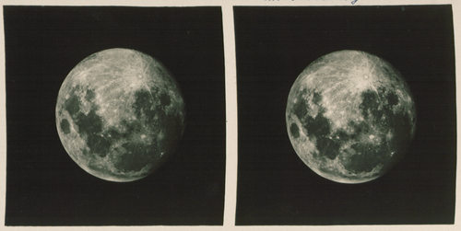

Wikidata link: <http://www.wikidata.org/entity/Q118720299>

Materials: photographic paper

Year: N/A

Location: Adolf-Würth-Zentrum für Geschichte der Psychologie

## 4.5 Die Kaisergalerie

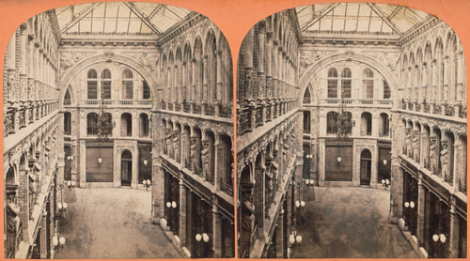

Wikidata link: <http://www.wikidata.org/entity/Q118720300>

Materials: cardboard, albumin paper

Year: 1864

Location: Adolf-Würth-Zentrum für Geschichte der Psychologie