NSCC
Looz Server - Security Assessment Report
Looz
O’Quinn,Callahan
3-15-2026

Note: The contents of this document are confidential and for authorized persons of the Looz team only.

Table of Contents
1 Executive summary 3
2 Methodology 3
2.1 Scope 3
2.2 Methodology 3
2.3 Tools 3
3 Reconnaissance 4
3.1 Host Discovery 4
3.2 Port Scanning 4
3.3 Service Version Analysis 4
4 Pre-exploitation 5
4.1 Web Application Enumeration 5
4.1.1 Port 80 5
4.1.2 Port 8081 5
5 Penetration 5
6 Post Exploitation 5
7 Figures 6
7.1 6
7.2 6
7.3 6
7.4 7
7.5 7
7.6 8
7.7 8
7.8 8
7.9 9
7.10 9
7.11 9
7.12 10
7.13 10
8 Key Findings 10
8.1 Plaintext Credentials in HTML Comments 10
8.2 WordPress Administrator Access 10
8.3 Weak Password for Gandalf 11
8.4 Privilege Escalation Using a SUID Binary 11
9 Mitigation Recommendations 11
9.1 Immediate (critical-High) 11
9.2 Short-Term (Medium-Low) 12
10 Conclusion 12

Executive summary
I was tasked with conducting a penetration test on the Looz server prior to their go live date to assess the security of the system. During my assessment, I found critical vulnerabilities that allowed me to fully compromise the system. Here is a summary of the process I followed & the vulnerabilities that allowed me to do so:
A plain-text password was left in an HTML comment, which gave me access to a WordPress administrator account. From there, I was able to harvest more credentials and install a malicious plug-in which I used to create a reverse shell from the docker container. From there, I was able to brute-force a login, granting me access to SSH into the main system. Once in the system, I was easily able to escalate to root privilege, taking over the system.
Due to my findings, the server should not be deployed until significant security measures have been implemented. The vulnerabilities found should be addressed immediately.

Methodology

Scope
- The Looz server will be tested with no prior knowledge to the system (black-box). The only thing I will have knowledge of is the fact that the server will be connected to the same network as my own system. Anything I can access from any information gathered will be viable for me to access. While I intend to not harm the system, I will be attempting intrusion by any means, therefore it is important to understand the risks associated.

Methodology
The test will be conducted in the following phases:
- Reconnaissance
  - This phase will focus on scans to identify the system and its open ports/running services
- Pre-Exploitation
  - This phase will focus on exploring the web application and services based on reconnaissance to discover vulnerabilities
- Exploitation
  - This phase will focus on attempting to leverage vulnerabilities to gain access to the system
- Post-Exploitation
  - This phase will focus on internal enumeration and attempted privilege escalation
- Documentation
  - This phase will focus on the compilation of my findings and evidence, as well as mitigation recommendations.

Tools
The tools used throughout the test are:
- A Kali Linux system on the same network
- netdiscover
- nmap
- gobuster
- dirb
- nikto
- Burp Suite
- netcat
- Pentestmonkey - php-reverse-shell
- john
- rockyou word list

Reconnaissance

Host Discovery
- A ping sweep was conducted to identify the hosts on the network.
  - nmap -sn 192.168.159.0/24
- The scan let me determine the target IP as 192.168.159.133

Port Scanning
- A comprehensive port scan was conducted to enumerate open services.
  - nmap -p- -sV -sC 192.168.159.133
Open Port (TCP) | Service | Version
22 | SSH | OpenSSH 8.2p1 Ubuntu 4ubuntu0.2
80 | HTTP | Nginx 1.18.0 (Ubunutu)
3306 | MySQL | MariaDB 5.5.5-10.5.10-MariaDB
8081 | HTTP | Apache httpd 2.4.38 (Debian)
- The results are as follows:

Service Version Analysis
- Port 80 hosts a static webpage
- Port 8081 hosts a WordPress instance

Pre-exploitation

Web Application Enumeration

Port 80
- Manual inspection of the http://192.168.159.133/ revealed a static HTML site
  - Upon reviewing the source code, a comment was discovered containing plain-test credentials (Figure 7.1)
- Directory enumeration with gobuster uncovered /images & /index.html (Figure 7.2)
- Vulnerability scanning with nikto revealed several vulnerabilities (Figure 7.3)

Port 8081
- Initially, accessing http://192.168.159.133:8081/ resulted in a redirect to port 80. Adding an entry to /etc/hosts resolved the virtual host.
- Directory enumeration with gobuster revealed several paths, including the WordPress login page http://wp.looz.com:8081/wp-login.php (Figure 7.4)

Penetration
- Using the credentials found in the source code (john; yoUC@n'tbr3akIT), I was able to successfully log into the WordPress page (Figure 7.5)
- Through manually exploration of the WordPress interface, I was able to find other accounts, including another administrator “gandalf” (Figure 7.6)
- Using a script by PentestMonkey (php-reverse-shell) I attempted to start a reverse shell script through various methods. Adding it as a theme was unsuccessfull, however zipping the script and installing it as a new plugin worked (Figure 7.7). This let me access it at http://wp.looz.com:8081/wp-content/plugins/wp-easy-shell/wp-easy-shell.php?cmd=id (Figure 7.8) and would communicate with a netcat listener I had running on port 4444 (Figure 7.9). This was a success, and I had gained access to the docker container.

Post Exploitation
- In the docker container, I was able to enumerate hashes for users (Figure 7.9). These hashes were saved in a file (hashes.txt).
- Using the exfiltrated hashes, I ran john with rockyou. This cracked the password for Gandalf (Figure 7.10). Once I had the password, I was able to ssh into the server as gandalf (Figure 7.11)
- Once into the server, I was able to enumerate an executable binary (Figure 7.12). This binary granted root access upon execution, granting me control of the system (figure 7.13)

Figures

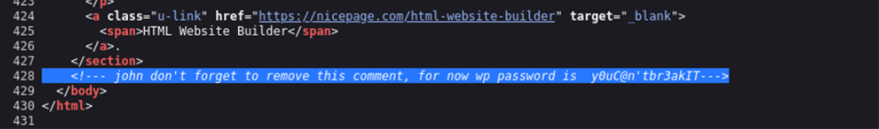

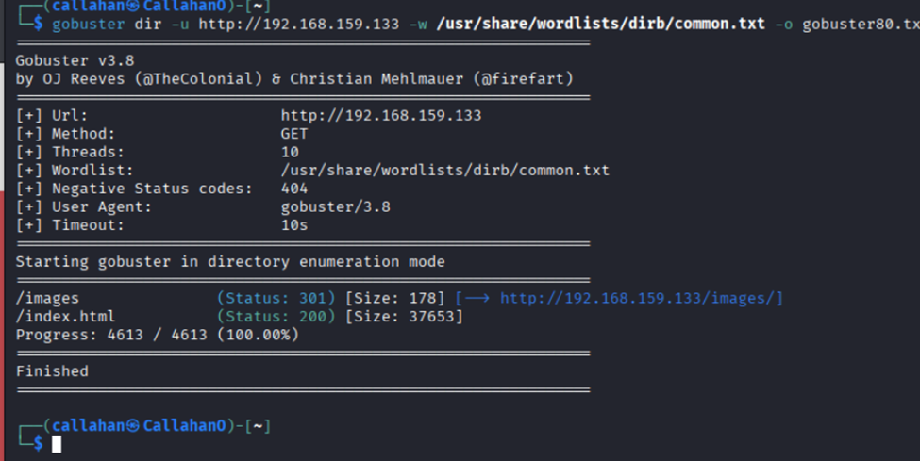

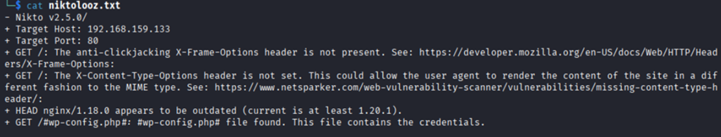

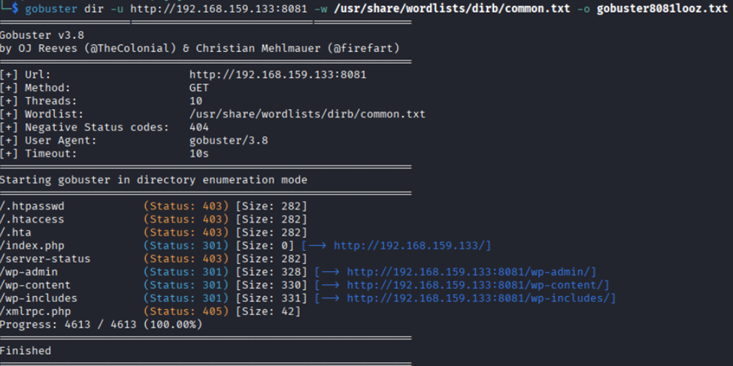

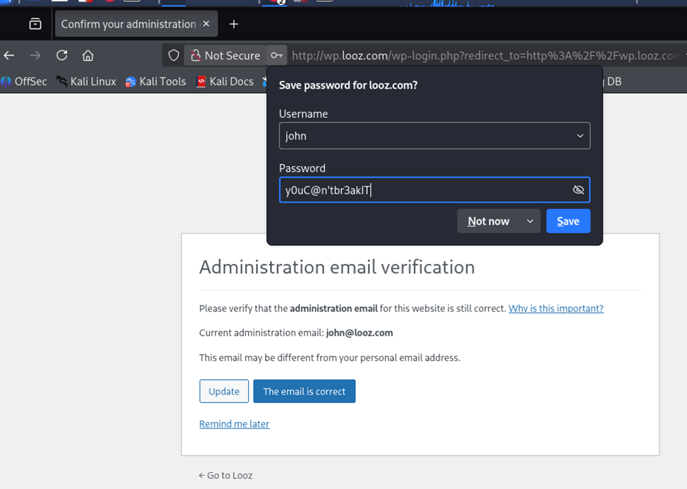

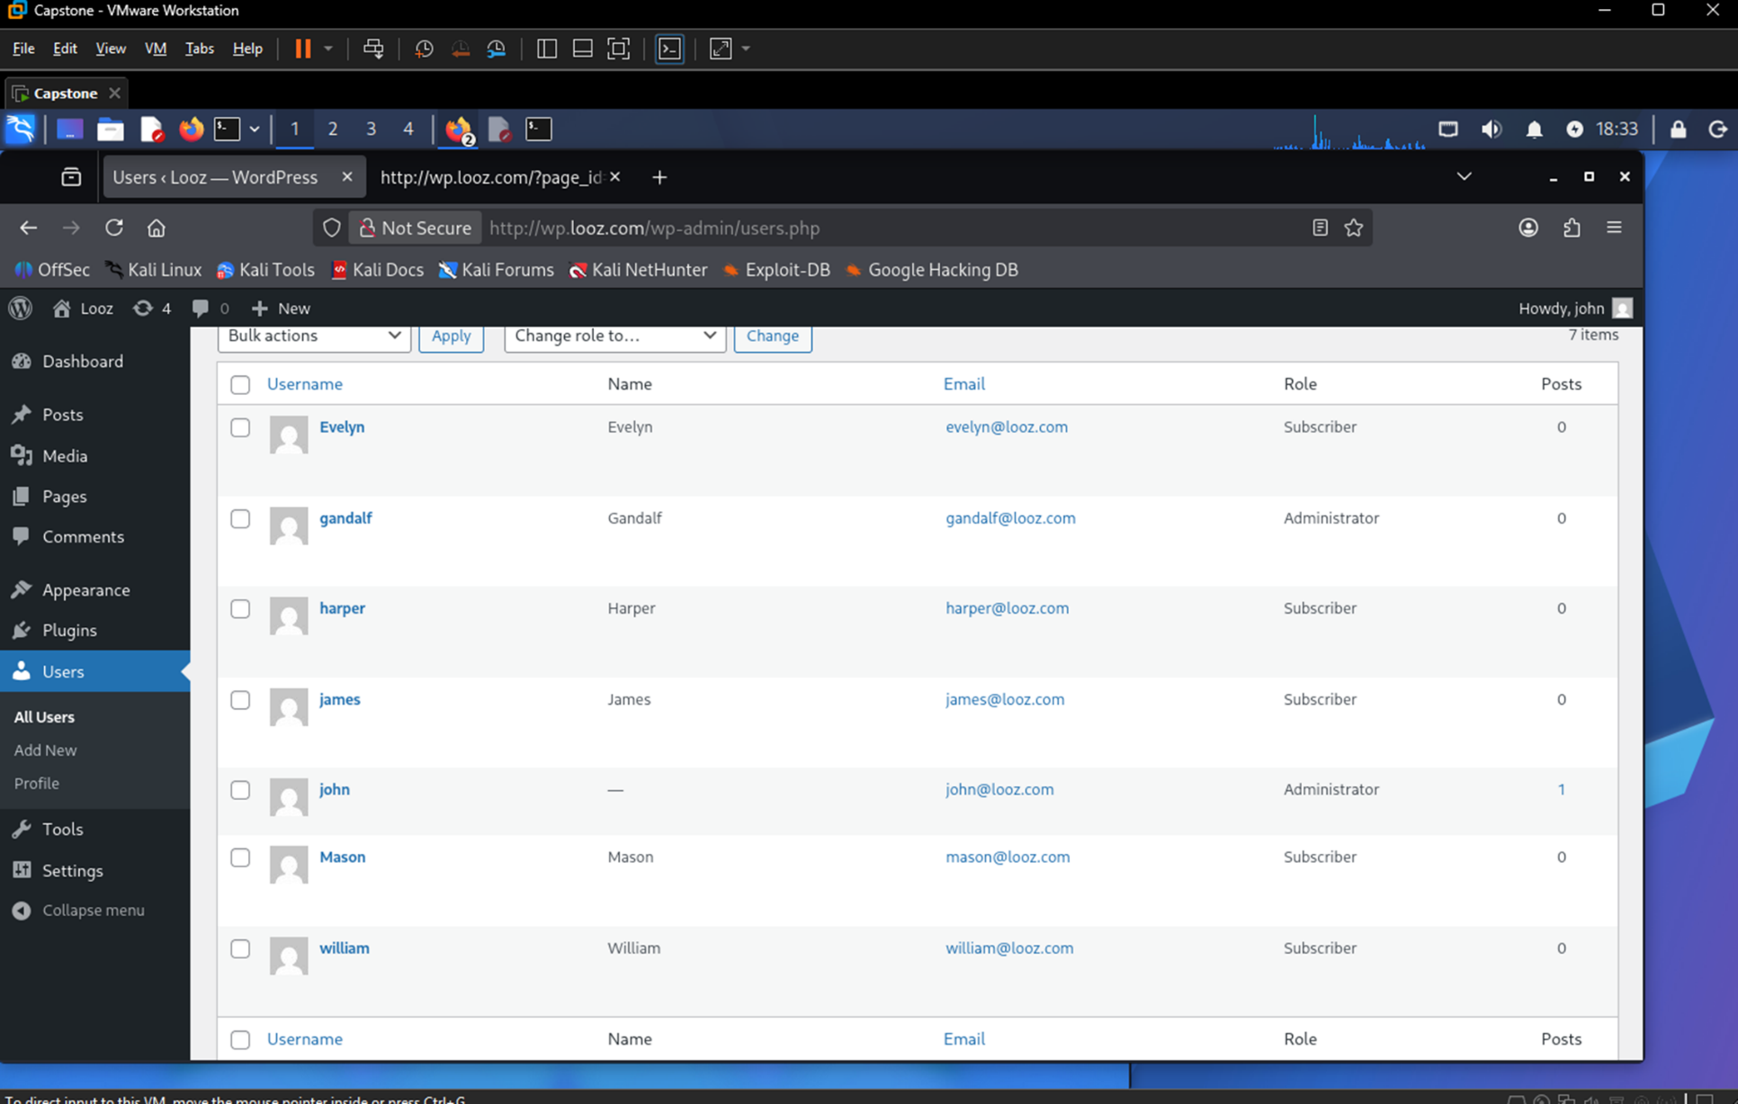

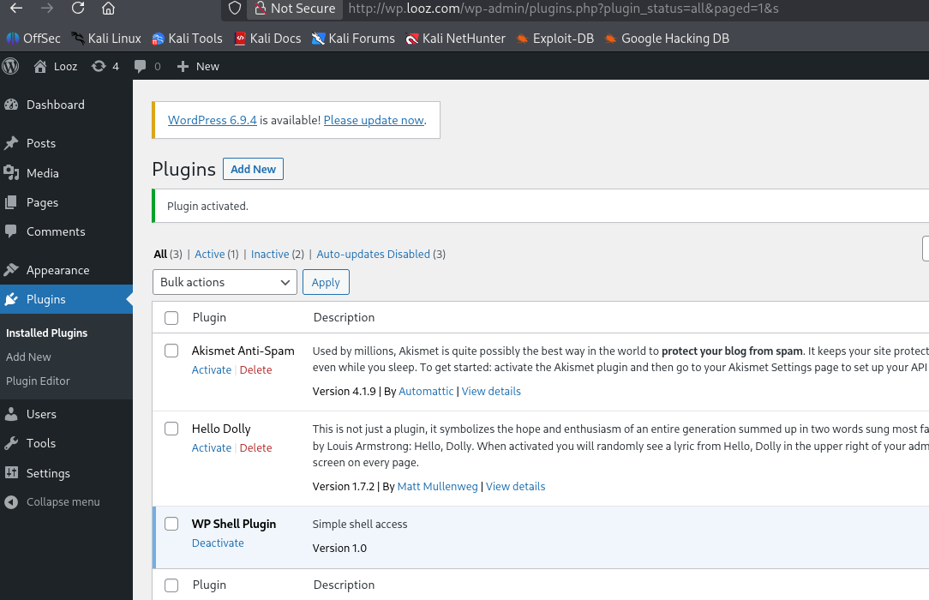

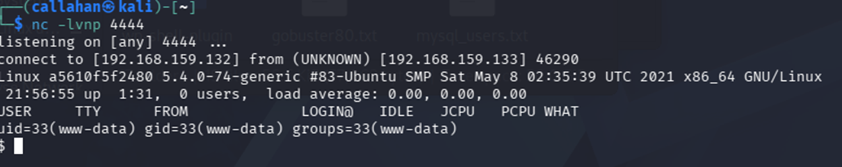

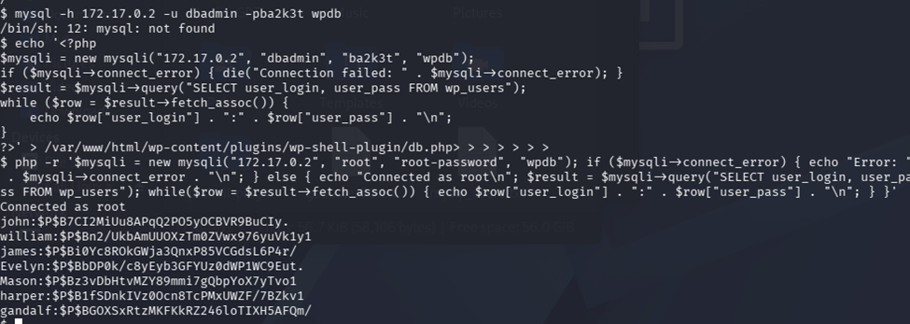

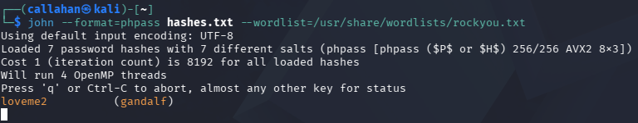

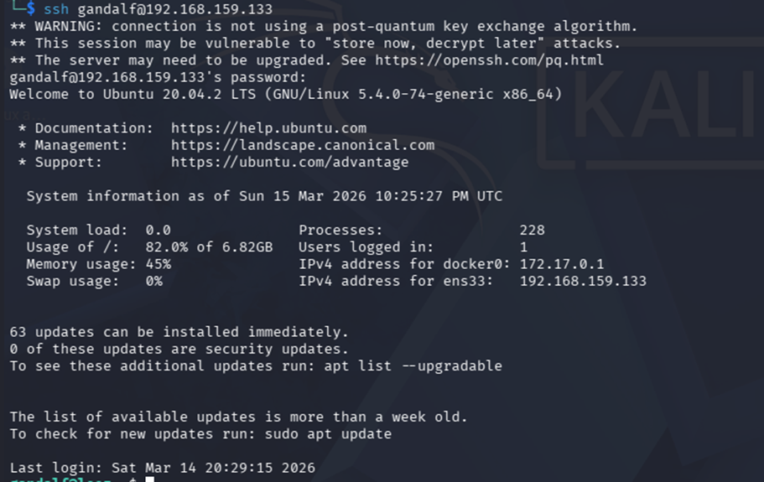

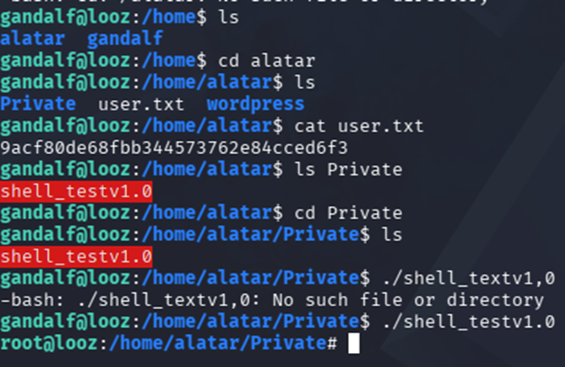

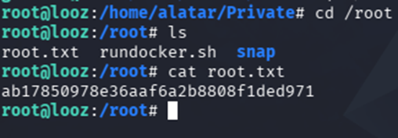

Key Findings

Plaintext Credentials in HTML Comments
- Severity: High
- Description: Plaintext credentials for the WordPress login were identified upon manually reviewing source code. The comment was intended to be deleted but were not.
- Impact: These credentials could easily be discovered and used to access the WordPress site. Access to the WordPress site could allow an attacker to upload malicious code, steal data, or deface the site.
- Recommendations:
  - Review source code, and remove anything containing plain-text sensitive information, such as the credentials found.
  - Ensure all code does not contain sensitive information through strict review processes in the future.

WordPress Administrator Access
- Severity: Critical
- Description: Having Access to the administrator user on the WordPress site provided access to enumerate other users and find more attack surfaces.
- Impact: An attacker could take full control over the WordPress application, upload malicious plugins, manipulate themes and exfiltrate data. The attacker can leverage this into gaining more access to the system (ex. reverse shell).
- Recommendations:
  - Enforce strong, unique passwords
  - Implement MFA for all accounts
  - Remove redundant administrator accounts and restrict the ability to install plugins.

Weak Password for Gandalf
- Severity: High
- Description: The password for the user gandalf was identified using a dictionary attack against hashes extracted from the database. This password could easily be brute forced and could allow an attacker access to the server.
- Impact: An attacker could gain access to the host, allowing them to further enumeration information and potentially escalate their privileges.
- Recommendations:
  - Enforce users to use strong, unique passwords or use key-based authentication for SSH
  - Audit user accounts and passwords.

Privilege Escalation Using a SUID Binary
- Severity: Critical
- Description: A world-executable binary was easily found and immediately granted root access to the server.
- Impact: An attacker with root access could compromise the entire system. They could install backdoors, exfiltrate more sensitive data, and jump to other systems on the network.
- Recommendations:
  - Remove or restrict access to this binary
  - Audit the system for all SUID binaries
  - Review permissions for files and executables
  - Implement the principle of least privilege

Mitigation Recommendations

Immediate (critical-High)
- Remove or revoke privilege to the SUID binary
- Change all passwords for WordPress & System users to strong, complex passwords
- Remove any sensitive information in HTML source code
- Implement a strong password policy for all user accounts.
- Enforce a key-based SSH authentication for all users.
- Review and restrict user permissions for the host, docker, and WordPress. Ensure users only have access to what is completely essential.

Short-Term (Medium-Low)
- Audit all SUID binaries on the system to ensure they are necessary and restricted properly
- Enable security headers (X-Frame-Options, X-Content-Type-Options) to avoid clickjacking & mime sniffing.
- Update & upgrade all software and plugins (nginx, Apache, PHP, WordPress)
- Implement regular vulnerability scanning
- Securely communicate credentials, and do not allow sensitive information to appear in code.

Conclusion
The Looz server currently contains several critical vulnerabilities that lead to a full system compromise. These vulnerabilities can easily be leveraged and exploited to escalate privilege, exfiltrate data and execute critical attacks. The server should not be deployed until all security recommendations have been followed. Regular auditing of the security should occur through the deployment process and post deployment.

