Exercises:
Section 1: Read chapter1, concepts,..
Section 2:
- Solve the following systems using graphs and

- The students of Unilak solve a linear programming problem which has an objective function, and get the figure A that is resulted from their constraints solution: find and sketch isoprofit and isocost lines for that results.
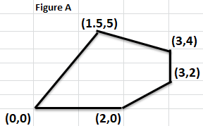

- Given a matematical model, then find the optimal solution at 1st iteration :
- Find the dual problem of LPP:
maximize
- Detect the degeneracy and solve the LPP
b.

- Find the dual of the following linear programming problem and solve it .
- Find the optimal solution using corner point method

- Solve the following simultaneous inequality

