NLP Ödevi: Word Embedding ile Duygu Analizi

1. What is Word Embedding?
Word embedding is a method used in Natural Language Processing (NLP) to represent words as dense vectors in a continuous vector space. Unlike one-hot encoding, which produces sparse and uninformative vectors, embeddings capture semantic and syntactic relationships between words by mapping similar words to nearby vectors in the space.

2. Embedding Models Overview
Several popular embedding techniques exist:
- Word2Vec: Predicts context from a target word (CBOW) or vice versa (Skip-gram), trained via neural networks.
- GloVe: Uses global co-occurrence statistics to generate embeddings.
- FastText: Improves upon Word2Vec by representing words as character n-grams, useful for morphologically rich languages like Turkish.
- Keras Embedding Layer: Learns word vectors during the training of your model, starting from random initialization.
In this assignment, we used Keras’ built-in embedding layer which was trained alongside the LSTM model.

3. Embedding Implementation
- Tokenizer: We tokenized 120,000+ Turkish product review sentences using Tokenizer from Keras.
- Embedding Layer: Used Embedding(input_dim=20000, output_dim=128) to project word indices to 128-dimensional vectors.
- Visualization: Word vectors were extracted and visualized using projector.tensorflow.org, with PCA used for 3D projection.
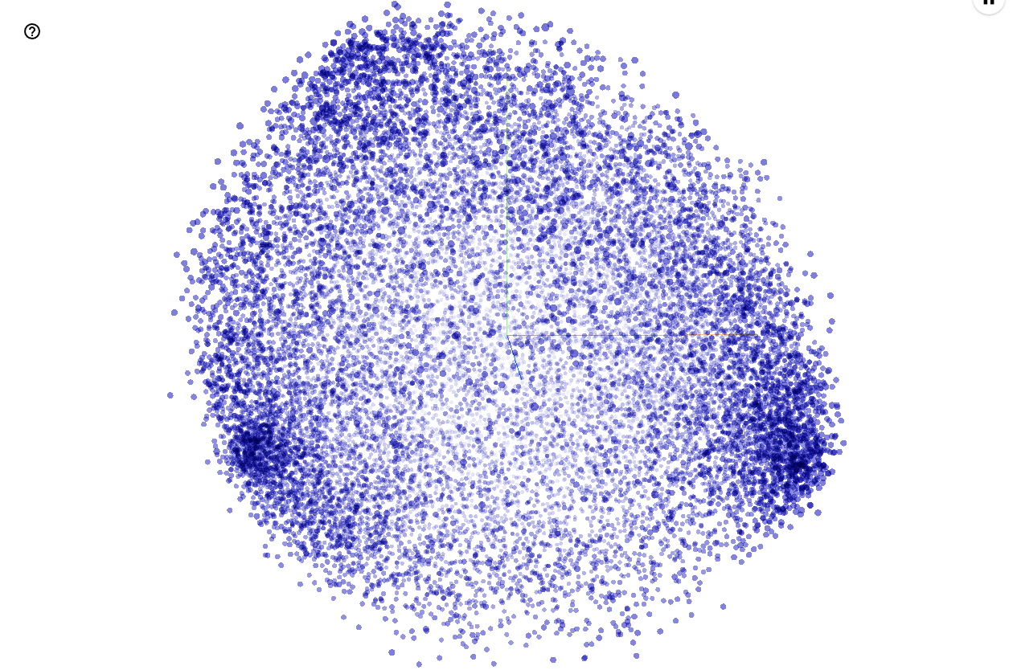
4. Problem Definition & Model Comparison
Task: Turkish Sentiment Analysis on product reviews
Dataset: Kaggle - Turkish Sentiment Analysis Dataset
🧪 Model 1: TF-IDF + Logistic Regression (No Embedding)
- Accuracy: 93%
- F1-score (macro): 0.87
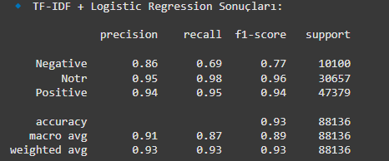
🤖 Model 2: LSTM + Embedding (Keras)
- Accuracy: 94%
- F1-score (macro): 0.90
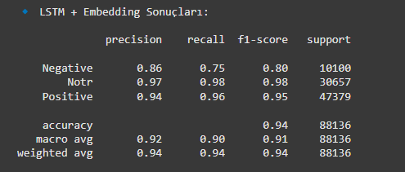
Class | TF-IDF F1 | LSTM F1
Negative | 0.75 | 0.86
Notr | 0.96 | 0.93
Positive | 0.94 | 0.94

📌 Conclusion: LSTM with word embeddings outperformed the classic model, especially in capturing the subtleties in negative sentiment, thanks to context-aware learning.

🧑‍🤝‍🧑 Group Contributions
Member | Contribution | Explanation
Abdullah | 33.4% | Data preprocessing, TF-IDF implementation, writing model comparison section in report
Batu | 33.3% | LSTM + Embedding implementation, Projector visualization setup, model training
Ege | 33.3% | Report formatting, preparing .tsv files for visualization, GitHub organization
🔹 Each group member contributed equally to discussions and validations during the project process.

6. GitHub Link
All files including source code, datasets, .tsv files for embeddings and this report are available at:
📁 https://github.com/kullaniciadi/turkish-nlp-sentiment
(Replace with your actual GitHub repo link)

7. References
- Kaggle Dataset: https://www.kaggle.com/datasets/winvoker/turkishsentimentanalysisdataset
- TensorFlow Docs: https://www.tensorflow.org/api_docs/python/tf/keras/layers/Embedding
- TensorFlow Projector: https://projector.tensorflow.org
- Scikit-learn, Pandas, Keras, Matplotlib

