|  |  |
| --- | --- |
|  | James J. Morgan  **(1932– )**  Interviewed by Shirley K. Cohen May 25, June 1 and 16, 1999 |

|  |  |
| --- | --- |
| **ARCHIVES**  **CALIFORNIA INSTITUTE OF TECHNOLOGY**  **Pasadena, California** |  |

# Subject area

Engineering, environmental engineering

# Abstract

Interview in 1999 with James J. Morgan, Marvin L. Goldberger Professor of Environmental Engineering Science, emeritus. Born in New York City to Irish immigrant parents, Morgan was raised in County Monaghan, Ireland, during the Depression. He studied civil engineering at Manhattan College, received a master’s degree from the University of Michigan in environmental health engineering with C. J. Velz (1956), and after three years as an instructor at the University of Illinois took his PhD at Harvard in 1964 with the water chemist Werner Stumm. Morgan came to Caltech in 1965 to join the environmental engineering science program in the Division of Engineering and Applied Science, where he worked on manganese chemistry in water and the use of polyelectrolytes in water treatment. Recollections of colleagues Jack McKee, Sheldon Friedlander, Norman Brooks, and the early years of the environmental engineering science program. In 1966 he became first editor of the American Chemical Society’s journal *Environmental Science and Technology*. Recalls stint on Caltech’s Freshman Admissions Committee and as dean of students in the early 1970s. Coauthored *Aquatic Chemistry* with Werner Stumm. Comments on his consulting for industry and government in the 1970s. Becomes vice president for student affairs (1980-1989). Recalls postdocs and students, including François Morel, James Pankow, Alan Stone, Howard Liljestrand, Yigal Erel, Windsor Sung. Awarded 1999 Stockholm Water Prize jointly with Werner Stumm (d. April 1999). In an epilogue to this interview, Morgan describes his trip to Stockholm to accept the award on behalf of Stumm and himself and his receipt that year of theClarke Prize of the National Water Research Institute.

# Administrative information

## Access

The interview is unrestricted.

## Copyright

Copyright has been assigned to the California Institute of Technology © 2001, 2002. All requests for permission to publish or quote from the transcript must be submitted in writing to the University Archivist.

### Preferred citation

Morgan, James J. Interview by Shirley K. Cohen. Pasadena, California, May 25, June 1 and June 16, 1999. Oral History Project, California Institute of Technology Archives. Retrieved [supply date of retrieval] from the World Wide Web: http://resolver.caltech.edu/CaltechOH:OH_Morgan_J

### Contact information

Archives, California Institute of Technology  
Mail Code 015A-74  
Pasadena, CA 91125  
Phone: (626)395-2704 Fax: (626)793-8756  
Email: archives@caltech.edu

Graphics and content © California Institute of Technology.

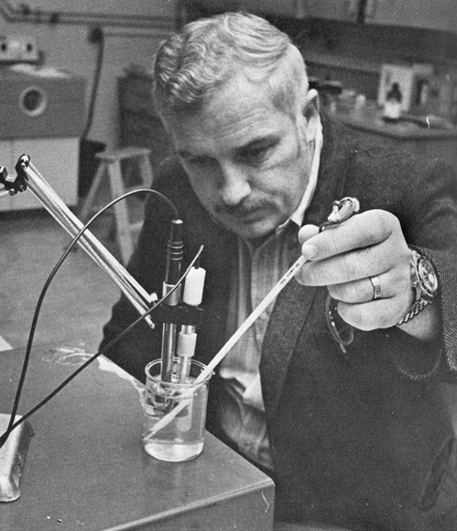

James Morgan tests the waters in 1970, the year Caltech started a degree program in environmental engineering science. His work on water quality and wastewater treatment would later win him the Stockholm Water Prize and the Clarke Prize (both 1999).