

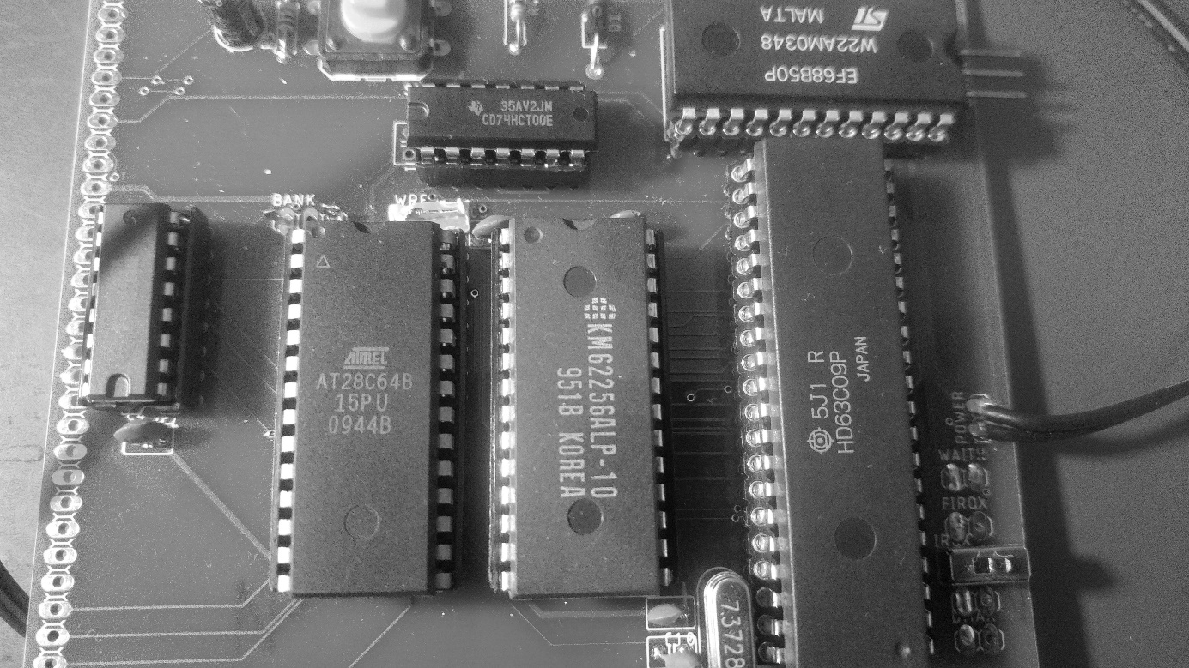

OMEN Kilo / issue 1

Technical Documentation

INTRODUCTION

===========

The OMEN Kilo computer kit is a low-cost computer trainer, based on the MC6809 / HD6309 CPU. It has these features:

* MC6809 CPU working at 1.8432 MHz
* 32 kB RAM
* 8 kB EEPROM
* Serial port up to 115.200 Bd / MC6850 ACIA
* Application system bus

ASSEMBLY INSTRUCTIONS

===================

1. Solder sockets for the integrated circuits
2. Test all soldered connections
   1. Test if all pins are well connected
   2. Check if GND is not short connected to Vcc
   3. Check if each IC has properly connected GND and Vcc
3. Solder all passive parts /capacitors, diode, resistors, push button, crystals/
4. Connect the power adapter and check
5. Insert the CPU into its socket /keep the proper orientation!/ and try to power it up. Check if oscillator lives /at CPU pin 34/
6. Insert the other ICs. Again: keep the proper orientation! Bad orientation can damage the IC!
7. Connect the serial pins TxD, RxD and GND /pinhead SERIAL/ to the TTL-to-USB converter
8. Start the serial terminal on your PC, select proper serial port and set the parameters to 115.200 Bd, 8 data bits, no parity, 1 stop bit.
9. Power your Kilo and check the terminal.

MONITOR

=======

The main software for OMEN Kilo issue 2 is the Kilo Monitor version 2.0. Source codes are available on GitHub.

Basic commands are:

Daddr – Memory dump. Next line with ENTER, SPACE aborts dumping, BACKSPACE displays previous addresses.

Maddr – Modify memory byte by byte. Use ENTER, SPACE and BACKSPACE in the same way as in DUMP.

Gaddr – Go to program (JMP)

W from to – export memory as SREC

X from to – export memory as HEX

: - start HEX file to load. You can just send HEX file directly to the terminal to load data or program into the memory.

U – start a use module. Kilo EEPROM contains one preprogrammed module, the TINY BASIC interpreter. See source code to further information about the modular concept.

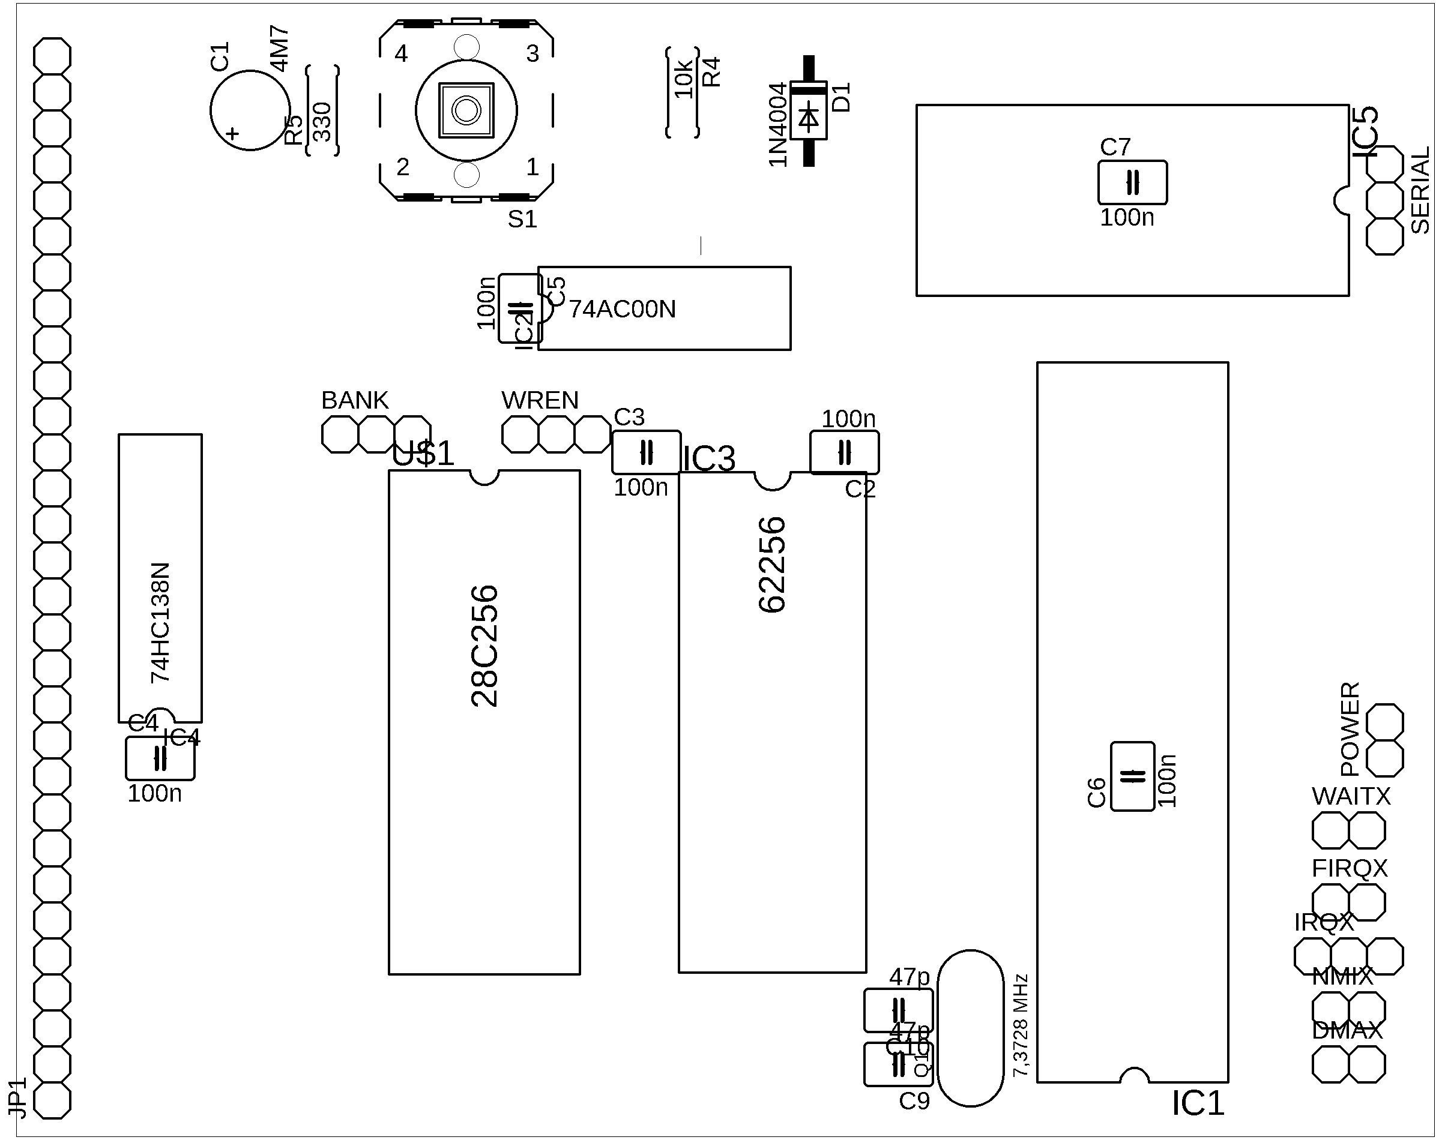THE BOARD

========

Jumpers and pin headers

--------------------

SERIAL: Serial port. Pins are RxD, TxD, GND from up to the bottom, RxD is near the edge.

WREN: PLEASE DO NOT USE, just solder the middle pin and the left pin /close to the BANK switch/ together. I am sorry.

BANK: EEPROM bank selector – only for AT28C256. Leave it open.

NMIX: NMI enabler. Close to disable non-maskable interrupts, open to leave it on the application bus. Connect the 10k resistor to make it “open-collector signal”.

IRQX: Interrupt enabler. Close to disable maskable interrupts, open to leave it on the application bus. Connect the 10k resistor to make it “open-collector signal”.

FIRQX: Fast Interrupt enabler. Close to disable maskable interrupts, open to leave it on the application bus. Connect the 10k resistor to make it “open-collector signal”.

WAITX, DMAX: Connect the 10k resistor or short wire, if you does not plan using these features.

SYSTEM APPLICATION CONNECTOR

=========================

This connector is on the right edge of board. Pin 1 is on the upper side, next to the SYSTEM label.

Pins:

1. /WR
2. D0
3. D1
4. D2
5. D3
6. D4
7. D5
8. D6
9. D7
10. A0
11. A1
12. A2
13. /RD
14. IO1 --- 9000h – 93FFh
15. IO2 --- 8800h – 8BFFh
16. IO3 --- 9800h – 9BFFh
17. IO4 --- 8400h – 87FFh IOx signals are decoded by 74138
18. IO5 --- 9400h – 97FFh
19. IO6 --- 8C00h – 8FFFh
20. IO7 --- 9C00h – 9FFFh
21. Vcc
22. GND
23. IRQ --- See the IRQX jumper
24. PHI2
25. /RESET
26. /WAIT --- See the WAITX jumper
27. /BUSRQ --- See the DMAX jumper
28. /BUSACK
29. /FIRQ --- See the FIRQX jumper

PERIPHERAL IC ADDRESSES  
=====================

ACIA 68B50:  
--------

83FEh – Command Register

83FFh - Data Register

MEMORY MAP  
==========

0000h – 7FFFh - System RAM 32k

8000h – BFFFh – I/O space

C000h – DFFFh – EEPROM 8k shadow

E000h – FFFFh – EEPROM 8k