Beginner SQL exercises

# Intro

Not all the topics in the skill sheet are covered in these exercises. The last challenge is to build a question yourself. If you are able to add questions that will broaden the coverage of the skill sheet, we will be extremely grateful.

If you are struggling to get the correct answers or your not even sure where to start, please let us know, we will be more than happy to help out or point you in the right direction.

Getting the correct answer is only part of the exercise here. Some of these questions are simplified and you can solve them in multiple ways. We recommend you think about different ways of solving each of these and discuss the pros and cons of each.

The expected results are shown, but the solutions are only available after submission. Once you have completed the exercises we encourage you to compare your solutions with the answers we put together. We are always keen to discuss the different approaches to solving these.

# Connecting to the Database

These exercises are based on the database we are hosting on AWS at:

sql-learner.cqhut6o3gqjk.ap-southeast-2.rds.amazonaws.com (port 1433)

Use the PopSQL setup guide to get connected. If you are having trouble connecting to it please let us know and we will endeavour to assist.

# Recommendations

It will be a lot easier to solve these if you understand the db schema and data. We highly recommend you find an ERD for the database we are using and if you can a Data Dictionary. We have not supplied these, but they are freely available online if you can find them.

# Exercises

## – Basic Query

Write a query that returns the name, product number and list price

where the list price is at least $120.

list them from most expensive to least

**Expected count:**

209 results

**Example output:**

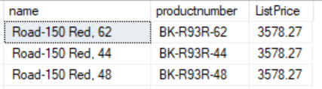

## E1b – Categories

Modify the first query to include the category and subcategory they all belong to too?

**Expected count:**

209

**Expected output:**

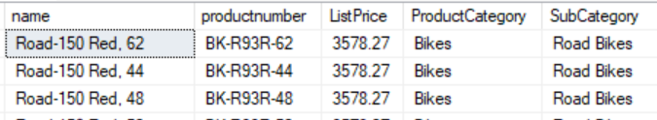

## – Who manages who

Can you please tell me who has the most staff reporting to them

**Expected count:**

47

**Expected output:**

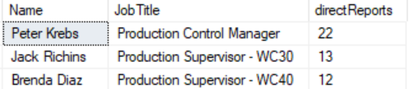

## – Average hourly rate

What is the current average hourly rate for a production technician per WC

**Expected count:**

7

**Expected output:**

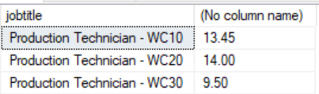

## – Customers options

A customer has rung up asking to buy a touring bike or high-end road bike for a woman (ignore colour variants)

write a query that will return all bikes that meet the specified criteria, giving them the:

- model of the bike

- List price

- size and weight (include units)

**Expected count:**

20

**Expected output:**

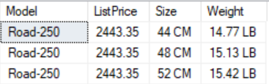

## – Hitting the target

**List all the Female Sales persons who have achieved the sales target in first quarter in the year of 2014**

**Expected count:**

6

**Expected output:**



## – Products and Discounts

**The Sales Manager wants a report that he can use to see the total quantity of Products sold by month and what discount types are available for each…**

**Expected count:**

300

**Expected output:**



## - Constraints

**Give an example of a constraint in the LearnerDB and explain what the impact of the constraint is.**

## – XML

**List the degree, first name and last name of the candidates with a bachelor’s degree.**

***(Note this table is small and this could easily be done manually. But try to do it using a query. If you want to try your luck on a bigger table with XML, have a look at the Sales.Store table)***

Expected count: 4

Expected output:



## – Build your own query

**Come up with your own question and write the solution to it.**

**Try to use as much of what you've learnt as possible**

## – Broken Stored Procedures

**The stored procedure uspGetEmployeeManagers is supposed to return the chain of management for any given employee. However this stored procedure does not work as expected.**

**Find and define the bug.**

**Can you fix it?**