Group Report

COMPUTING – ECU177

TIC-TAC-TOE

CALUM CHAMBERLAIN | Khadiza Yesmin | MUHAMMAD SAQAB | PRINCE FRIMPONG | SALMAN FAZAL | SYED ALI

2015

Table of Contents

Project Management 3

Methodology 4

Storyboard 5

Work allocation 9

Evaluation 10

**.**

# Project Management

*Explain how you approached the project (i.e. methodology, management etc.). Include a brief outline of the requirements you came up with for the game.*

This report will be centred around our assigned group project which was to programme Tic-Tac-Toe onto a Raspberry Pi. A part of the aim was to get the game up and running within eleven weeks with all requirements met and all testing matters dealt with to ensure a high level of quality. We took several steps to ensure that our final product was up to par in terms of excellence. As computing students, we understand that there should be a proper systematic and formal method intact when developing this game. Our system included having clear timescales, milestones, agreed deliverables as well as the breakdown and allocation of tasks.

The process first began by brainstorming and gathering up as many ideas as possible from each member that will help make our game stand out. The brainstorming included the most simplistic ideas to the most complex. Once all ideas have been gathered, we went through the process of elimination, as it would not be realistic to include every single feature mentioned from our brainstorming session. The group unanimously selected the final features that will make it into our actual Tic-Tac-Toe game.

These selected features were then slowly analysed into further details and then placed onto our list of requirements. It is important that all the items on this particular list are met by the end of the project to ensure that we have reached our aim and therefore have a quality product to present.

The following table will show our list of requirements, an explanation and whether is a tick sign next to it to indicate if they have been successfully met.

|  |  |  |
| --- | --- | --- |
| **Requirements** | **Analysis** | **Successful?** |
| Game board | The game board is the foundation of the game. It would be very simple; a table consisting of three rows by three columns. With a default background as white. | ✓ |
| Score board | The scoreboard will keep a track of how many wins each player gains during the games. The figures on the scoreboard will continue to increase if the user continually plays the game. The scoreboard will also keep a record of how many draws there have been. | ✓ |
| Colours | This is where the user gets the opportunity to customise their game. They will be given various colours to choose from. | ✓ |
| Mutli-player/ Single-player | The user gets the option to play against another person or can play against the computer itself (AI). | ✓ |
| New Game/End game | This will allow the user to start a new game at any point as well as exit the game at any point | ✓ |
| Navigation Bar | The purpose of the navigation bar is to ensure that the user is aware of all the options and features they are provided with. They will be able to see the menus for themselves and use their own initiative to either change the colour of their game board or begin a new game. | ✓ |
|  |  |  |

# Methodology

The methodology which we saw fit for our project was the spiral methodology as it appropriate for the timescale we were given. This methodology works by creating and building prototypes to go through trials. After every trial, the feedback allows us to take necessary actions to deal to any unforeseen issues and mishaps. With this, the next prototype is created and this process continues until there is a satisfactory Tic-Tac-Toe game delivered. An advantage of this is being able to implement changes at any convenient time.

The spiral methodology allowed us to reap the benefits of us group members being able to work in parallel on other sections of the project. This had save us a lot of time, in contrast to if we decided to take on a more iterative or linear method. It is understood that this means

We firstly had to identify all the agreed requirements that needed to be met to then analyse any risks that could potentially occur. Once the risks have been identified we then go on the actually coding the game in Python and then test it out. After the test we would produce a brief report on the outcomes.

Visual aid of agile spiral method:

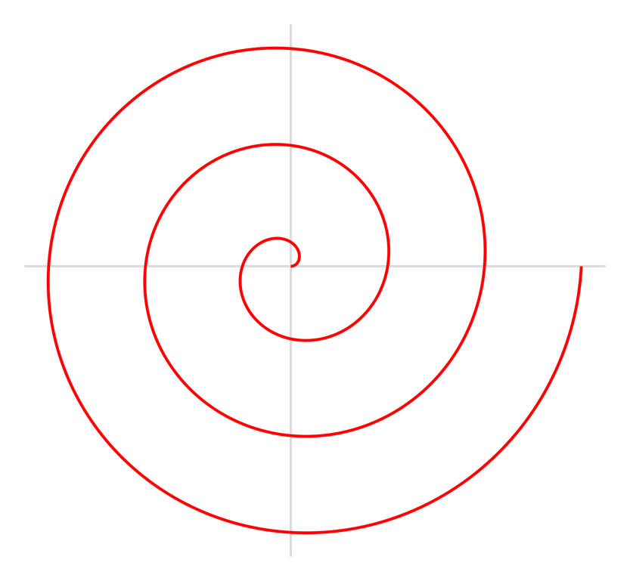

Final approved Tic-Tac-Toe game

Prototyping

Build in phases

Starting Point

List of requirements

Trial and evaluation

Prototyping is valuable to this project as it allows us to add any any other functions which have been detected as missing, incomplete or incorrect.

# Storyboard

The next couple of pages will show the design of our game. This is useful for the purpose of visual support. It will give us an idea of what our final product should look like. We have aimed to keep it simple and easy to use for novice users.

**Game Board**

**Game Title**

**Font = Helvetica**

**Font size = 12**

**Font Colour = Black**

**Close button**

**Minimise button**

**Maximise button**

Text

**-**

**X**

Text

**Font = Helvetica**

**Font size = 12**

**Font Colour = Black**

Text

**Background colour- grey**

**Dimensions**

**316 x 345**

**Note : Dimensions can be changed later on**

**Menu bar**

**X**

**-**

Text

Text

Text

Text

Text

Text

Text

**All menus should have drop down list**

**Scoreboard**

**-**

**X**

Text

Text

Text

Text

Text

Text

Text

Text

Text

Text

Text

**Font = Helvetica**

**Font size = 12**

**Font Colour = Black**

**Final View**

Text

**X**

**-**

Text

Text

Text

Text

Text

Text

Text

Text

Text

Text

Text

# Work allocation

This specific part of the report will explain who was allocated which section of the work in terms of coding the game. We worked collaboratively to ensure our game was operative.

After the story board was created by all members of the group, we broke down each element of the game and distributed the tasks amongst ourselves. The menu bar at the top of the screen was created created by four of our members – Prince created the ‘Help’ button alongside Saqab, Syed created the button for ‘Themes’ and ‘Font’ with Salman. The coding for the scoreboard was done by Salman, Prince and Khadiza and the buttons were created by Calum.

The single player code was completed by Calum, Salman, Prince and Syed, whereas the multiplayer was also created by Calum and Salman with additional help from Khadiza and Saqab. Calum was able to complete the server by himself, as he has had previous experience in programming and was confident in doing this himself.

As we used the spiral methodology, we faced created four prototypes in total. We had to debug several times and this was done by al members of the team. We all identified a few errors each and dealt with them as a team or individually depending on the level of difficulty we were faced with.

# Evaluation

To conclude, we believe we created a quality game whilst still remaining simple and easy to use. We had managed to meet all functions on our list of requirements which was made during our first group briefing. We kept on referring back to our list of requirements to ensure that we were on track and being able to tick of functions meant that we were making progress.

We did discuss what and how we would improve out game and we came up the following list:

* Sound
* Animations
* Level of difficulties
* Rollover images
* Scrolling marquee
* Personal profiles with pictures and short biography for players

Due to our lack of experience in programming, we were not to do these as most of us were very new to programming. For similar upcoming assignments we would have hoped to include at least some of them.

For future projects we would improve upon better communication between the group. We would have had a logbook to update every time someone was renewed the code and they would specify what they did. By this we would all be informed by how the code has changed.

Overall, we are satisfied with our game and the contribution of all members.