ECE 414 – Fall 2022
Homework 1
Due September 30, 2022

Note: this is an individual assignment. You may not collaborate, share answers, or discuss your homework with any other students before the assignment is collected and graded. If you have questions about how to work the problems, see me for clarification. Please capture your homework as a PDF document and upload it to Moodle by the due date.
Problems 1-6 refer to the following design problem:
You have been hired to design a replacement door alarm for a Lafayette residence hall. As shown in the schematic diagram, the alarm consists of a Microstick-II connected to an input sensor that is high when the door is open, an LED warning light that turns on when the output is asserted high, and a loud buzzer that sounds when asserted high. The following diagram shows how these parts are wired to the Microstick-II:

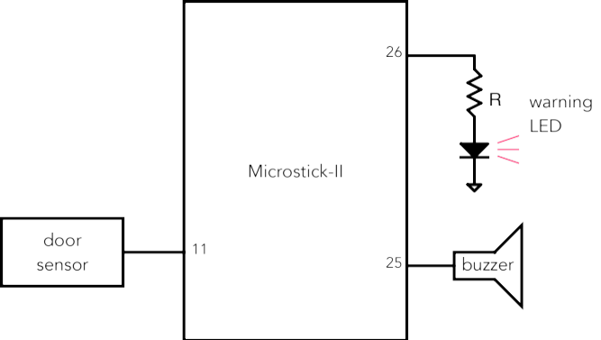
Figure 1 – Door Alarm Hardware
The requirements of this design are as follows:
- When the door is open, the LED warning light shall blink on and off once every second.
- When the door has been open longer than 30 seconds, the buzzer shall sound until the door is closed.
- When the door is closed, the buzzer shall stop sounding.
- Figure 2 shows the overall structure of the software for this alarm system, which shall consist of an interface module alarm_intf and two software state machines. The ALARMFSM state machine is responsible for the overall control of the design, while the WARNFSM state machine is responsible for blinking the warning LED when the variable warn is true.
- The interface module handles the low-level interfacing of the PIC32 to GPIO pins and communicates using the functions shown in its header file in Figure 3.
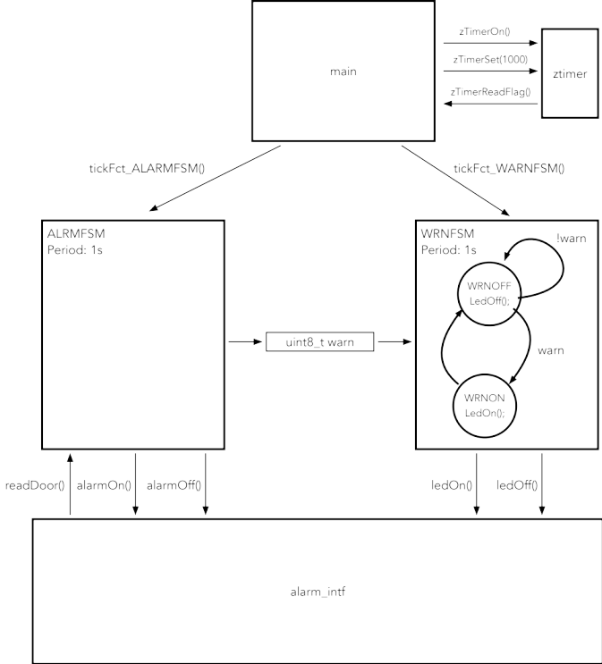
Figure 2 – Door Alarm Software
#ifdef ALARM_INTF_H
#define ALARM__INTF_H
#include <inttypes.h>

// Initialize the alarm interfaces
void initAlarm();

uint8_t readDoor();

// turn warning LED OFF
void ledOff();

// turn warning LED ON
void ledOn();

// turn alarm buzzer OFF
void alarmOff();

// turn alarm buzzer ON
void alarmOn();

#endif
Figure 3 – Interface Module Header File alarm_intf.h

Part 1: Ports and Interfacing
- Create a C file alarm_intf.c that implements the functions defined in the header file using the PIC32 SFRs.
- Create a C file alarm_intf_p.c that implements the functions defined in the header file using the PLIB peripheral library.

Files may be found at end of document, figures 5-15

Part 2: State Machine Design and Implementation
- Create a C implementation of the WARNFSM using the state diagram in Figure 2.
- Create a state diagram for the ALARMFSM state machine that satisfies the requirements for the alarm system.
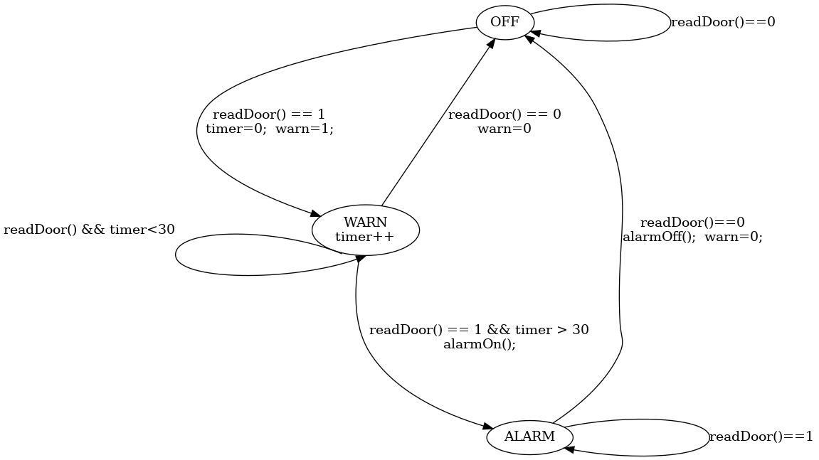
Figure 4: Alarm FSM State Transition Diagram
- Create a C implementation of the ALARMFSM state machine using the state diagram you created in the previous problem.
- Write a main() function that uses the ztimer module discussed in class to dispatch the tick functions for the two state machines.

Part 3: PIC32 Electrical Characteristics / Reading Data Sheets
In ECE 414 our primary emphasis has been on the software side of embedded systems design. However, microcontrollers are electronic devices and like any other electronic device, they have electrical characteristics and limitations. For the following questions, assume that we are working with a PIC32MX250F128B microcontroller (PIC32 for short) on a Microstick-II evaluation board.
To answer the following questions, you will need to refer to documentation including the PIC32 datasheet and related documentation and other sources that you may need to search for on the web. For each question, indicate the source of information that you used to produce an answer (e.g., “PIC32 Data Sheet Table x-x, p. xxx”).
- How much current does the PIC32 draw from the power supply at 40MHz assuming it is driving no I/O pins?
It typically draws 20 milliamps, though it may draw up to 30. (PIC32MX250F128B Data Sheet Table 30-5, p. 262)
- (a) What is the maximum current you can source from a single I/O pin? (b) What is the maximum current you can source from the sum of all I/O pins on our PIC32 device?
A) 15 milliamps
B) 200 miliamps
Sourced from PIC32MX250F128B datasheet, page 262, “Absolute Maximum Ratings”
- The Microstick II contains a voltage regulator (part no. MCP-1727) that converts the 5V USB power supply to a 3.3V output that powers the PIC32 along with any external resources connected through the VDD jumper. What is the maximum current that can be supplied by this regulator?
1.5 Amps
Sourced from page 1 of the MCP1727 data sheet
- In upcoming labs we will be using an AdaFruit LCD display. This display will be powered by the voltage regulator on the Microstick-II board and draws about 100mA of current. Assuming an LCD is connected to a Microstick-II, how much additional current is available from the voltage regulator to drive additional peripherals?
With 100mA consumed by the display, plus 20mA consumed by the PIC32, and assuming that negligible current is required to operate the communications with the display, we see that 1.38 amps of current are available to operate other peripherials, including the modules needed to interact with the display.

Code Listings
Note: Code also available on github at
alarm_intf.h
#ifndef ALARM_INTF_H
#define ALARM_INTF_H

#include <inttypes.h>
// Initialize the alarm interfaces
void initAlarm();

// gets the status of the door: 0 for closed, 1 for open
uint8_t readDoor();

// turn warning LED OFF
void ledOff();

// turn warning LED ON
void ledOn();

// turn alarm buzzer OFF
void alarmOff();

// turn alarm buzzer ON
void alarmOn();

#endif
alarmfsm.h
#ifndef ALARMFSM_H
#define ALARMFSM_H

#include <inttypes.h>

extern uint8_t warn;

void tickFct_ALARMFSM();

#endif /* ALARMFSM_H */

warnfsm.h
#ifndef WARNFSM_H
#define WARNFSM_H

void tickFct_WARNFSM();

#endif /* WARNFSM_H */

ztimer.h
#ifndef ZTIMER_H
#define ZTIMER_H
#include <inttypes.h>

// initialize timer to set a flag every given period (in ms)
extern void zTimerSet(uint32_t period);

// enable the timer and turn on the interrupt
extern void zTimerOn();

// read and return the timer flag value
// SIDE EFFECT: clear the flag
extern uint8_t zTimerReadFlag();

// return elapsed time in milliseconds since last call to zTimerOn
extern uint32_t zTimerReadms();

#endif /* ZTIMER_H */

alarm_intf.c
#include <xc.h>
#include <inttypes.h>

#include "alarm_intf.h"

#ifndef ALARM_USE_PLIB

void initAlarm(){
// we use the CLR and SET registers throughout to avoid interfering with
// some later addition of features. Maybe someone in facilities will want to
// take my homework and use it for the actual door alarm.
// (if someone does, please put a disable button, because those alarms
// drive people NUTS on move-in day, or during a power outage)

// ensure the door sensor is being digital
ANSELBCLR = 0x01 << 4;

// also ensure the outputs are digital
ANSELBCLR = (0x0003 << 14);

// set inputs
TRISBSET = 0x01 << 4;

// set outputs
TRISBCLR = 0x03 << 14;
}

uint8_t readDoor(){
// returns bit 4 (the sensor bit)
return (PORTB & 0x10) >> 4 ;
}

// turn warning LED OFF
void ledOff(){
PORTBCLR = 0x01 << 15;
}

// turn warning LED ON
void ledOn(){
PORTBSET = 0x01 << 15;
}

// turn alarm buzzer OFF
void alarmOff(){
PORTBCLR = 0x01 << 14;
}

// turn alarm buzzer ON
void alarmOn(){
PORTBSET = 0x01 << 14;
}

#endif /* ALARM_USE_PLIB */
alarm_intf_p.c
#include <plib.h>

#include "alarm_intf.h"

#ifdef ALARM_USE_PLIB

#include <inttypes.h>
// Initialize the alarm interfaces
void initAlarm(){
PORTSetPinsDigitalIn(IOPORT_B, BIT_4);
PORTSetPinsDigitalOut(IOPORT_B, BIT_14 | BIT_15);

}

// gets the status of the door: 0 for closed, 1 for open
uint8_t readDoor(){
mPORTBReadBits(BIT_4) >> 4;
}

// turn warning LED OFF
void ledOff(){
mPORTBClearBits(BIT_15);
}

// turn warning LED ON
void ledOn(){
mPORTBSetBits(BIT_15);
}

// turn alarm buzzer OFF
void alarmOff(){
mPORTBClearBits(BIT_14);
}

// turn alarm buzzer ON
void alarmOn(){
mPORTBSetBits(BIT_14);
}

#endif
alarmfsm.c
#include "alarm_intf.h"
#include "alarmfsm.h"

uint8_t warn = 0;

void tickFct_ALARMFSM(){
static enum state_t {OFF, WARN, ALARM} state = OFF;
static uint16_t timer = 0;

// mealy actions and transitions
switch(state){
case OFF:
if(readDoor()){
// do meally actions before transition; compiler won't care,
// but we can pretend it's safer
timer = 0;
warn = 1;
state = WARN;

}
else {
// will be optimized out
state = OFF;
}
break;
case WARN:
if(readDoor()){
if(timer >= 30){
alarmOn();
state = ALARM;
}
else{
state = WARN;
}
}
else{ //door closed
state = OFF;
}
break;
case ALARM:
if(readDoor()){
// beep beep beep
state = ALARM;
}
else{
alarmOff();
state = OFF;
}
break;
}

// moore actions
// some idempotent mealy actions in diagram were made into moore actions for
// safety
switch(state){
case OFF:
timer = 0;
warn = 0;
break;
case WARN:
timer ++;
/*fall through*/
case ALARM:
warn = 1;
break;
}

}

main.c

#include "warnfsm.h"
#include "alarmfsm.h"
#include "ztimer.h"

void main() {
zTimerSet(1000);
zTimerOn();
while(1){
if(!zTimerReadFlag()){
// loop on reading the flag until it is set
continue;
}
// tick both FSMs
tickFct_ALARMFSM();
tickFct_WARNFSM();
}
}

warnfsm.c

#include "warnfsm.h"
#include "alarmfsm.h"
#include "ztimer.h"

void main() {
zTimerSet(1000);
zTimerOn();
while(1){
if(!zTimerReadFlag()){
// loop on reading the flag until it is set
continue;
}
// tick both FSMs
tickFct_ALARMFSM();
tickFct_WARNFSM();
}
}

ztimer.c
#include <xc.h>
#include <plib.h>
#include "ztimer.h"

static uint32_t count, elapsedCount;
static uint32_t period, targetCount;

static uint8_t zTimerFlag = 0;

#pragma interrupt InterruptHandler ipl1 vector 0
void InterruptHandler(void)
{
// add code to set flag when we reach target
count++;
elapsedCount++;
if (count == period) {
zTimerFlag = 1;
count = 0;
}
mT2ClearIntFlag();
} // Interrupt Handler

// initialize timer to set a flag every given period (in ms)
void zTimerSet(uint32_t pdms) {
period = pdms;
}

// enable the timer and turn on the interrupt
void zTimerOn() {
// 1. initialize timer
PR2 = 4999; // Timer2 periodic reset every 5000 ticks (1ms)
T2CON = 0x8030; // Timer2 scaling factor of 8 (200ns)
TMR2 = 0; // start out at 0
count = 0;
elapsedCount = 0;
zTimerFlag = 0;
// 2. initialize interrupts
mT2SetIntPriority(1);
INTEnableSystemSingleVectoredInt();
mT2IntEnable(1);
}

void zTimerOff() {
mT2IntEnable(0);
T2CON = 0x0; // turn off timer
}

// read and return the timer flag value
// SIDE EFFECT: clear the flag
uint8_t zTimerReadFlag() {
if (zTimerFlag) {
zTimerFlag = 0;
return 1;
} else return 0;
}

// return elapsed time in milliseconds since last call to zTimerOn
uint32_t zTimerReadms() {
return elapsedCount;
}

See https://learn.adafruit.com/adafruit-2-4-color-tft-touchscreen-breakout for documentation.

