Calum Brown
S1229952
Games (Software Development) Year 2
Games Programming 1

I confirm that the code contained in this file (other than that provided or authorised) is all my own work and has not been submitted elsewhere in fulfilment of this or any other award.
Signature,

Code Explanation

Declarations

At the start of main.ccp I forward declare my SpawnEnemy method that I use to spawn the enemies. I also declare all of my variables there (i.e. the enemy and lazer vectors, the positioning arrays etc.).

WndProc method

This method handles all of the input for the game. First it handles the left and right key inputs, checking if they are within the bounds of the client and moving appropriately. Then it checks for the spacebar and then checks if the shooting is on cool down or not, if it isn't then a laser is created. It then handles the menu transitioning.

InitWindow method

This method instantiates the window. The only change to this I made was to the name.

WinMain

WinMain is where most of the game code is. First the method instantiates a few things like the time, retrieving textures etc. Then there is a while loop which is the actual game loop. Inside this is an if statement that ends the game if true, if false then goes into my gameState switch.

The gameState switch displays different menus/the game depending on an integer value that is instantiated as 1. If gameState is 1 then the game displays a menu, and the background image is set to the menu background image. In the menu if the player presses enter the gameState is changed to 2 and the main game begins, if they press space the gameState is set to 4.

If the gameState is 2 the actual game loop where the game logic happens. The first thing in the actual game loop is the start up if, the start up if statement initializes the background images, clears the enemy and laser vectors, general initialisation code. It then sets a Boolean called start up to false so that this is not called again. Next is the game logic, first we handle the laser cool down, then we check if it is time to spawn an enemy and if it is we invoke the SpawnEnemy method and decrement the maximum spawn time and increment the enemy speed. Then we loop through each enemy in the aBalloon vector. Inside the loop we update the position of the enemy and then position them at their new position. We then loop through each laser in the laser vector inside the aBalloon loop. We check the current iterator of the aBalloon loop for collisions with the current iterator of the laser vector, if they have collided we destroy the enemy and the laser, increment the score, decrement the number of enemies and create the explosion effect. If there is no collision then the laser iterator is incremented to keep looking for collisions. We end the laser vector loop here. Still in the aBalloon vector loop we check if any of the enemies have reached the bottom of the screen by checking to see if their y position equates to the bottom of the screen. This marks the end of the aBalloon vector for loop. After this is the draw code, which draws the sprites onto the screen.

Next we check if the gameState is 3 (the game over screen). This scene displays game over screen, the score the player achieved and then the players options. The player can then choose to replay the game which sets the gameState to 2, or go back to the main menu by pressing space which sets the gameState to 1.

Finally we check if the gameState is 4 (the instruction screen). This scene displays a short story, the controls and allows the player to start the game. When the player presses enter the gameState is set to 2.

After this the game loop is ended and the d3dx manager cleans up all of the sprites, ending the game.

The last piece of code is my Spawn Enemy method which creates an enemy, this method takes in two integer parameters, the first one is the current enemy number to feed into the vector, the second is a random integer value with a maximum of 8, this is used to randomly select from position vectors to give the appearance of random enemy spawning positions.

Class Diagram

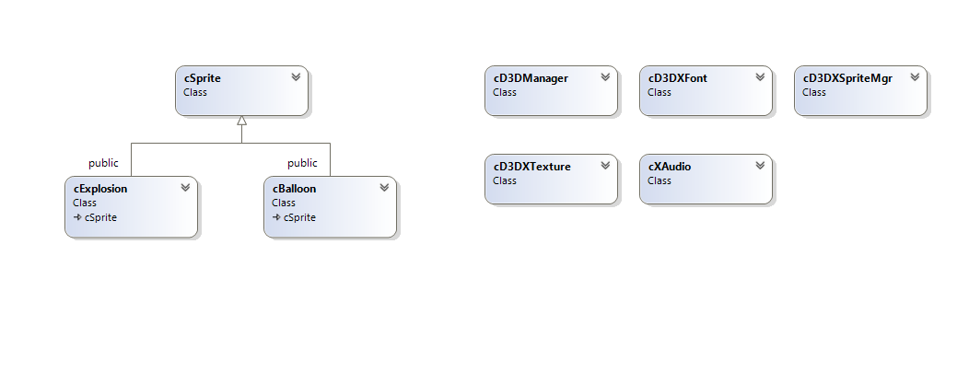

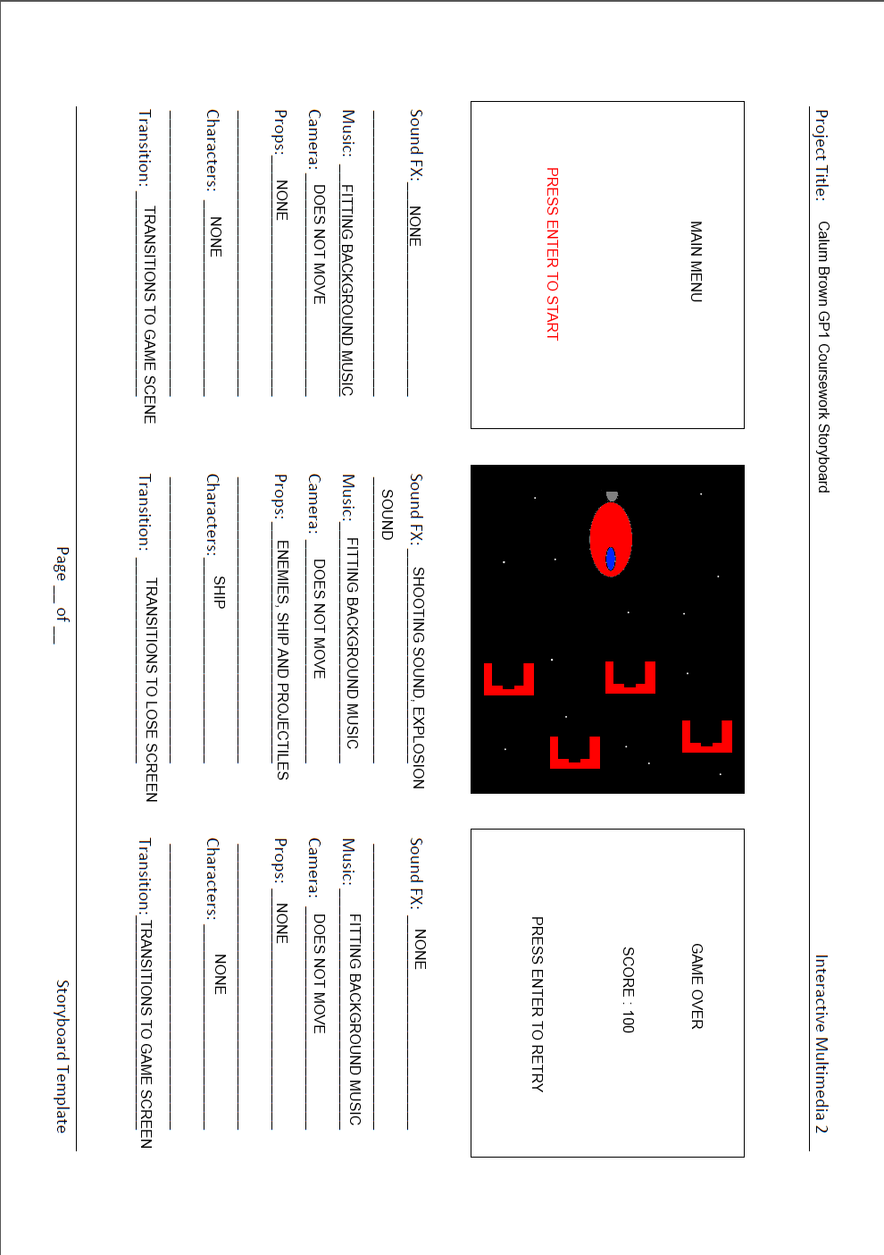

MAIN.CCP CODE

/*
=================
main.cpp
Main entry point for the Card application
=================
*/

#include "GameConstants.h"
#include "GameResources.h"
#include "cD3DManager.h"
#include "cD3DXSpriteMgr.h"
#include "cD3DXTexture.h"
#include "cBalloon.h"
#include "cSprite.h"
#include "cExplosion.h"
#include "cXAudio.h"
#include "cD3DXFont.h"

using namespace std;
void SpawnEnemy(int currentEnemy, int ePos);
void SpawnNonMoveEnemy(int currentEnemy);

HINSTANCE hInst; // global handle to hold the application instance
HWND wndHandle; // global variable to hold the window handle
// Get a reference to the DirectX Manager
static cD3DManager* d3dMgr = cD3DManager::getInstance();
// Get a reference to the DirectX Sprite renderer Manager
static cD3DXSpriteMgr* d3dxSRMgr = cD3DXSpriteMgr::getInstance();
D3DXVECTOR2 balloonTrans = D3DXVECTOR2(300,300);
vector<cBalloon*> aBalloon;
vector<cBalloon*>::iterator iter;
vector<cBalloon*>::iterator oldIter;
vector<cBalloon*>::iterator index;
vector<cBalloon*> aLazer;
vector<cBalloon*>::iterator lazeIter;
vector<cBalloon*>::iterator lazeIndex;
vector<cBalloon*>::iterator lazeErase;
RECT clientBounds;
TCHAR szTempOutput[30];
bool gHit = false;
int gBalloonsBurst = 0;
char gBalloonsBurstStr[50];
D3DXVECTOR3 expPos;
list<cExplosion*> gExplode;
cXAudio gExplodeSound;
cXAudio GameMusic;
cXAudio missleLaunch;
cD3DXTexture shipTex;
cD3DXTexture* balloonTextures[4];
char* balloonTxtres[] = {"Images\\Ship1.png","Images\\BalloonGreen.png","Images\\BalloonRed.png","Images\\explosion.png","Images\\Lazer.png",};
int spritePosX[] = {0,100,200,300,400,500,600,700,};
int spritePosY[] = { 0, 80, 10, 60, 80, 0, 60, 20, 50, 100, };
D3DXVECTOR3 shipPos;
D3DXVECTOR3 lazerPos;
D3DXVECTOR3 balloonPos;
D3DXVECTOR2 rocketTrans = D3DXVECTOR2(0, 0);
cBalloon player;
cBalloon lazer;
cD3DXTexture lazerTex;
D3DXVECTOR2 lazerTrans= D3DXVECTOR2(0,-200);
int lazerSpawn = 0;
bool lazerShoot = false;
int lazTime = 10;
int lazMax = 10;
float enemySpeed = 30.0f;
bool weapon;
int gameState = 1; // used in the game switch
D3DXVECTOR3 buttonPos;
cBalloon playButton;
float dt;
int currentEnemy = 0;
bool startUp = false;
bool menuStart = true;
int spawnTime = 0;
int spawnMax = 50;
int enemycounter = 0;
/*
==================================================================
* LRESULT CALLBACK WndProc(HWND hWnd, UINT message, WPARAM wParam,
* LPARAM lParam)
* The window procedure
==================================================================
*/
LRESULT CALLBACK WndProc(HWND hWnd, UINT message, WPARAM wParam, LPARAM lParam)
{
// Check any available messages from the queue
switch (message)
{
case WM_KEYDOWN:
{
if (wParam == VK_LEFT && shipPos.x >0 && gameState == 2)
{
player.setSpritePos(D3DXVECTOR3(shipPos.x -= 30.0f, clientBounds.bottom - 120.0f, 0.0f));
return 0;
}
if (wParam == VK_RIGHT && shipPos.x <770 && gameState == 2)
{
player.setSpritePos(D3DXVECTOR3(shipPos.x += 30.0f, clientBounds.bottom - 120.0f, 0.0f));
return 0;
}
if (wParam == VK_SPACE )
{
switch (gameState)
{
case 1:
gameState = 4;
break;
case 2:
if (lazTime == lazMax)
{
lazerPos = D3DXVECTOR3(shipPos.x+25, shipPos.y, 0); // starting position of lazer
aLazer.push_back(new cBalloon());
aLazer[lazerSpawn]->setSpritePos(lazerPos); // set sprite pos
aLazer[lazerSpawn]->setTranslation(D3DXVECTOR2(0.0f, -200.0f)); // set translation direction and speed
aLazer[lazerSpawn]->setTexture(new cD3DXTexture(d3dMgr->getTheD3DDevice(), "Images\\lazer.png")); // apply texture
lazerSpawn++; // increment number of lazers
lazTime--; // decrement lazer time
missleLaunch.playSound(L"Sounds\\heavyLazer.wav", false); // play sound
}
break;
case 3:
break;
case 4:
break;
default:
break;
}
return 0;

//return 0;
}
if (wParam == VK_RETURN)
{
switch (gameState)
{
case 1:
gameState = 2;
break;
case 3:
gBalloonsBurst = 0;
gameState = 1;
break;
case 4:
gameState = 2;
break;
default:
break;
}
return 0;
}
if (wParam == VK_ESCAPE)
{
if (gameState == 3)
{
gameState = 1;
return 0;
}
return 0;
}
return 0;
}
case WM_LBUTTONDOWN:
{

return 0;
}
case WM_CLOSE:
{
// Exit the Game
PostQuitMessage(0);
return 0;
}

case WM_DESTROY:
{
PostQuitMessage(0);
return 0;
}
}
// Always return the message to the default window
// procedure for further processing
return DefWindowProc(hWnd, message, wParam, lParam);
}

/*
==================================================================
* bool initWindow( HINSTANCE hInstance )
* initWindow registers the window class for the application, creates the window
==================================================================
*/
bool initWindow( HINSTANCE hInstance )
{
WNDCLASSEX wcex;
// Fill in the WNDCLASSEX structure. This describes how the window
// will look to the system
wcex.cbSize = sizeof(WNDCLASSEX); // the size of the structure
wcex.style = CS_HREDRAW | CS_VREDRAW; // the class style
wcex.lpfnWndProc = (WNDPROC)WndProc; // the window procedure callback
wcex.cbClsExtra = 0; // extra bytes to allocate for this class
wcex.cbWndExtra = 0; // extra bytes to allocate for this instance
wcex.hInstance = hInstance; // handle to the application instance
wcex.hIcon = LoadIcon(hInstance,MAKEINTRESOURCE(IDI_MyWindowIcon)); // icon to associate with the application
wcex.hCursor = LoadCursor(hInstance, MAKEINTRESOURCE(IDC_GUNSIGHT));// the default cursor
wcex.hbrBackground = (HBRUSH)(COLOR_WINDOW+1); // the background color
wcex.lpszMenuName = NULL; // the resource name for the menu
wcex.lpszClassName = "Balloons"; // the class name being created
wcex.hIconSm = LoadIcon(hInstance,"Balloon.ico"); // the handle to the small icon

RegisterClassEx(&wcex);
// Create the window
wndHandle = CreateWindow("Balloons", // the window class to use
"FTL: Super Mega Calum Brown Delux Edition", // the title bar text
WS_OVERLAPPEDWINDOW, // the window style
CW_USEDEFAULT, // the starting x coordinate
CW_USEDEFAULT, // the starting y coordinate
800, // the pixel width of the window
600, // the pixel height of the window
NULL, // the parent window; NULL for desktop
NULL, // the menu for the application; NULL for none
hInstance, // the handle to the application instance
NULL); // no values passed to the window
// Make sure that the window handle that is created is valid
if (!wndHandle)
return false;
// Display the window on the screen
ShowWindow(wndHandle, SW_SHOW);
//ShowWindow(wndHandle, SW_MAXIMIZE);
UpdateWindow(wndHandle);
return true;
}

/*
==================================================================
// This is winmain, the main entry point for Windows applications
==================================================================
*/
int WINAPI WinMain( HINSTANCE hInstance, HINSTANCE hPrevInstance, LPTSTR lpCmdLine, int nCmdShow )
{

#pragma region GameInitStuff
// Initialize the window
if ( !initWindow( hInstance ) )
return false;
// called after creating the window
if ( !d3dMgr->initD3DManager(wndHandle) )
return false;
if ( !d3dxSRMgr->initD3DXSpriteMgr(d3dMgr->getTheD3DDevice()))
return false;

// Grab the frequency of the high def timer
__int64 freq = 0; // measured in counts per second;
QueryPerformanceFrequency((LARGE_INTEGER*)&freq);
float sPC = 1.0f / (float)freq; // number of seconds per count

__int64 currentTime = 0; // current time measured in counts per second;
__int64 previousTime = 0; // previous time measured in counts per second;

float numFrames = 0.0f; // Used to hold the number of frames
float timeElapsed = 0.0f; // cumulative elapsed time

GetClientRect(wndHandle,&clientBounds);

float fpsRate = 1.0f/30.0f;

D3DXVECTOR3 aballoonPos;

sprintf_s(gBalloonsBurstStr, 50, "SCORE : %d", gBalloonsBurst);

//====================================================================
// Load four textures for the balloons; yellow, green, red & explosion
//====================================================================
for (int txture = 0; txture < 4; txture++)
{
balloonTextures[txture] = new cD3DXTexture(d3dMgr->getTheD3DDevice(), balloonTxtres[txture]);
}

// Initial starting position for Rocket
D3DXVECTOR3 balloonPos;

/* initialize random seed: */
srand ( (unsigned int)time(NULL) );
/* generate random number of balloons */

shipPos = D3DXVECTOR3(clientBounds.right/2-30.0f,clientBounds.bottom-120.0f,0); // starting positionof player;
player.setTexture(new cD3DXTexture(d3dMgr->getTheD3DDevice(), "Images\\Ship.png"));
player.setSpritePos(shipPos);
player.setTranslation(D3DXVECTOR2(0.0f,0.0f));

LPDIRECT3DSURFACE9 aSurface; // the Direct3D surface
LPDIRECT3DSURFACE9 theBackbuffer = NULL; // This will hold the back buffer

MSG msg;
ZeroMemory( &msg, sizeof( msg ) );

// Create the background surface
//aSurface = d3dMgr->getD3DSurfaceFromFile("Images\\Nighttime.png");

// load custom font
cD3DXFont* balloonFont = new cD3DXFont(d3dMgr->getTheD3DDevice(),hInstance, "JustinFont12Bold");

RECT textPos;
SetRect(&textPos,0, 0, 600, 100);
RECT menutextPos;
SetRect(&menutextPos, clientBounds.right/2-50,clientBounds.bottom/2,clientBounds.right/2+300,clientBounds.bottom/2+100);
//shipPos = D3DXVECTOR3(rocketTrans.x, clientBounds.bottom-120, 0); //rocket stuff
//player.setSpritePos(shipPos);

QueryPerformanceCounter((LARGE_INTEGER*)&previousTime);
#pragma endregion GameInitStuff
while( msg.message!=WM_QUIT )
{
// Check the message queue
if (PeekMessage(&msg, NULL, 0U, 0U, PM_REMOVE) )
{
TranslateMessage( &msg );
DispatchMessage( &msg );
}
else
{
if (gameState == 1)
{
OutputDebugString("gameState == 1");
if (menuStart)
{
GameMusic.playSound(L"Sounds\\MenuMusic.wav", true);
menuStart = false;
aSurface = d3dMgr->getD3DSurfaceFromFile("Images\\FTLMENUBACKGROUND.png");
}

startUp = true;
d3dMgr->beginRender();
theBackbuffer = d3dMgr->getTheBackBuffer();
d3dMgr->updateTheSurface(aSurface, theBackbuffer);
d3dMgr->releaseTheBackbuffer(theBackbuffer);
d3dxSRMgr->endDraw();
d3dMgr->endRender();
}

else if(gameState == 2)
{
#pragma region gameCode
// Game code goes here
OutputDebugString("gameState == 2");
if (startUp)
{
aSurface = d3dMgr->getD3DSurfaceFromFile("Images\\Nighttime.png"); // change the backrgound to the game background
startUp = false; // set the startup bool to false so this only happens once
enemySpeed = 30.0f; // sets the enemy speed to the default
timeElapsed = 0.0f; // sets the time elapsed to 0
currentEnemy = 0; // sets the currentEnemy to 0
lazerSpawn = 0; // sets the current lazer to 0
aBalloon.clear(); // clears the aBalloon vector
aLazer.clear();// clears the aLazer vector to 0
SpawnNonMoveEnemy(currentEnemy); // creates initial enemy
gBalloonsBurst = 0; // sets the scire to 0
sprintf_s(gBalloonsBurstStr, 50, "SCORE : %d", gBalloonsBurst); // displays the score
}

QueryPerformanceCounter((LARGE_INTEGER*)&currentTime);
dt = (currentTime - previousTime)*sPC;
// Accumulate how much time has passed.
timeElapsed += dt;
//lazer.setSpriteTransformMatrix(
/*
==============================================================
| Update the postion of the balloons and check for collisions
==============================================================
*/
if (timeElapsed > fpsRate)
{
if (lazTime < lazMax)lazTime--; // if lazTime is less than the max
if (lazTime <= 0)lazTime = lazMax;
spawnTime--;
if (spawnTime <= 0)
{
spawnTime = spawnMax;
SpawnEnemy(currentEnemy, rand()%8);
currentEnemy++;
enemySpeed += 1.0f;
if (spawnMax >15)
{
spawnMax -= 1;
}

}
for (iter = aBalloon.begin(); iter != aBalloon.end();)
{
OutputDebugString("Ship update");
(*iter)->update(timeElapsed); // update balloon
aballoonPos = (*iter)->getSpritePos(); // get the position of the current balloon

for (lazeIndex = aLazer.begin(); lazeIndex != aLazer.end();)
{
if ((*iter)->collidedWith((*iter)->getBoundingRect(), (*lazeIndex)->getBoundingRect()))
{
//(*iter)->setTranslation(D3DXVECTOR2(0.0f, 0.0f));
//(*iter)->setTranslation(D3DXVECTOR2(0.0f, -enemySpeed)); // set translation direction and speed
//(*iter)->setSpritePos(D3DXVECTOR3(0.0f, -10000000000000000.0f, 0.0f));
expPos = (*iter)->getSpritePos();
gExplode.push_back(new cExplosion(expPos, balloonTextures[3]));
gExplodeSound.playSound(L"Sounds\\explosion.wav", false);
iter = aBalloon.erase(iter);
lazeIndex = aLazer.erase(lazeIndex);
currentEnemy--;
lazerSpawn--;
gBalloonsBurst+=10;
sprintf_s(gBalloonsBurstStr, 50, "SCORE : %d", gBalloonsBurst);
}
else
{
++lazeIndex;
}

}
if (aballoonPos.y > (clientBounds.bottom - 60))
{
gameState = 3;
}
++iter;
}

d3dMgr->beginRender();
theBackbuffer = d3dMgr->getTheBackBuffer();
d3dMgr->updateTheSurface(aSurface, theBackbuffer);
d3dMgr->releaseTheBackbuffer(theBackbuffer);
d3dxSRMgr->beginDraw();

player.setTranslation(rocketTrans);
d3dxSRMgr->setTheTransform(player.getSpriteTransformMatrix());
d3dxSRMgr->drawSprite(player.getTexture(), NULL, NULL, NULL, 0XFFFFFFFF); // draw player &player.getSpritePos()
d3dxSRMgr->setTheTransform(lazer.getSpriteTransformMatrix());

d3dxSRMgr->drawSprite(lazer.getTexture(), NULL, NULL, NULL, 0XFFFFFFFF); // draw lazer &player.getSpritePos()
lazer.setTranslation(lazerTrans);
player.update(timeElapsed);
lazer.update(timeElapsed);
vector<cBalloon*>::iterator iterB = aBalloon.begin();
for (iterB = aBalloon.begin(); iterB != aBalloon.end(); ++iterB)
{
d3dxSRMgr->setTheTransform((*iterB)->getSpriteTransformMatrix());
d3dxSRMgr->drawSprite((*iterB)->getTexture(), NULL, NULL, NULL, 0xFFFFFFFF);

}
vector<cBalloon*>::iterator iterC = aLazer.begin();
for (iterC = aLazer.begin(); iterC != aLazer.end(); ++iterC)
{
d3dxSRMgr->setTheTransform((*iterC)->getSpriteTransformMatrix());
d3dxSRMgr->drawSprite((*iterC)->getTexture(), NULL, NULL, NULL, 0xFFFFFFFF);
(*iterC)->update(timeElapsed);
}
list<cExplosion*>::iterator iter = gExplode.begin();
while (iter != gExplode.end())
{
if ((*iter)->isActive() == false)
{
iter = gExplode.erase(iter);
}
else
{
(*iter)->update(timeElapsed);
d3dxSRMgr->setTheTransform((*iter)->getSpriteTransformMatrix());
d3dxSRMgr->drawSprite((*iter)->getTexture(), &((*iter)->getSourceRect()), NULL, NULL, 0xFFFFFFFF);
++iter;
}
}
d3dxSRMgr->endDraw();
balloonFont->printText(gBalloonsBurstStr, textPos);
d3dMgr->endRender();
timeElapsed = 0.0f;
}
previousTime = currentTime;
#pragma endregion gameStuff
}
if (gameState == 3)
{
startUp = true;
aSurface = d3dMgr->getD3DSurfaceFromFile("Images\\MenuBack.png");
sprintf_s(gBalloonsBurstStr, 50, "SCORE : %d", gBalloonsBurst);

d3dMgr->beginRender();
theBackbuffer = d3dMgr->getTheBackBuffer();
d3dMgr->updateTheSurface(aSurface, theBackbuffer);
d3dMgr->releaseTheBackbuffer(theBackbuffer);
balloonFont->printText(gBalloonsBurstStr, menutextPos);
d3dxSRMgr->endDraw();
d3dMgr->endRender();

}
if (gameState == 4)
{
startUp = true;
aSurface = d3dMgr->getD3DSurfaceFromFile("Images\\FTLINSTRUCTIONS.png");
d3dMgr->beginRender();
theBackbuffer = d3dMgr->getTheBackBuffer();
d3dMgr->updateTheSurface(aSurface, theBackbuffer);
d3dMgr->releaseTheBackbuffer(theBackbuffer);
d3dxSRMgr->endDraw();
d3dMgr->endRender();

}
}
}
d3dxSRMgr->cleanUp();
d3dMgr->clean();
return (int) msg.wParam;

}

void SpawnNonMoveEnemy(int currentEnemy)
{
aBalloon.push_back(new cBalloon());
aBalloon[currentEnemy]->setSpritePos(D3DXVECTOR3 (10000000.0f,0.0f,0.0f)); // set sprite pos
aBalloon[currentEnemy]->setTranslation(D3DXVECTOR2(0.0f, 0.0f)); // set translation direction and speed
aBalloon[currentEnemy]->setTexture(balloonTextures[(rand() % 3)]); // set texture
}
void SpawnEnemy(int currentEnemy, int ePos)
{
balloonPos = D3DXVECTOR3(spritePosX[ePos], clientBounds.top - spritePosY[ePos], 0.0f); // starting position of enemy
aBalloon.push_back(new cBalloon());
aBalloon[currentEnemy]->setSpritePos(balloonPos); // set sprite pos
aBalloon[currentEnemy]->setTranslation(D3DXVECTOR2(0.0f, enemySpeed)); // set translation direction and speed
aBalloon[currentEnemy]->setTexture(balloonTextures[(rand()%3)]); // set texture
}

