Creating a static Chinese Wall in SELinux

The Chinese Wall policy states that a subject s_1 can operate on objects o_1 and o_2, where o_1 and o_2 are in the same CoI group.

A simple daemon process to open /var/log/messages

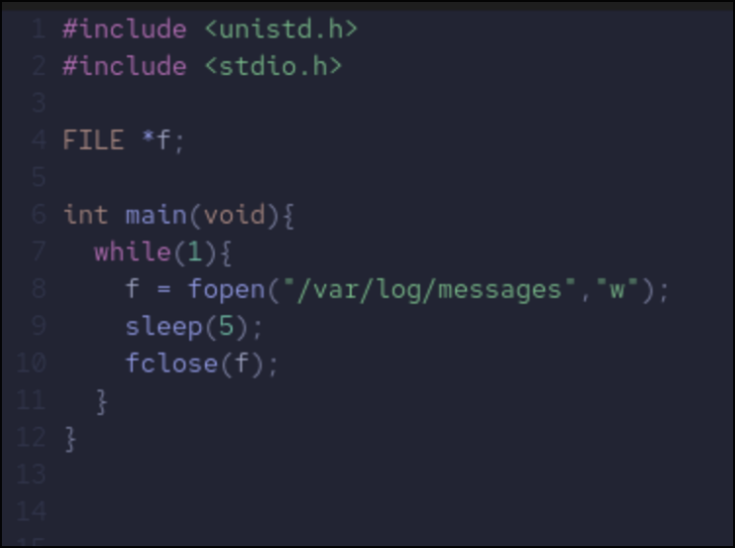
The result of ls –Z on /var/log
The result of ls –Z on mydaemon
This is just the labels on the executable, not the actual service

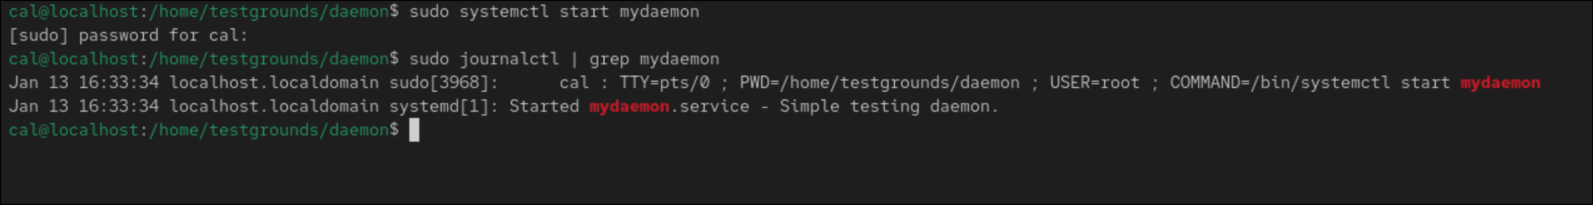
As it is running as unconfined_u, it is not restricted by SELinux.
```Sepolicy generate —init /usr/local/bin/mydaemon``` autogenerates a policy to run the daemon confined by SELinux

Policy generated by SELinux
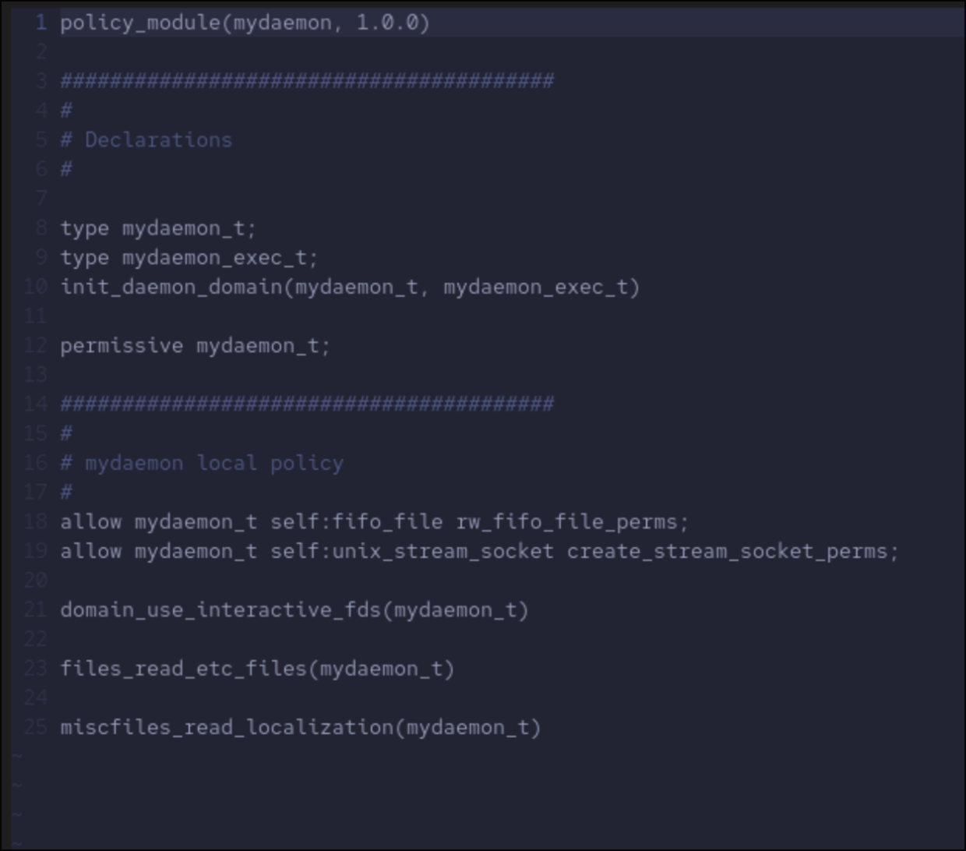
Once reloaded, the daemon is now running under the mydaemon_t type declared in the file
SELinux denies access, as there is no rule to allow mydaemon_t to read / write in var/messages
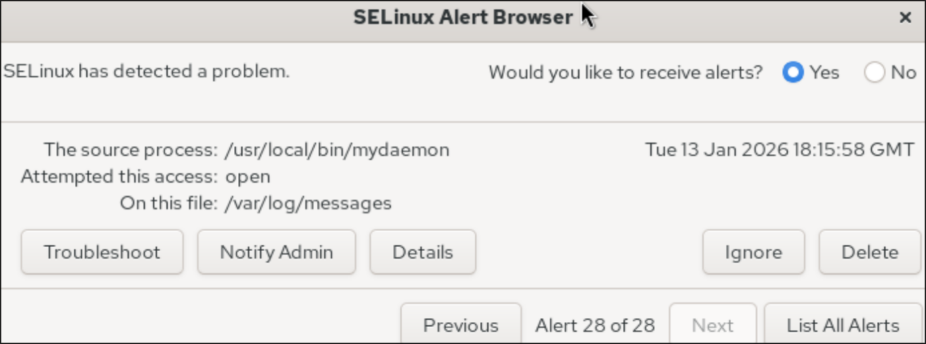
Adding these lines to the policy file allow it to work under SELinux
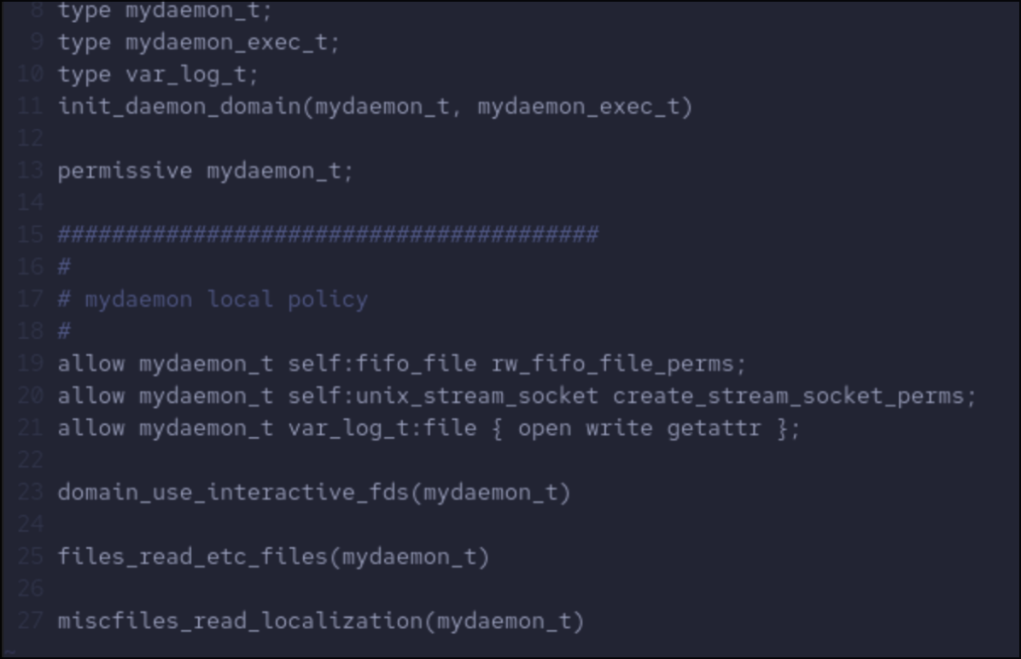
Now these fundamentals can allow us to create a static Chinese Wall

A static wall can be displayed with 2 different subjects, s_1 and s_2 being able to view different items in the same CoI class but not another. A chinese wall is better made with the subject being allowed to view all and then be restricted from the object they are disallowed from rather than being allowed to view the other object. SELinux policy modules have a neverallow feature that can be used for this
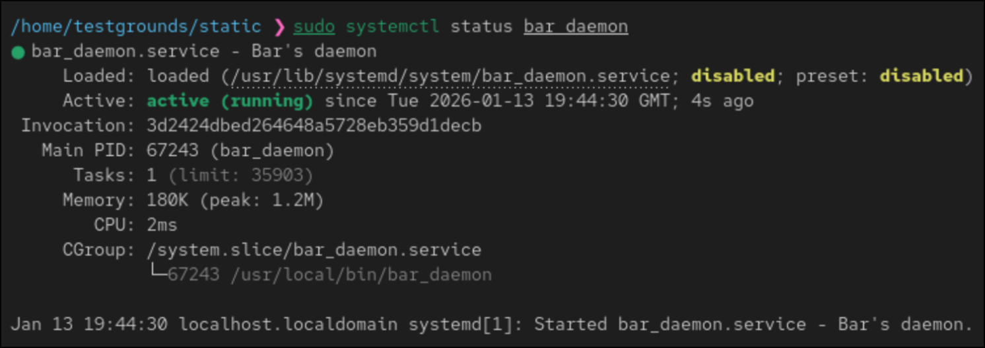
Created a bar daemon to try read foo_secret, works currently as its unconfined by SELinux
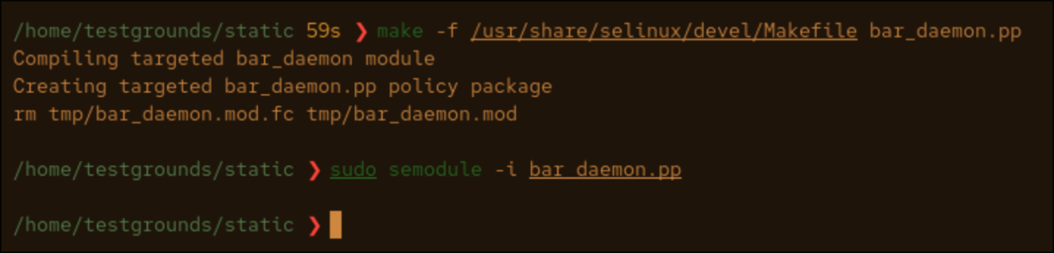
Policy created for bar_daemon to restrict access to secret_t (defined in another policy module)
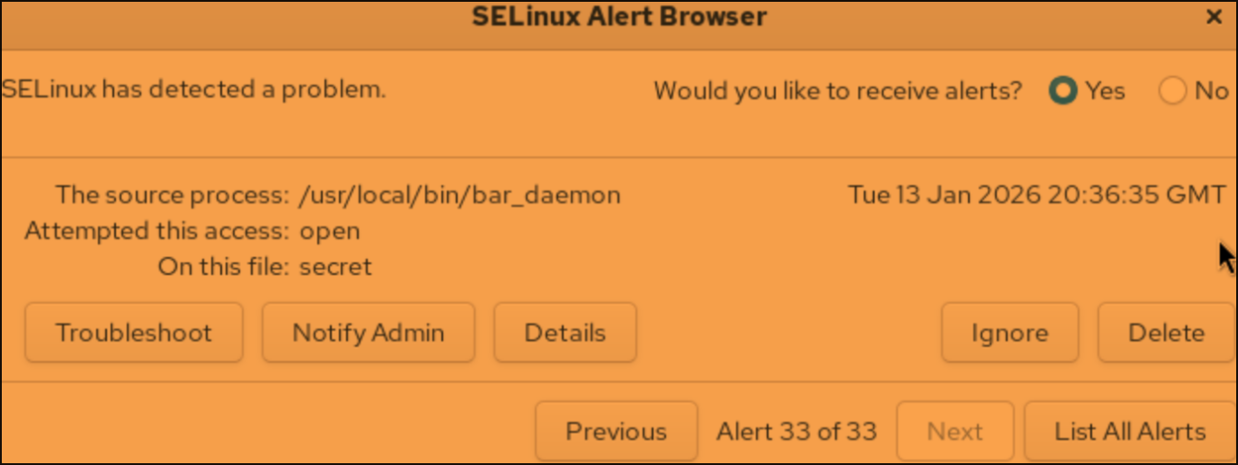
Bar Daemon is denied from accessing secret while foo still can. This is the preliminary functionality to implement a Chinese wall.

