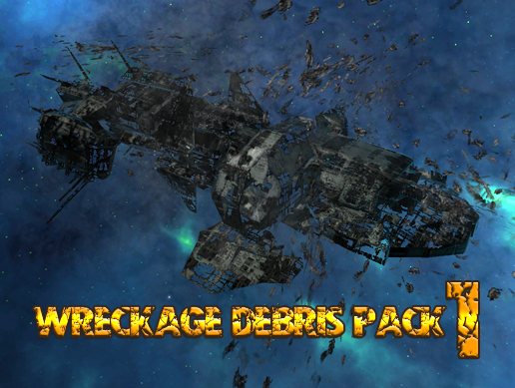**WRECKAGE DEBRIS PACK 01**

**FOR UNITY3D DOCUMENTATION**

**RELEASE VERSION 1.0**

***CREATED BY: DANIEL KOLE***

*Copywrite 2017 - Daniel Kole Productions*

***Wreckage Debris Pack 01 - Overview:***

Requires Unity 5.5.0f3 or higher.

***Wreckage Debris Pack 01*** *is a collection of destroyed starship space debris. It includes 2 complete Derelict Starship prefab, 22 starship debris pieces, and 9 starship debris clusters. Everything is randomized using C# scripts. Also includes 2 Skybox starfields: a Blue/Green skybox and a Orange/Green skybox. Includes 2 Materials with Diffuse and Normal Textures (2048x2048) transparent and non-transparent textures.*

***FEATURE LIST:***

*- 2 Derelict Starship Prefabs*

*- Starship Graveyard Prefab*

*- Debris Field Prefab*

*- 22 Starship Debris Pieces*

*- 9 Starship Debris Clusters*

*- Everything Randomized*

*- C# Scripts*

*- 3 Materials with Textures (Diffuse, Normal, Transparent/Non-Transparent)*

***SUPPORT, FEEDBACK, AND FUTURE VERSION INFORMATION CAN BE FOUND AT THE SUPPORT FORUM PAGE HERE:***

**[Visit the Support/Version Information Forum Thread here!](https://forum.unity3d.com/threads/wreckage-debris-pack-01-coming-soon.458793/)**

***Wreckage Debris Pack 01 - Usage and Version History:***

***Usage and Installation:***

To use this package:

- Start a new project and import the Wreckage Debris Pack 01 Asset Package into the project.

Open any of the demo scenes located in the ***DKP/WreckageDebrisPack01/Scenes*** folder to view the different included prefabs.

***Version History:***

***Version 1.0 -***

**- First Release Version of Wreckage Debris Pack 01.**

**- Includes 3 Demo Scenes of the Prefabs Included with Cameras and Skyboxes**