**Project Objectives – Neater Meter**

**ENGR 339-A: Prof. VanderLeest**

**27 September 2010**

**Team 01: A. Ball, N. Jen, A. Sterk, K. Wiersma**

**Project Goals**

1. Provide a working, physical, system by graduation.
2. Provide documentation on how the system is installed, functions, interfaces with other systems and technical specifications.
3. All team-members shall survive this ordeal and be healthy by graduation time.
4. The team-members should be able to enjoy their time working on this project.
5. Seek out and collect prospective customer feedback for a system like that being proposed.
6. Interface with Google Power service.
7. Successfully, safely, and understandably monitor and report power usage information.
8. Thoroughly test all necessary components for functionality and durability.

**Project Requirements**

1. General Requirements
   1. Shall provide an easy to use interface.
   2. Shall be at least as accurate as current power meters.
   3. Shall not interfere with the expected delivery of power
   4. Shall provide a base level of functionality, in accordance with what the consumer and the power company requires.
   5. Shall provide an interface for expansion to extend system functionality.
   6. Shall require as little on-site maintenance as possible.
   7. Shall be capable of withstanding outdoor conditions.
2. Functional Requirements
   1. Shall be capable of monitoring the entire power usage of a particular installation.
   2. Shall record power usage information with as much accuracy and granularity as required by the power company.
   3. Shall report errors and malfunctions of its components and any external components to which it is attached.
   4. Shall record and report evidence of tampering.
   5. Shall provide an interface for active user notification in the event of an emergency or other critical, time-sensitive, issue that arises.
   6. Shall provide, to the power company, the ability to remotely shut off and lock out the power connection to the consumer.
   7. Shall keep a record of power disruptions.
3. Behavioral Requirements
   1. Shall be tolerant of situations during which power to the unit may be lost or is otherwise disconnected.
      1. The data recorded by the device shall be stored in such a way that it is non-volatile.
   2. Shall report information to the power company, as the power company would require.
   3. Shall report all information, across any external interface over a secure protocol.
      1. Shall provide a method to establish identity, ownership, and authentication tokens.
   4. Shall be able, in the event of a power loss, to safely shut down without losing any data and log that it has done so.
   5. Shall be delivered to the installation site in a ready to install state.
   6. Shall be capable of receiving and installing firmware updates in such a way that normal monitoring is not affected.
      1. Shall be capable of providing firmware updates to any of its connected component.
      2. Shall be capable of restoring itself to a previous firmware version in the event of a corrupted flash.
   7. Shall perform a system health and status sweep routinely and on-demand.

**Block Diagrams**

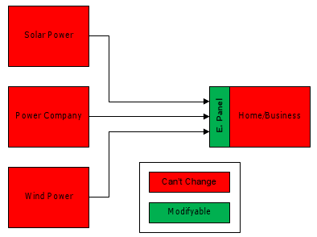

Figure 1: Overall System integration with existing e-panel.

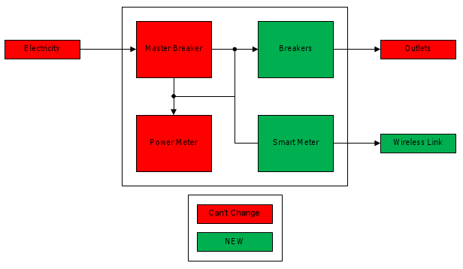

Figure 2: E-panel internal block diagram.

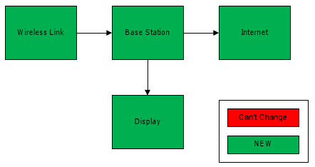

Figure 3: Base station block diagram.

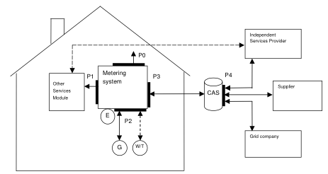

Figure 4: System level block diagram for SMART grid interface.