Team PICA

Power Information Collection Architecture



28 February 2011

Calvin College

Engineering Senior Design Project

Team 01: A. Ball, N. Jen, A. Sterk, K. Wiersma

**The Team:**

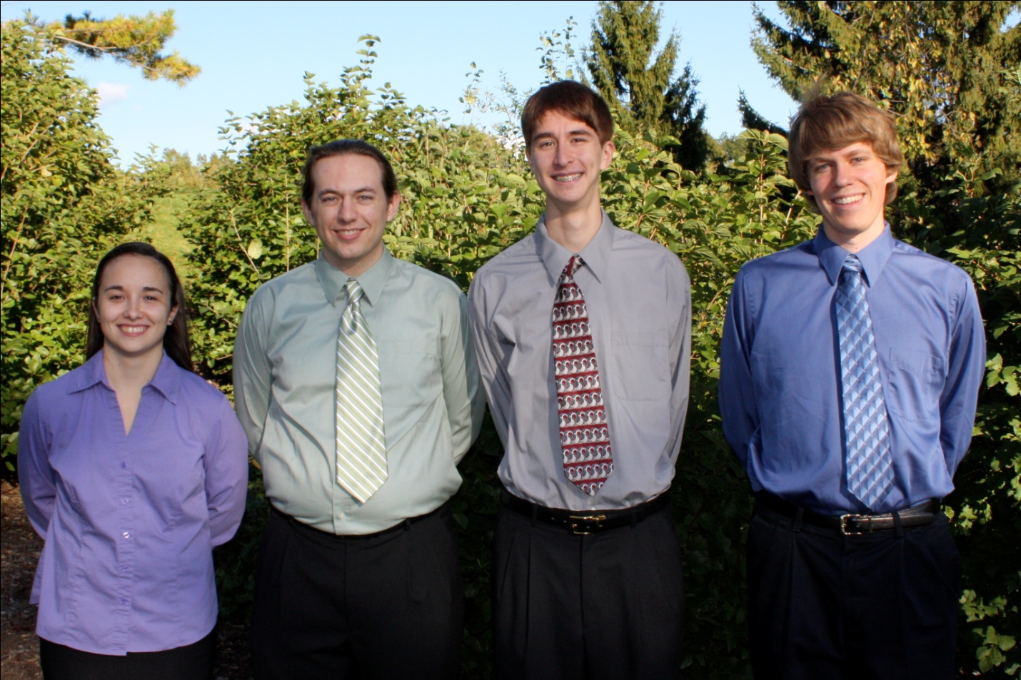From left: Amy Ball, Kendrick Wiersma, Nathan Jen, Avery Sterk

**Project Description:**

Team PICA seeks to develop a digital power-system monitoring tool for home and commercial use. With this device, we hope to provide more accurate and timely data to the consumer and power company in a unique and affordable manner. A few of our system’s unique features include:

1. Circuit-by-circuit analysis of a building’s power consumption.
2. A remotely controlled power shutoff.
3. Active reporting and alert mechanisms, configurable by either the consumer or the provider.

Our system includes three major subsystems, the E-Meter, the Solid-State Breakers, and the Base Station, each with a specific task.

The first of these subsystems, the E-Meter, monitors the power delivered to the consumer from the utility provider, much like a traditional power meter. The E-Meter operates in either 3-phase or single-phase mode, depending on requirements. The E-Meter may also optionally report usage data wirelessly to the utility provider through a radio uplink.

The second major component of our monitoring tool, the solid-state breakers, provides circuit-by-circuit analysis and control of power throughout a building. Each circuit runs through a solid-state relay, instead of a traditional air-gap breaker, providing our system with the ability to monitor and control the status of each circuit (on/off/tripped). In order to collect data from each individual circuit, current transformers and voltage shunts are attached to each circuit, read by an apparent energy IC from Analog Devices.

The third major component of our system, the base station, provides a data aggregation point for each of the other systems. Each of the other major components connect to the base station using a yet to be determined communications protocol. The base station for our project’s purposes will be a Xilinx development board containing a Virtex 5 FPGA flashed with a SPARC V8 LEON3 processor from Gaisler Aerospace running a custom Linux kernel.

**Project Requirements:**

1. Shall provide the power company with the number of kilowatt-hours used by the consumer.
2. Shall provide measurements with at least as much accuracy as specified by United States electric codes.
3. Shall provide an interface for future power monitoring devices to extend system functionality.
4. Shall provide circuit-by-circuit power usage monitoring.
5. Shall have a method of reporting errors, based on a severity prioritized event log.
6. Shall provide an option for active user notification, as specified by the user in the system configuration.
7. Shall provide to the authenticated power company the ability to remotely shut off power to the consumer.
8. Shall detect and report activity that would indicate efforts to tamper with the system.
9. Shall store required usage data, critical alerts and system configuration in non-volatile memory.
10. Shall communicate with outside parties using secure CA server certificates.
11. Shall be capable of updates and restoration to previous versions without interruption of power monitoring.

**Project Status:**

E-Meter:

The team chose to develop the E-Meter on a TI MSP430 platform. It took significantly longer than expected to compile the toolchain for the MSP430 from the MSPGCC4.x project. However, now that this task is completed, work can continue on developing the main E-Meter control software. Currently work is being done to become familiar with writing software for the TI MSP430. Future tasks include integrating the LCD screens and other system peripherals. Current difficulties include working with surface mount components (LCD screens), which cannot directly connect to our development boards. The team has assigned Kendrick as the technical lead on the E-Meter.

Solid State Breakers:

Approximately 35% of the Solid State Breaker tests are completed (the solid-state relays and analog input networks for the ADE chips), with another 30% ready to be tested as soon as the control software is completed. Currently the team has chosen to use a PIC16F777 to control the ADE7763 apparent energy IC. Current tasks include completing the PIC control software in order to begin testing the ADE7763 devices and finalizing the control-circuit for the solid-state relays as well as documentation of the current design decisions. The team has assigned Nate as the technical lead on the solid-state breakers portion of our project.

Base Station:

Our team has chosen to design a proof-of-concept for the base station, which right now amounts to running Linux on a Xilinx Virtex 5 FPGA development board. We selected the processor, a Leon3 Sparc-V8-compatible, an open-source VHDL core, and is currently working towards booting Linux on it. The team assigned Avery the task of building the hardware and software for the base station. Several major difficulties Avery faced involved incorporating a floating-point unit into the processor, configuring the board to work with the tools designed to work with the Leon3 processor, and actually getting Linux to boot. So far, Avery has configured and compiled the Leon3 core, programmed the development board to allow more access with the Leon3 tools, and installed a pre-built version of Linux onto a Compact Flash card. This pre-built version of Linux does not correctly interact with the hardware on the board, so Avery is currently compiling a custom Linux kernel and installation that is more closely tailored to our board and intended purposes.

Power Supply:

Amy has been assigned the task of building power supplies for each subsystem in our project. Currently the first power supply PCB is in layout. This first power supply will power the solid-state breakers and their associated control circuitry. As part of this process, Amy is working to create an LTSPICE simulation of the power supply as verification for correct operation. This simulation has proven difficult due to the lack of an adequate SPICE model for one of the chosen parts. Future tasks include assembling the power supply and testing the final circuit for correctness.