Solid-State Breaker Designs

The Solid-State Breaker design will have three main parts, an isolator circuit, a discharge circuit, and an interrupter circuit. The solid-state breaker section will act as the switch. A sensor measures critical information about the power signal, which a controller uses to interrupt power on a circuit. The controller also transmits the measured data to the MCU over an Ethernet link.

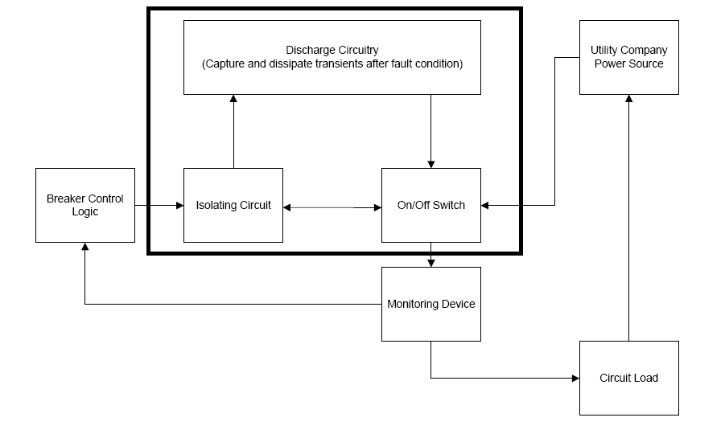

Figure 8: Highlighted the Breaker Section

A standard United States home uses two voltages, 120VRMS and 240VRMS, to support this the solid-state breakers require 2 models. Standard circuit breakers for home use are rated for either 10 or 20 amperes. Thus, for each voltage level, 2 overcurrent ratings are required. This brings the total number of models of circuit interrupt to 4, summarized in the table below.

The requirements section outlines the specifics regarding system functionality. The most important requirement is that once the current rises to an unsafe value the circuit interrupter trips stopping current flow. Additionally, the circuit interrupter must be reliable and safe to operate. If possible, the design team desires to keep the cost of the replacement circuit interrupters and associated controller comparable to a standard circuit interrupter system. However, if added functionality pushes the cost higher it is acceptable.

For safety reasons, the current controller must also be able to stop the AC current flow through the device. If too much current is flowing through a circuit, the wires can overheat, causing a fire. When the current reaches an unsafe level, generally considered as 10% of the interrupter rating, the controller sends a signal to open the circuit. In order to effectively control the circuit interrupter, the control signals require isolation from the (relatively) high voltages in the interrupter circuit. Research has shown that many circuit interrupters use optocouplers to this end.

Both overcurrent and overvoltage can cause damage to electrical devices attached to a circuit. However, many devices can withstand a small spike for a very short period time. Because of this the design team is aiming for the fastest circuit interruption possible. Solid-state devices lend themselves nicely to speed requirements as their switching capabilities greatly exceed that of a mechanical lever. The use of solid-state devices brings about another concern part fatigue over the life of the components caused by the on/off cycles. With this in mind, the team has added a discharge network to catch and deplete any transients caused by the rapid disconnection of the circuit load. Such a network should prolong the life of the components. A standard mechanical circuit interrupter is rated to last 10 years, PICA circuit interrupters should last at least as long, if not longer.

The team considered keeping the standard mechanical breakers, but adding a monitor wrapper to gather data. However, after meeting with Consumer’s Energy decided to move to a controllable circuit interrupter. The technicians the team spoke with expressed that the ability to remotely switch breakers on or off would provide a substantial cost savings in terms of labor hours for turning service on or off to buildings. While mechanical breakers could be augmented with devices to set or reset the breaker from a remote signal, the team questioned the size of implementation and practicality of such a design. However, this decision may limit the customer base of the PICA system by requiring all circuit interrupters to be replaced.

Several solid-state components have shown promise for replacing mechanical circuit breakers: power MOSFETs and Thyristors. Thyristors come in several different types: silicon controlled rectifiers (SCR) and the triode for alternating current (TRIAC). An SCR is a unidirectional thyristor and a TRIAC is a bidirectional thyristor.

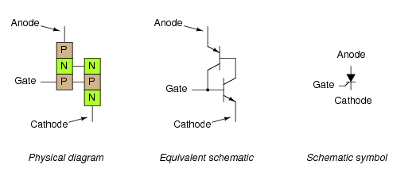

Figure : SCR(<http://www.allaboutcircuits.com/vol_3/chpt_7/5.html>)

Two SCRs in inverse parallel will create a TRIAC.

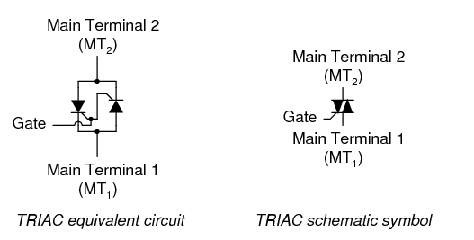

Figure : TRIAC (http://www.allaboutcircuits.com/vol_3/chpt_7/6.html)

Typical SCRs have a high current and high voltage rating, meaning finding components capable of functioning with 15A and 117VRMS should not be difficult. (<http://www.allaboutcircuits.com/vol_3/chpt_7/5.html>) SCRs characteristics state that for each ampere conducted 1.5 watts of power are emitted (<http://www.ccipower.com/support/description.php>). As PICA circuit interrupters are required to conduct 15-20A, the amount of energy dissipated will be 22.5-30W of energy (<http://www.ccipower.com/support/description.php>). This will require a heat sink to keep the SCR from melting. A downside of designing with SCRs is that it cannot be directly turned off, only prohibited from starting up again at the beginning of the next phase. A gate turn off (GTO) thyristor solves this, however is rated for lower current flows than an SCR. (http://www.switches.machinedesign.com/guiEdits/Content/bdeee4/bdeee4_20.aspx)

The strengths and weaknesses for SCRs are the same as for TRIACs, except that TRIACs are bidirectional. For an SCR on an alternating current feed, current can flows through an attached load resistor for half of the input cycle. Replacing an SCR with a TRIAC allows current to flow through the load resistor during both halves of the input cycle. (<http://www.tpub.com/neets/book7/26e.htm>) The figures shown below are examples of these cases.

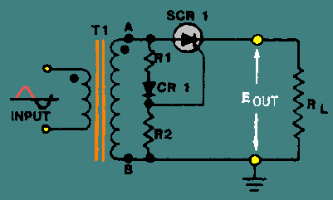

Figure 3: SCR (<http://www.tpub.com/neets/book7/26e.htm>)

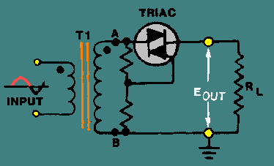

Figure : TRIAC (<http://www.tpub.com/neets/book7/26e.htm>)

The design team is also considering power MOSFETs, because they are designed to handle significant power levels. In comparison to other power semi-conductor devices, power MOSFETs features higher commutation speed and higher efficiency at voltages lower than 200V. The isolated gate on a power MOSFET makes it easy to use these devices as a switch, as only a small voltage is required to drive the gate. Members of the design team have more experience working with MOSFET circuits than with thyristor circuits.

Power MOSFETs provide the switching characteristics necessary to shut off power to a circuit. The voltage on the load will also have to be 117 volts RMS, since the source terminal of the MOSFET is attached to the top of the load. The figure shown below is an example of what this could look like.

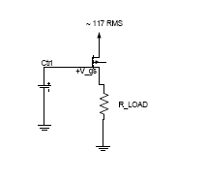

Figure 7: MOSFET

Figure 1 shows a circuit provided by Micrel for a solid-state breaker device based upon their MIC5013 chip. The team noticed that the given design is constructed for DC circuits whereas the PICA system controls AC circuits. Thus, the design from Micrel did not meet the team’s specifications and was eliminated as a potential design.

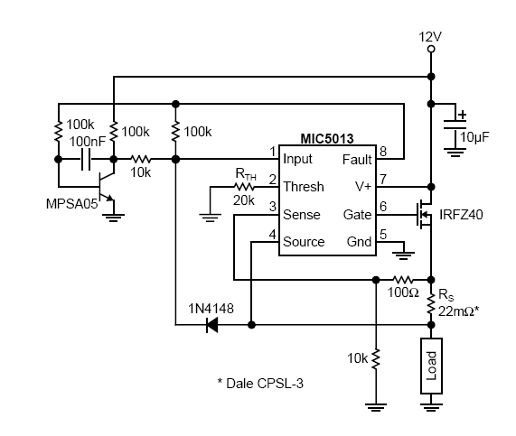

Figure 1: An eliminated design (http://www.micrel.com/_PDF/App-Notes/an-5.pdf)

Figure 6 shows a solid-state breaker design by Davis Johnson using a TRIAC to control 600 watts of power. (<http://www.imagineeringezine.com/e-zine/ssr.html>) The team considered making changes to push the power rating up to 1800 watts. (Power=Current x Voltage, where voltage is that of a typical power outlet of 120V and current is from a typical breaker threshold of 15A). Reverse-engineering this design has provided information on designing with thyristors.

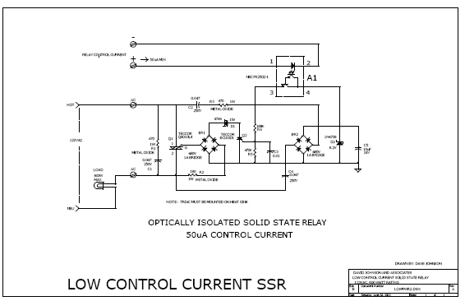

Figure 6: Example Circuit using a TRIAC (http://www.imagineeringezine.com/e-zine/ssr.html)

The controller will need to be isolated from voltage or current spikes that are associated with rapid shut on and off. An optocoupler achieves the goal of controller isolation. The control signal is applied to one side of the device, which using light transmits the signal to a receiver on the other side reproducing the signal but without any electrical connection between the two halves of the component.

Summary Table:

|  |  |  |
| --- | --- | --- |
| Component | Pros | Cons |
| Mechanical Breakers | Does not require much design work, already being used in homes | No remote shutoff, has an air gap, slower response time on an on/off switch |
| SCRs | High current, high voltage, | cannot be turned off by a negative signal on the gate, requires heat sinks |
| TRIACs | High current, high voltage, bidirectional | Cannot be turned off by a negative signal on the gate, requires heat sinks |
| Power MOSFETs | High current, high voltage, have a patent source that has shown promise, team experience, | Gate and source voltage restrictions |

Before making a final decision on which technology discussed in this section provides the best solution the design team plans to perform additional analysis. This includes a transient analysis of a feeder line when going from steady state to open-circuit conditions and modeling how a MOSFET based device would function as a circuit interrupter.