CSCI 3055 A3 Report

By Calvin Lo, 100514352

Part A

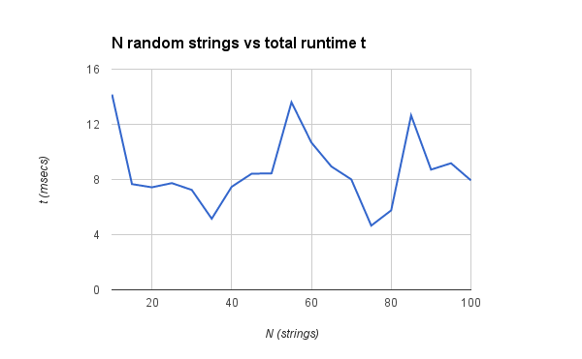

Part B

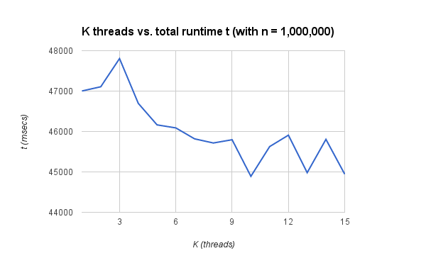

The time will decrease when the threads increase. However, there are not any decrease after 9 threads.