Assignment 2 Compiler CSCI 4020U & SOFE 3960U

A. Designing a topdown parser: Consider the following grammar.

**prog : stmt-list**

**stmt-list : stmt-list stmt | stmt**

**stmt : PRINT expr | PRINT string**

**string : BEGINQUOTE charlist ENDQUOTE**

**charlist : charlist LETTER | ε**

**expr : expr + term | expr - term | term**

**term : term * factor | term / factor | factor**

**factor : ( expr ) | NUM**

The nonterminal symbols are:

**prog, stmt-list, stmt, string, charlist, expr, term, factor**

The terminal symbols are:

**PRINT, BEGINQUOTE, ENDQUOTE, LETTER, +, -, *, /, (, ), NUM**

(A1) The grammar is left-recursive. Transform it into a non-left recursive grammar using the following ranking of the nonterminals.

**prog, stmt-list, stmt, string, charlist, expr, term, factor**

**prog : stmt-list**

**stmt-list : stmt stmt-list $'$**

**stmt-list $'$: stmt stmt-list| ε**

**stmt : PRINT expr | PRINT string**

**string : BEGINQUOTE charlist ENDQUOTE**

**charlist : charlist $'$**

**charlist $'$: LETTER charlist| ε**

**expr : term expr $'$**

**expr $'$: + term expr | - term expr | ε**

**term : factor term $'$**

**term $'$: * factor term | / factor term | ε**

**factor : ( expr ) | NUM**

(A2) Further modify the grammar so it is left factored.

**prog : stmt-list**

**stmt-list : stmt stmt-list $'$**

**stmt-list $'$: stmt stmt-list| ε**

**stmt : PRINT word**

**word : expr | string**

**string : BEGINQUOTE charlist ENDQUOTE**

**charlist : charlist $'$**

**charlist $'$: LETTER charlist| ε**

**expr : term expr $'$**

**expr $'$: + term expr | - term expr | ε**

**term : factor term $'$**

**term $'$: * factor term | / factor term | ε**

**factor : ( expr ) | NUM**

(A3) Compute the FIRST sets of each nonterminal symbols.

**prog : { PRINT }**

**stmt-list : { PRINT }**

**stmt-list $'$: { PRINT }**

**stmt : { PRINT }**

**word : { (, NUM, BEGINQUOTE }**

**string : { BEGINQUOTE }**

**charlist : { LETTER }**

**charlist $'$: { LETTER }**

**expr : { (, NUM }**

**expr $'$: { +, - }**

**term : { (, NUM }**

**term $'$: { *, / }**

**factor : { (, NUM }**

(A4) Compute the FOLLOW sets of each nonterminal symbols

**prog : {}**

**stmt-list : {}**

**stmt-list $'$: {}**

**stmt : { PRINT }**

**word : { PRINT }**

**string : { PRINT }**

**charlist : { ENDQUOTE }**

**charlist $'$: { ENDQUOTE }**

**expr : { PRINT, ) }**

**expr $'$: { PRINT, ) }**

**term : { +, -, PRINT, ) }**

**term $'$: { +, -, PRINT, ) }**

**factor : { *, /, +, -, PRINT, ) }**

(A5) Compute the predictive parsing table of the grammar.

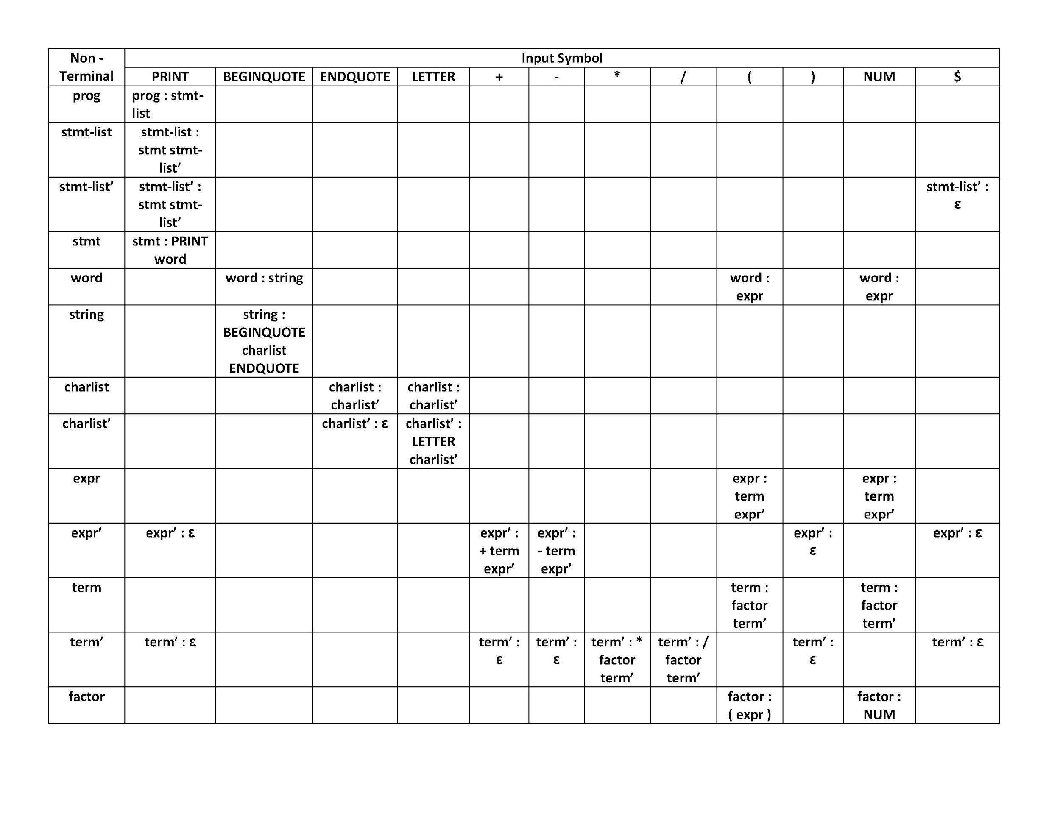

(A6) Consider the following program.

**PRINT ( NUM + NUM ) * NUM**

Use the predictive parsing table to construct the parse tree. At each step, show the production used to expand the nodes.



P1. **prog : stmt-list**

P2. **stmt-list : stmt stmt-list’**

P3. **stmt-list’ : stmt stmt-list’**

P4. **stmt-list’ : ε**

P5. **stmt : PRINT word**

P6. **word : expr**

P7. **word : string**

P8. **string : BEGINQUOTE charlist ENDQUOTE**

P9. **charlist : charlist’**

P10. **charlist’ : ε**

P11. **charlist’ : LETTER charlist’**

P12. **expr : term expr’**

P13. **expr’ : ε**

P14. **expr’ : + term expr’**

P15. **expr’ : - term expr’**

P16. **term : factor term’**

P17. **term’ : ε**

P18. **term’ : * factor term’**

P19. **term’ : / factor term’**

P20. **factor : ( expr )**

P21. **factor : NUM**