(1.1)
1. L₁ = {a}, L₂ = {b}
L₁³ · L₁* · L₂*

2. L₁ = {0, 1, 2, 3, 4, 5, 6, 7, 8, 9}, L₂ = { }, L₃ = {,}
L₁* · (L₂* · L₃ · L₁*)

3. L₁ = {a, b}
L₁⁴
(1.2)
1. {aaaa*b*}
2. {[0-9]*(\s?,\s? [0-9]*)}
3. {(a | b)(a | b)(a | b) (a | b)}

(1.3) NFA

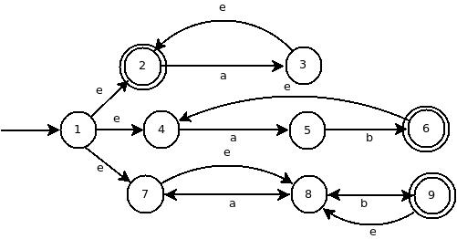

(1.4) NFA to DFA

{1, 2, 4, 7, 8}  F | a ⟶ {3, 5, 8, 2}  b ⟶ {9, 8}
{3, 5, 8, 2}  F | a ⟶ {3, 2}  b ⟶ {6, 9, 4, 8}
{3, 2}  F | a ⟶ {3, 2}  b ⟶ {}
{6 , 9 ,4, 8}  F | a ⟶ {5}  b ⟶ {9, 8}
{9, 8}  F | a ⟶ {}  b ⟶ {9, 8}
{5} | a ⟶ {}  b ⟶ {6, 4}
{6, 4}  F | a ⟶ {5}  b ⟶ {}

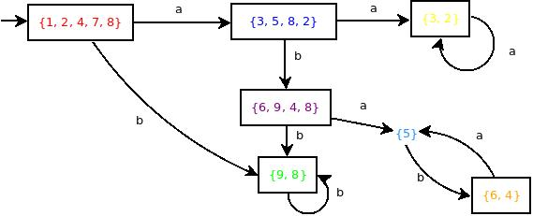

Notes: For the DFA file in question (2.2),
{1, 2, 4, 7, 8} = 1
{3, 5, 8, 2} = 2
{3, 2} = 4
{6 , 9 ,4, 8} = 5
{9, 8} = 6
{5} = 7
{6, 4} = 8

