|  |
| --- |
|  |
|  |
| User documentation |
|  |
| **Calvin Chiew** |
| **5/26/2016** |

|  |
| --- |
|  |

Contents

Admin 2

1. View sites 2

2. View course coordinator 2

3. Add course coordinator 3

4. Edit course coordinator 4

5. Delete course coordinator 5

Course Coordinator 6

1. Site 6

a) View 6

b) Add 6

c) Edit 7

d) Delete 8

e) View student’s project 9

2. Assessor 10

a) View 10

b) Add 11

c) Edit 12

d) Delete 13

e) Assign student 14

3. Student 16

a) Select student by site 16

b) Add student 17

c) Edit student 19

d) Delete student 20

Assessor 22

Student 22

Others 23

# Admin

## View sites

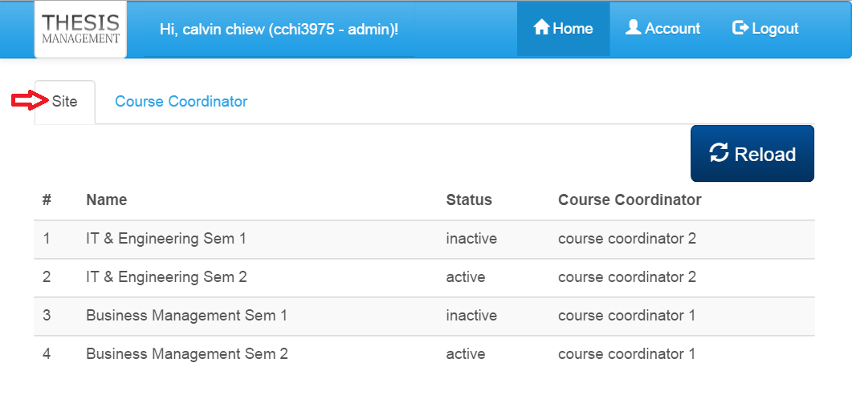

* Click the tab ‘Site’, a list of sites created by course coordinator will be shown.
* The list should show name of the sites, status and course coordinator’s name.

## View course coordinator

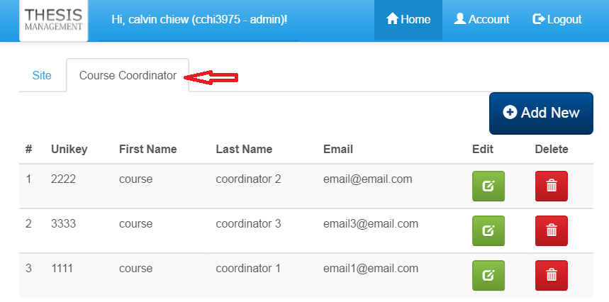

* Click the tab ‘Course Coordinator’, a list of course coordinator will be shown.

## Add course coordinator

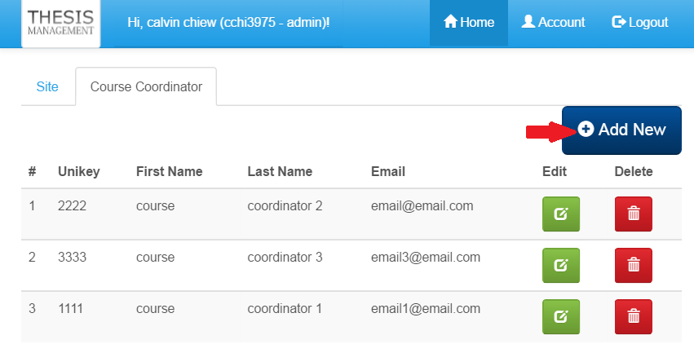

* To add new course coordinator, click the button ‘Add New’.

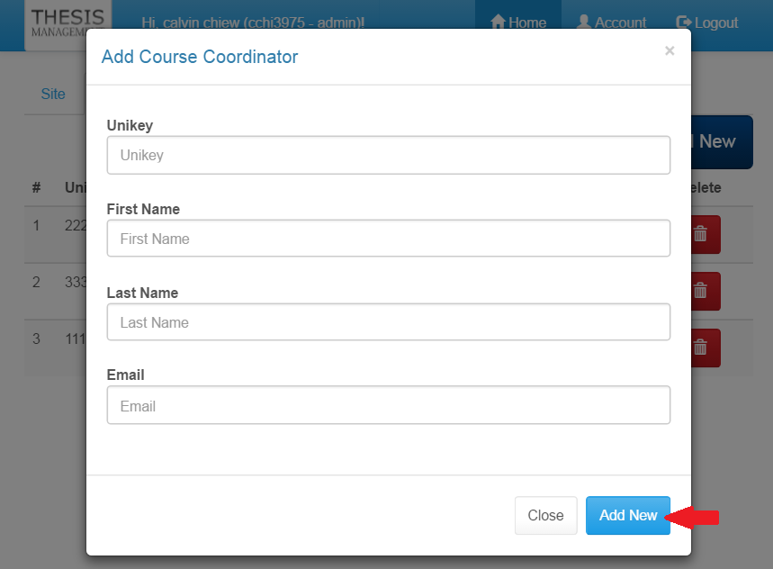

* A form will pop up. Fill up all the course coordinator information. Then Click button ‘Add New’.
* The new course coordinator will be added into the list without reload the page.
* New password automatically generated. By default, the password is unikey. Users are advised to change their password after login.

## Edit course coordinator

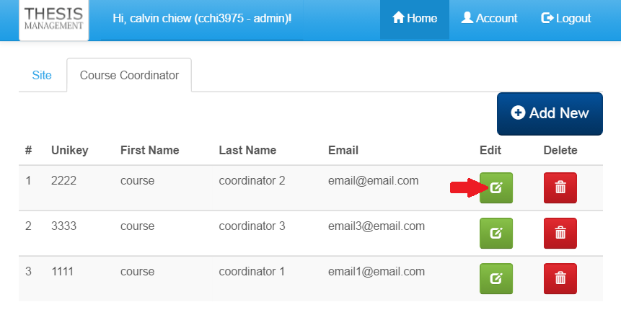

* To edit course coordinator, click edit button in green color under the ‘Edit’ column.

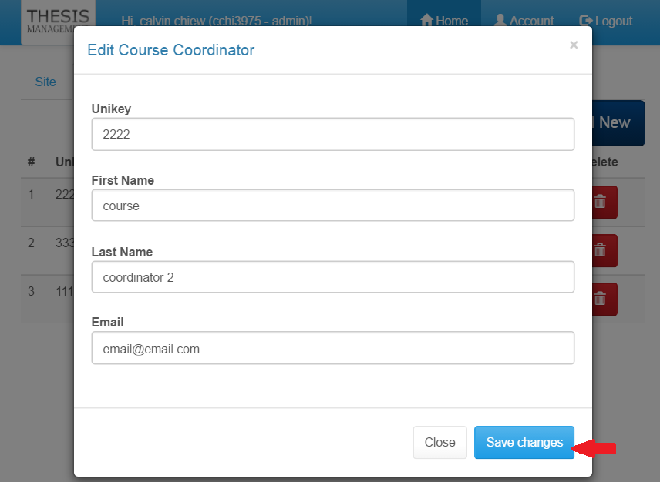

* A form will pop up with the pre-filled information. After making changes, click the button ‘Save changes’.
* New changes will be reflected on the course coordinator list.

## Delete course coordinator

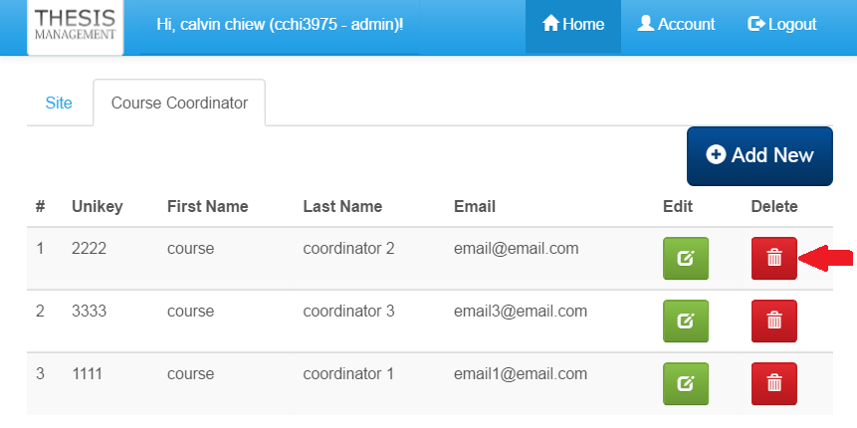

* To delete course coordinator, click the delete button in red color under the ‘Delete’ column.

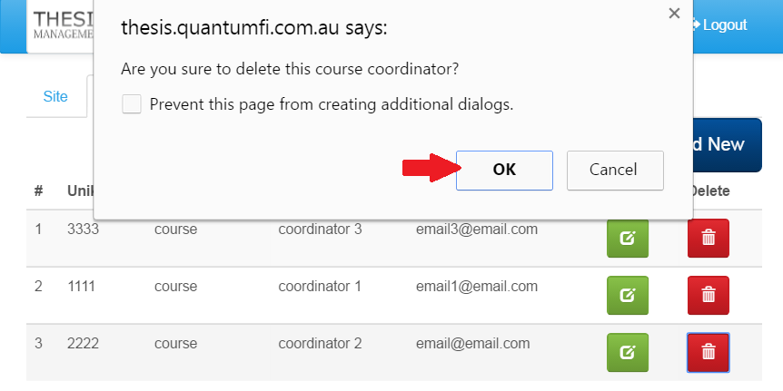

* A confirmation message will pop up. Click ‘OK’ button to delete the course coordinator.
* Deleted course coordinator will be removed from the course coordinator list.
* Click ‘Cancel’ button if you do not want it to be deleted. Then no deletion action will be made.

# Course Coordinator

## Site

### View

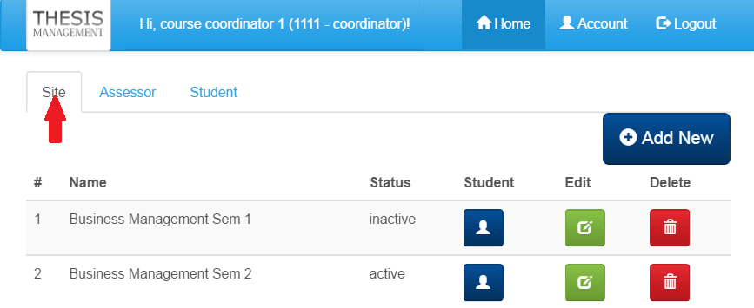

* Click the tab ‘Site’, a list of site created by own self will be shown.
* Only one active status is allowed for sites.

### Add

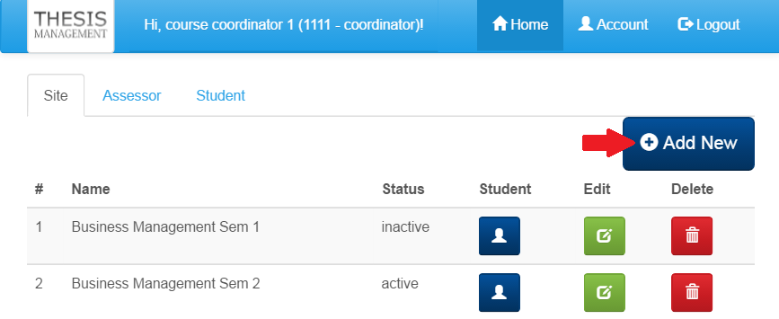

* To add new site, click button ‘Add’.

.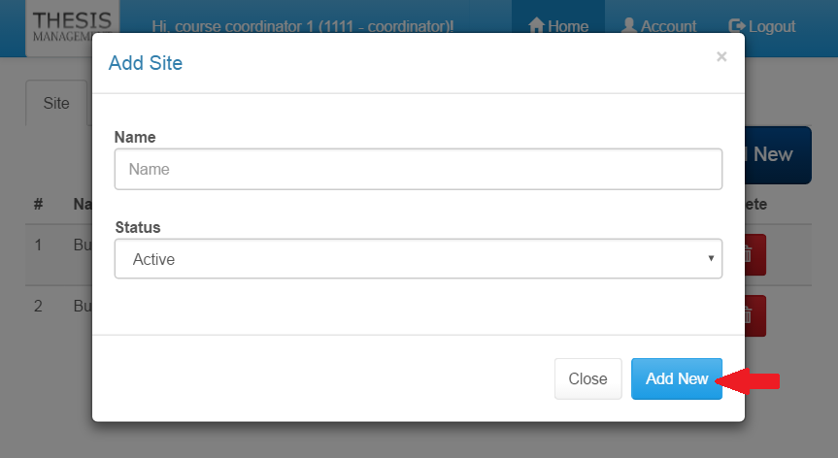

* An ‘Add Site’ form will pop up.
* Fill up the site name and select the appropriate status. Make sure only one active status is selected for all the sites created.
* Then, click ‘Add New’ button to save the site data.

### Edit

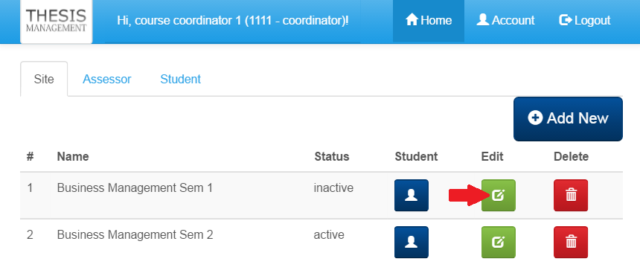

* To edit site detail, click on the edit button in green colour under the ‘Edit’ column.

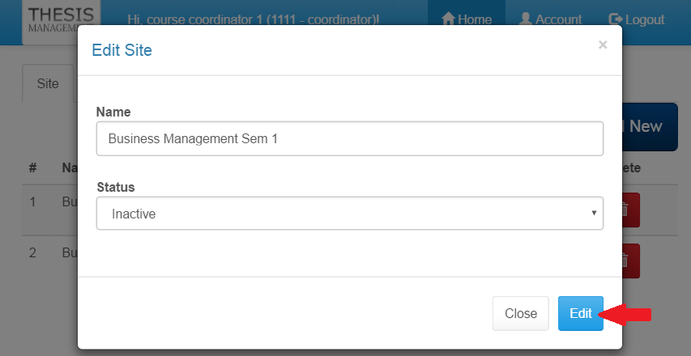

* An ‘Edit Site’ form pre-filled with the data will pop up.
* Make necessary changes and click the ‘Edit’ button.

### Delete

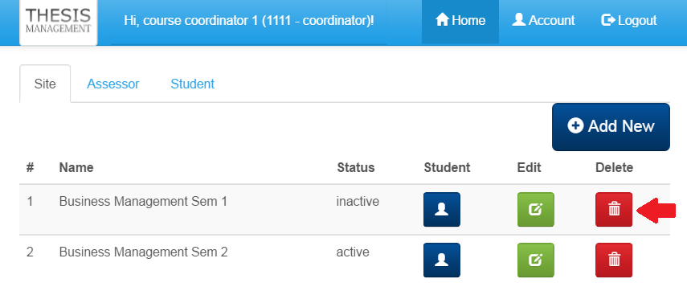

* To delete site, click on the delete button in red colour under ‘Delete’ column.

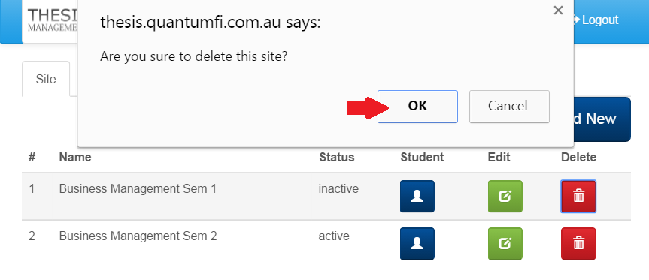

* A delete confirmation message will pop up.
* Click ‘OK’ button to continue the delete process.
* Click ‘Cancel’ to cancel the delete process.

### View student’s project

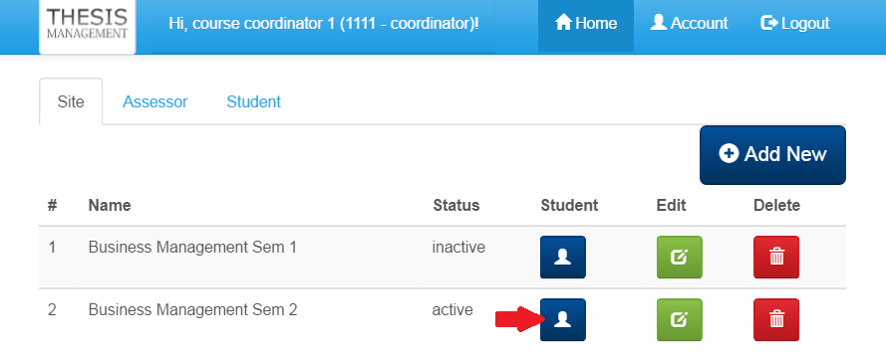

* To view all students’ project, click the student button in blue colour under student column.

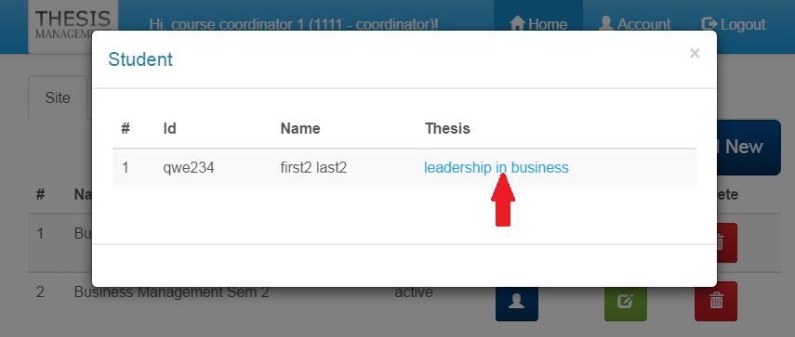

* Student list will pop up.
* Click the thesis title link, and it will open the pdf file at new browser tab.

## Assessor

### View

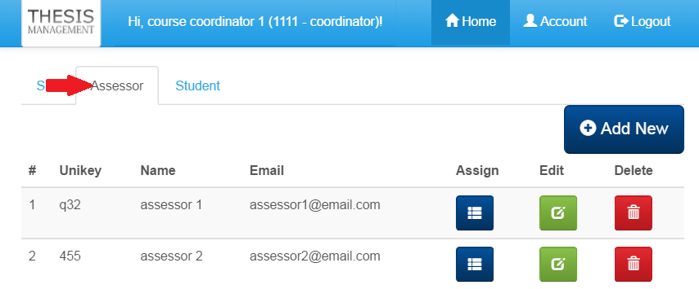

* To view assessor list, click on the ‘Assessor’ tab.
* A list of assessor information will be shown.

### Add

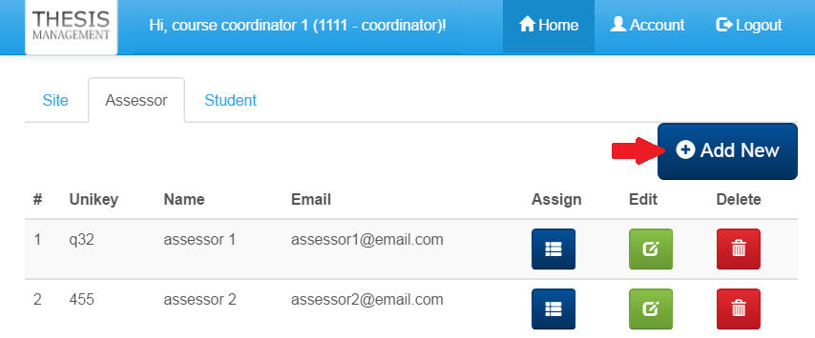

* To add a new assessor, click ‘Add New’ button.

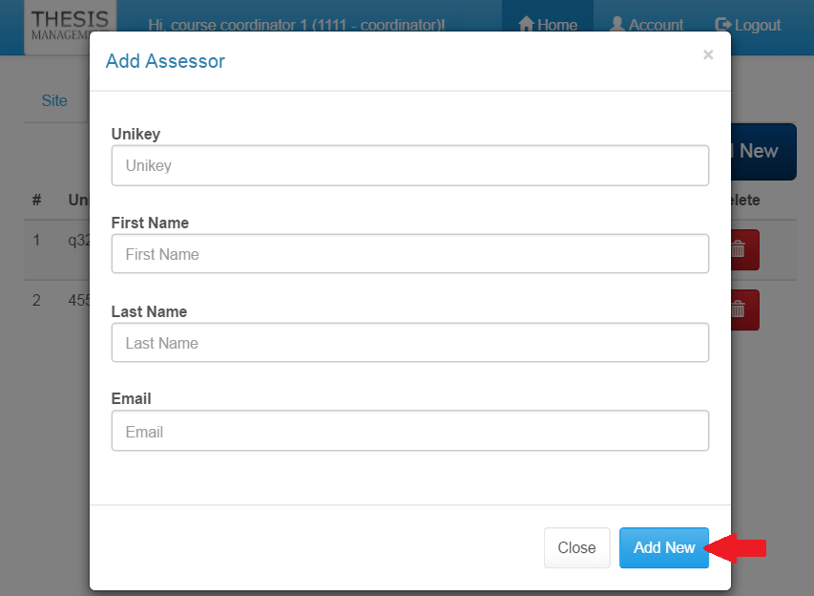

* An ‘Add Assessor’ form will pop up.
* Fill up all the data and click ‘Add New’ button to save the new assessor information.

### Edit

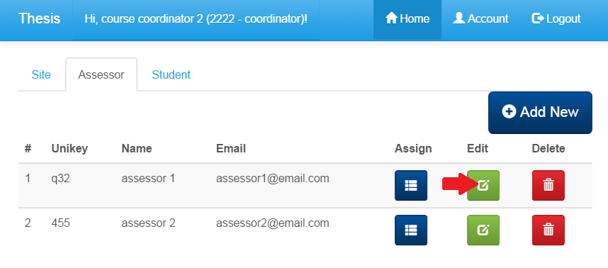

* To edit assessor data, click edit button in green colour under ‘Edit’ column.

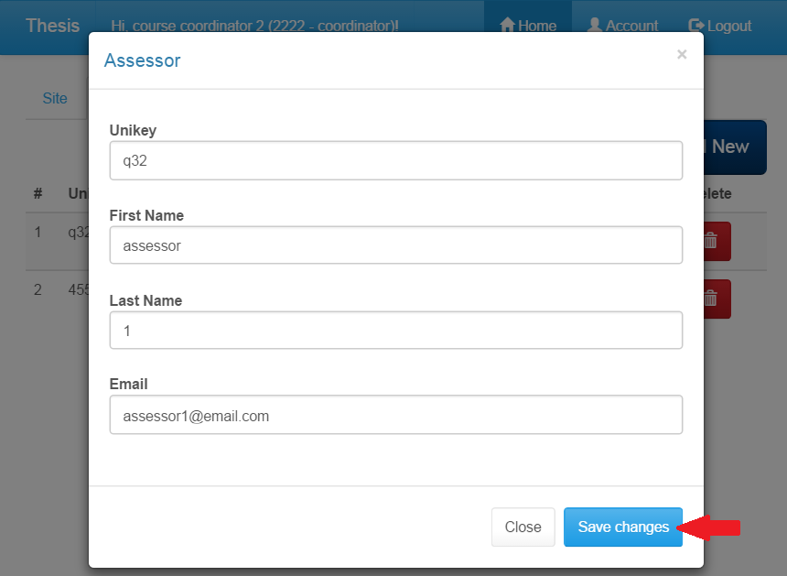

* An ‘Assessor’ form will pop up.
* Make necessary changes and click ‘Save changes’ button.

### Delete

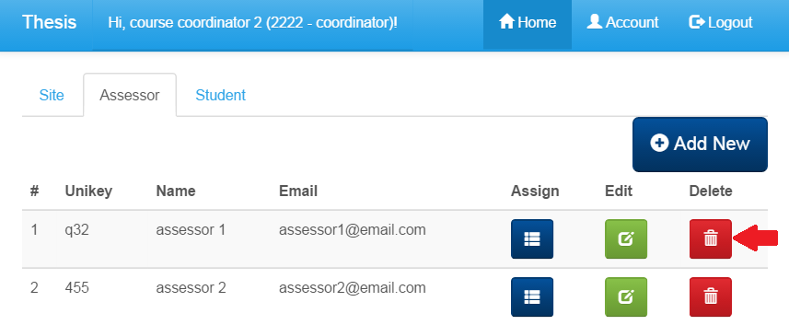

* To delete assessor, click delete button in red colour under the ‘Delete’ column.

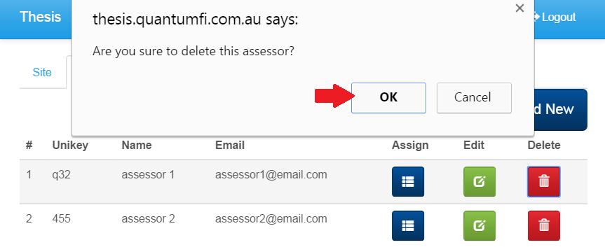

* A delete confirmation message will pop up.
* Click ‘OK’ to continue deletion process.
* Click ‘Cancel’ to cancel deletion process.

### Assign student

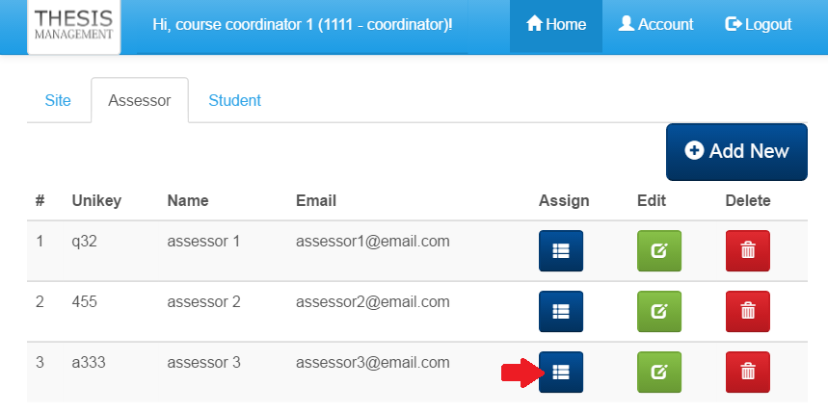

* To assign students to Assessor, click assign button in blue colour under ‘Assign’ column.

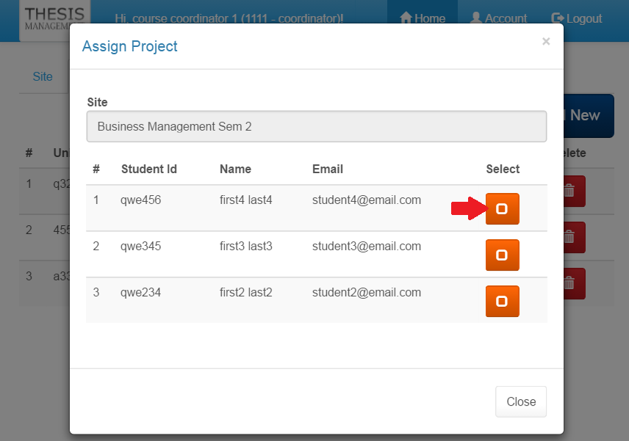

* Student list will pop up. Click the select button in orange colour under ‘Select’ column.

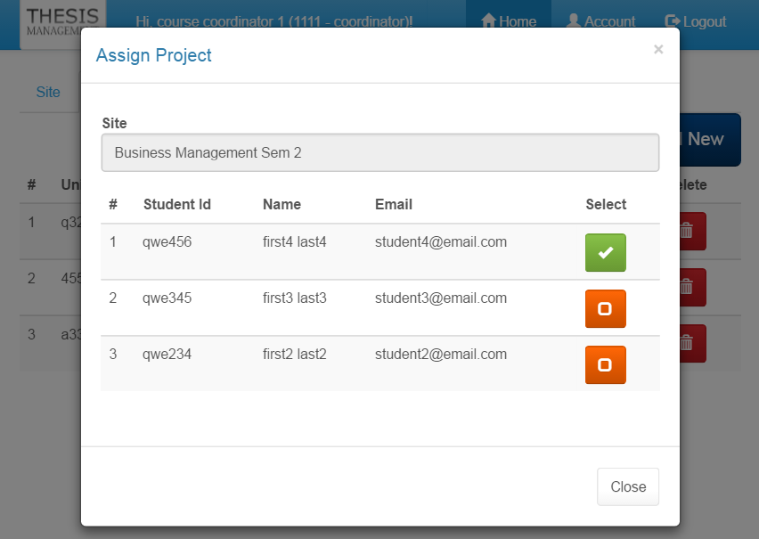

* After clicking the select button, the selected student will be assigned to the assessor for thesis marking. And the select button will change to green colour.
* To deallocate the student from the assessor, click the button in green colour. Once the colour change from green to orange, it means that it has successfully deallocate the student from the assessor.

## Student

### Select student by site

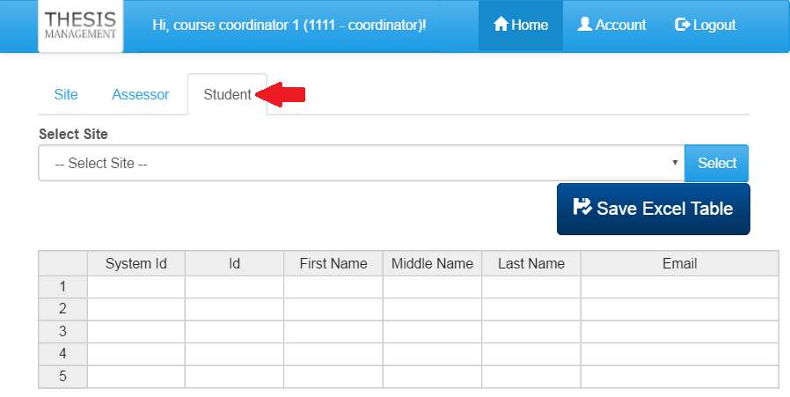

* To view list of student under sites, click ‘Student’ tab.

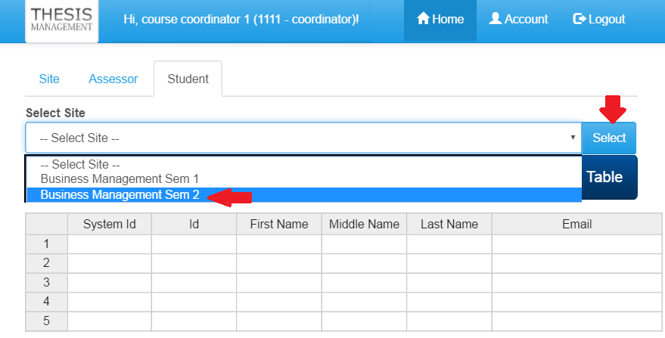

* Select site from the site list, then click ‘Select’ button.

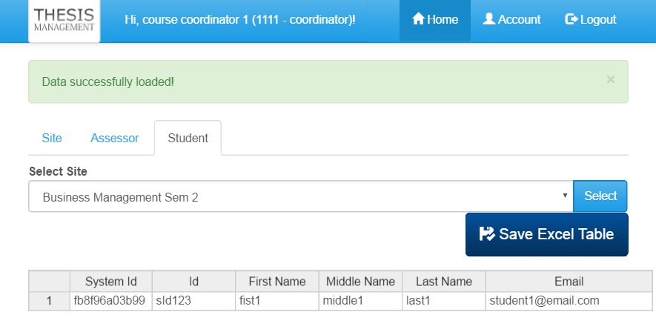

* List of student will be shown based on the selected site.

### Add student

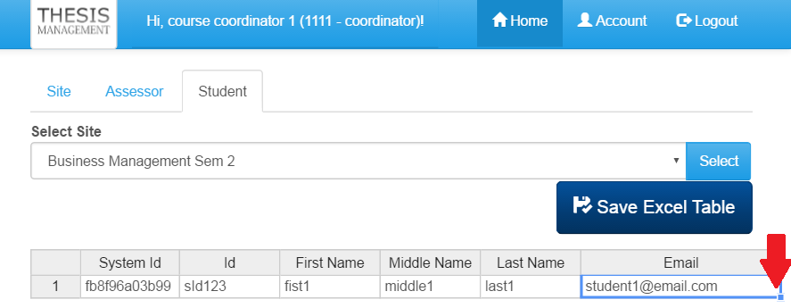

* To add students to the sites, make sure you have selected the intended site. Click the last cell of the excel table.

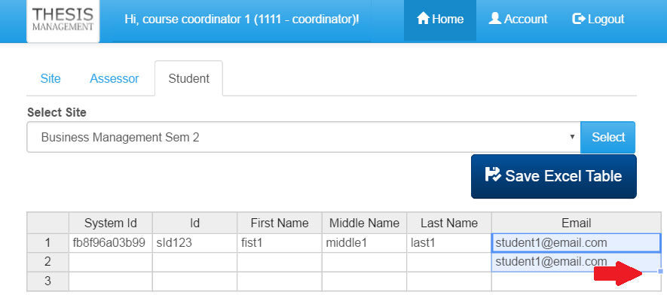

* And then use you mouse to drag the tiny blue square at the corner. Drag it at downward direction.
* Extra empty rows will be created.

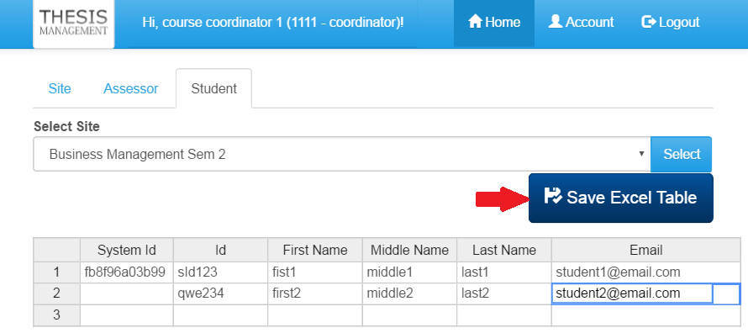

* Fill up student information in the empty cells corresponding to the table header.
* Make sure to leave the ‘System Id’ cell empty. So that the information will perform adding operation instead of editing operation.
* Finally, click ‘Save excel table’ button to save new student information.
* 1 or multiple student information can be added into the excel table before click the ‘Save Excel Table’ button.

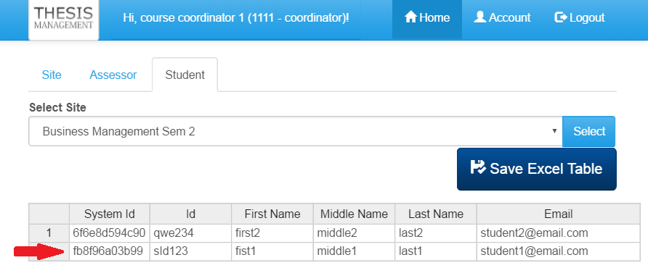

* Once data saved, ‘System Id’ will be generated. System Id should not be modified and deleted whatsoever. It is for system use to perform add/edit/delete operation.

### Edit student

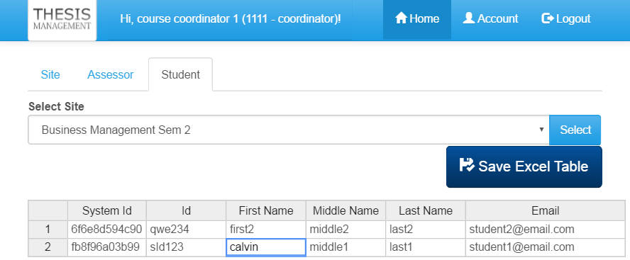

* To edit student information, click on the cell and modify the data. It works just like the normal excel spreadsheet.

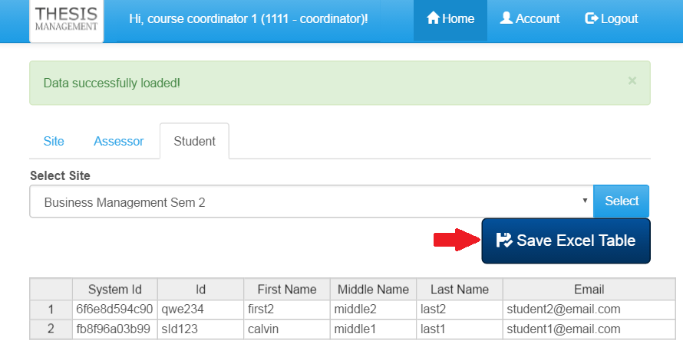

* Once necessary changes have been made, click ‘Save Excel Table’ button to save the changes.

### Delete student

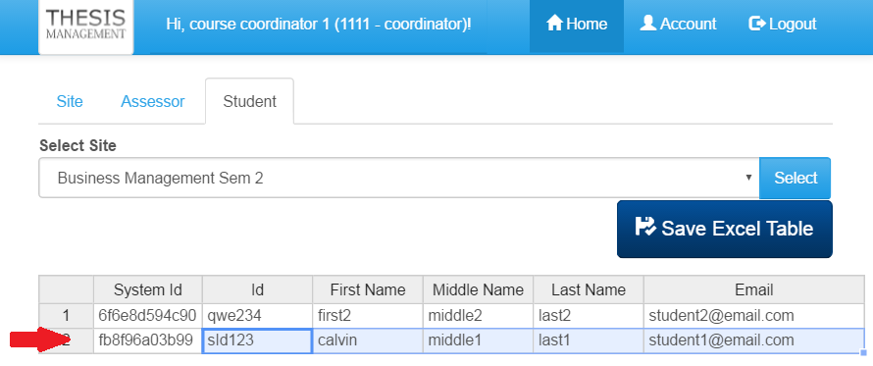

* To delete student from the site, select all the cells for the intended student, except ‘**System Id’** cell.

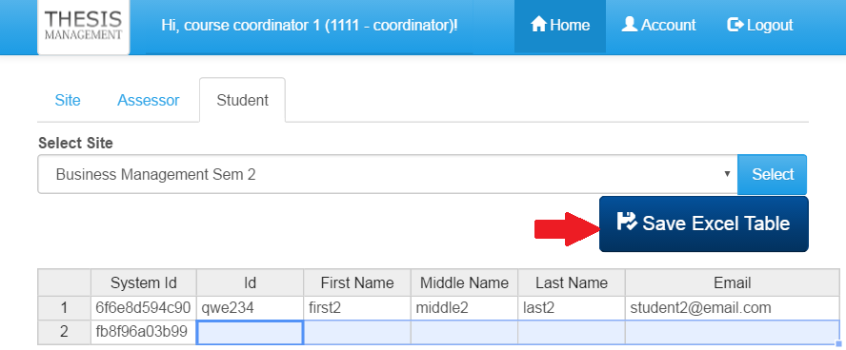

* Then click delete key from keyboard to empty the cell (except system id).
* Next, click ‘Save Excel Table’ button, to continue deletion operation.

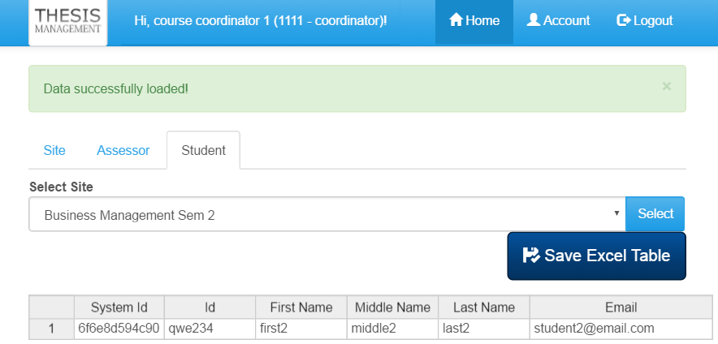

* After clicking ‘Save Excel Table’ button, the list will be updated instantly.
* A status message will be displayed.

## Assessor

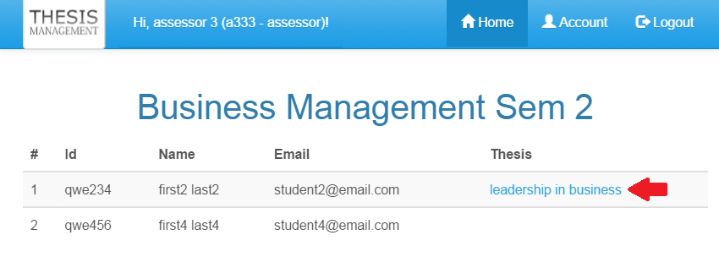

* After login, an active site will be shown together will the list of student’s project.
* To view pdf, click the link under ‘Thesis’ column.
* The pdf file will be open at new tab of the Internet browser.

## Student

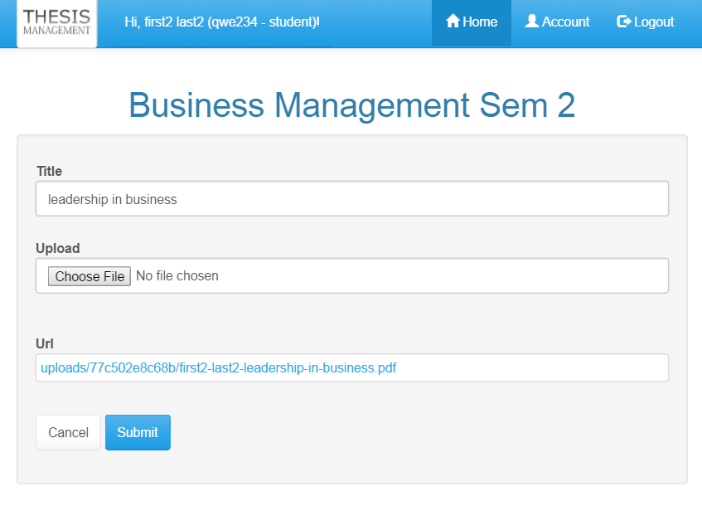

## Others