|  |
| --- |
|  |
|  |
| User documentation |
|  |
| **Calvin Chiew** |
| **8/18/2016** |

|  |
| --- |
|  |

Contents

Admin 2

1. View sites 2

2. View course coordinator 2

3. Add course coordinator 3

4. Edit course coordinator 4

5. Delete course coordinator 5

Course Coordinator 6

1. Site 6

a) View 6

b) Add 7

c) Edit 8

d) Delete 9

e) View student’s project 10

f) Alert Assessor by Email 10

2. Assessor 12

a) View 12

b) Add & Edit 12

c) Delete 13

3. Student 13

a) Select student by site 13

b) Add student 14

c) Edit student 14

d) Delete student 14

Assessor 15

Student 15

Others 16

# Admin

## View sites

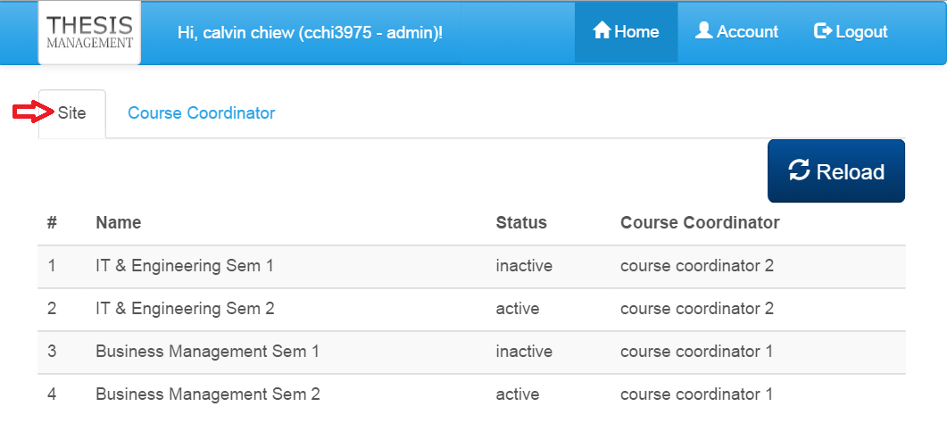

* Click the tab ‘Site’, a list of sites created by course coordinator will be shown.
* The list should show name of the sites, status and course coordinator’s name.

## View course coordinator

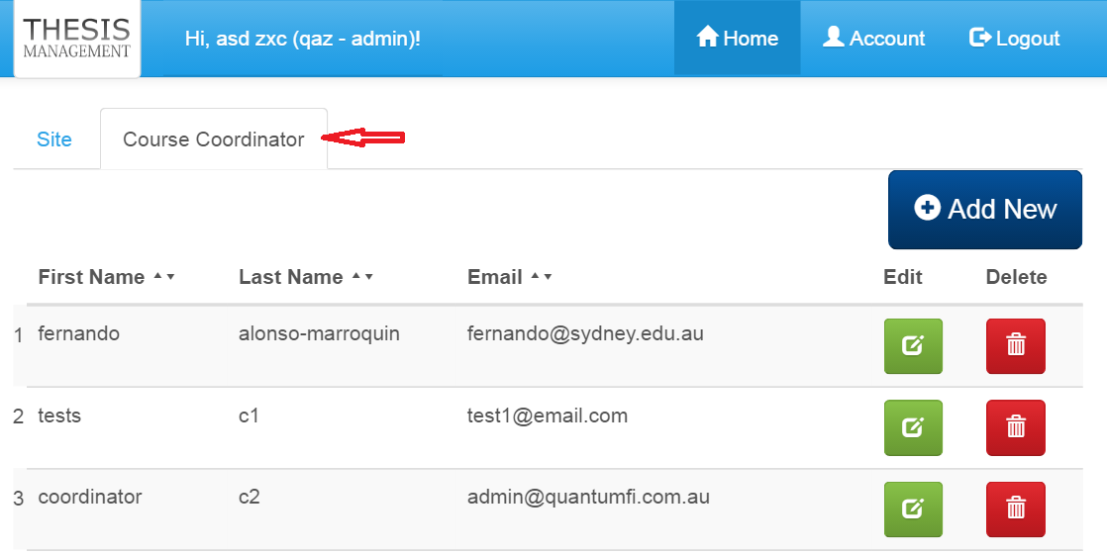

* Click the tab ‘Course Coordinator’, a list of course coordinator will be shown.

## Add course coordinator

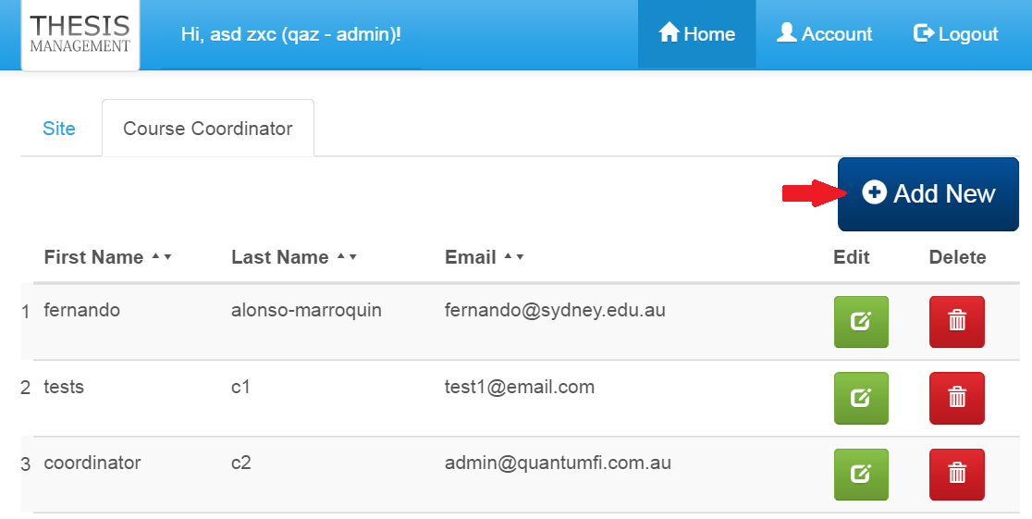

* To add new course coordinator, click the button ‘Add New’.

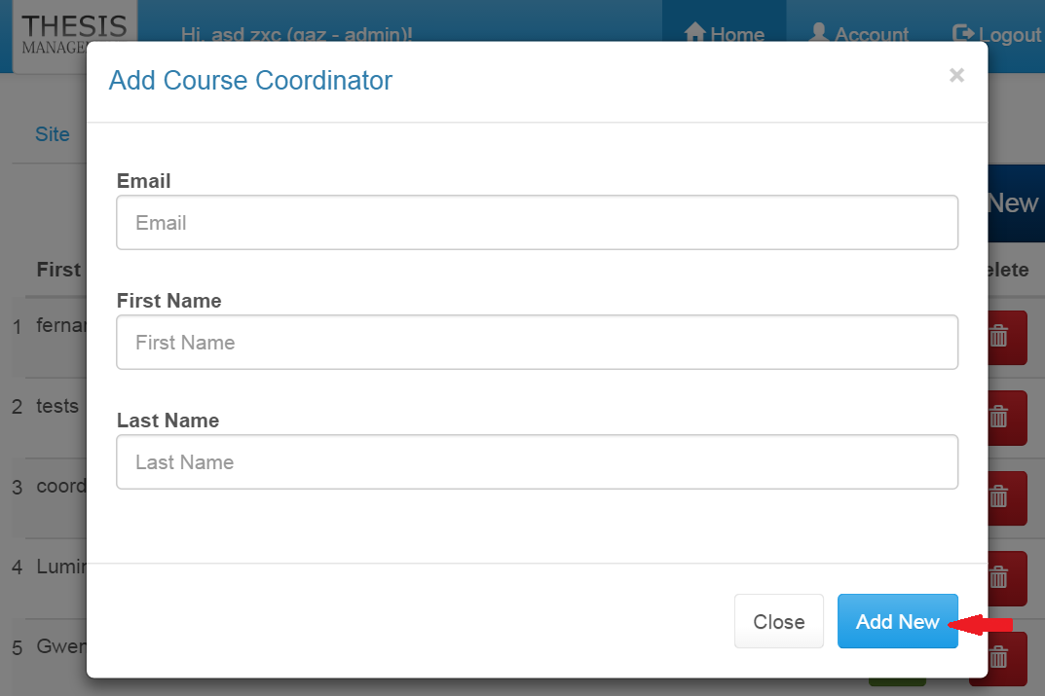

* A form will pop up. Fill up all the course coordinator information. Then Click button ‘Add New’.
* The new course coordinator will be added into the list without reload the page.
* New password automatically generated. By default, the password is email. Users are advised to change their password after login.

## Edit course coordinator

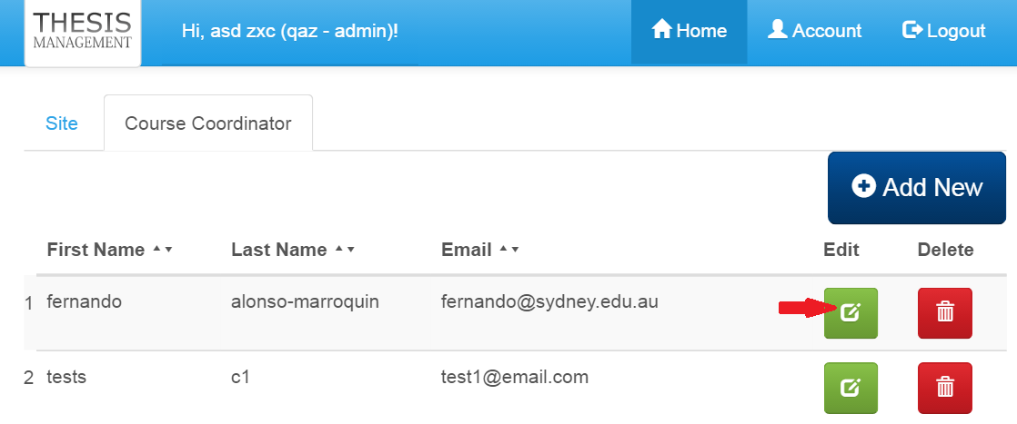

* To edit course coordinator, click edit button in green color under the ‘Edit’ column.

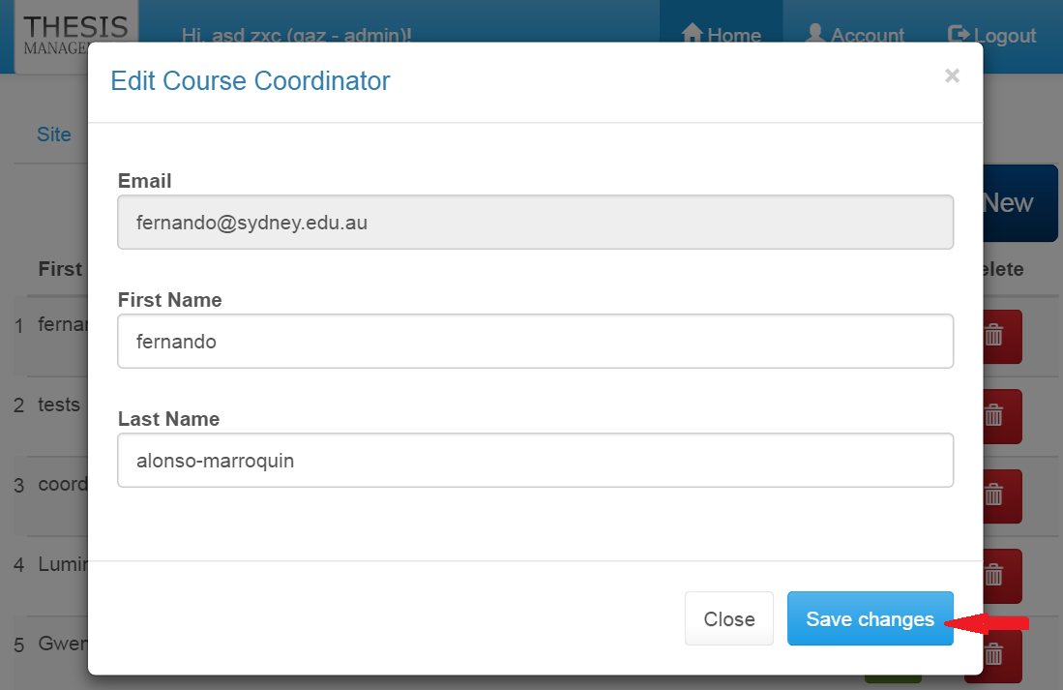

* A form will pop up with the pre-filled information. After making changes, click the button ‘Save changes’.
* New changes will be reflected on the course coordinator list.

## Delete course coordinator

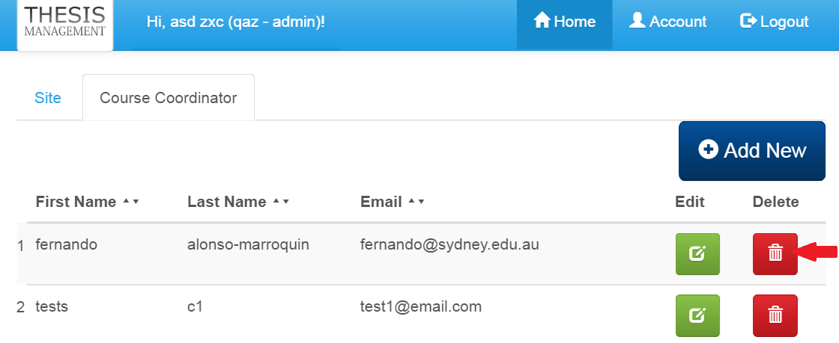

* To delete course coordinator, click the delete button in red color under the ‘Delete’ column.

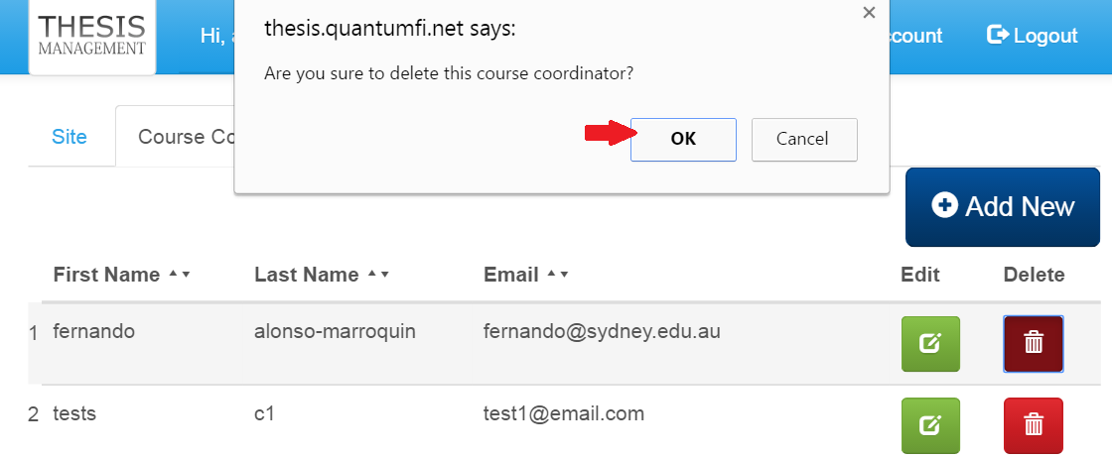

* A confirmation message will pop up. Click ‘OK’ button to delete the course coordinator.
* Deleted course coordinator will be removed from the course coordinator list.
* Click ‘Cancel’ button if you do not want it to be deleted. Then no deletion action will be made.

# Course Coordinator

## Site

### View

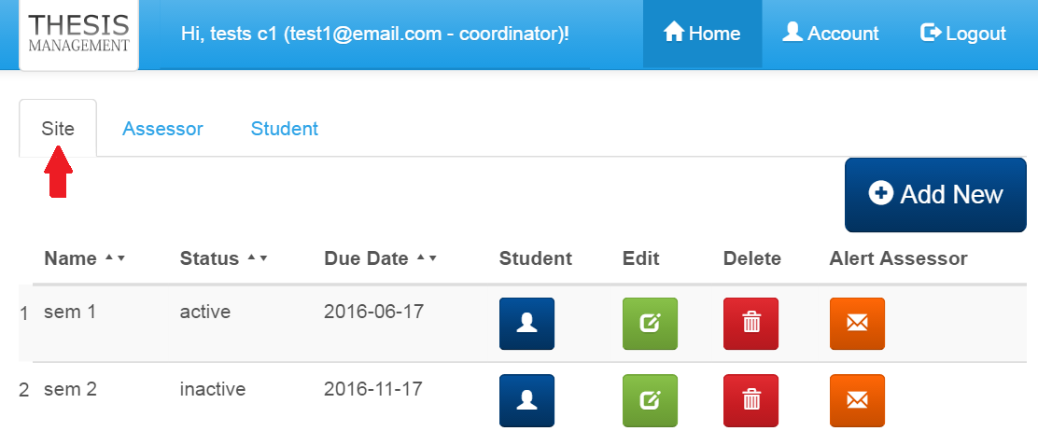

* Click the tab ‘Site’, a list of site created by own self will be shown.
* Only one active status is allowed for sites.

### Add

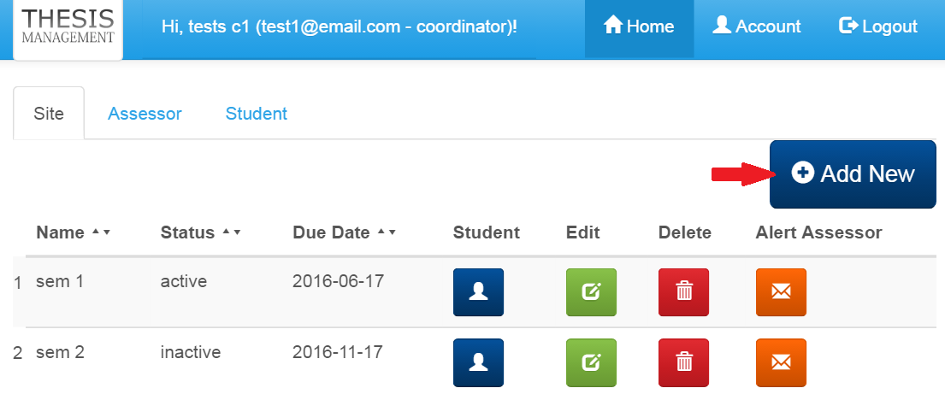

* To add new site, click button ‘Add’.

.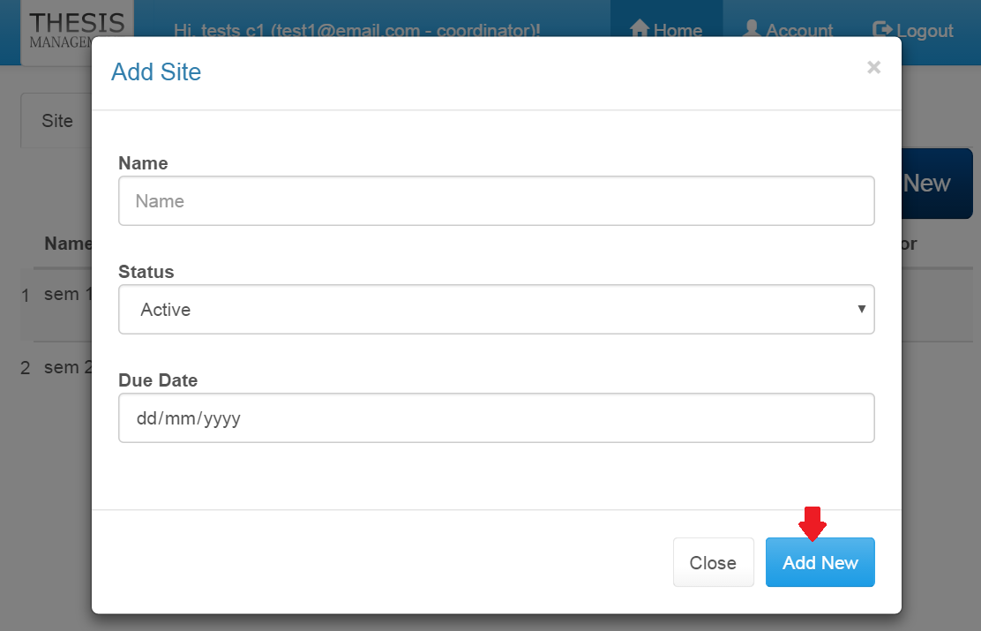

* An ‘Add Site’ form will pop up.
* Fill up the site name and select the appropriate status. Make sure only one active status is selected for all the sites created.
* Then, click ‘Add New’ button to save the site data.

### Edit

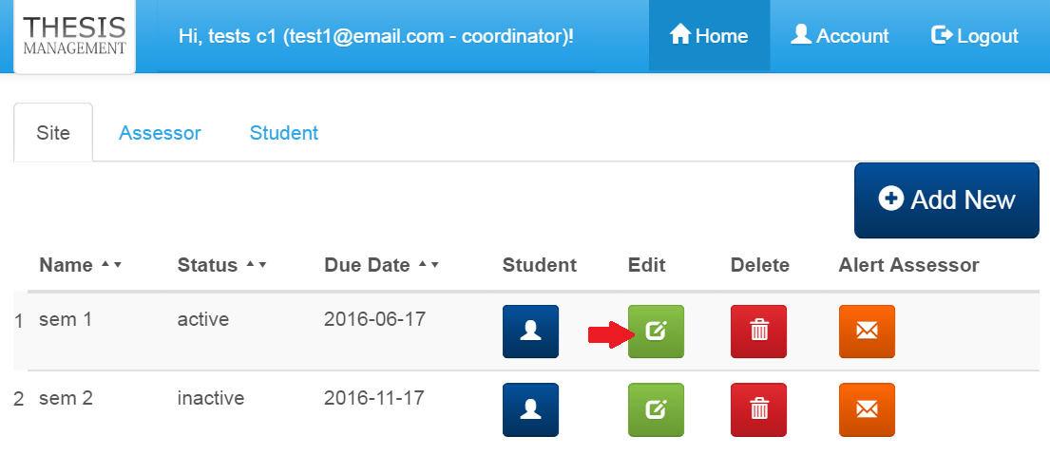

* To edit site detail, click on the edit button in green colour under the ‘Edit’ column.

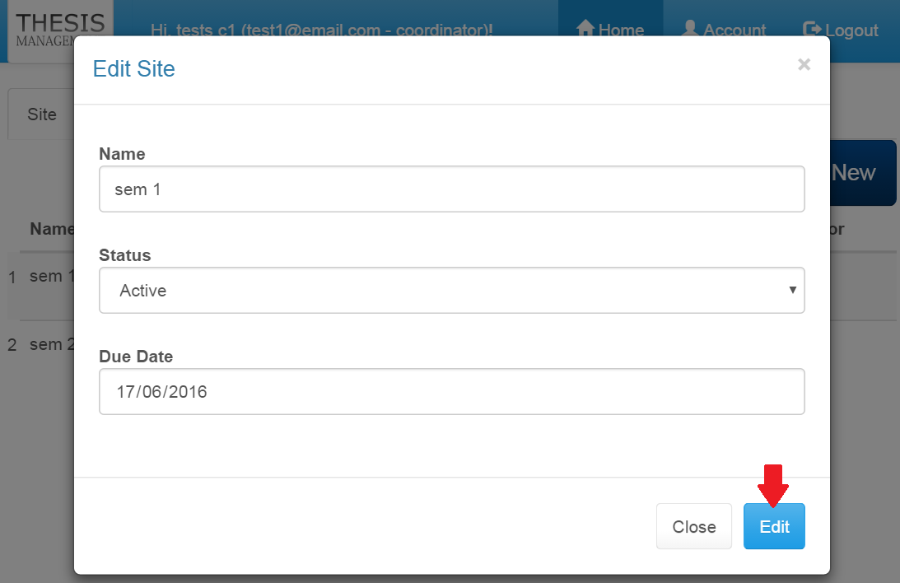

* An ‘Edit Site’ form pre-filled with the data will pop up.
* Make necessary changes and click the ‘Edit’ button.

### Delete

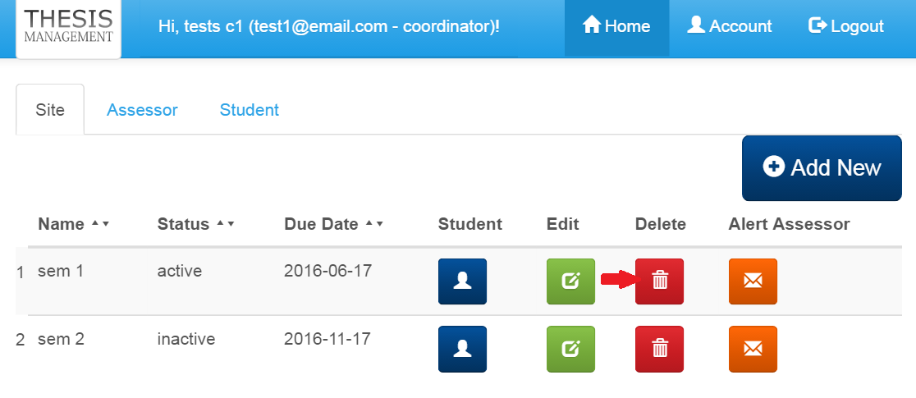

* To delete site, click on the delete button in red colour under ‘Delete’ column.

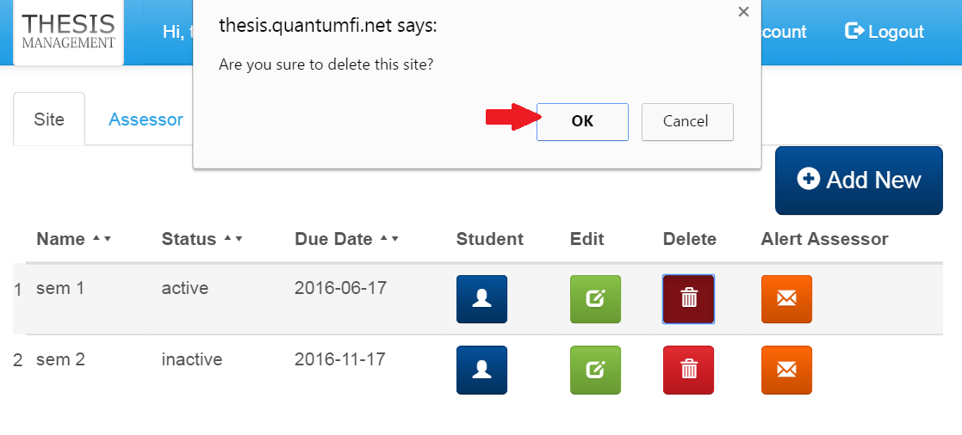

* A delete confirmation message will pop up.
* Click ‘OK’ button to continue the delete process.
* Click ‘Cancel’ to cancel the delete process.

### View student’s project

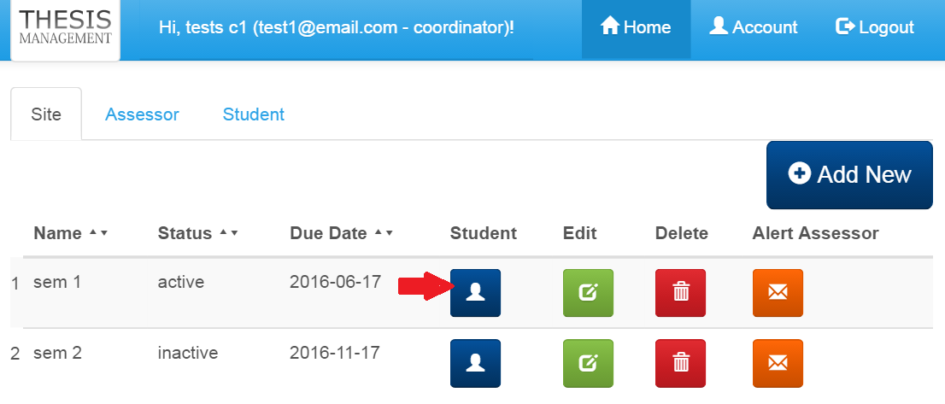

* To view all students’ project, click the student button in blue colour under student column.

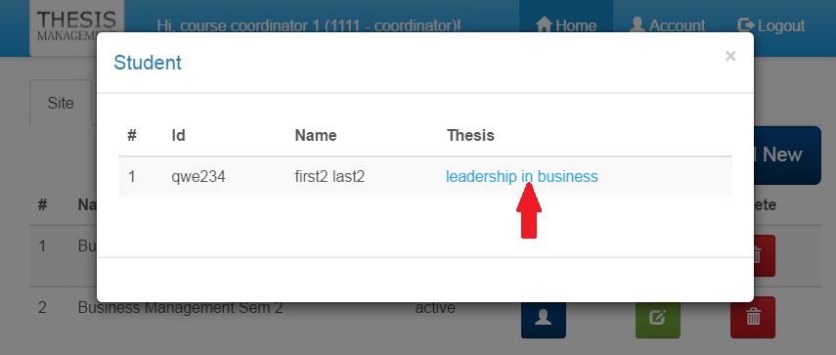

* Student list will pop up.
* Click the thesis title link, and it will open the pdf file at new browser tab.

### Alert Assessor by Email

* Course Coordinator could send email to all assessors under the selected site.

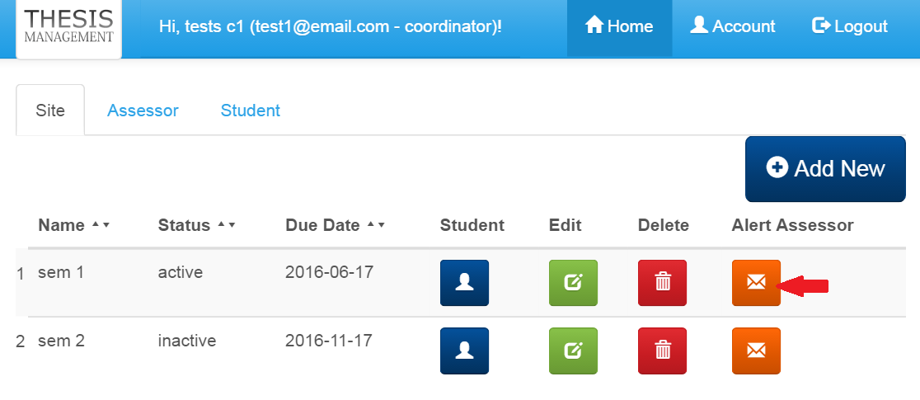

* After clicking the button ‘Alert Assessor’, an email pop up box will be shown. Course coordinator will be able to write the email alert content.

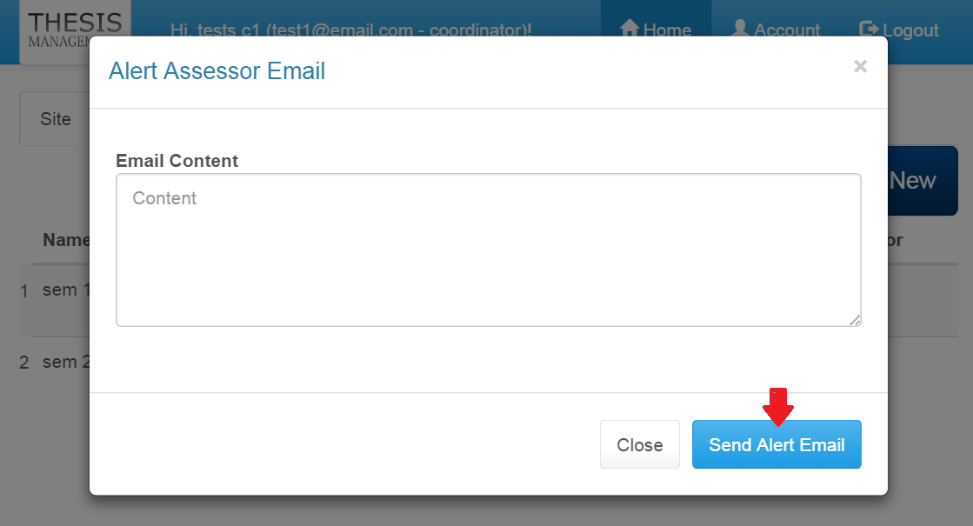

## Assessor

### View

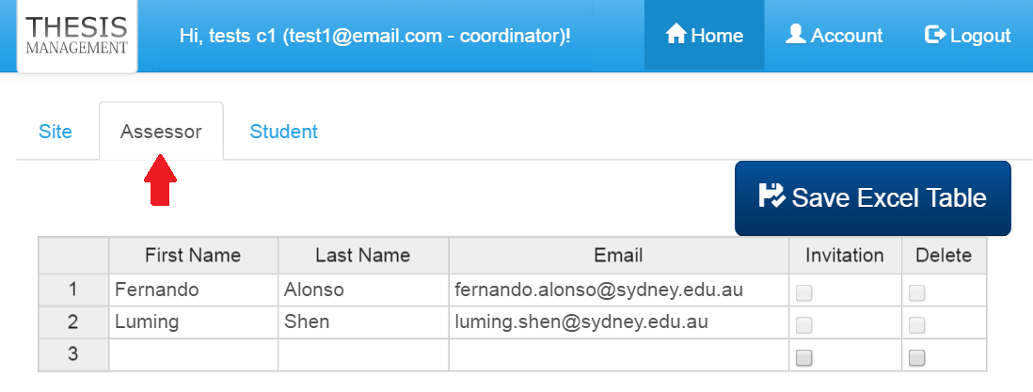

* To view assessor list, click on the ‘Assessor’ tab.
* A list of assessor information will be shown.

### Add & Edit

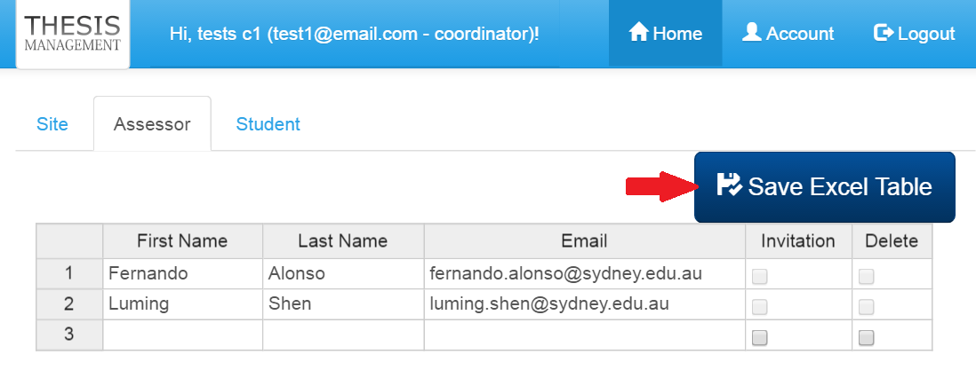

* Fill up all the data and click ‘Save Excel Table’ button to save the new assessor information.
* To edit data, update the existing data and click ‘Save Excel Table’ button to save the new changes.

### Delete

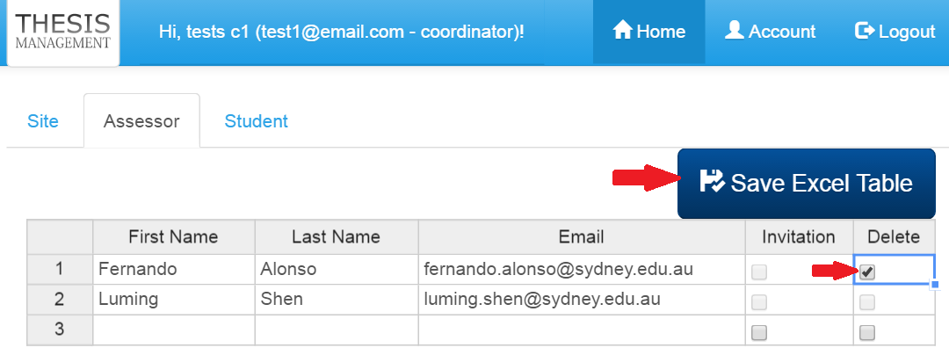

* To delete assessor, click delete checkbox in the excel list under the ‘Delete’ column. Then click button ‘Save Excel Table’ to execute the delete process.

## Student

### Select student by site

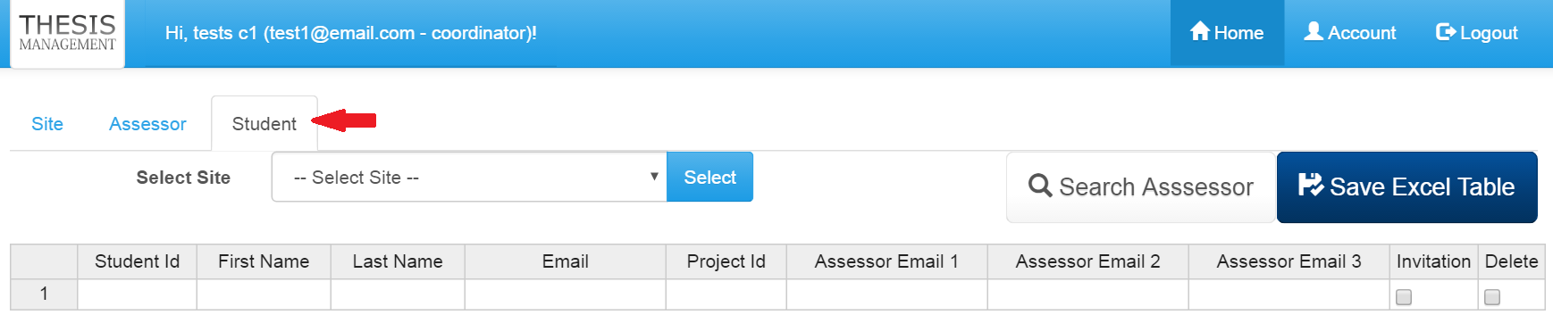

* To view list of student under sites, click ‘Student’ tab.

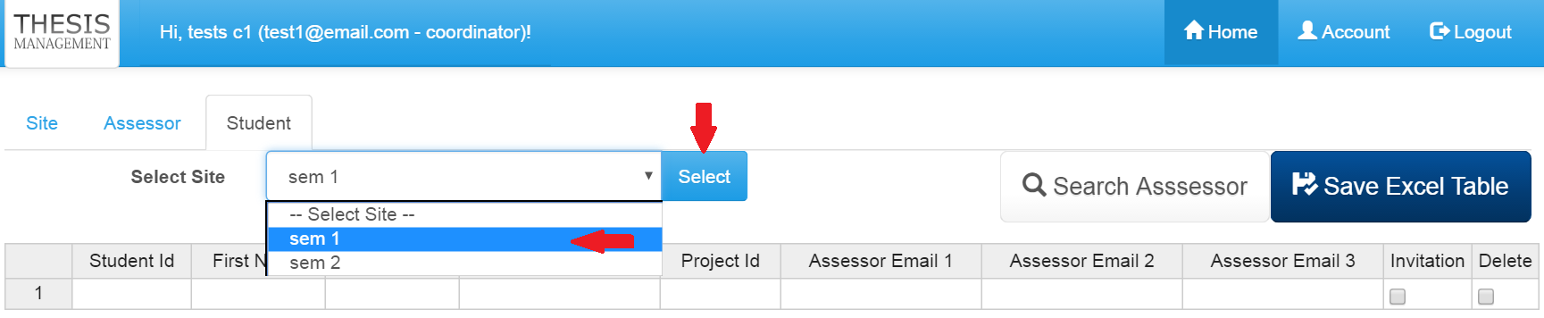

* Select site from the site list, then click ‘Select’ button.
* List of student will be shown based on the selected site.

### Add student

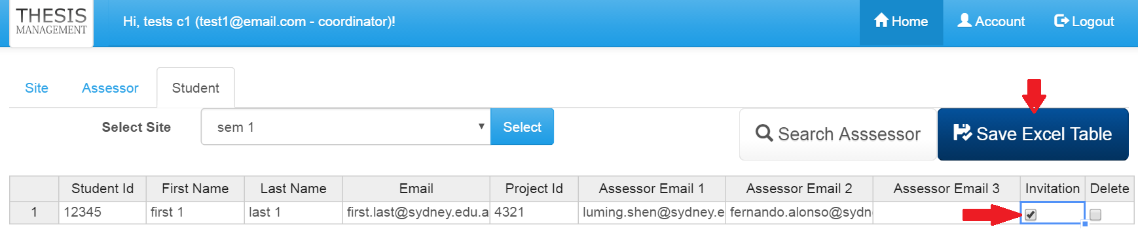

* To add students to the sites, make sure you have selected the intended site. Then fill up all the mandatory fields (Student Id, first name, last name and email).
* Project Id, Assessor Email 1, Assessor Email 2 and Assessor Email 3 are optional and can be added later.
* Check the Invitation Checkbox to allow system to send invitation email to the student.
* Finally, click the button ‘Save Excel Table’ to save the new data.
* If they were no empty row for new data, click the last cell of the excel table.
* And then use you mouse to drag the tiny blue square at the corner. Drag it at downward direction.
* Extra empty rows will be created.

### Edit student

* To edit student information, click on the cell and modify the data. It works just like the normal excel spreadsheet.
* Once necessary changes have been made, click ‘Save Excel Table’ button to save the changes.

### Delete student

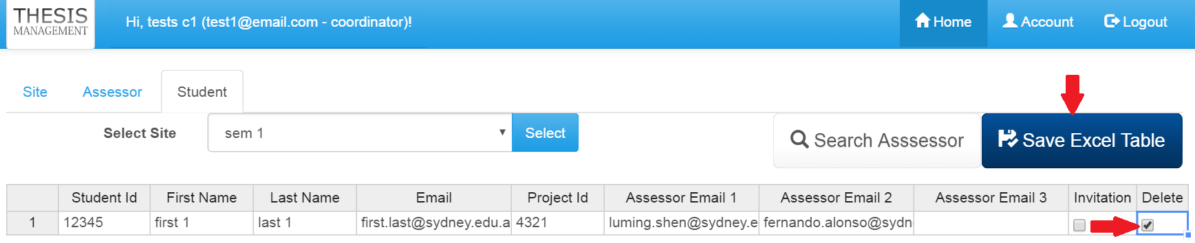

* To delete student from the site, check the delete checkbox
* Next, click ‘Save Excel Table’ button, to continue deletion operation.
* After clicking ‘Save Excel Table’ button, the list will be updated instantly.
* A status message will be displayed.

## Assessor

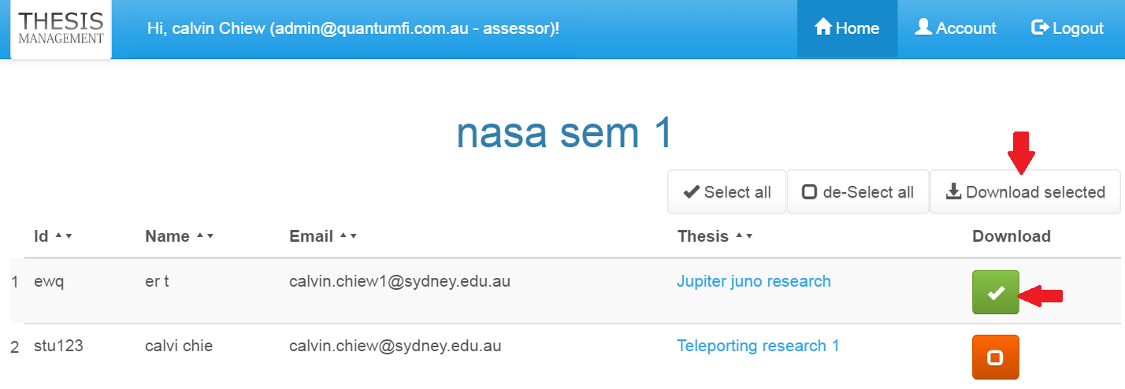

* After login, an active site will be shown together will the list of student’s project.
* To view pdf, click the link under ‘Thesis’ column.
* The pdf file will be opened at new tab of the Internet browser.
* To download the pdf, specify the files that you would like to download by clicking the orange button the ‘Download’ column. Then click the button ‘Download selected’ to start the download process.

## Student

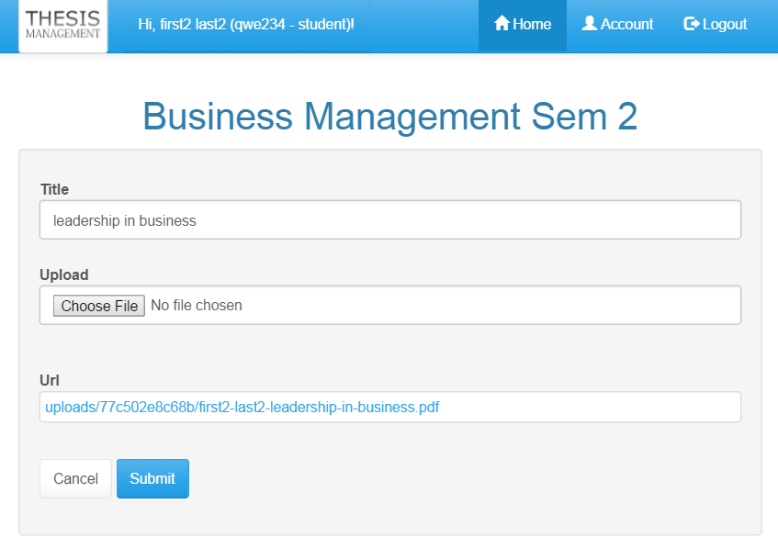

* To upload thesis, put the title of the thesis on ‘Title’ field, and choose the file that wanted to be uploaded. Make sure the file is in PDF format.
* Finally click the button ‘Submit’ to start the upload process.

## Others



* To updates account detail, click on the ‘Account’ at the top menu. An Account form will pop up.

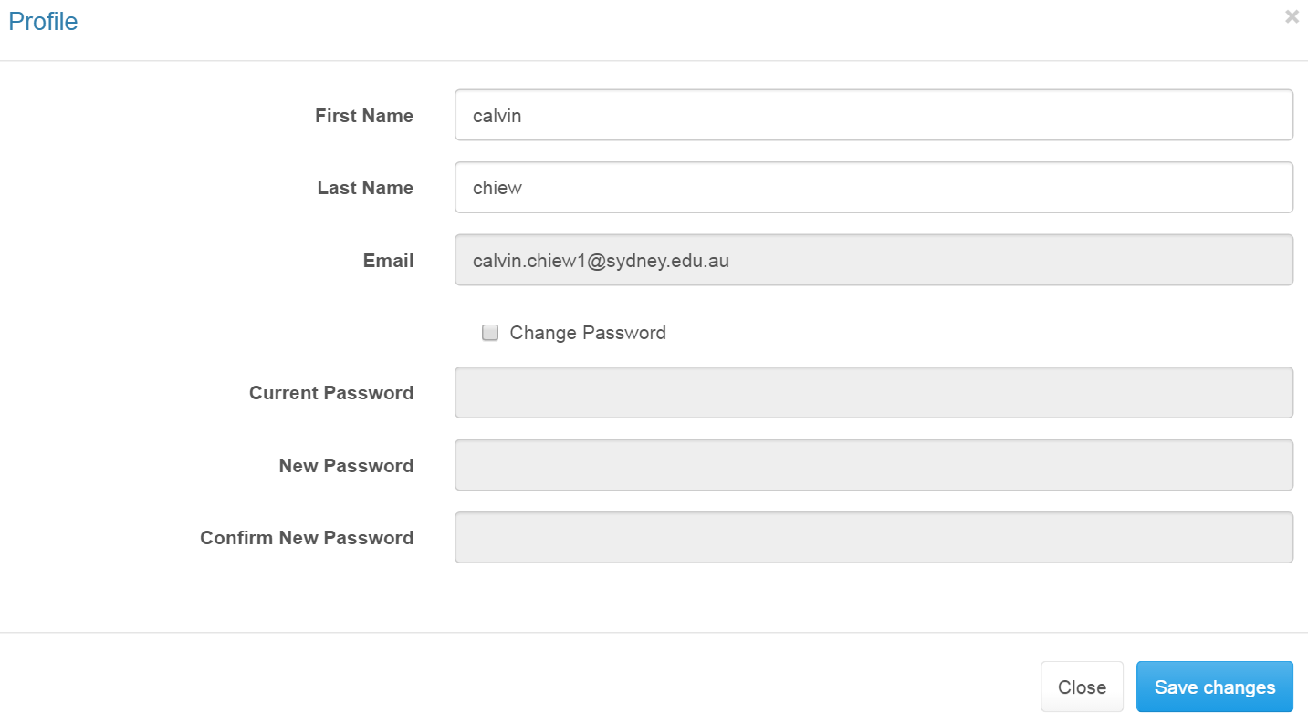

* Made the necessary changes and click the button ‘Save changes’.
* Note that only email cannot be edited.
* Note that all users except admin must change their password as their password is the same as their email.