Requirements

## Basic Requirements

* Minimum 800 x 800 pixels screen size
* Two players required (maximum and minimum is 2 players)
* Host and client

## Main Menu

This is the main menu which is the first screen that you see when the program is running. At this screen you are given three options:

1. Enter game – This will start the actual game and lead you to the screen to activate the network.
2. About – This button will lead you to the about screen which describes where and who created the program.
3. Help – This allows the user to read how to set up the network, set up their ships and rules about Battleship.

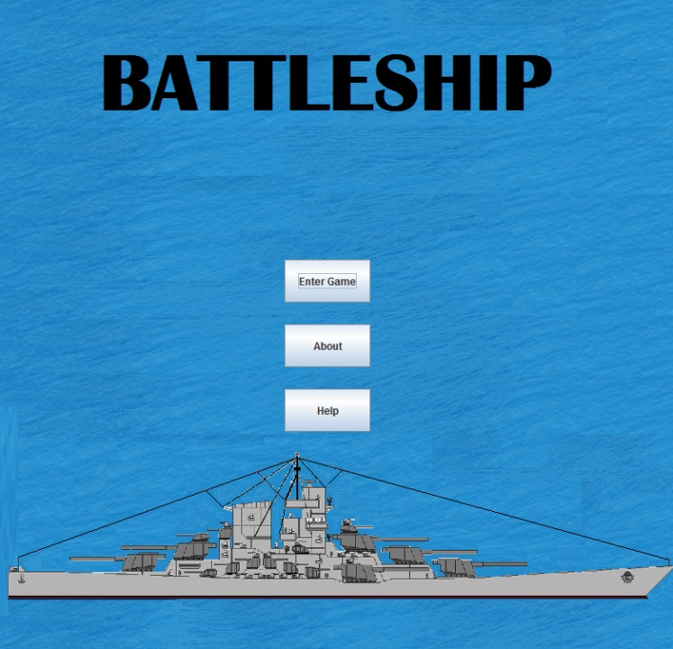All pictures on the main menu screen have been drawn by the developers of this version of Battleship.

## About Screen

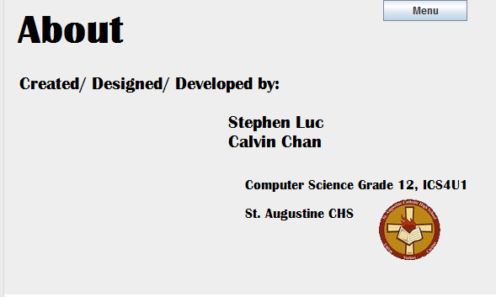This is the about screen and it just informs the players about who developed this version of Battleship and where it was created.

## Help screen

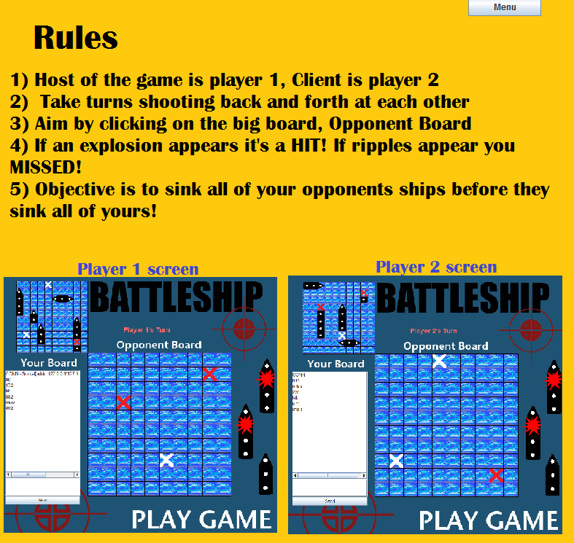The help screen was designed to answer the players questions on how to run the game at each major step.

1. The first step the user will need to do is set up the network. The first help screen shows you step by step on what you will need to do to either host a game or to join a game and become a client of a already being hosted game. The first help screen also tells you how to select the prefered theme you would like to choose.
2. 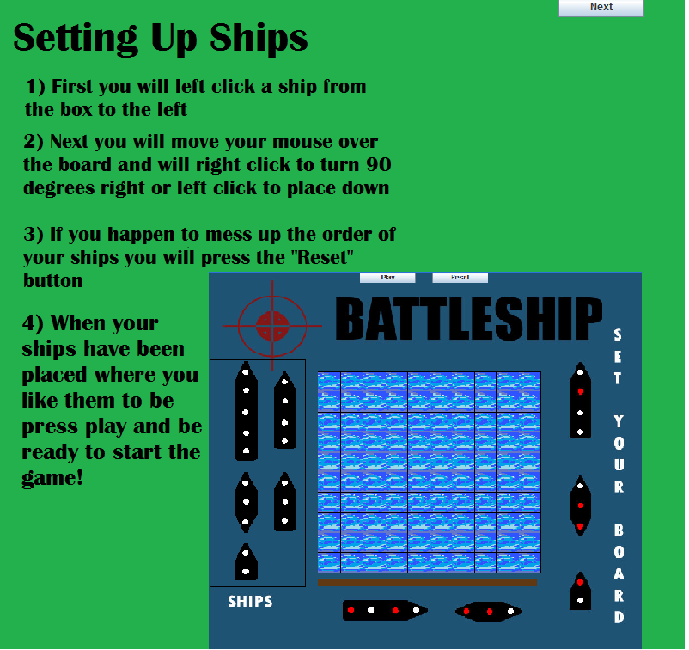The second help screen instructs you on how to set up your ships and tells you what to do if you had made a mistake when placing down your ships.
3. The last page of the help screen gives you a brief explanation of the rules that need to be followed in order to successfully play the game properly. It also tells you what the objective of this game is.

## Network/Theme Screen

This is the first screen that appears when you have pressed the “enter game” button on the main menu. This screen allows you to choose a theme from 2 different themes; the original Battleship theme and the new school supply theme.

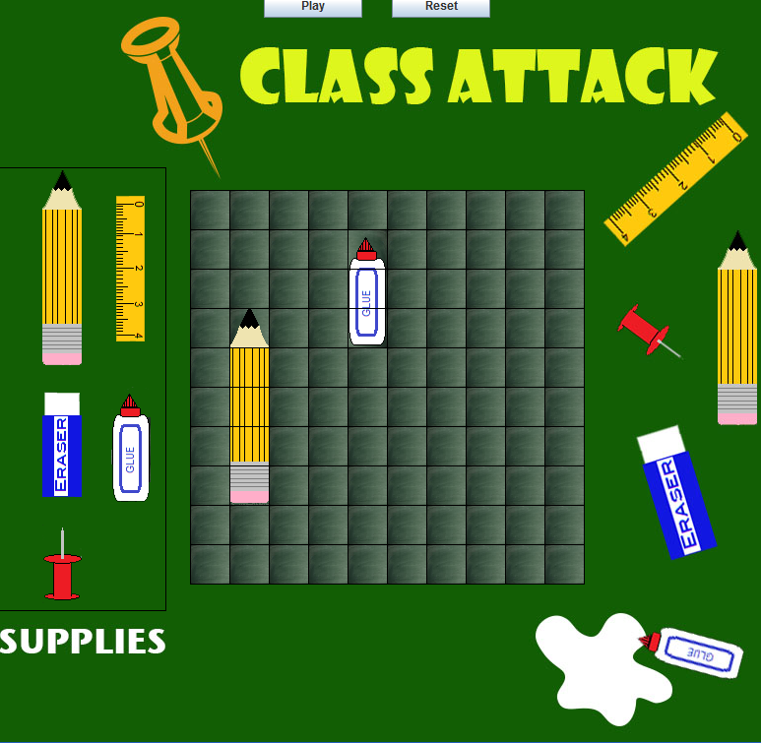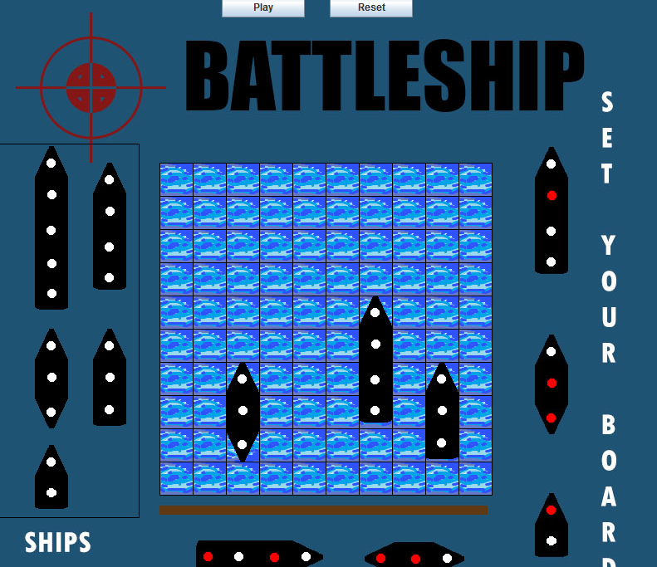

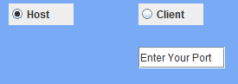Also you will have the option to choose if you want to host the game by selecting host button and entering your port number into the port number text area.

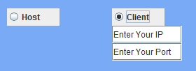If you select Client, you will need to enter in the IP Address of the host and the same port number that the host has inputted. Doing this will allow you to connect to their computer.

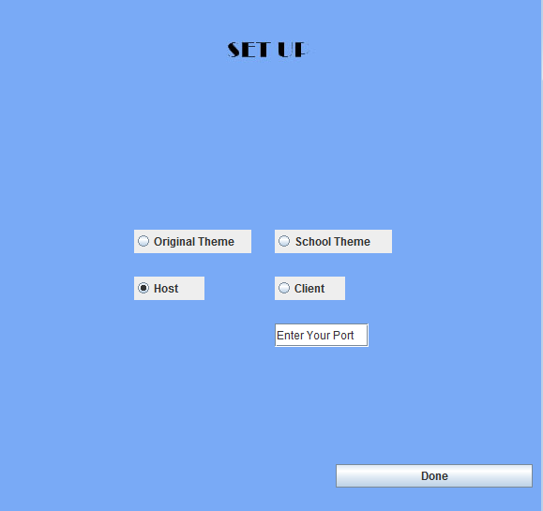

When everything is done press Done at the bottom right of the screen to confirm all selected buttons.

## Theme Text File

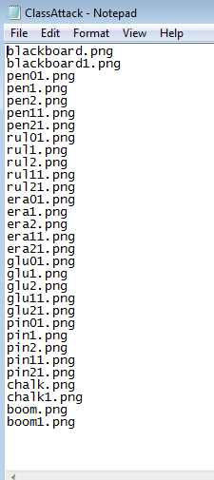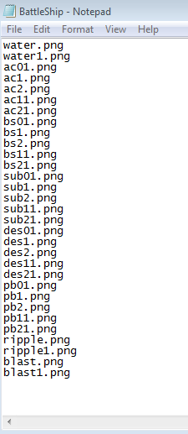Text file have been used within our game. These text files hold all the picture names that are needed for both themes. By using text files we are able to read the image names from these files and easily input them into an array. They are also both easily accessed. During the theme picking screen, each button corresponds with their text file and by selecting one theme we just need to open up that text file to be read by the image array. This saves several extra lines of hardcoding in the image names into variables.

## Game Screen

The game screen is where most of the code happens. We have added a chat box so that both players can chat with each other and also this box allows code to be transferred over so that both players can see what the other player is doing. Like where they shot at and if they missed or hit one of your ships.

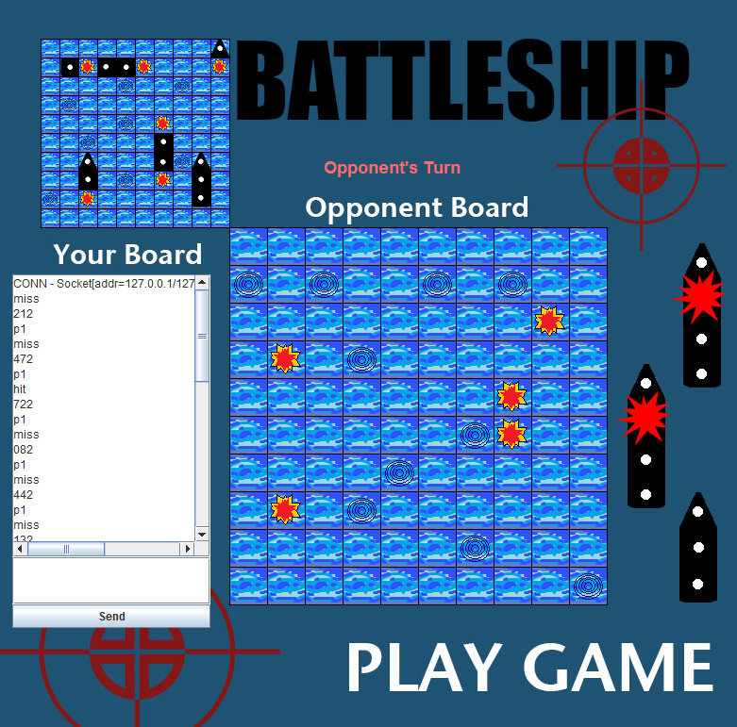

The opponent’s board and the blasts and ripples are where you shot at

Your board and where your enemy has shot. Blasts are hits and blue circles, ripples, are misses

This the chat box